**Changes needed in Chef’s Puzzle App**

1. Change default tab on recipe page

<https://app.chefspuzzle.com/recipe/view/public/dc045827-7203-486b-b2a4-c2db6409a72f>

The default tab should be instructions instead of cost

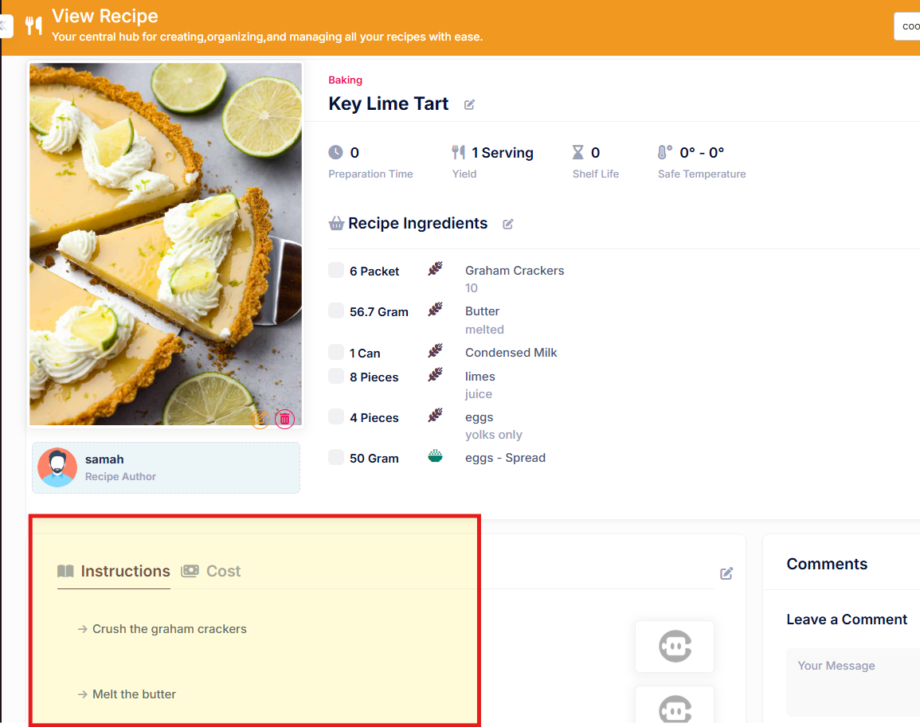

1. Changes in the Edit button throughout the app.

Change the edit button color throughout the app to orange color to make it more visible.

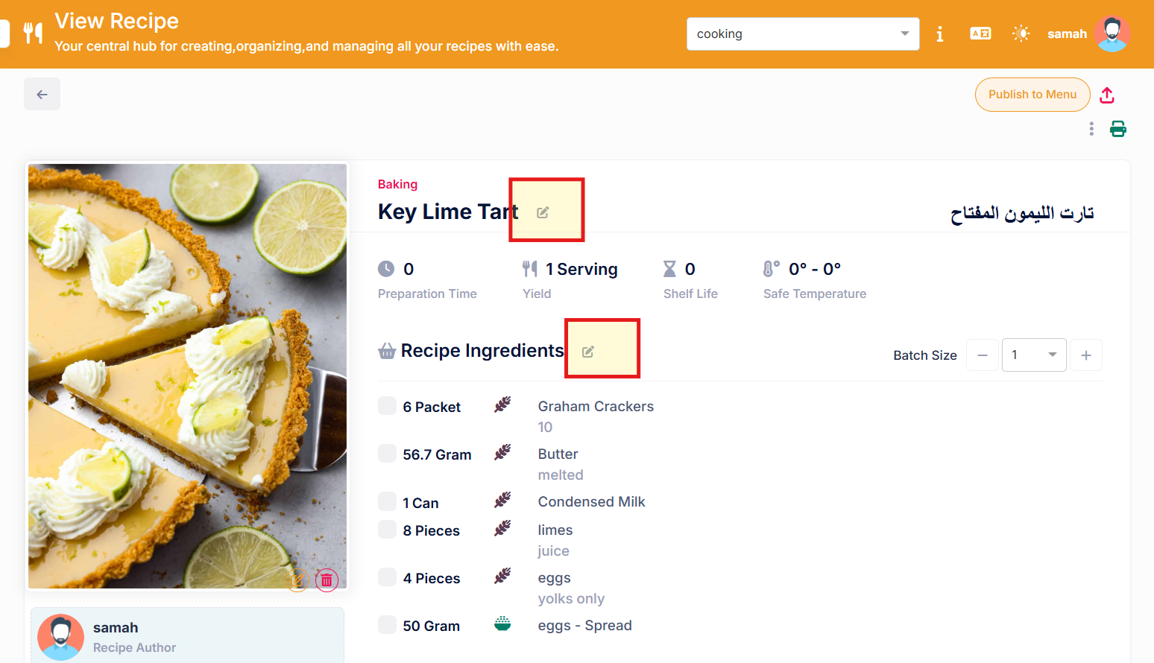

1. Change in the columns in Menu > inquiry

<https://app.chefspuzzle.com/menu/menu-inquiry>

Add the following columns, including the ones already viewed:

* Cost – if 4 recipes then show sum of cost of 4 recipes
* Sale price (excluding VAT) - if 4 recipes then show sum of price of 4 recipes
* Food Cost Percentage - if 4 recipes then price of 4 recipes divided by cost of 4 recipes
* Profit – sum of sales price minus sum of cost

*Ensure that the values are total of the items selected in the particular menu.*

