1、

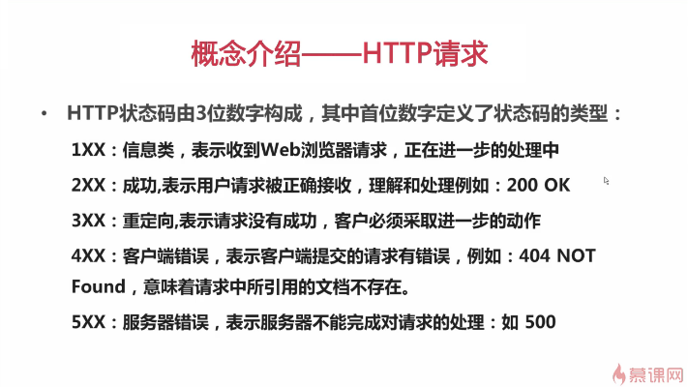

2、浏览器发送请求：

|  |
| --- |
| C:\Users\zj\AppData\Local\Microsoft\Windows\INetCache\Content.Word\2345截图20180326205936.png |

3、获取服务器的响应：

|  |
| --- |
|  |

监听服务器readState来确定服务器的状态：

|  |
| --- |
| C:\Users\zj\AppData\Local\Microsoft\Windows\INetCache\Content.Word\2345截图20180326210640.png |

具体使用方法：

|  |
| --- |
| C:\Users\zj\AppData\Local\Microsoft\Windows\INetCache\Content.Word\2345截图20180326210859.png |

4、json:

|  |
| --- |
| C:\Users\zj\AppData\Local\Microsoft\Windows\INetCache\Content.Word\2345截图20180327122347.png |

|  |
| --- |
|  |

json解析方法：JSON.parse()

|  |
| --- |
|  |

在线校验工具：jsonlint.com

一般步骤：

|  |
| --- |
|  |
| C:\Users\zj\AppData\Local\Microsoft\Windows\INetCache\Content.Word\2345截图20180327132652.png |
|  |

=========================

5、利用jquery实现Ajax

|  |
| --- |
|  |

典型案例：

|  |
| --- |
|  |

|  |
| --- |
|  |

较完整版如下：

读取信息

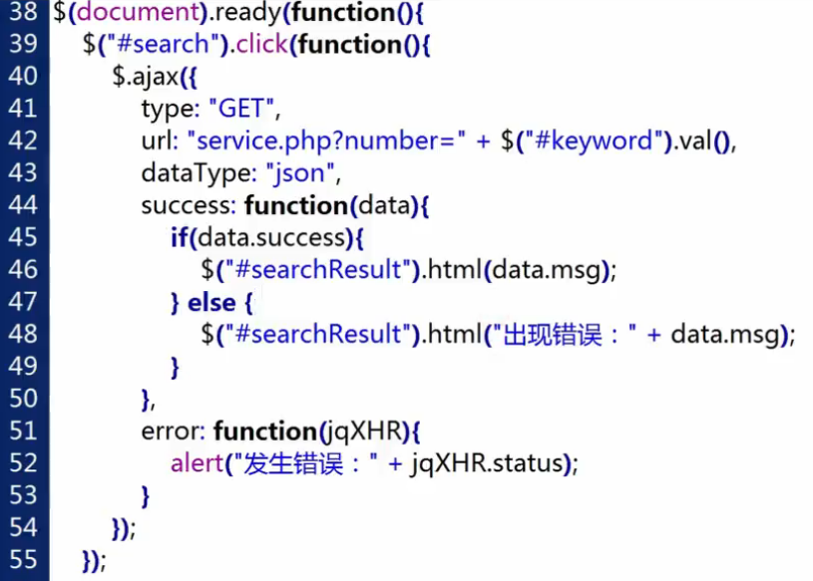

下面两张图表示post请求，写入信息

|  |
| --- |
|  |

实例1：

|  |
| --- |
| **function** personchange() {  $.ajax({  type: "POST",  url:"/personchange",  dataType:"json",  data: {  nickname: $("#nickname").val(),  username: $("#username").val(),  },  success: **function**(data) {  console.log(data.nickname);  },  error: **function** (msg) {  console.log(msg);  }   }); |
| <div>  <button type="submit" class="btn btn-primary" id="change" onclick="personchange()">  修改  </button> </div> |