Thymeieaf相关知识：

|  |
| --- |
|  |

|  |
| --- |
|  |

|  |
| --- |
|  |

|  |
| --- |
|  |

|  |
| --- |
|  |

|  |
| --- |
| C:\Users\zj\Desktop\2345截图20180323201900.pngC:\Users\zj\Desktop\2345截图20180323201947.pngC:\Users\zj\Desktop\2345截图20180323202004.png |

|  |
| --- |
|  |
|  |

|  |
| --- |
|  |

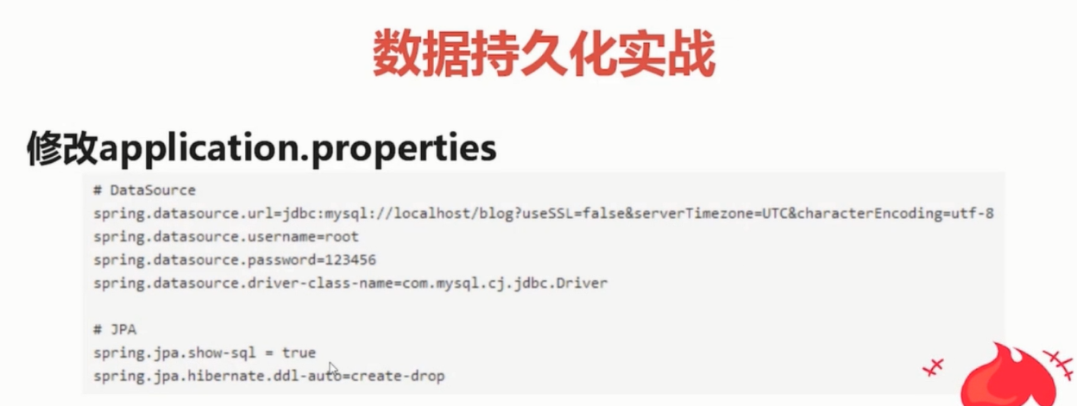

JPA

