**1.MATRIX MULTIPLICATION:**

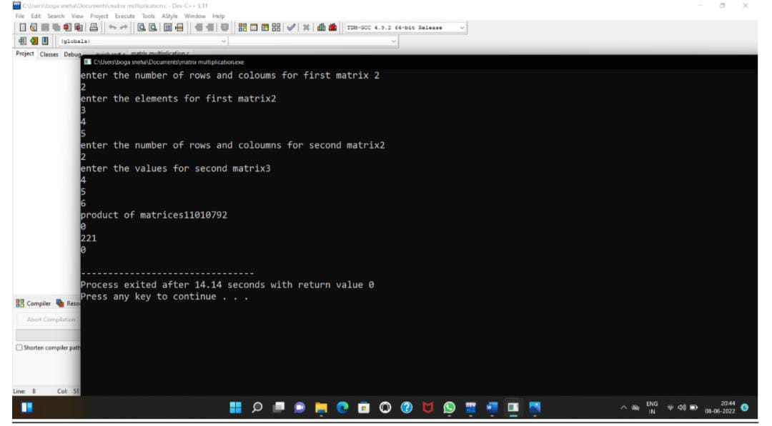

**2.odd or even:**

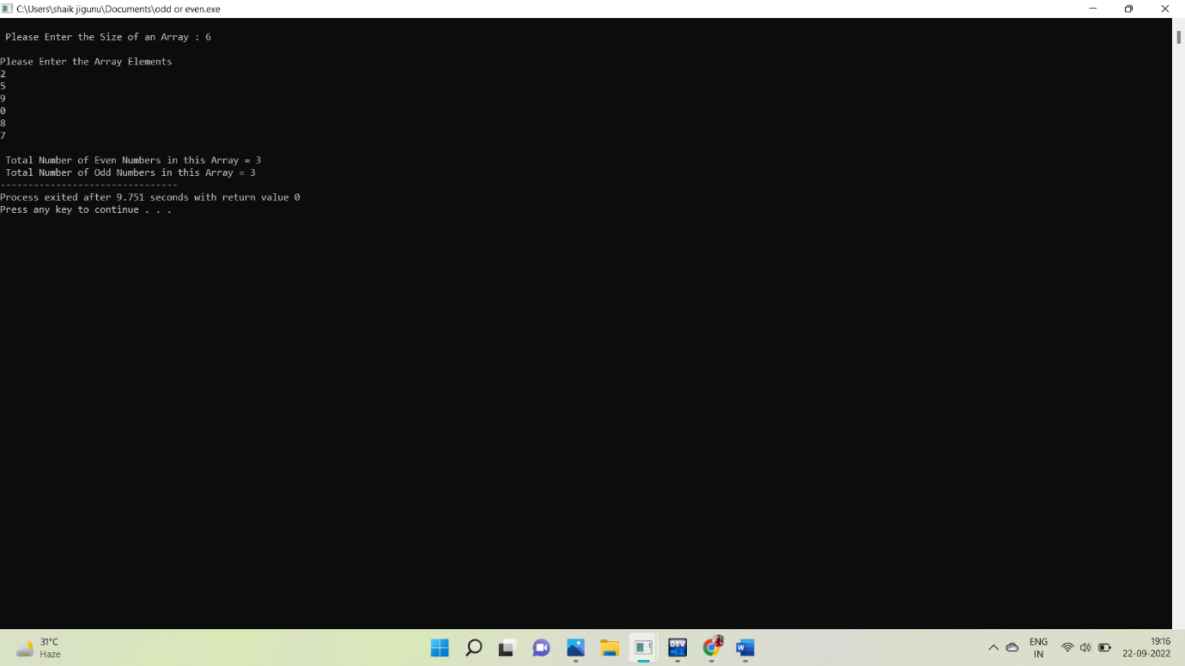

**3.factorial without using recursion:**

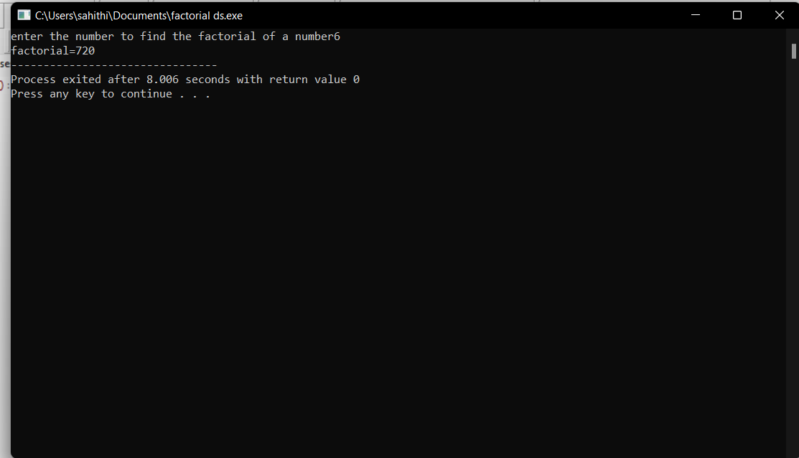

**4.fibonacci without using recursion:**

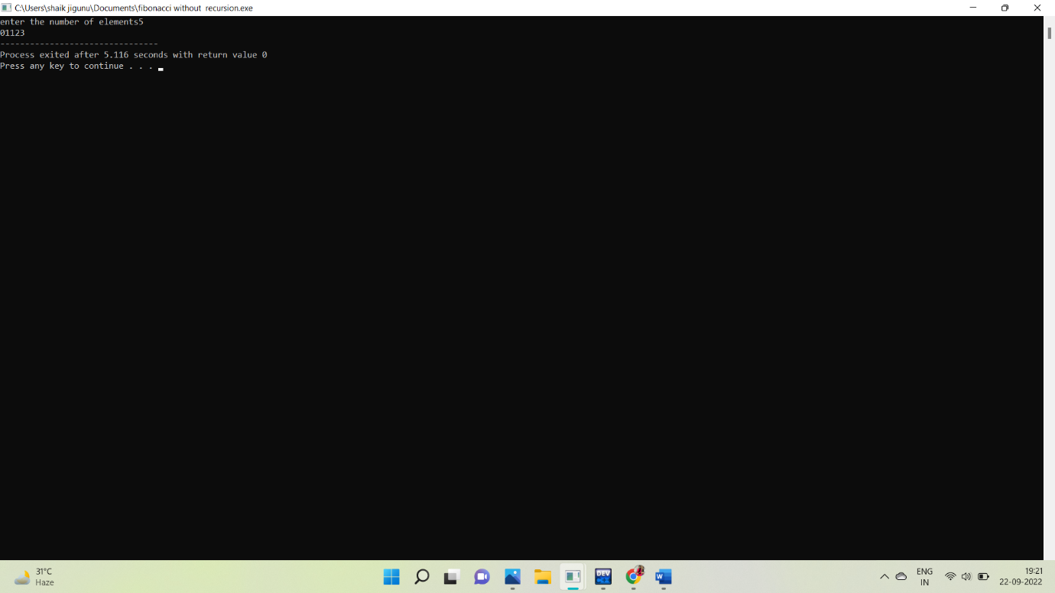

**5.factorial with using recursion:**

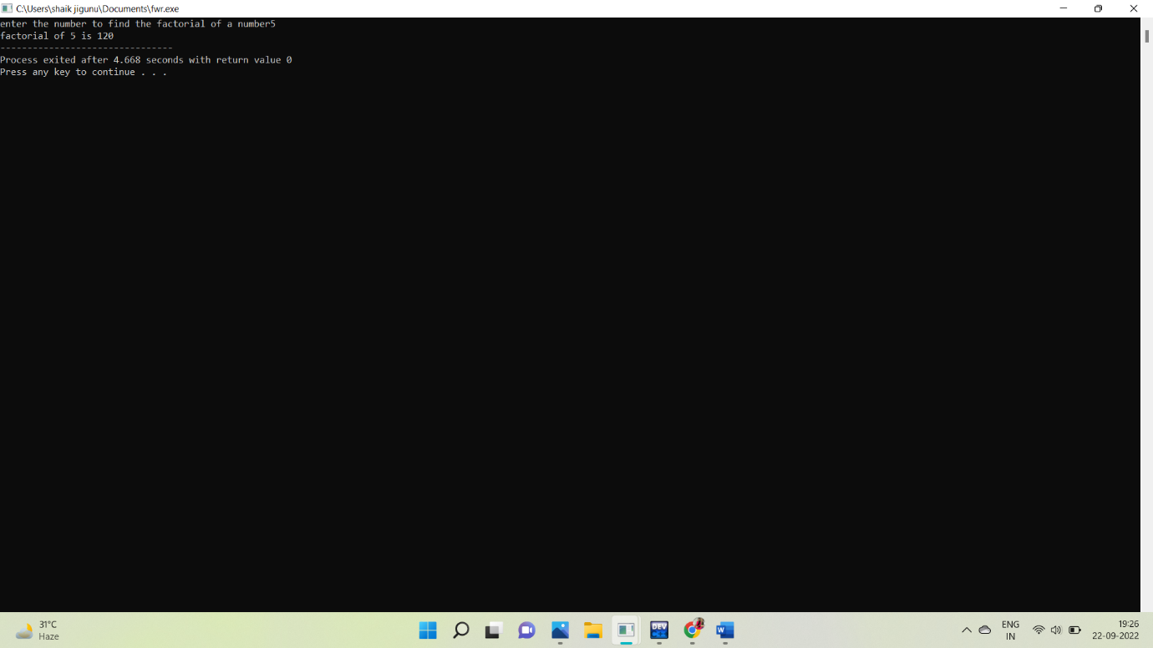

**6.Fibonacci using recursion:**

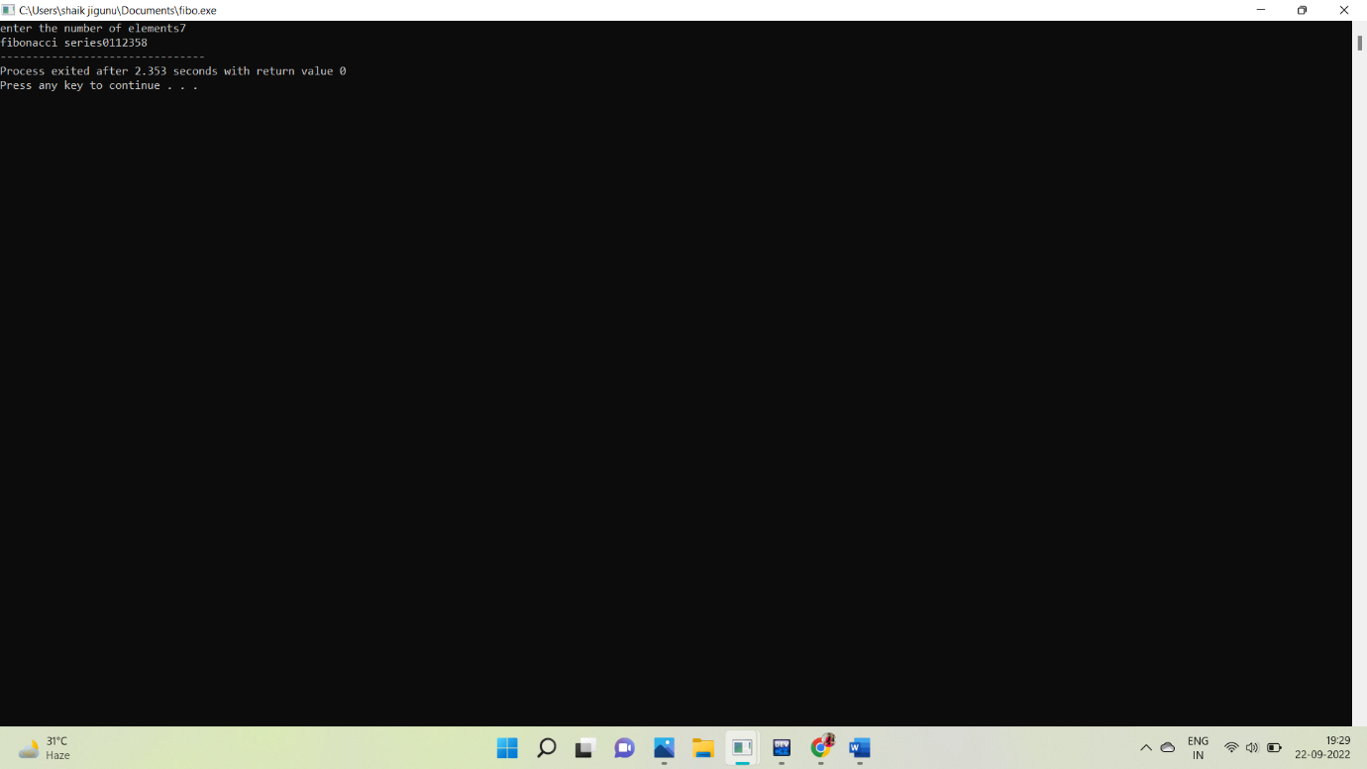

**7.ARRAY OPERATIONS:**

**1.insertion:**

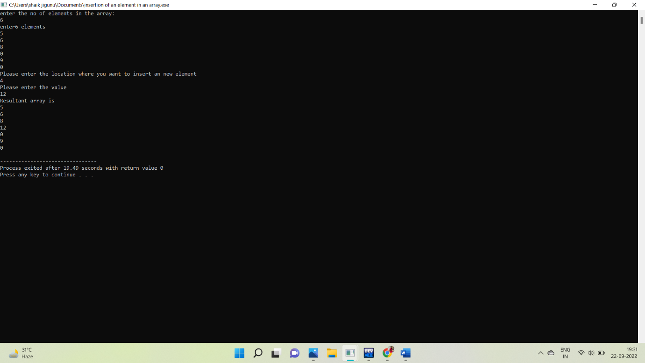

**2.delete:**

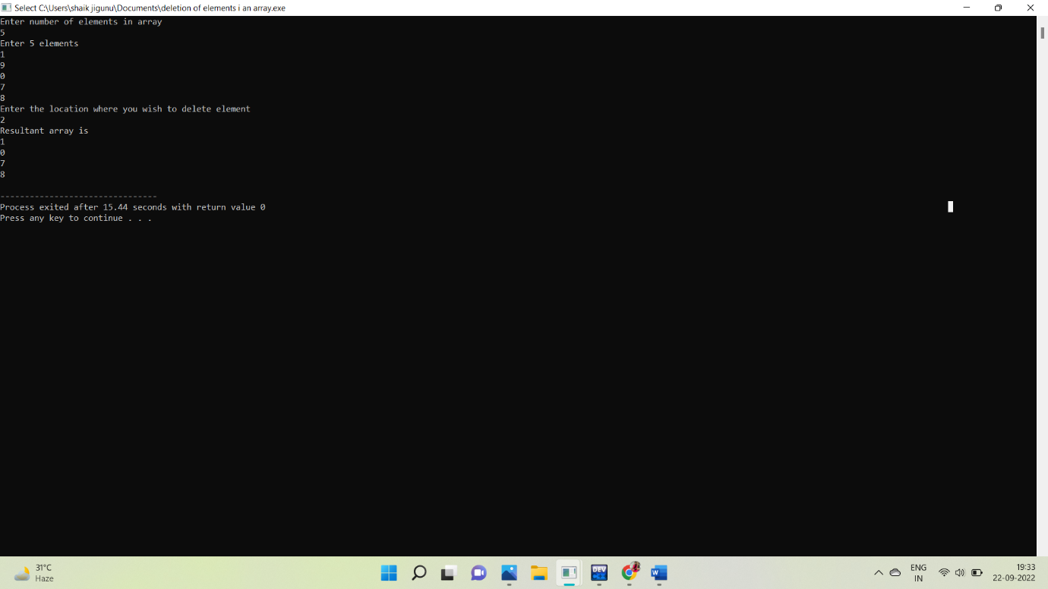

**3.update:**

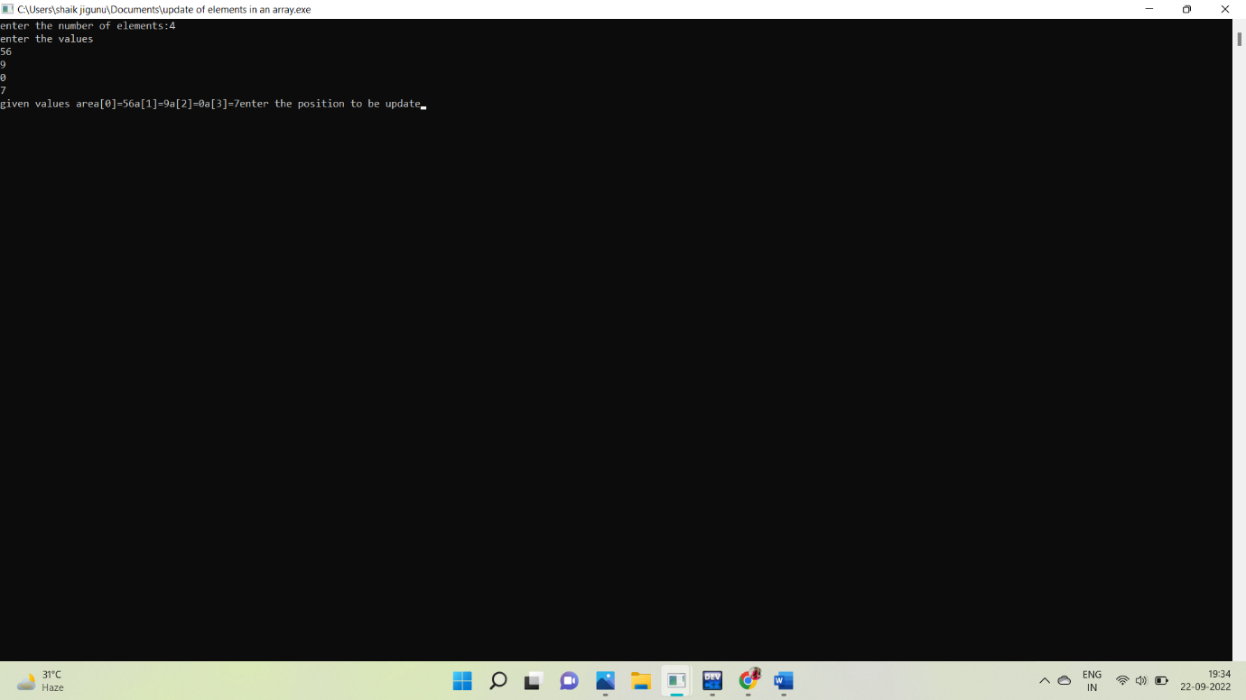

**8.LINEAR SEARCH:**

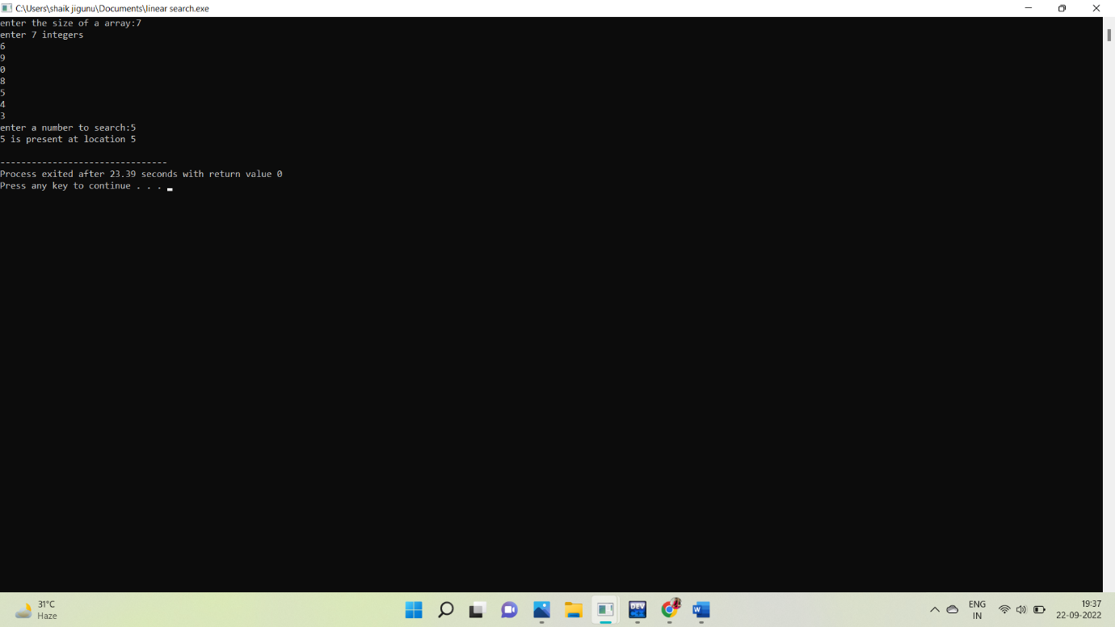

**9.BINARY SEARCH:**

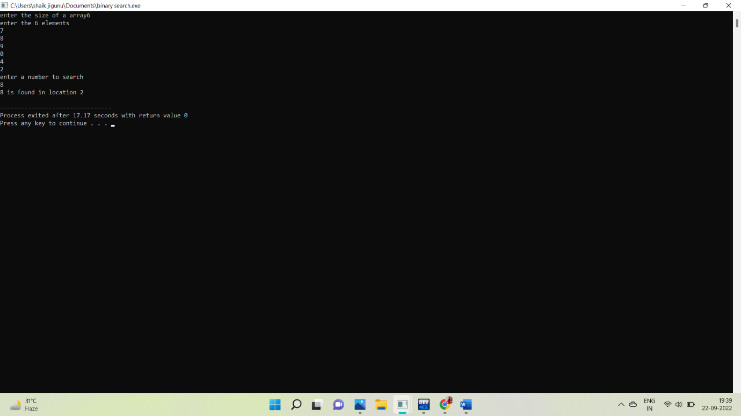

**10.LINKED LIST:**

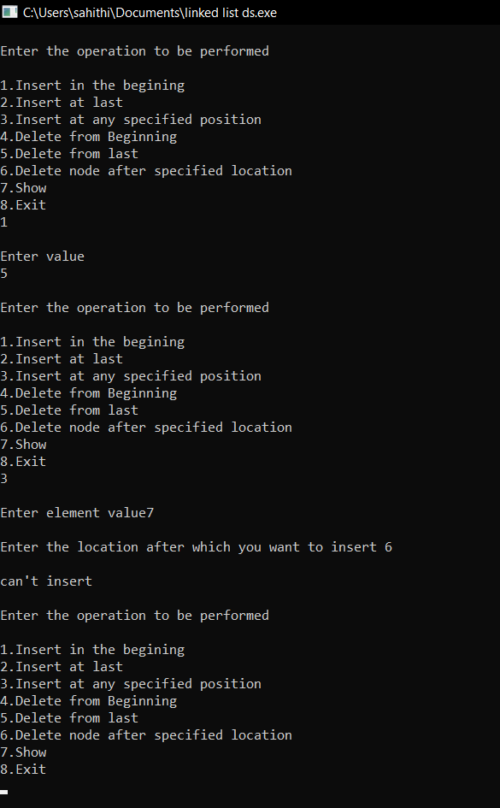

**11.STACK OPERATIONS:**

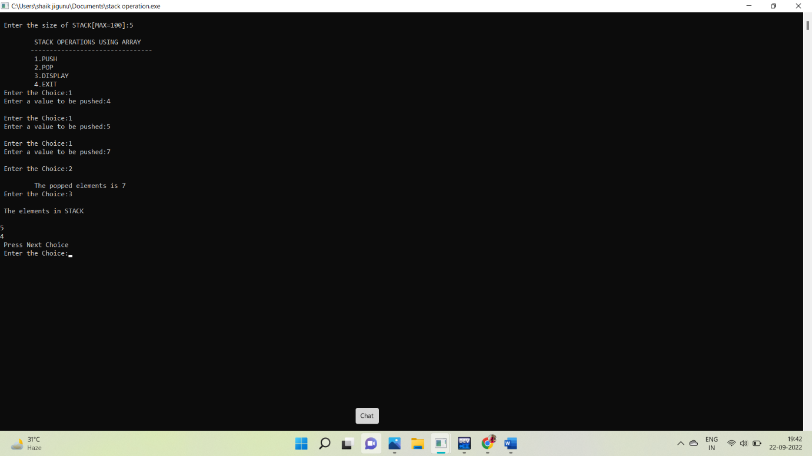

**12.STACK APPLICATIONS:**

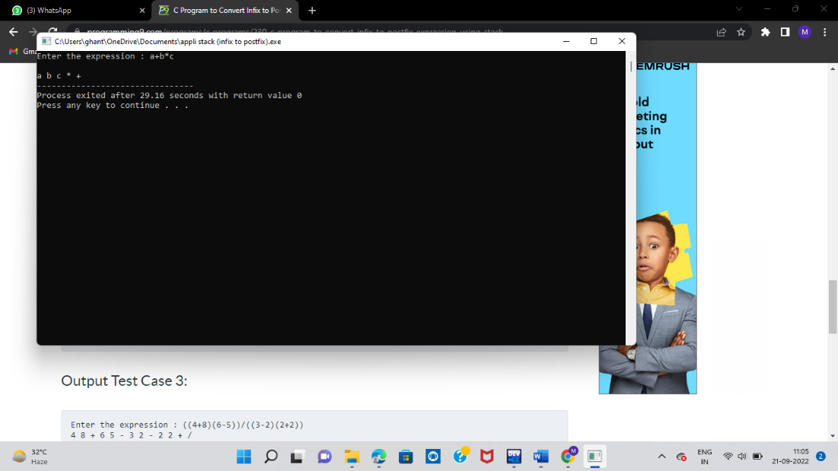

**13.QUEUE OPERATIONS:**

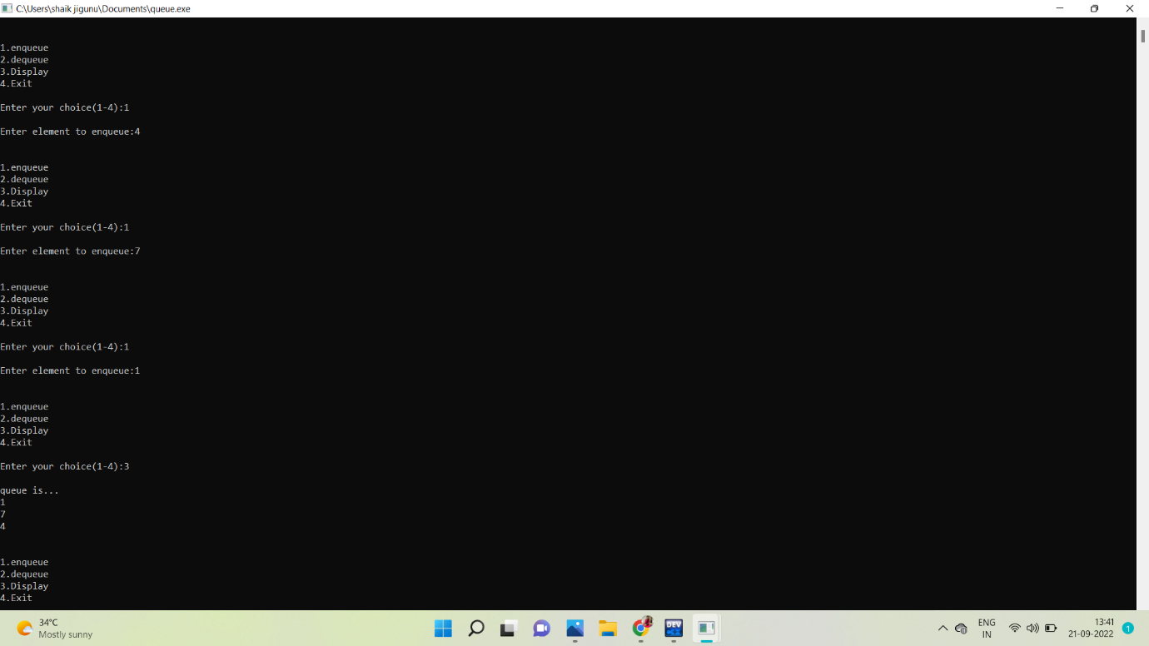

**14.TREE TRAVERSALS:**

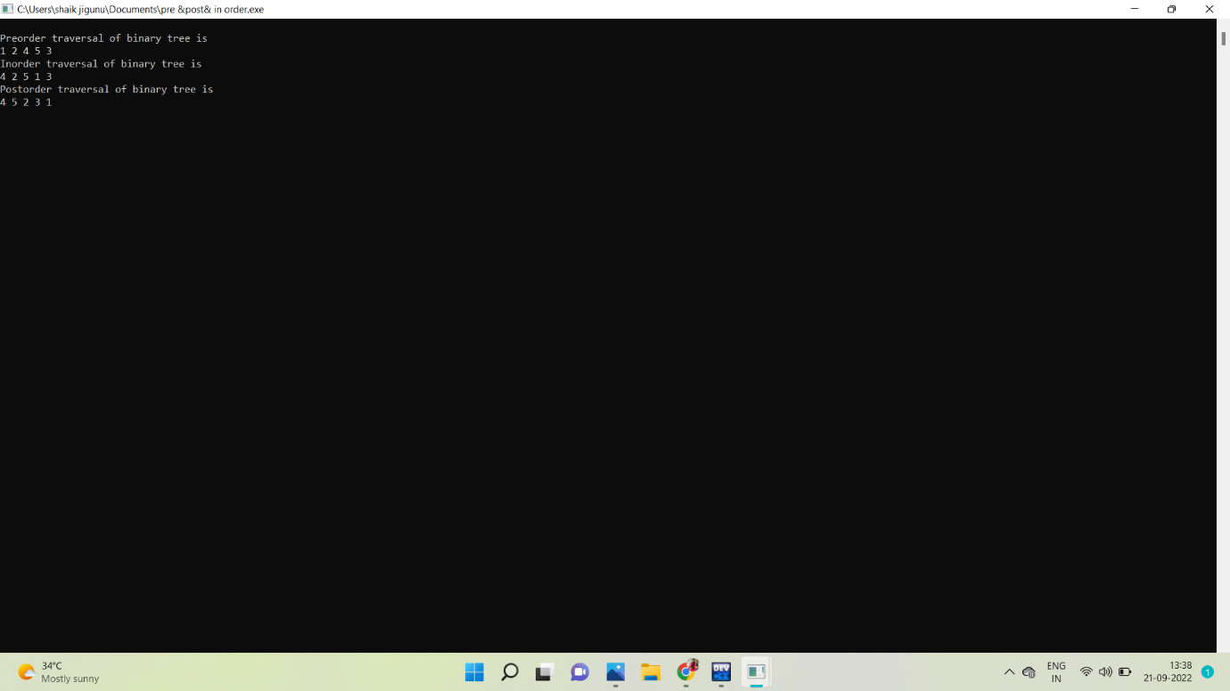

**15.HASHING:**

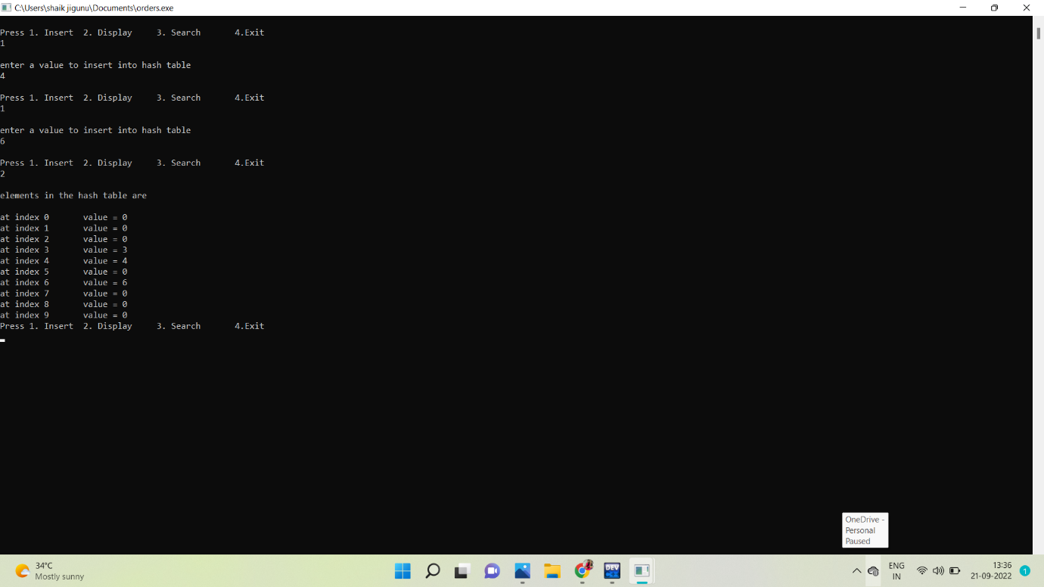

**16.INSERTION SORT:**

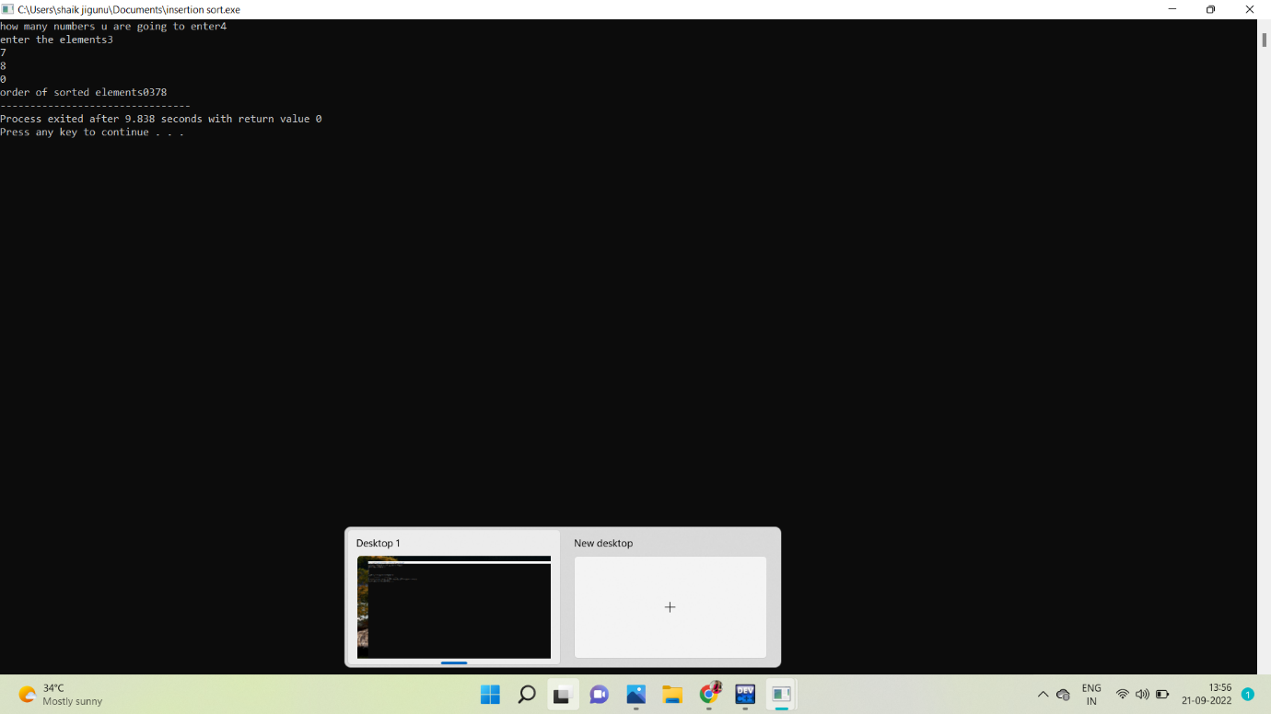

**17.MERGE SORT:**

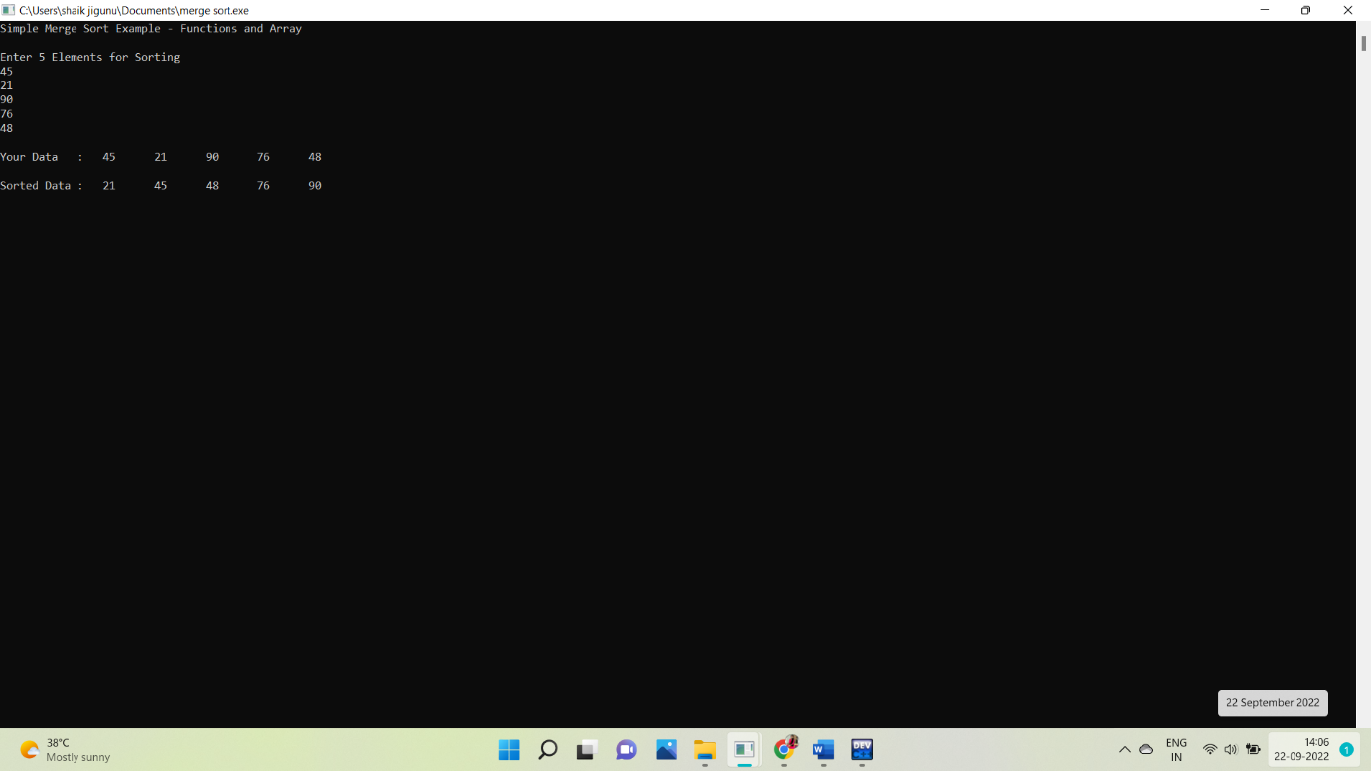

**18.QUICK SORT:**

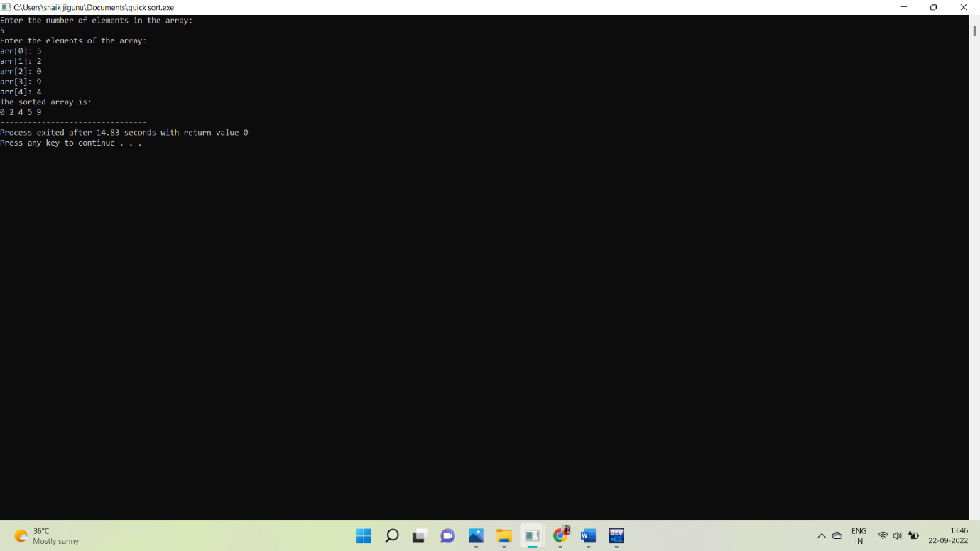

**19.HEAP SORT:**

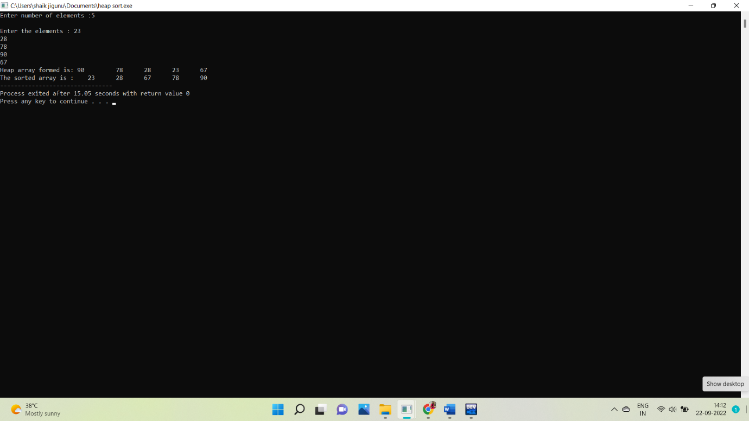

**20.AVL TREE OPERATIONS:**

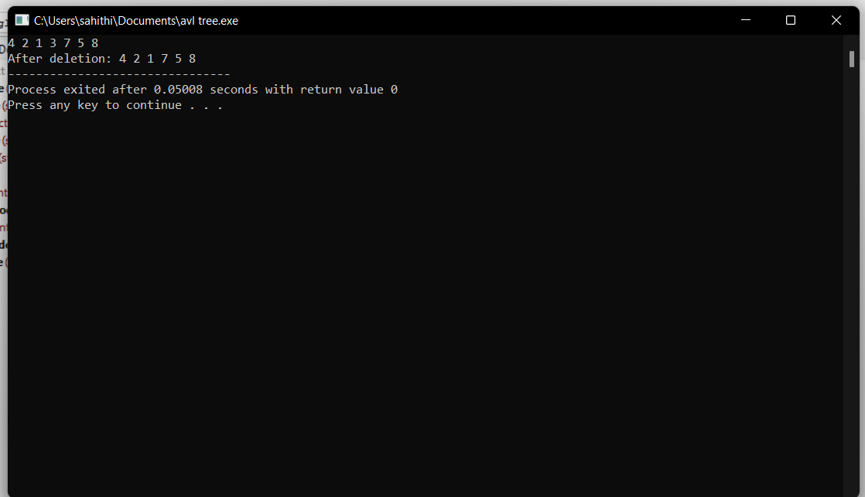

**21.BREADTH FIRST SEARCH:**

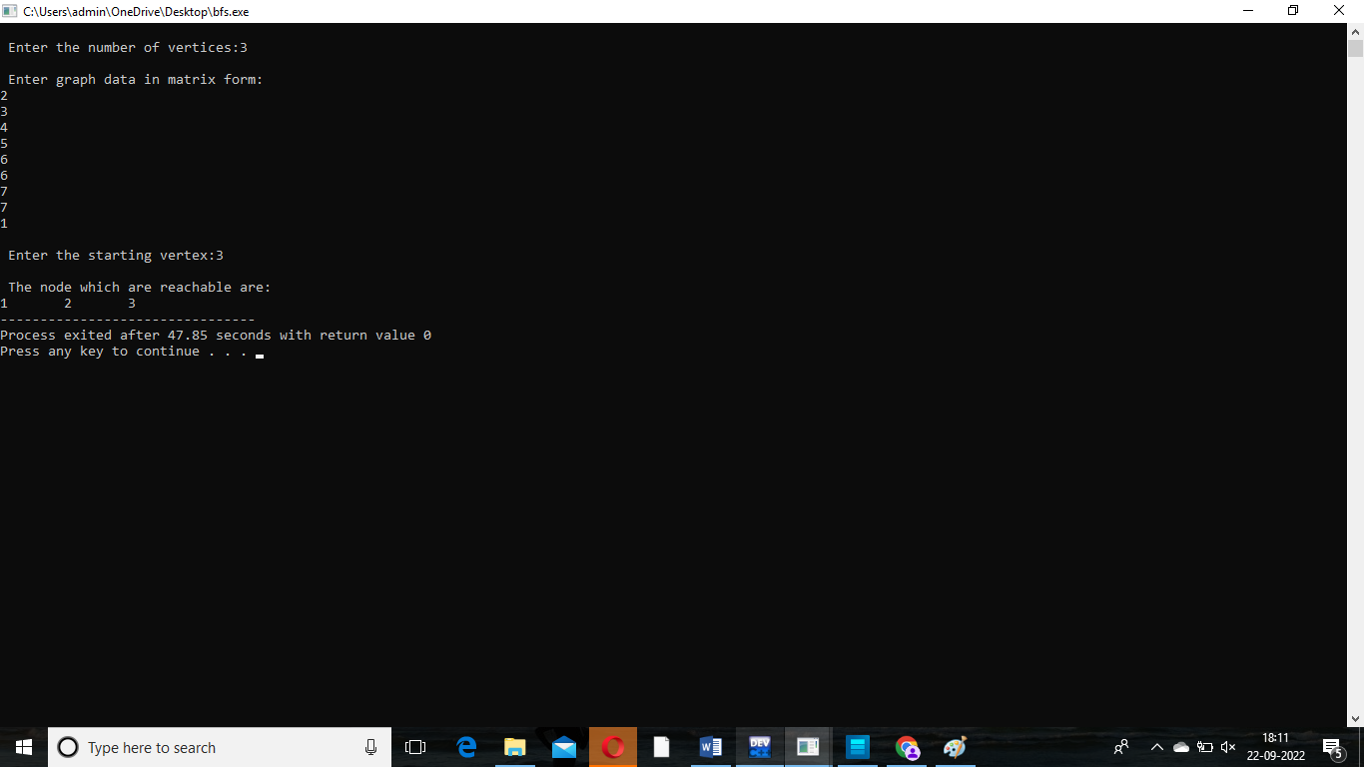

**22.DEPTH FIRST SEARCH:**

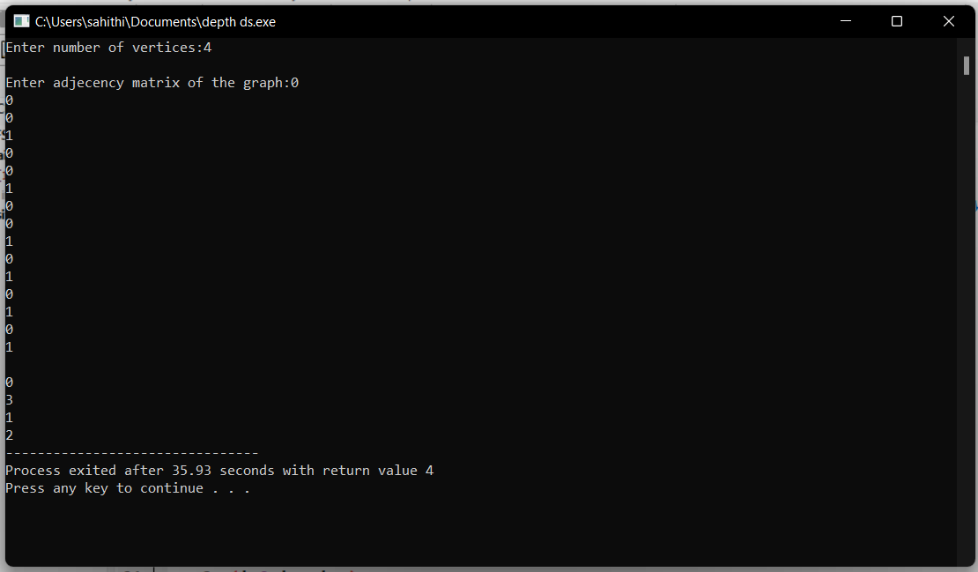

**23.DIJKSTRA’S ALGORITHM:**

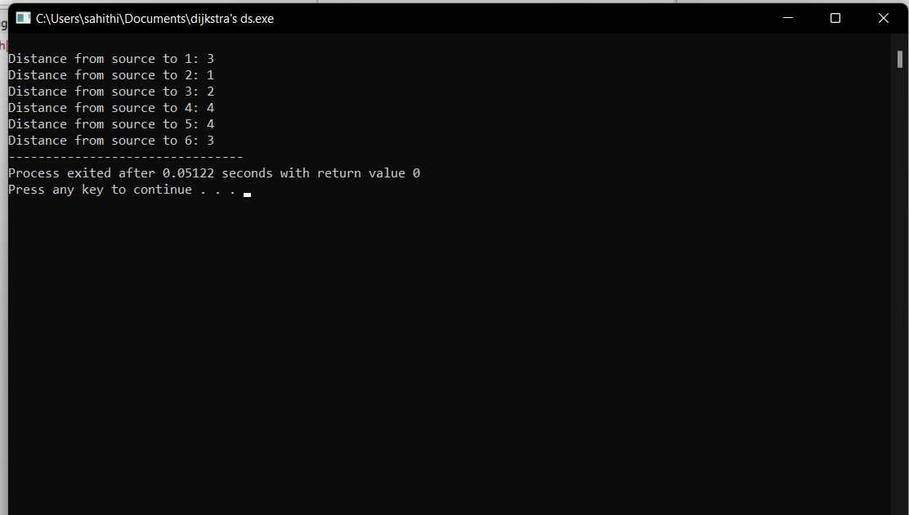

**24.PRIM’S ALGORITHM:**

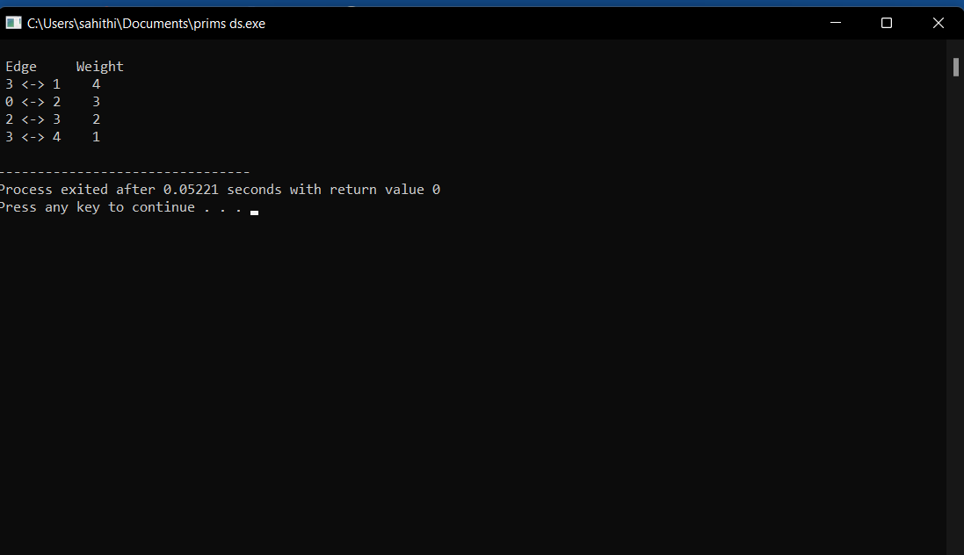

**25.KRUSKAL ALGORITHM:**

