BUDGETBUDDY
Task 1 — Core Database Schema
Infosys Springboard Virtual Internship 7.0
Project Name | Intelligent Student Budget Planning and Personal Expense Management Platform — BudgetBuddy
Task | Task 1 — Design BudgetBuddy's Core Database Schema
Student Name | Jigyansa Mohanty
Mentor | K Dikshita — Infosys Internship Program

1. Task Objective
Design the initial relational data model required for BudgetBuddy. The ER/data model covers the eight entities specified for Task 1: User, Profile, Income, Expense, Budget, Savings Goal, Notification, and Report.

2. ER / Data Model Diagram
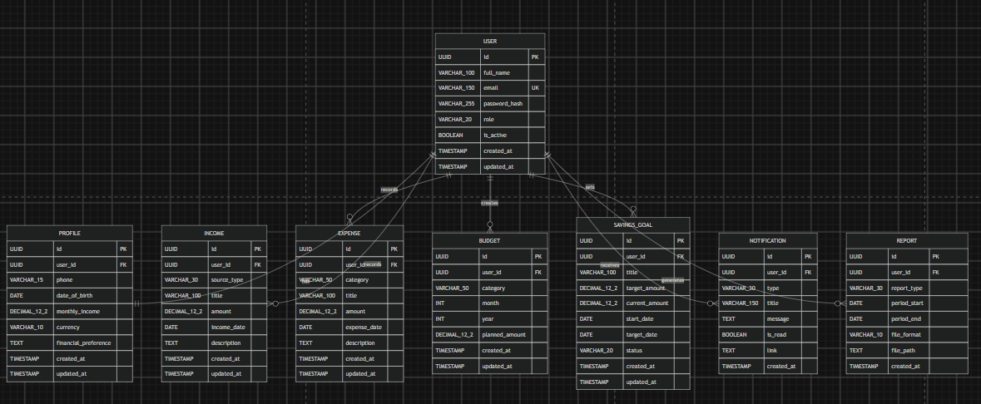

Figure 1. BudgetBuddy Core Database ER / Data Model Diagram.

3. Entities Covered
Entity | Purpose
User | Main account entity.
Profile | Additional user profile and financial-preference information.
Income | Income records belonging to a user.
Expense | Expense records including category, amount and date.
Budget | Planned spending by month/year and optionally category.
Savings Goal | Savings target, current progress and status.
Notification | Alerts, reminders and other user notifications.
Report | Generated report metadata and reporting period information.

4. Relationship Summary
Parent | Child | Cardinality | Description
User | Profile | 1 : 1 | One User has one Profile.
User | Income | 1 : N | One User can have many Income records.
User | Expense | 1 : N | One User can have many Expense records.
User | Budget | 1 : N | One User can create multiple Budget records.
User | Savings Goal | 1 : N | One User can have multiple Savings Goals.
User | Notification | 1 : N | One User can receive many Notifications.
User | Report | 1 : N | One User can generate multiple Reports.

