#include<stdio.h>

#include <stdlib.h>

#include <time.h>

int rules();

int round1();

int main()

{

 rules();

 printf("\n\n");

 round1();

 return 0;

}

int round1()

{

 char name[50];

 printf("Enter your name : ");

 scanf("%s", &name);

 printf("\n\n");

 int deposit1;

 printf("Enter the amount of money to deposit for the game : rupees");

 scanf("%d", &deposit1);

 printf("\n\n");

 printf("Your current balance is rupees %d", deposit1);

 printf("\n\n");

 int bet1;

 printf("%s, Enter the money to bet : rupees", name);

 scanf("%d", &bet1);

 printf("\n\n");

 if(bet1>deposit1)

 {

 printf("Money Exceeds,\n");

 printf("Enter Again : rupees");

 scanf("%d", &bet1);

 }

 printf("\n\n");

 srand(time(NULL));

 int computer1;

 computer1 = rand() % 10+1;

 int guess1;

 printf("Guess a number from 1 to 10 : ");

 scanf("%d", &guess1);

 printf("\n\n");

 if(guess1>10)

 {

 printf("Number Exceeds,\n");

 printf("Enter Again : ");

 scanf("%d", &guess1);

 }

 printf("\n\n");

 if(guess1==computer1)

 {

 printf("You have won rupees %d", bet1);

 printf("\n\n");

 int bet2;

 bet2 = bet1 * 10;

 int new_won;

 if(bet1==deposit1)

 {

 new_won = bet2 + 0;

 }

 else

 {

 new_won = bet2 + deposit1;

 }

 printf("Congratulations! You have won rupees %d as total", new_won);

 }

 else if(guess1!=computer1)

 {

 printf("You have loss rupees %d", bet1);

 printf("\n\n");

 printf("The correct number is : %d", computer1);

 printf("\n\n");

 int new_los;

 new_los = deposit1 - bet1;

 printf("Now you have rupees %d as a balance", new_los);

 printf("\n\n");

 if(new_los==0)

 {

 printf("Sir,you have rupees 0 as a balance\n");

 printf("You have no more money to play\n");

 printf("Have a nice day");

 }

 else

 {

 int decision;

 printf("Press 1 for YES\n");

 printf("Press 2 for NO\n\n");

 printf("Do you want continue(Y/N) : ");

 scanf("%d", &decision);

 printf("\n\n");

 if(decision==1)

 {

 printf("\n\n");

 printf("Now you have rupees%d as a balance", new_los);

 printf("\n\n");

 int bet3;

 printf("%s, Enter the money to bet : rupees",name);

 scanf("%d", &bet3);

 printf("\n\n");

 if(bet3>new_los)

 {

 printf("Money Exceeds,\n");

 printf("Enter Again : rupees");

 scanf("%d", &bet3);

 }

 int guess2;

 printf("Enter a number from 1 to 10 : ");

 scanf("%d", &guess2);

 printf("\n\n");

 srand(time(NULL));

 int computer2;

 computer2 = rand()%10+1;

 if(guess2>10)

 {

 printf("Number Exceeds,\n");

 printf("Enter Again : rupees");

 scanf("%d", &guess2);

 printf("\n\n");

 }

 if(guess2==computer2)

 {

 printf("You have won rupees %d", bet3);

 printf("\n\n");

 int b;

 b = bet3 * 10;

 int b1;

 if(bet3==new_los)

 {

 b1 = b + 0;

 }

 else

 {

 b1 = b + new_los;

 }

 printf("You have won rupees %d as total",b1);

 }

 else if(guess2!=computer2)

 {

 printf("The correct number is : %d\n\n", computer2);

 printf("You have loss rupees %d", bet3);

 printf("\n\n");

 int b2;

 b2 = new_los - bet3;

 printf("You have rupees%d as a total\n\n", b2);

 printf(" Thank you for playing\n");

 printf("\n\n");

 if(b2==0)

 {

 printf("Sir,you have rupees 0 as a balance\n");

 printf("You have no more money to play\n");

 printf("Have a nice day");

 }

 }

 }

 else if(decision==2)

 {

 printf("Have a good day sir");

 }

 }

 }

}

int rules()

{

 printf("----------------------------------------------------------------------------\n");

 printf(" RULES\n");

 printf("-----------------------------------------------------------------------------\n");

 printf(" 1. Choose any number between 1 to 10\n");

 printf(" 2. The game stops if you win in first attempt and you get second change if you lose\n ");

 printf(" 3. If you win you will get 10 times of money you bet\n");

 printf(" 4. if you bet on wrong number you will lose your betting amount\n");

 printf("------------------------------------------------------------------------------\n")

}

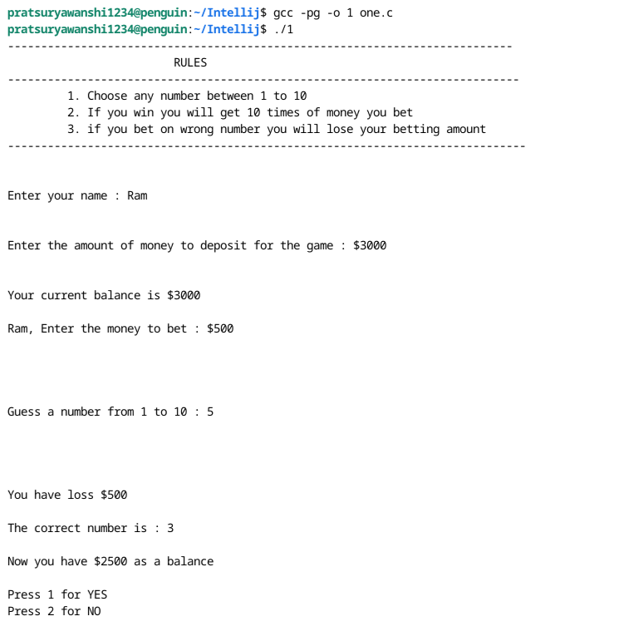

ne.c -o one && "/home/pratsuryawanshi1234/Javanew/"one

one.c: In function ‘round1’:

one.c:51:17: warning: implicit declaration of function ‘rand’ [-Wimplicit-function-declaration]

51 | computer1 = rand() % 10;

| ^~

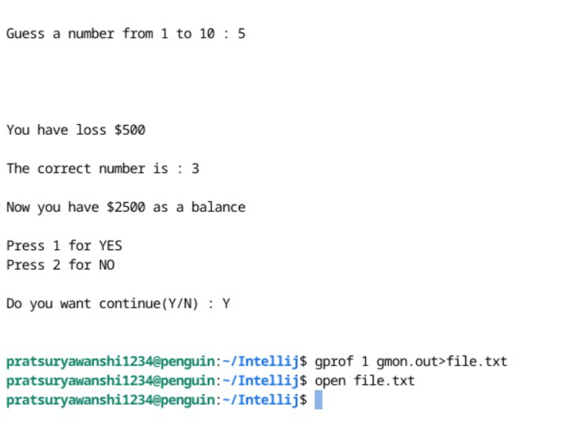

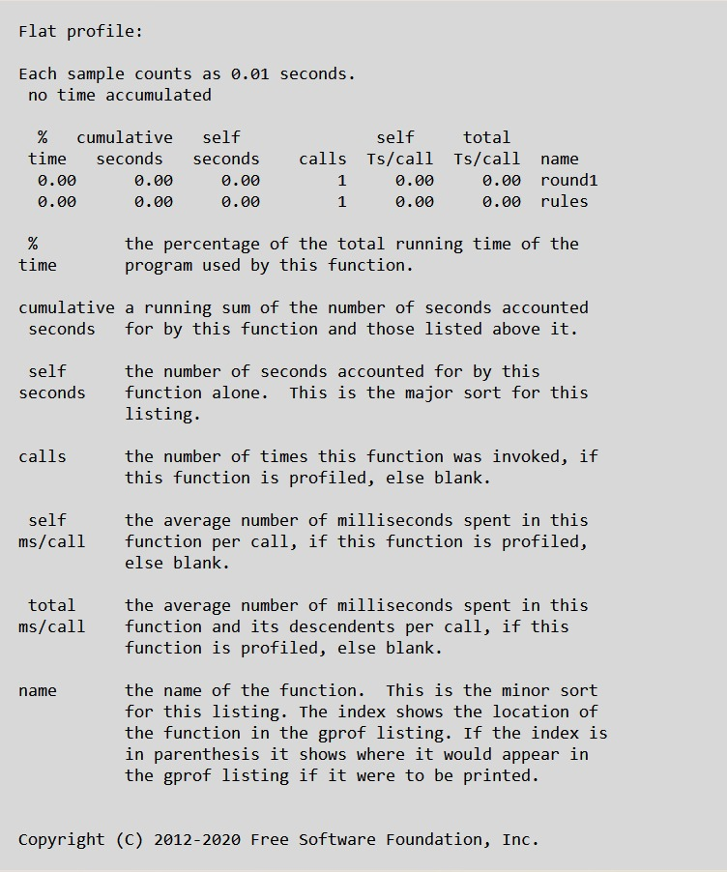

Latex Code

\documentclass{article}

\usepackage[utf8]{inputenc}

\title{Number Guessing Game in C}

\author{}

\date{}

\begin{document}

\maketitle

\section*{Description: Number Guessing Game in C}

This C program is a classic number guessing game that allows players to guess a randomly chosen number within a predefined range. The game starts by generating a random number between a specified lower and upper bound. The player is then prompted to guess the number. After each guess, the program provides feedback to the player, indicating whether the guessed number is too high, too low, or correct.

\textbf{Initialization:}

The program initializes necessary variables, including the lower and upper bounds of the random number range and the randomly generated number. The \texttt{rand()} function is used to generate a random number within the specified range.

\begin{verbatim}

#include <stdio.h>

#include <stdlib.h>

#include <time.h>

int main() {

int lowerBound = 1;

int upperBound = 100;

int randomNumber, playerGuess;

srand(time(0)); // Seed for the random number generator using current time

randomNumber = (rand() % (upperBound - lowerBound + 1)) + lowerBound;

\end{verbatim}

\textbf{Game Loop:}

The game runs in a loop, allowing the player to make multiple guesses until they correctly guess the number. Inside the loop, the player is prompted to enter their guess.

\begin{verbatim}

printf("Welcome to the Number Guessing Game!\n");

printf("Guess the number between %d and %d\n", lowerBound, upperBound);

while (1) {

printf("Enter your guess: ");

scanf("%d", &playerGuess);

\end{verbatim}

\textbf{Comparing Guess and Random Number:}

The program compares the player's guess with the randomly generated number. Depending on the comparison, the player receives feedback indicating whether their guess was too high, too low, or correct.

\begin{verbatim}

if (playerGuess == randomNumber) {

printf("Congratulations! You guessed the correct number: %d\n", randomNumber);

break; // Exit the loop as the correct number was guessed

} else if (playerGuess < randomNumber) {

printf("Too low! Try again.\n");

} else {

printf("Too high! Try again.\n");

}

}

\end{verbatim}

\textbf{End of the Game:}

Once the player guesses the correct number, the game congratulates them and exits the loop, ending the game.

This number guessing game provides players with an engaging and interactive experience, encouraging them to use their intuition and deduction skills to guess the randomly chosen number within the given range. Players can enjoy the challenge of the game while honing their problem-solving abilities.

\end{document}

Output

Number Guessing in c

Description: Number Guessing Game in C  
This C program is a classic number guessing game that allows players to guess  
a randomly chosen number within a predefined range. The game starts by  
generating a random number between a specified lower and upper bound. The  
player is then prompted to guess the number. After each guess, the program  
provides feedback to the player, indicating whether the guessed number is too  
high, too low, or correct.  
Initialization: The program initializes necessary variables, including the  
lower and upper bounds of the random number range and the randomly gener-  
ated number. The rand() function is used to generate a random number within  
the specified range.  
#include <stdio.h>  
#include <stdlib.h>  
#include <time.h>  
int main() {  
int lowerBound = 1;  
int upperBound = 100;  
int randomNumber, playerGuess;  
srand(time(0)); // Seed for the random number generator using current time  
randomNumber = (rand() % (upperBound - lowerBound + 1)) + lowerBound;  
Game Loop: The game runs in a loop, allowing the player to make multiple  
guesses until they correctly guess the number. Inside the loop, the player is  
prompted to enter their guess.  
printf("Welcome to the Number Guessing Game!\n");  
printf("Guess the number between %d and %d\n", lowerBound, upperBound);  
while (1) {  
printf("Enter your guess: ");  
scanf("%d", &playerGuess);  
Comparing Guess and Random Number: The program compares the  
player’s guess with the randomly generated number. Depending on the compar-  
ison, the player receives feedback indicating whether their guess was too high,  
too low, or correct.  
1

if (playerGuess == randomNumber) {  
printf("Congratulations! You guessed the correct number: %d\n", randomNumber)  
break; // Exit the loop as the correct number was guessed  
} else if (playerGuess < randomNumber) {  
printf("Too low! Try again.\n");  
} else {  
printf("Too high! Try again.\n");  
}  
}  
End of the Game: Once the player guesses the correct number, the game  
congratulates them and exits the loop, ending the game.  
This number guessing game provides players with an engaging and interac-  
tive experience, encouraging them to use their intuition and deduction skills to  
guess the randomly chosen number within the given range. Players can enjoy  
the challenge of the game while honing their problem-solving abilities.