PROJECT DOCUMENTATION
Personalized Travel Itinerary Planner
An AI-powered full-stack web application using React, FastAPI, Supabase and Generative AI
Item | Details
Student | Jigyasha Jain
Project type | Individual project
Domain | Transportation / Travel
Skills used | Python, FastAPI, React, Generative AI, Prompt Engineering, Supabase
GitHub link | https://github.com/jigyashajain427/Travel-iternary-planner
Demo link | [Paste your Vercel URL here]

1. Project Description
The Personalized Travel Itinerary Planner is a full-stack, AI-powered web application that simplifies travel planning through intelligent automation and personalized recommendations. It generates customized day-by-day itineraries from the traveler’s destination, dates, budget, group size, interests and travel style, using prompt engineering and generative AI.
The frontend is built with React and Vite, the backend with FastAPI, authentication and storage with Supabase, and the itinerary is generated by the Llama-3 model through the Groq API. Destination photos are fetched from the Unsplash API. The system returns a structured plan that includes attractions, dining, accommodation and transportation.

Problem Statement
Planning a trip means searching many websites for attractions, restaurants, routes and costs. This takes hours and leads to decision fatigue. Generic tourist suggestions also fail to match individual budgets and interests.

Objectives
- Generate personalized day-wise itineraries within seconds.
- Let users edit, add, remove and regenerate parts of the plan.
- Track estimated costs against the budget.
- Save trips per user and share them through a public read-only link.
- Provide a modern, responsive SaaS-style interface with dark and light modes.

Key Features
- Smart Trip Builder: destination, dates, budget, group size, traveler type, interests, pace, stay and transport.
- AI generation: system prompt with a few-shot example, strict JSON output, Pydantic validation and one automatic retry.
- Interactive itinerary: day tabs, activity editing, regenerate a single day, cost charts.
- Dashboard: total trips, upcoming trips, estimated spend, search, duplicate and delete.
- Authentication and storage: Supabase Auth with Row Level Security.
- Sharing and export: public read-only link and PDF export.
- Mock mode: the app still runs without an API key, using a built-in itinerary generator.

2. Scenarios

Scenario 1: Solo Traveler Planning a Weekend Getaway
A solo traveler has limited time to research attractions and routes. They enter the destination, budget, travel dates and interests such as food and sightseeing. Within seconds the system generates a balanced itinerary that optimizes travel time, suggests nearby attractions and recommends affordable dining spots. The traveler follows one clear plan instead of searching many websites, which makes the getaway smooth and stress-free.

Scenario 2: Couple Planning a Personalized Vacation
A couple wants a customized experience rather than generic recommendations. They select relaxed pacing, scenic spots and premium stays. The platform creates a day-wise itinerary with curated restaurants, unique experiences and optimized routes. They can modify activities, regenerate specific days and track estimated costs, so they can refine the plan together.

Scenario 3: Small Group Coordinating a Multi-Day Trip
A group of friends faces challenges in coordinating schedules, budgets and shared interests. Using the dashboard they create a trip, enter the group size and combine preferences such as adventure, culture and budget limits. The system structures activities and allocates time efficiently, and the group shares the plan through a read-only link. This reduces coordination effort and gives everyone the same organized plan.

3. Prerequisites

Knowledge
- Python programming and the FastAPI framework
- JavaScript, React and basic Tailwind CSS
- REST APIs and JSON
- Basics of Generative AI and prompt engineering
- Git and GitHub

Software and Accounts
Requirement | Purpose
Python 3.10 or higher | Runs the FastAPI backend
Node.js 18 or higher | Builds and runs the React frontend
Git and GitHub account | Version control and code hosting
VS Code or Antigravity | Code editor
Supabase account (free) | Authentication and PostgreSQL database
Groq API key (free) | Llama-3 generative AI model
Unsplash developer key (optional) | Destination photos
Render account | Backend hosting
Vercel account | Frontend hosting

System Requirements
- CPU: Intel Core i5 / AMD Ryzen 5 or equivalent.
- RAM: 4 GB minimum, 8 GB recommended.
- Storage: About 1 GB free disk space for dependencies.
- GPU: Not required. No ML model runs locally.
- Network: Internet connection required for LLM API calls and Google Fonts.

4. Technical Architecture
The system follows a three-layer architecture. The React frontend (hosted on Vercel) talks to the FastAPI backend (hosted on Render) for AI features, and talks directly to Supabase for login and saved trips, where Row Level Security protects each user’s data. The backend calls the Groq API to generate itineraries and the Unsplash API for destination images.
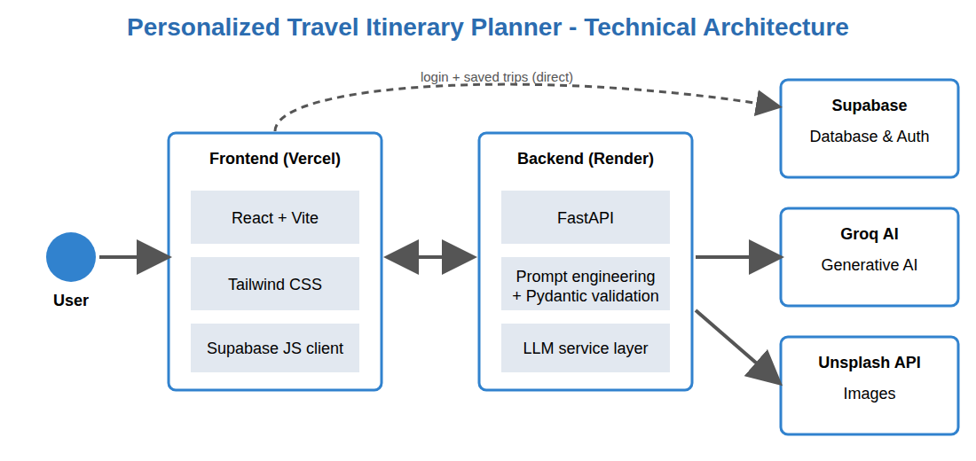
Figure: Technical architecture
Layer | Technology | Responsibility
Frontend | React, Vite, Tailwind CSS, Supabase JS | User interface, forms, itinerary view, charts, dark mode
Backend | Python, FastAPI, Pydantic, Uvicorn | REST API, prompt building, JSON validation, retry, CORS
Generative AI | Groq (Llama-3); Gemini optional | Creates the itinerary and regenerates single days
Database and Auth | Supabase (PostgreSQL, Row Level Security) | User accounts, saved trips, share tokens
Images | Unsplash API | Destination photo
Hosting | Vercel (frontend), Render (backend), GitHub | Deployment and source control

Backend API Endpoints
Endpoint | Method | Description
/health | GET | Server status and AI mode (live or mock)
/api/generate-itinerary | POST | Generates a full itinerary from preferences
/api/regenerate-day | POST | Regenerates one day, keeps the rest
/api/image | GET | Returns a destination photo from Unsplash
/api/trips and /api/trips/{id} | GET, POST, DELETE | Trip list, create, delete
/api/trips/{id}/share and /api/shared/{token} | POST, GET | Create and open a public share link

Database Design
A single table named trips stores id, user_id, destination, preferences (JSONB), itinerary (JSONB), share_token and created_at. Row Level Security gives each owner full access to their rows, and allows reading a trip that has a share token.

Prompt Engineering
The system prompt instructs the model to act as a travel planner and to reply with valid JSON only, following a fixed schema (trip title, summary, days with activities, meals, accommodation, transport tips, costs, packing and local tips). One example activity is included as a few-shot sample. The reply is validated with Pydantic, and if it is invalid the request is retried once.

5. Project Workflow
- Login: the user signs up or logs in through Supabase Authentication (or continues as a guest in demo mode).
- Dashboard: saved trips and statistics are loaded from the database.
- Trip Builder: the user fills in destination, dates, budget, group, interests, pace, stay and transport.
- Request: the frontend sends the preferences to POST /api/generate-itinerary.
- Prompt and AI call: the backend builds the prompt (system prompt plus few-shot example) and calls the Groq Llama-3 model.
- Validation: the JSON reply is validated with Pydantic; invalid output is retried once.
- Display: the itinerary appears with day tabs, activity timeline and cost charts; a destination photo is fetched from Unsplash.
- Customize: the user edits, adds or removes activities, or regenerates a single day.
- Save: the trip is stored in Supabase under the user’s account.
- Share and export: a public read-only link is created, and the plan can be exported as PDF.

6. Milestones and Activities
No. | Milestone | Activities | Deliverable
1 | Requirement analysis | Study the problem, scenarios and required skills; select the tech stack | Project plan and scope
2 | Environment setup | Install Python, Node.js and Git; create project folders; create the GitHub repository | Working development setup
3 | Backend API | Build FastAPI app, data models, endpoints, CORS and error handling | Running REST API
4 | GenAI integration | Write the system prompt and few-shot example; connect Groq; JSON validation and retry; mock mode | AI itinerary generation
5 | Database and authentication | Design the trips table; enable Row Level Security; connect Supabase Auth | schema.sql and login
6 | Frontend UI | Build Trip Builder, dashboard, itinerary view with React and Tailwind CSS | Responsive web interface
7 | Itinerary features | Edit, add and remove activities; regenerate a day; cost charts | Interactive itinerary
8 | Sharing and extras | Share links, PDF export, dark mode, Unsplash images | Complete feature set
9 | Testing | Write pytest tests for the API; test the full user flow in the browser; fix bugs | Passing tests
10 | Deployment and documentation | Deploy backend on Render and frontend on Vercel; push to GitHub; write README and project report | Live demo and documentation

7. Output
For each request the application produces a structured, editable itinerary. A sample output for a 4-day relaxed couple trip to Jaipur is summarized below.
Output element | Sample result
Trip title and summary | 4-Day Jaipur Trip: a relaxed couple trip to Jaipur
Day theme | Day 1: Food
Activities (Day 1) | 09:00 Jaipur food highlight (3 h); 13:00 Local lunch spot (1 h); 16:00 Scenic walk / landmark (2 h)
Meals | Breakfast at hotel, local lunch, dinner nearby
Accommodation and transport | Premium stay in Jaipur; use local transit or walk
Cost tracking | Estimated total for 2 travelers: $720 against a budget of $1000
Charts | Cost per day and cost by category
Tips | Packing tips and local tips for the destination

Other outputs of the system:
- Saved trips list with statistics on the dashboard.
- A public read-only link to share the plan.
- A printable PDF of the itinerary.
- Backend health check showing live or mock AI mode, and 4 automated tests passing.

8. Screenshots with Description
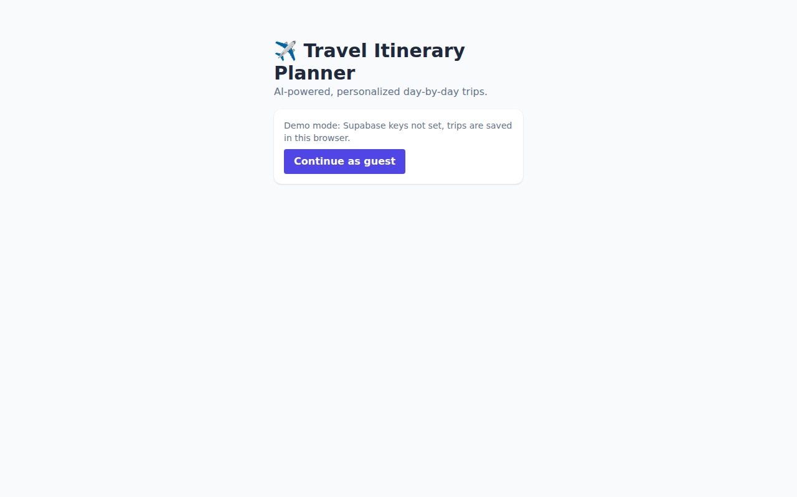
Figure: Login / Get Started page
The entry point of the application. Users sign in or sign up through Supabase Authentication. When Supabase keys are not configured, the app offers a Continue as guest option so the project can still be demonstrated.

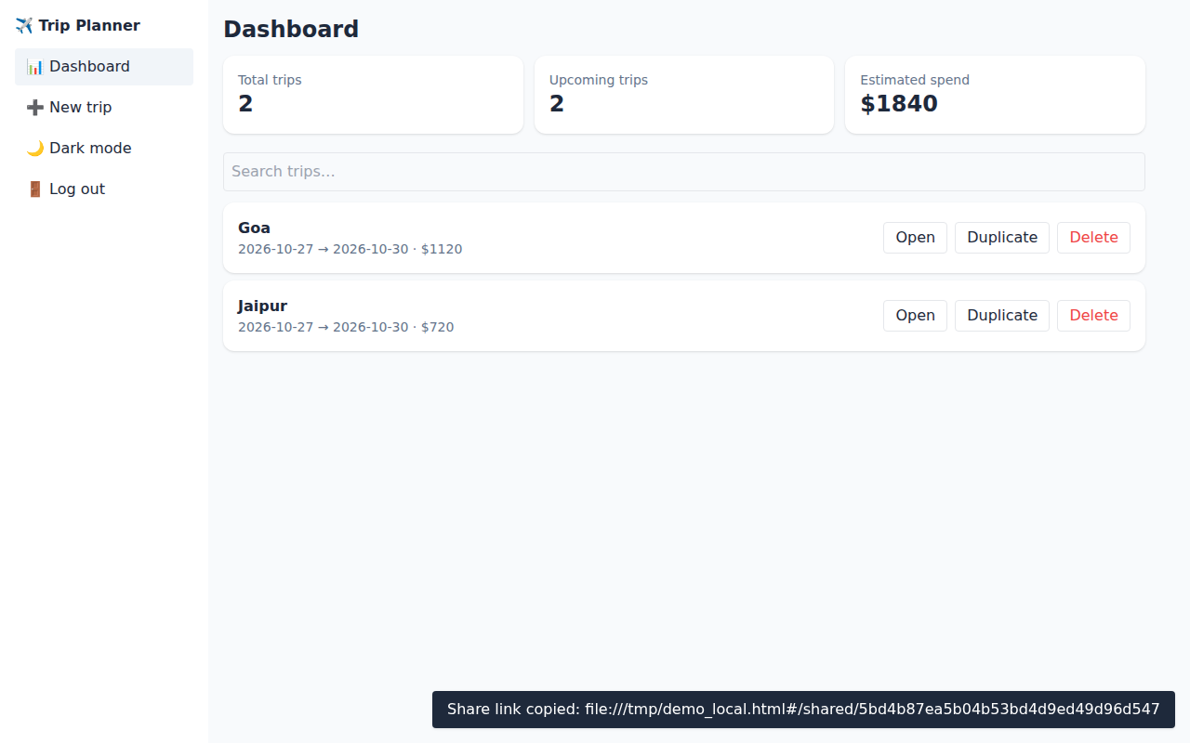
Figure: Dashboard
The dashboard shows summary cards (Total trips, Upcoming trips, Estimated spend), a search box and the list of saved trips. Each trip can be opened, duplicated or deleted.

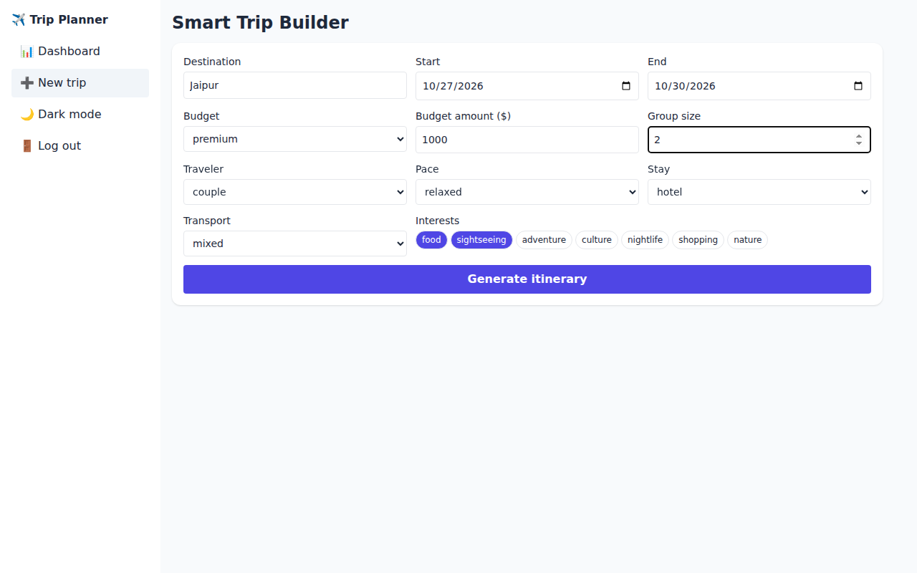
Figure: Smart Trip Builder
The user enters the destination, travel dates, budget level and amount, group size, traveler type, pace, accommodation and transport preferences, and selects interests such as food, culture or nature.

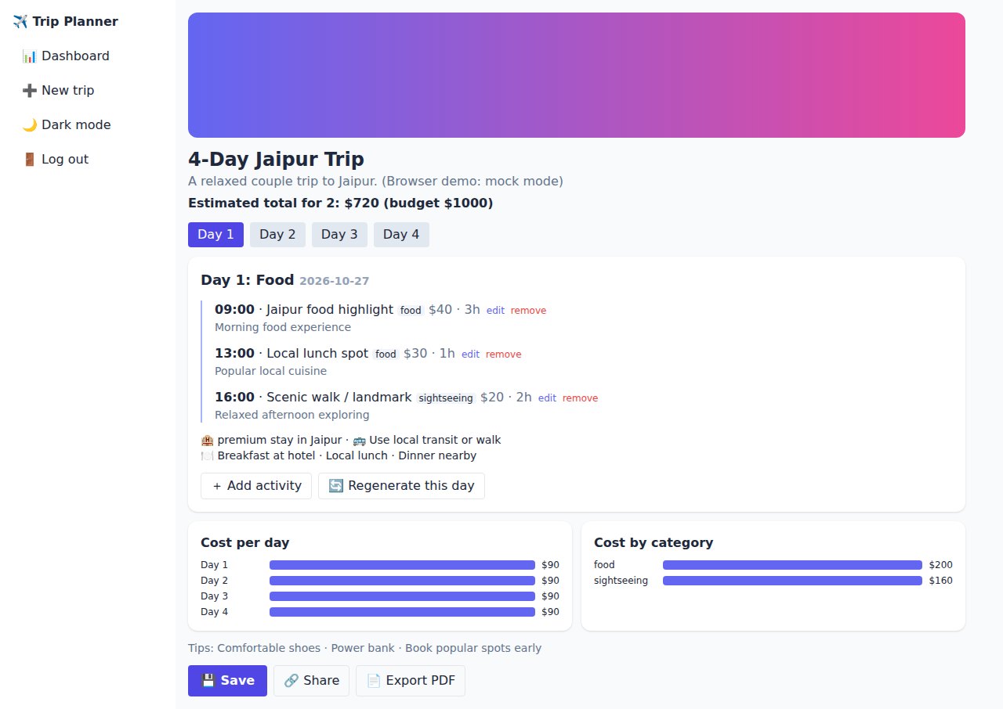
Figure: Generated Itinerary View
The AI-generated plan is shown with day tabs, a timeline of activities (time, title, category, cost, duration), meals, stay and transport tips, the estimated total cost, and two cost charts (per day and by category).

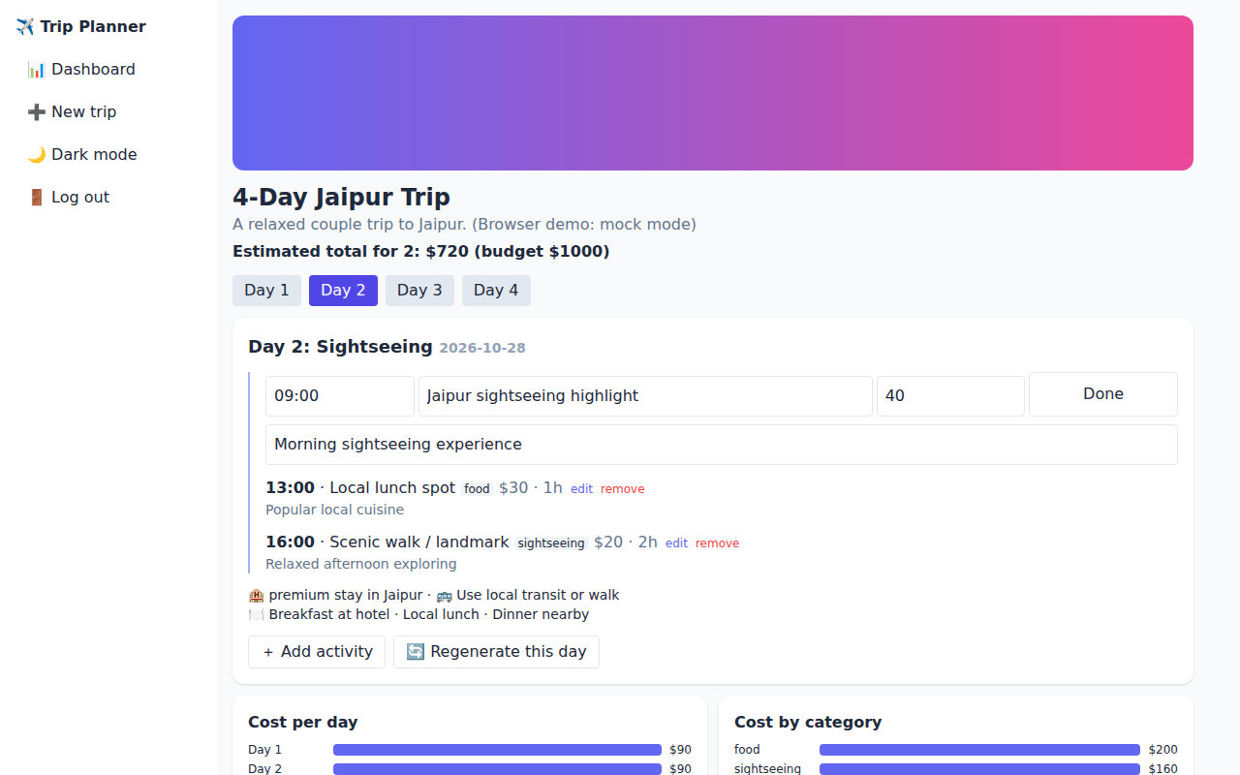
Figure: Editing an Activity
The user can edit the time, title, cost and description of any activity, add a new activity, remove one, or regenerate only the selected day while the rest of the plan stays unchanged.

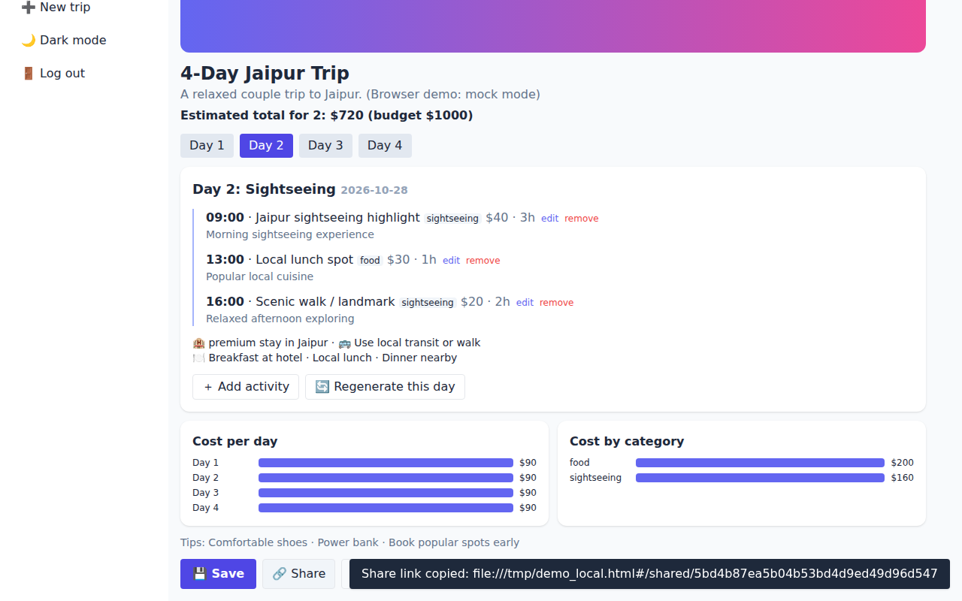
Figure: Save and Share
After saving, the Share button creates a public read-only link and copies it to the clipboard. A confirmation message appears at the bottom of the screen.

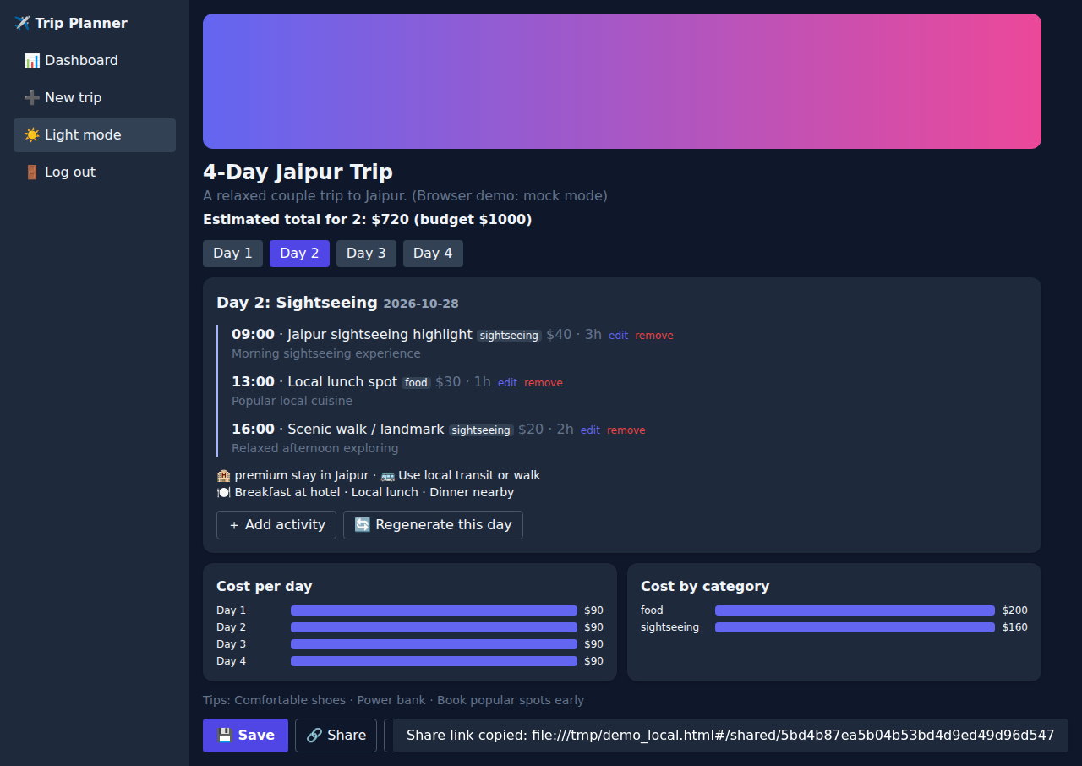
Figure: Dark Mode
The interface supports a light and dark theme that can be switched from the sidebar, improving readability in low light.

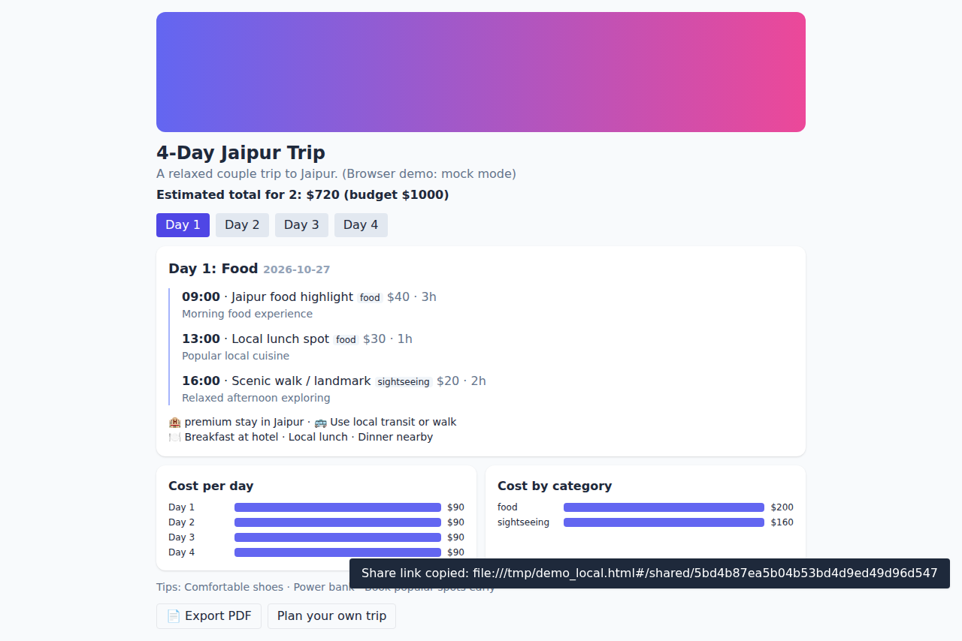
Figure: Shared Read-only Trip Page
Anyone with the share link can view the itinerary without logging in. Editing buttons are hidden so the plan cannot be changed. This helps groups coordinate a trip.

9. Conclusion
The Personalized Travel Itinerary Planner shows how generative AI can turn a long, manual travel research process into a quick and personalized experience. By combining a React frontend, a FastAPI backend, Supabase for authentication and storage, and Groq’s Llama-3 model, the project generates structured day-by-day plans that users can edit, regenerate, save, share and export.
The project covered the full development cycle: requirement analysis, prompt engineering, backend and frontend development, database design with security rules, testing and deployment. It meets the three scenarios of a solo traveler, a couple and a group of friends.

Future Scope
- Real-time data such as opening hours, ticket prices and weather.
- Map view and route optimization between activities.
- Collaborative editing, where group members can vote on activities.
- Booking integration for hotels, transport and activities.
- Multi-language support and a mobile application.

