**Test**

1)Insert 10 different prs from the code index sheet to the tables

Query:

INSERT into et3test.pr_issue

(issue_id,comment,link,se,platform,size,difficulty,status,version,by_state,ah_state,ht_state,date) VALUES

(1234,'comment 1234','link 1234','AH','mobile-client','Easy','Hard','Needs Review','8.1.0',0,0,0,'2022-01-04'),

(1235,'comment 1235','link 1235','HT','kh-server-node','Medium','Easy','Has Comments','8.1.5',0,0,1,'2022-01-04'),

(1236,'comment 1236','link 1236','BY','kh-sqs-worder','Hard','Madium','Needs Review','8.2.0',0,1,0,'2022-01-05'),

(1237,'comment 1237','link 1237','AH','kh-server-firebase','Easy','Easy','Merged','8.1.0',0,1,1,'2022-01-05'),

(1238,'comment 1238','link 1238','BY','kh-admin-client','Hard','Hard','Has Comments','8.1.5',1,0,0,'2022-01-06'),

(1239,'comment 1239','link 1239','HT','kh-admin-server-new','Easy','Medium','Needs Review','8.2.0',1,0,1,'2022-01-06'),

(1240,'comment 1240','link 1240','AH','kh-admin','Medium','Hard','Merged','8.1.0',1,1,0,'2022-01-15'),

(1241,'comment 1241','link 1241','HT','fa-mobile-client','Easy','Easy','Has Comments','8.1.5',1,1,1,'2022-01-15'),

(1242,'comment 1242','link 1242','AH','fa-server-firebase','Easy','Hard','Needs Review','8.2.0',1,0,1,'2022-01-17'),

(1243,'comment 1243','link 1243','BY','kh-website','Medium','Easy','Merged','8.1.0',1,1,0,'2022-01-17')

Results:

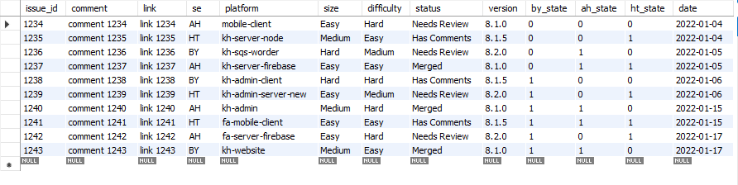

2)Write a query to update the status of all the pr that has status need review for more than 10 days to closed

Query:

UPDATE et3test.pr_issue SET status = 'closed' WHERE

((date <= '2022-01-07') and status = 'Needs Review');

Results:

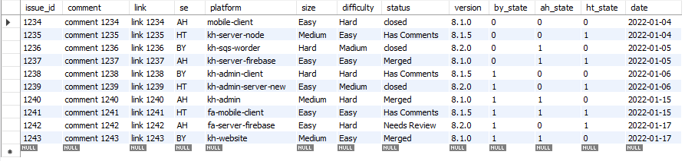

3)Write a query to retrieve all the closed prs

Query:

SELECT * FROM et3test.pr_issue where (status = 'closed');

Results:

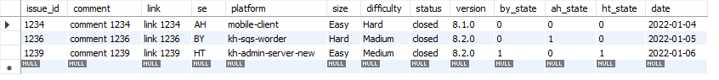

4)Write a query to retrieve prs on a particular date

Query:

SELECT * FROM et3test.pr_issue where (date = '2022-01-17');

Results:



5)Write a query to get the number of prs on each day

Query:

select Count(issue_id) as Prs_total, date from et3test.pr_issue

group by date;

Results:

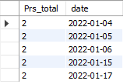

6)Write a query to retrieve the prs that took more than 2 days to review

Query:

select * from et3test.pr_issue where

((date <= '2022-01-15') and status != 'closed');

Results:

