User Management System

**System Overview:**

Is a small system for user management, list all users in the system with different features.

**Main features:**

1. Listing page for the users with the following details

* Filtration
* Pagination
* Sorting

1. User can Add new user
2. User can Edit/Delete Existing user
3. Localization(ar and en)
4. Notification Messages with success & failure for all actions

**Rolls:**

User management system has one role.

**Admin**: can view and control all system.

**PROJECT SPECIFIC TECHNICAL**

**1.1. Login**

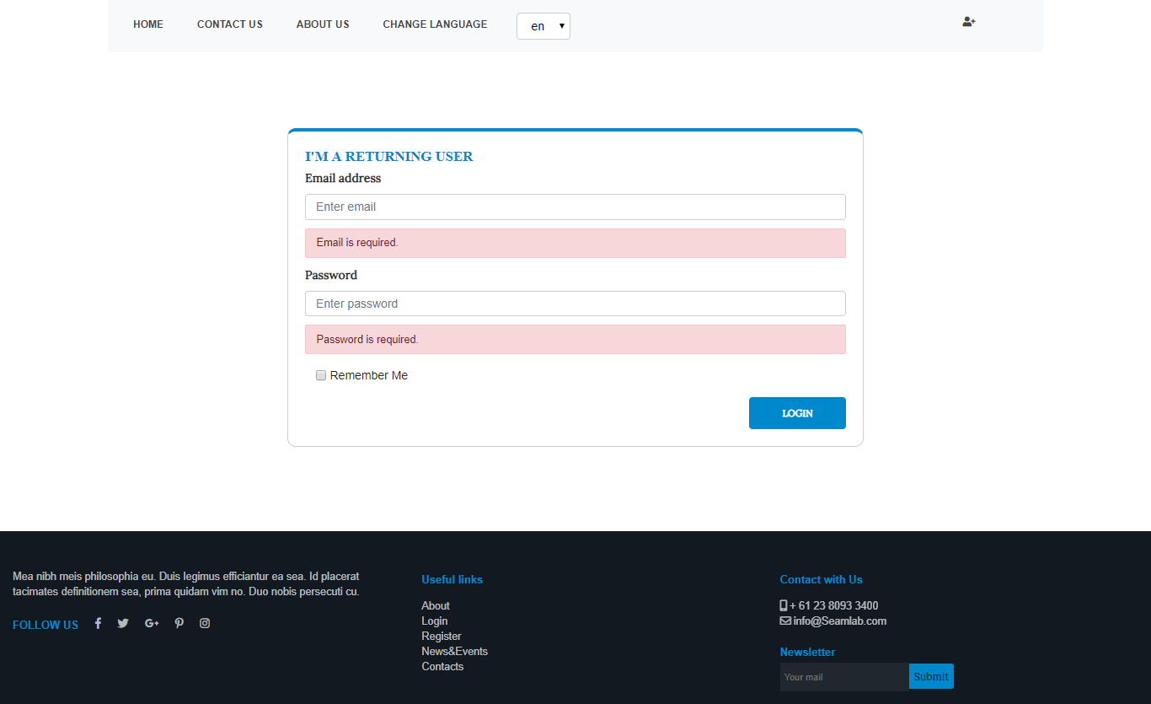

**1.2. Home**

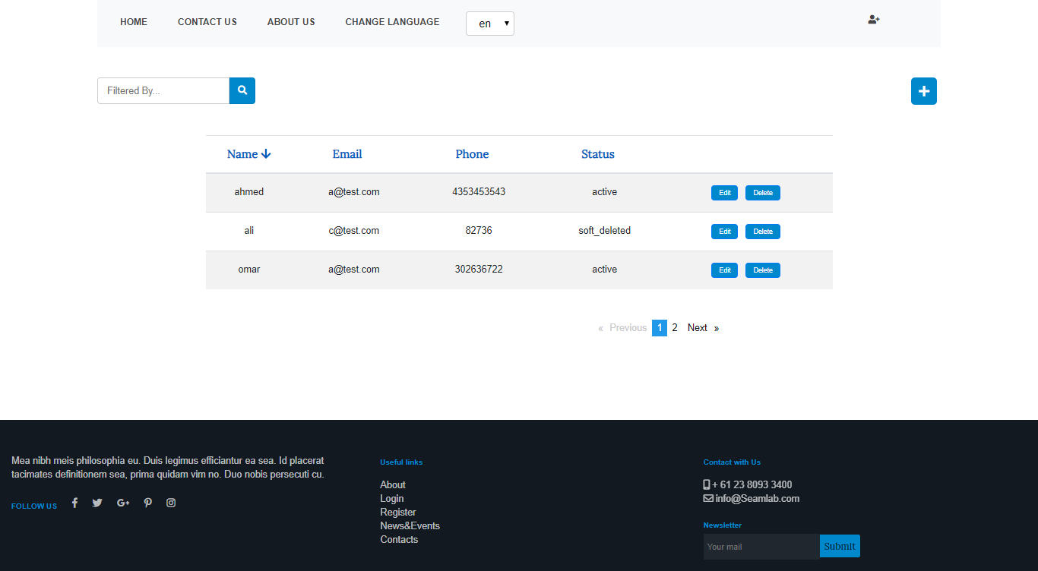

**1.3. Add User**

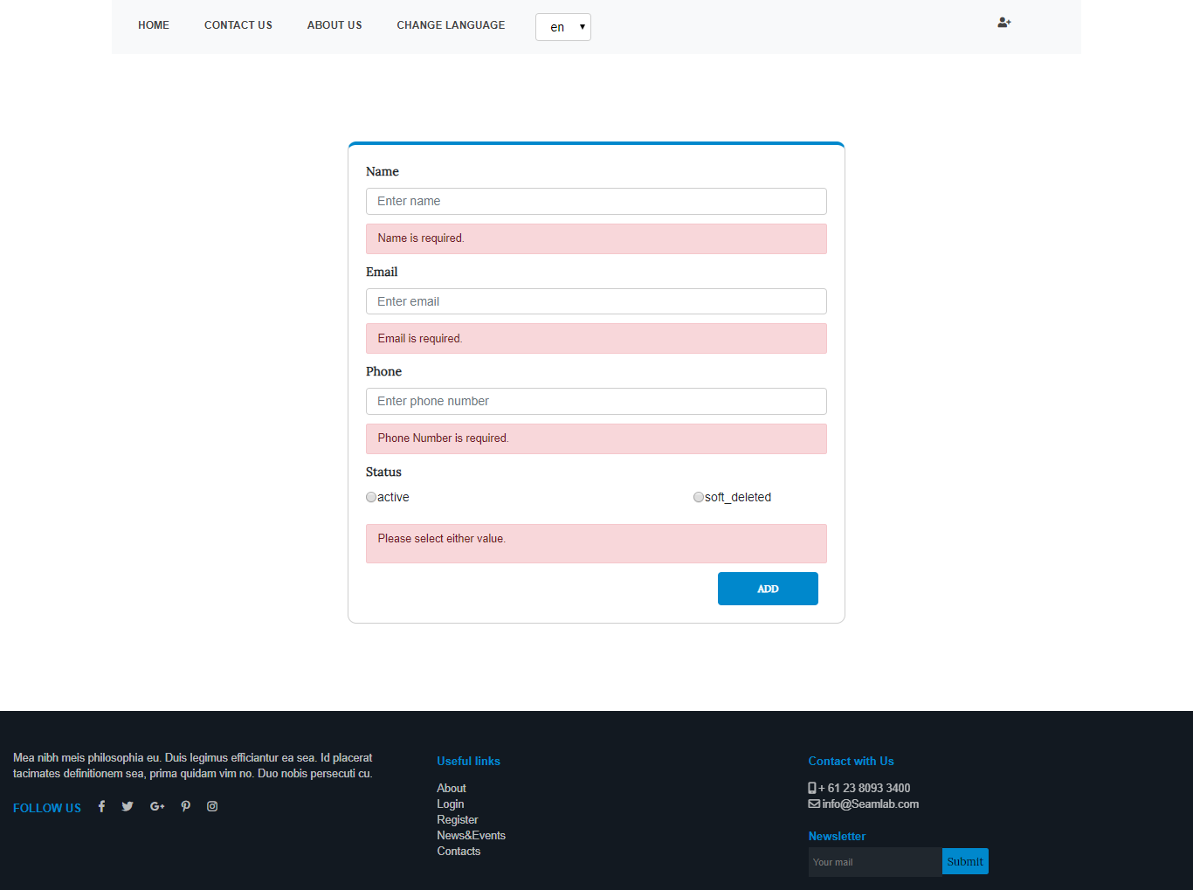

**3.4. Edit User**

