**KAZI JIHADUR RASHID**

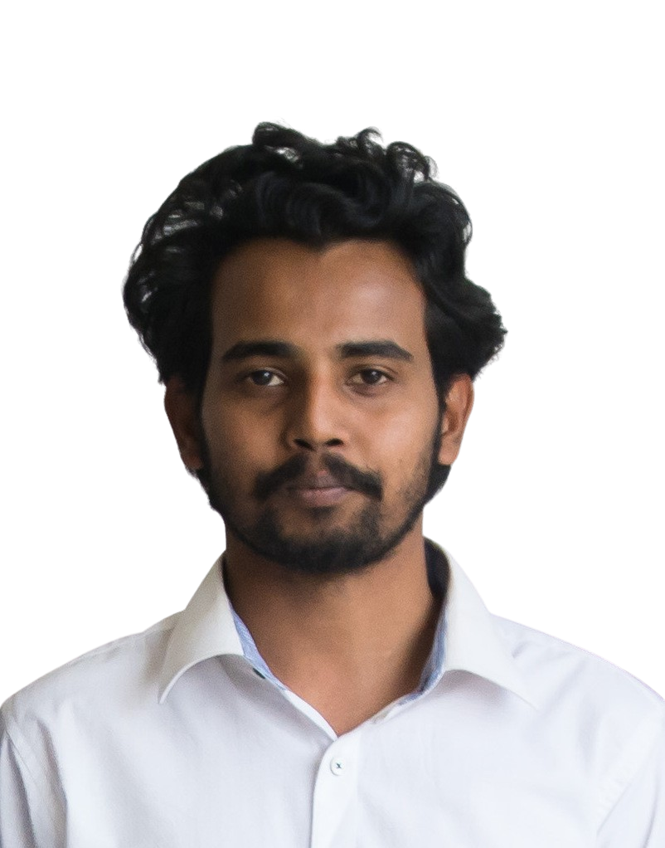

Portfolio: jihadrashid.github.io

Email: [jihadrashid.gis@gmail.com](mailto:jihadrashid.gis@gmail.com)

Mobile: +880 1998357435

# Work Experience

## Technical Assistant

## Remote Sensing Division, Center for Environmental and Geographic Information Services (CEGIS) *May ‘20 - Present*

## Responsibilities:

* On-screen digitization and feature extraction from satellite images
* Visual interpretation and analysis of satellite images
* ESRI supported GIS Shapefiles preparation, editing, and topology building
* Updating geodatabase

## Research Assistant

## Dr. Atiqur Rahman’s Lab, Dept. of GES, CU *Mar ‘19 - Apr ‘20*

## Responsibilities:

* Collection of primary and secondary data from various sources
* Processing, analysis ,and interpretation of geospatial, historical, and survey data
* Presentation of analyzed data in tables, graphs, and maps
* Reviewing literature and writing of research reports

## Research Consultant

**Child Protection Sector (HCMP), BRAC**  *Jul ‘18 - Sep ‘18*

**Responsibilities:**

* Collection of GPS coordinates of the Child-Friendly Spaces (CFS) along with a third eye observation about the present infrastructural conditions and the surrounding environment
* Geospatial and statistical analysis of collected data to measure the physical and social vulnerabilities of the CFS centers
* Identifying CFSs prone to flood and landslides

## Research Assistant

## Dr. Alak Paul’s Lab, Dept. of GES, CU *Dec ‘17 - Jul ‘18 / Sep ‘18* *- Feb ‘19*

## Responsibilities:

* Collection of primary data from survey, group discussion, key informants
* Tabulation, analysis, and visualization of data in tables, graphs, and maps
* Literature review and writing of research proposals

# Technical Skills

* **Software/web:** ArcGIS, QGIS, Google Earth Engine, SPSS, KOBO Toolbox, MS Office
* **Programming:** R, SQL/MySQL

# Education & Certifications

## BSc in Geography & Environmental Studies

## University of Chittagong, Chattogram *2014 -2018*

## R Programming

## Johns Hopkins University (via Coursera) *Apr ‘20 - May ‘20*

## Imagery, Automation, and Application

## University of California, Davis (via Coursera) *Jul ‘19 - Aug ‘19*

## Geospatial and Environmental Analysis

## University of California, Davis (via Coursera) *Apr ‘19 - May ‘19*

## GIS Data Format, Design and Quality

## University of California, Davis (via Coursera) *Nov ‘18 - Dec ‘18*

## GIS and Its Application

## Center for River, Harbor & Landslide Research (CRHLSR), CUET *Feb ‘18 - Mar ‘18*

Research Articles

* **Rashid, K.J.**, Hoque, M. A., Esha, T. A., Rahman, M. A., & Paul, A. (2020). Spatiotemporal changes of vegetation and land surface temperature in the refugee camps and its surrounding areas of Bangladesh after the Rohingya influx from Myanmar. *Environment, Development and Sustainability*, 1–16. <https://doi.org/10.1007/s10668-020-00733-x>
* Akter, T., **Rashid, K.J.** (2020, Dec 27). Spatio-temporal Change Detection of Urban Surface Water Bodies in Chattogram City using GIS and Remote Sensing Techniques, 4th International Conference on Bangladesh Environment (ISBEN-4), Dhaka.
* Mahmud, A., **Rashid, K.J.**, Jabed, M.A., Paul, A. (2020). Spatial Concentration of Educational and Medical Facilities within Chattogram City. In: *Chattogram City: Geographical Survey*, 1st ed. Dhaka: Centre for Urban Studies & Academic Press & Publishers Library. Under publication.
* Paul, A., Hoque, M.A., Mahmud, A., Esha, T.A., **Rashid, K.J.**, Nath, T.K. (2020). Increasing Temperature, Water, Sanitation & Hygiene Conditions, and Health Outcomes of Rohingya Refugees and Local People in Southern Bangladesh. Manuscript submitted for publication.
* **Rashid, K.J.**, Islam, S., Rahman, M. A. (2021) Ecological Impact Evaluation of Urban Heat Island in Dhaka City: A Spatio-temporal approach. Manuscript submitted for publication.

Projects

**Non Academic:**

* Spatio-Temporal Investigation of the Lightning, Related Fatalities and Options to Mitigate the Losses under the Changing Climate of Bangladesh *May ‘19 - Dec ‘20*
* Assessment of Future Changes in Irrigation Demand of Boro Rice in Brahmaputra-Jamuna Floodplain of Bangladesh Using Observed and Model Data *May ‘19 - Oct ‘19*
* Physical Vulnerability Assessment of Child-Friendly Spaces (CFS) at the Rohingya Refugee Camp, Cox’s Bazar  *Jul ‘18 – Sep ‘18*

**Academic:**

* Impacts of Environmental Degradation on St. Martin’s Island: A Geo-Environmental Study
* Farmer’s Perception of Climate Change and Its Impact on Agriculture and Soil in the Hilly Regions of Bangladesh: The Case of Bandarban District
* The Livelihood of People Surrounding Kaptai Lake as well as Community-Based Tourism in Rangamati, Bangladesh
* Water Security in Urban Poor Areas of Sylhet City: A Geographical Study

References

|  |  |
| --- | --- |
| **Dr. Md. Atiqur Rahman**  Associate Professor, Dept. of GES, CU  Email: mmd.atiqur.rahman@gmail.com  Phone: +8801716471218 | **Bebek Kanti Das**  Project Manager (Child Protection, HCMP), BRAC  Email: bebek_ges@yahoo.com  Phone: +8801814317477 |