|  |  |
| --- | --- |
| **Ex No: 10**  **Date: 23th October 2024** | **Deploy on AWS- source code link** |

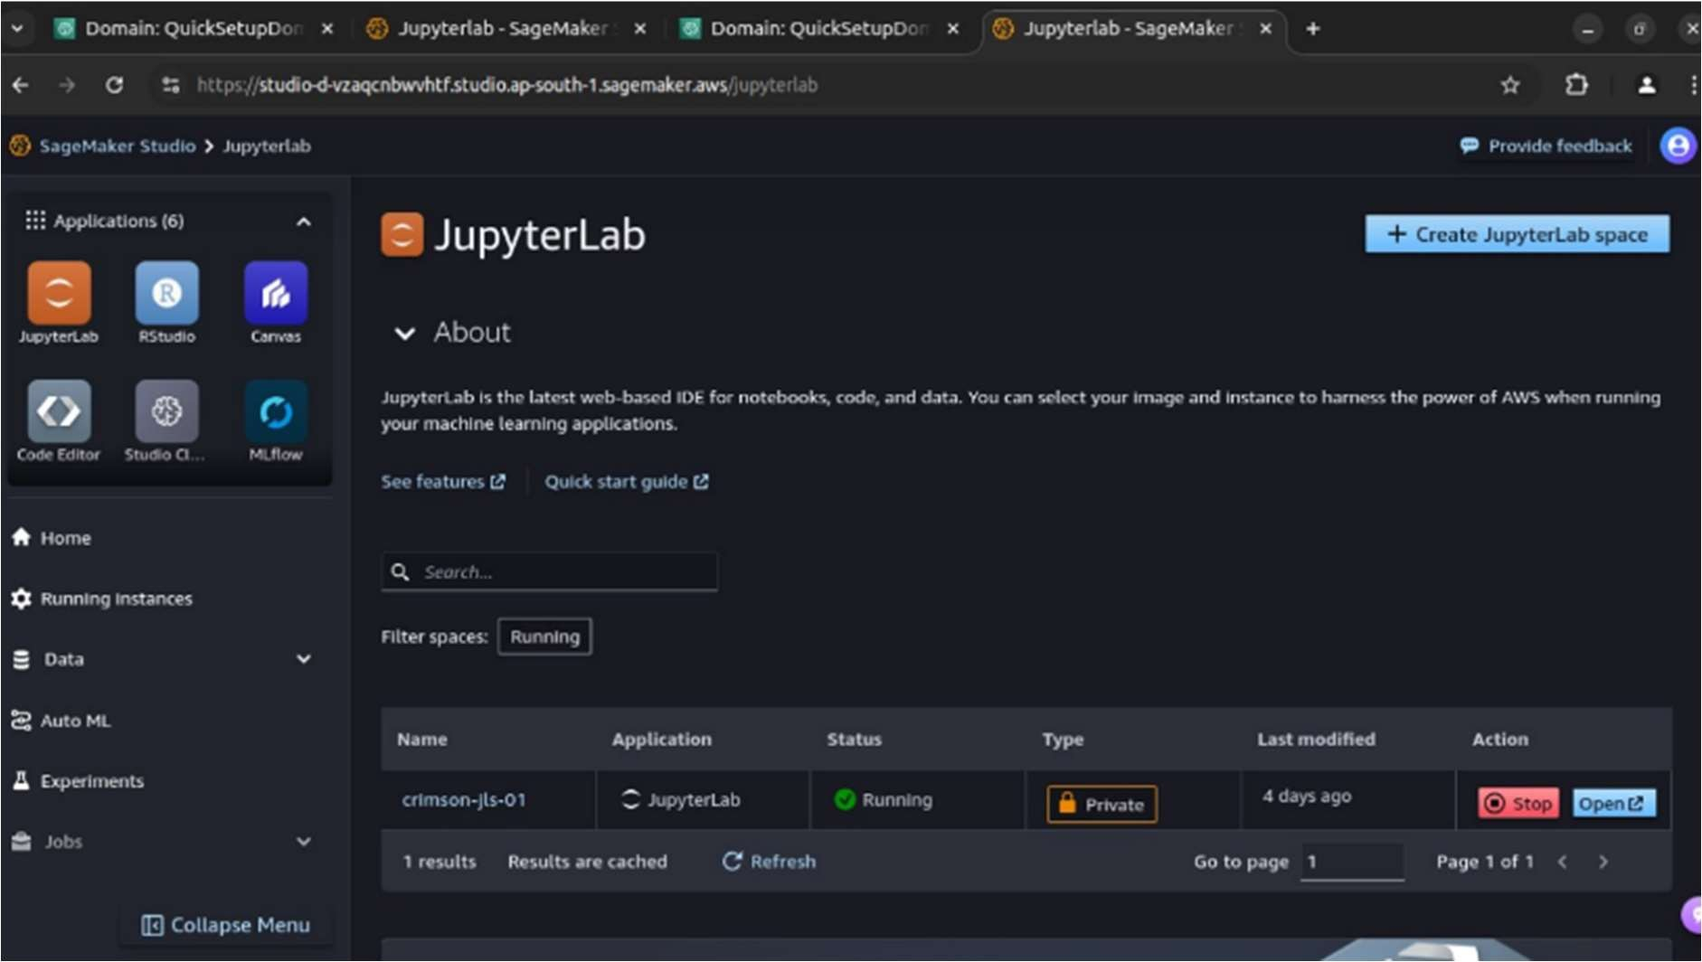

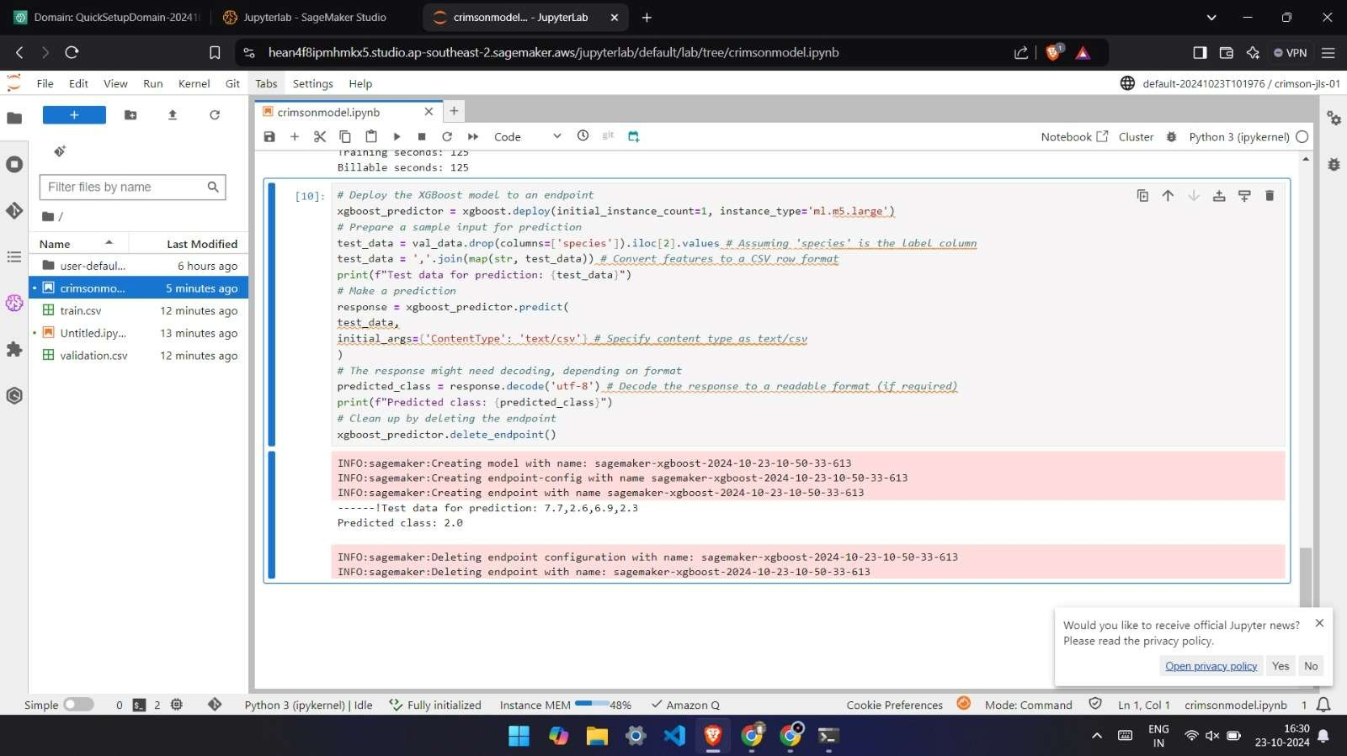

**GitHub Link:** [**https://github.com/jihanrjbtech22/DeepLearningLab**](https://github.com/jihanrjbtech22/DeepLearningLab)