|  |  |
| --- | --- |
| **Ex No: 2**  **Date: 13th August 2024** | **Implement Logistic Regression with a Neural Network mindset** |

**Objective:** The objective of this project is to build a logistic regression model with a neural network mindset for binary image classification. The model will classify images as either containing a cat (label 1) or not (label 0).

**Description:**

The task involves using a dataset of images labeled as either "cat" or "non-cat." Each image is in RGB format with a fixed shape, allowing us to simplify preprocessing and model development. The assignment steps through implementing logistic regression, exploring neural network concepts in terms of initializing parameters, computing the cost function and its gradient, and applying gradient descent optimization.

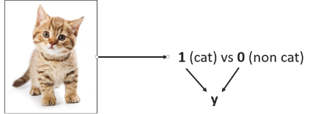

**Model:**

The model used here is logistic regression, viewed with a neural network perspective. Logistic regression is a linear model suitable for binary classification, where a single output node predicts the probability of an image being a cat.

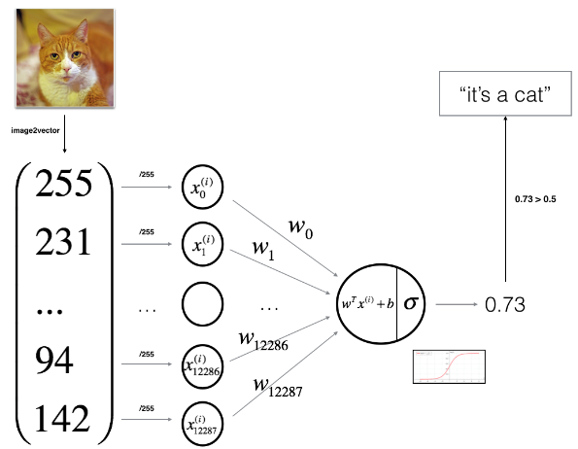

**Building the parts of the algorithm:**

1. **Data Loading and Exploration:** Load the image data and inspect it for better understanding. The dataset includes a training set and a test set, with images and labels.
2. **Data Preprocessing:** Normalize the pixel values to fall within the range [0, 1] and flatten the images into vectors to prepare them for logistic regression.
3. **Initializing Parameters:** Define the weights and bias for logistic regression. Initialize weights as zeros and set the bias to zero as well.
4. **Forward and Backward Propagation:** Implement forward propagation to calculate the prediction. Compute the cost function to assess prediction accuracy and perform backward propagation to compute the gradients.
5. **Optimization:** Use gradient descent to update weights and biases iteratively. This optimization step minimizes the cost function and improves the model’s performance.
6. **Model Function:** Integrate all components into a single function that handles the initialization, forward and backward propagation, and optimization to train the logistic regression classifier.
7. **Testing:** Evaluate the model on test data and compute accuracy to assess how well the model generalizes to unseen data.

**Key Observations:**

The logistic regression model developed here achieves binary classification effectively with basic linear computation. Although simple, this approach demonstrates foundational neural network concepts, such as parameter initialization, forward/backward propagation, and optimization. This exercise prepares for more complex architectures in deep learning by reinforcing essential principles.

**GitHub Link: <https://github.com/jihanrjbtech22/DeepLearningLab>**