***Network Security LAB-3***

***Jihan Rakesh Jain, 1RVU22CSE070***

***Exp1, Symmetric encryption***

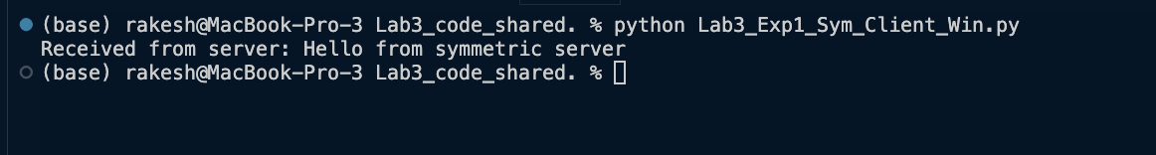



***Exp2, Asymmetric encryption***

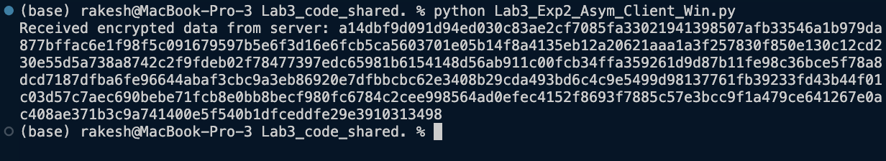

***Exp3a, Symmetric encryption***

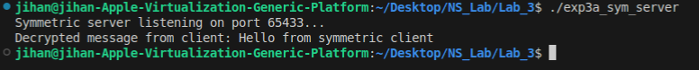



***Exp3b, Asymmetric encryption***

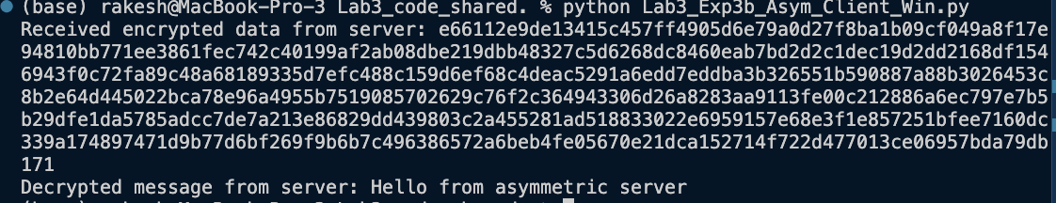

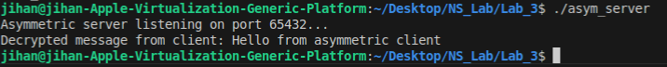

***Exp3c***



