A Physics-Guided Framework for Forward and Inverse SRAM V_{min} Estimation Under Process Variation
[Author Names — to be supplied]
[Affiliation — to be supplied]

Abstract—Verifying the minimum operating voltage (V_{min}) of SRAM bitcells involves a difficult trade-off: Monte Carlo (MC) simulation is too expensive for routine use, while standard PDK corner analysis often misses critical variation caused by local mismatch. This paper presents a physics-guided framework that bridges this gap. Using a single, fixed simulation budget, the method delivers high-fidelity V_{min} predictions and enables inverse process-window analysis. Unlike black-box machine-learning models, the approach explicitly separates device-level margin statistics — the mean and the standard deviation — from the analytic yield relation, preserving physical interpretability. Validated on silicon-calibrated simulation data from an advanced FinFET node, the framework predicts hold-out V_{min} with millivolt-level accuracy (3.98 mV RMSE for read, 5.65 mV for write) and correctly identifies limiting PDK corners unseen during training. Crucially, a total-order global sensitivity analysis exposes a fundamental blind spot in conventional corner-based verification: a local NMOS mismatch axis contributes more read-margin variance than the global PMOS threshold-shift corner axis, and at least 38 % of the read-margin variance lies in process directions orthogonal to the conventional corner set. Corner-only flows may therefore underestimate V_{min} by ignoring mismatch-driven tails. The framework also supports inverse queries, letting engineers determine the process shifts — a V_{th} tolerance, for example — needed to meet a target V_{min}. The margin distribution is treated as Gaussian throughout, and tail-shape correction is left to future work. Within that assumption the proposed method establishes a robust, efficient workflow that connects statistical variation, yield targets, and actionable process specifications.
Index Terms—SRAM, minimum operating voltage (V_{min}), process variation, local mismatch, Gaussian process, yield analysis, global sensitivity analysis, design-technology co-optimization (DTCO).

I. Introduction
In advanced technology nodes, process variation and device mismatch increasingly constrain SRAM bitcell stability, which is expressed through the minimum operating voltage (V_{min}) [1]–[3]. Traditional verification faces a dilemma. Full Monte Carlo (MC) analysis offers statistical completeness but is prohibitively expensive [4]–[6], while PDK corner analysis is fast but samples only a few predefined global directions.
The critical flaw in corner-based analysis is its inability to capture variance driven by local mismatch, which does not align with the standard global corners (SSG, FFG, and their skewed variants). Consequently, designs signed off using corner simulations alone risk silicon yield loss from unmodeled statistical tails. Conversely, relying on MC sweeps for every design iteration is impractical under runtime constraints.
This work proposes a physics-guided framework that resolves the trade-off. The goal is not to replace circuit simulation with a statistical surrogate, but to maximize the insight extracted from a fixed simulation budget. The core idea is to model the process-dependent statistics of the noise margin — its mean μ and standard deviation σ — rather than regressing V_{min} directly. By retaining an analytic yield relation, the framework preserves the physical link between the margin distribution and the yield probability. This provides three capabilities:
1) Accurate forward prediction: estimating V_{min} for arbitrary process conditions with millivolt precision.
2) Inverse process specification: determining the maximum allowable process shift — the process window — that still meets a target V_{min}.
3) Sensitivity-driven insight: quantifying the impact of global shifts against local mismatch, exposing the blind spots of corner-only verification.
We demonstrate the framework on an advanced FinFET node and show that local mismatch can dominate read-margin variance — a phenomenon invisible to standard corner analysis. This makes a compelling case for integrating statistical sensitivity analysis into the standard SRAM sign-off flow.

II. Physics-Guided Modeling Framework

A. Decoupling Margin Statistics From the Yield Definition
Directly regressing V_{min} hides the physical causes of failure. Instead, the framework models the conditional mean μ and standard deviation σ of the SRAM noise margin as continuous functions of the process parameters p — gate length, threshold voltage, oxide thickness, and the local-mismatch axes — and of the supply voltage V_{DD}. The yield probability Y then follows analytically from the standard normal cumulative distribution function Φ:
Y(V_{DD}, p) = Φ[ μ(p, V_{DD}) / σ(p, V_{DD}) ] (1)
and V_{min} is the lowest supply that still satisfies the yield target, equivalently the lowest supply at which the margin tail stays non-negative:
V_{min}(p) = min { V_{DD} : μ(p, V_{DD}) − k·σ(p, V_{DD}) ≥ 0 } (2)
where k is the yield-referenced tail multiplier set by the array size and the target failure probability. Two properties matter for device engineers.
Physical transparency. The model explicitly separates how process variation moves the center of the margin distribution from how it changes the spread. This makes it possible to diagnose whether a V_{min} shift stems from a global process drift or from increased local variability — a distinction a direct V_{min} regression collapses.
Robust inverse solving. Because the yield relation is analytic and monotonic in V_{DD} over the queried range, finding V_{min} in the forward direction or the limiting process parameter in the inverse direction becomes a stable root-finding problem, avoiding the instability of black-box inversion. The pipeline is summarized in Fig. 1.

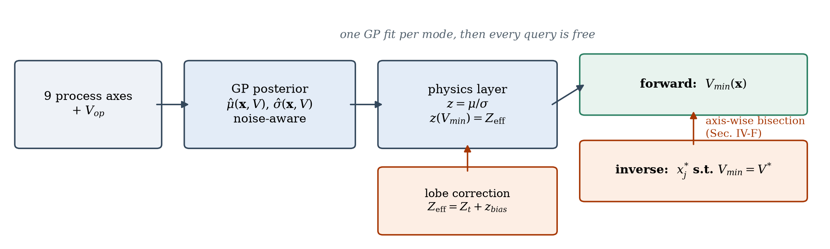
Fig. 1. Pipeline overview. Two Gaussian-process regressors predict the margin mean μ and standard deviation σ over the nine process axes and the supply voltage; the analytic yield relation of (1)–(2) converts those statistics to V_{min}, and the same relation is inverted axis-wise to recover a process window.

B. Capturing Process Continuity and Sensitivity
To model the mapping from process space to margin statistics we use a Gaussian process (GP) regressor [10], [11]. In device-physics terms the GP acts as a smooth, physics-consistent interpolator: it assumes that a small change in a process parameter — a 1 nm shift in gate length, say — produces a small, continuous change in the margin statistics, respecting the continuity of semiconductor behavior.
The model further uses automatic relevance determination (ARD) to learn a lengthscale per process axis. This lets the framework distinguish parameters whose variation produces rapid changes in stability, such as local V_{th} mismatch, from those that trend smoothly. The fitted lengthscales inform the model; the variance decomposition that quantifies risk is developed separately in Section V.

C. Inverse Query: From Electrical Target to Process Window
A distinguishing feature of the framework is the inverse query, which reverses the conventional analysis flow. Instead of asking what is the V_{min} at this process corner?, the engineer asks what process shift degrades V_{min} to our target limit?
Mathematically, for a fixed target V_{min} and yield we solve for the value of a single process axis p_{i} while holding the remaining axes fixed. Because the other coordinates are frozen, the problem is one-dimensional and is solved by bisection on an interval whose monotonicity has been verified. This maps the electrical specification boundary back into the process-control space, which is directly useful for:
• Setting process specs. Defining realistic 3σ limits for V_{th} or gate length from actual circuit yield targets rather than from historical convention.
• Yield debugging. Identifying the process parameter most likely responsible when silicon V_{min} exceeds expectation.

III. Validation: Prediction Accuracy and Corner Generalization
The framework was validated on silicon-calibrated simulation data from an advanced FinFET technology. Throughout this paper the reference values are independent circuit simulations, not silicon measurements. The evaluation focused on two metrics: prediction accuracy on unseen conditions, and generalization to standard PDK corners excluded from training.

A. Millivolt-Level Prediction Accuracy
The model shows high fidelity in predicting V_{min} across the process space: 3.98 mV RMSE for read and 5.65 mV for write on hold-out data (Table I, Fig. 2). Sub-5.65-mV accuracy is well inside the error budget required for early-stage design exploration, and the read and write errors now sit within roughly a factor of two of each other.
The remaining read/write gap is a σ-model effect, not a difference in the switching physics. With the σ GP specified as a full-ARD kernel on log σ — the scale on which the MC observation noise sem_{σ} = σ/√(2N) is homoscedastic — the write σ fit (R² = 0.9880) is comparable to read (R² = 0.9971). An earlier additive-kernel, linear-σ specification produced a much weaker write σ fit and invited the explanation that the write margin is intrinsically harder to model because V_{trip} is a ratio of two drive strengths. That explanation does not survive: the gap was kernel misspecification. Since V_{min} is the crossing of z = μ/σ, any σ error is inherited directly by V_{min}, which is why the σ kernel dominates the accuracy budget.
TABLE I
V_{MIN} PREDICTION ACCURACY
Test set | Read | Write
Hold-out conditions (RMSE) | 3.98 mV | 5.65 mV
Unseen PDK corners (RMSE) | 8.5 mV | 5.8 mV
Limiting corner identified | Correct | Correct
Margin σ fit (R²) | 0.9971 | 0.9880

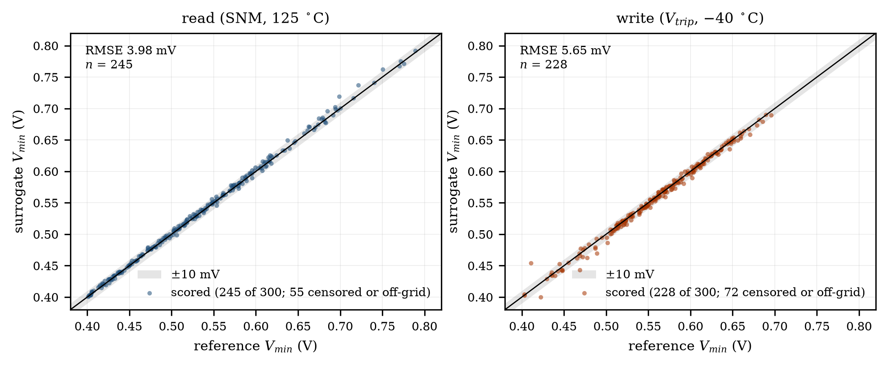
Fig. 2. Reference-simulation versus predicted V_{min} on the hold-out conditions, read (left) and write (right). Hold-out RMSE is 3.98 mV and 5.65 mV respectively.

B. Robustness to Unseen PDK Corners
A critical test for any compact model is extrapolation to the standard industry corners — SSG, FFG, SFG, FSG — held out of the training set. The model achieved 8.5 mV (read) and 5.8 mV (write) RMSE on the four unseen corners, and identified the worst-case corner correctly for both read and write. Table II lists the per-corner results and Fig. 3 plots both modes on one axis.
Two qualifications keep the claim honest. First, where two corners sit closer together than the corner RMSE, their predicted ordering is not supportable — the claim is that the limiting corner is identified, not that corners a few millivolts apart are ranked. That is what sign-off uses in any case. Second, read and write are limited by different corners (FSG and SFG respectively), each of which is censored below 0.4 V in the other mode, so a single-mode corner sweep sees only half the picture.
These results confirm that the framework acts as a high-fidelity verification layer, filling the gaps between discrete PDK corners without the cost of full MC sweeps.

TABLE II
V_{MIN} PER PDK CORNER — REFERENCE SIMULATION vs. SURROGATE
Corner | (ΔV_{th,N}, ΔV_{th,P}) mV | Read: ref → GP | Write: ref → GP
FSG | (-29.16, 38.64) | 0.5903 → 0.5961 ← worst | clamped < 0.4 V
SFG | (31.63, -36.76) | clamped < 0.4 V | 0.5924 → 0.5933 ← worst
FFG | (-36.42, -44.32) | 0.4731 → 0.4633 | 0.4923 → 0.4824
SSG | (36.30, 44.80) | 0.4672 → 0.4764 | 0.5335 → 0.5324

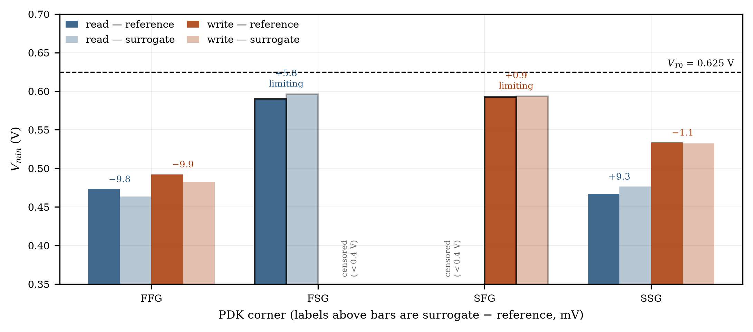
Fig. 3. V_{min} at the four PDK corners excluded from training, read and write on one axis. Outlined bars mark each mode's limiting corner — FSG for read, SFG for write — and the label above each pair is the surrogate-minus-reference error in millivolts.

IV. Inverse Analysis: Deriving Process Specifications

A. Coordinate Recovery Accuracy
The inverse capability turns the tool from a passive predictor into an active specification engine. We evaluated the model's ability to recover the threshold-voltage shift required to hit a specified target V_{min}, holding the other process axes fixed. The model recovers V_{th} shifts with 1.46–1.94 mV RMSE (Table III), and Fig. 4 shows the corresponding V_{min} contours and the recovered specification boundary in the (ΔV_{th,N}, ΔV_{th,P}) plane.
TABLE III
INVERSE RECOVERY OF THRESHOLD-VOLTAGE SHIFT
Recovered axis | RMSE | Median | Bias
ΔV_{th,N} (NMOS) | 1.46 mV | 1.11 mV | 0.70 mV
ΔV_{th,P} (PMOS) | 1.94 mV | 1.48 mV | +-0.97 mV

This accuracy lets process-integration teams tighten or loosen process windows on the basis of actual circuit sensitivity. If the analysis shows that a 5 mV V_{th} shift causes a V_{min} violation, the process spec can be set with confidence at ±15 mV (3σ). The direct mapping from an electrical target to a process limit streamlines the design-technology co-optimization (DTCO) loop, and because the inverse runs on the already-validated surrogate, no additional simulation campaign is needed per query.
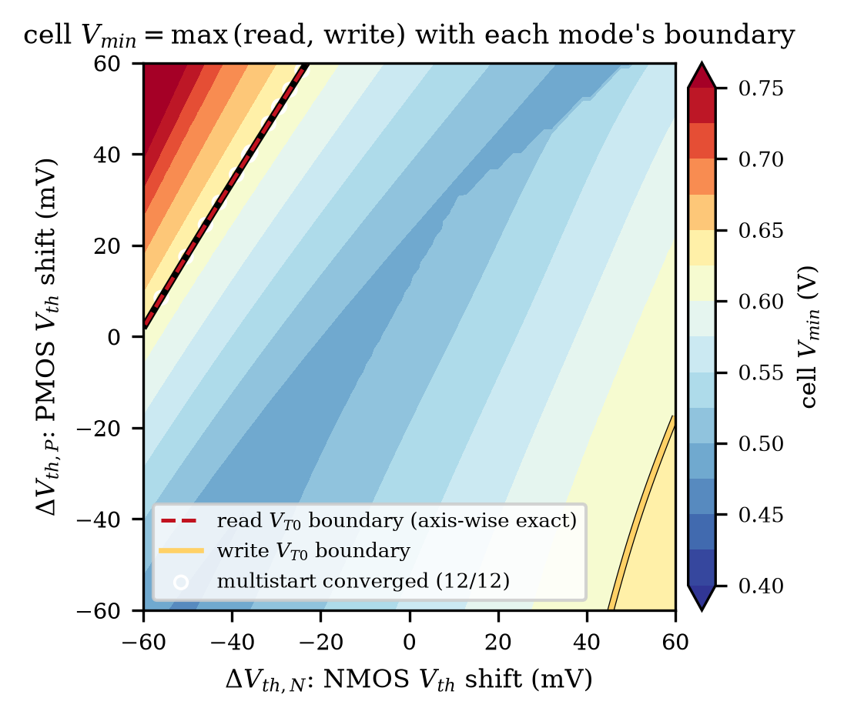
Fig. 4. V_{min} contours over the (ΔV_{th,N}, ΔV_{th,P}) plane with the specification boundary recovered by axis-wise inverse query.

B. Scenario: Meeting a 50 mV Lower V_{min} Target
The same machinery answers the question a customer actually asks. Suppose the target moves from V_{T0} = 0.625 V down to 0.575 V. Section III-B established that FSG limits read and SFG limits write, and that each is censored below 0.4 V in the other mode, so both Vmin(FSG, read) and Vmin(SFG, write) must clear the new target — today they exceed it by 21.1 mV and 18.3 mV. Treating each improvement lever as the axis to solve for, the same one-dimensional bisection returns how far that lever has to move (Table IV). The levers that reach it on their own are NMOS local-σ, global Vth corner, while PMOS local-σ cannot inside the box. The smallest single ask is a 10.9 % reduction in NMOS local-σ. Splitting the burden across both local-σ axes drops each to 7.8 %. Fig. 5 draws the resulting passing window for each case, with the read and write boundaries on one plane; the shipped window is their intersection, not either one alone.

TABLE IV
PROCESS IMPROVEMENT REQUIRED FOR V_{MIN} = 0.575 V
Improvement lever | Required setting | Binding V_{min}
NMOS local-σ | σ × 0.891 (−10.9 %) | 0.5750 V
PMOS local-σ | short even at the floor, σ × 0.70 (−30 %) | 0.5756 V (at floor)
global Vth corner | 53 % of the PDK offset (−47 %) | 0.5750 V
NMOS + PMOS local-σ | σ × 0.922 (−7.8 %) | 0.5750 V

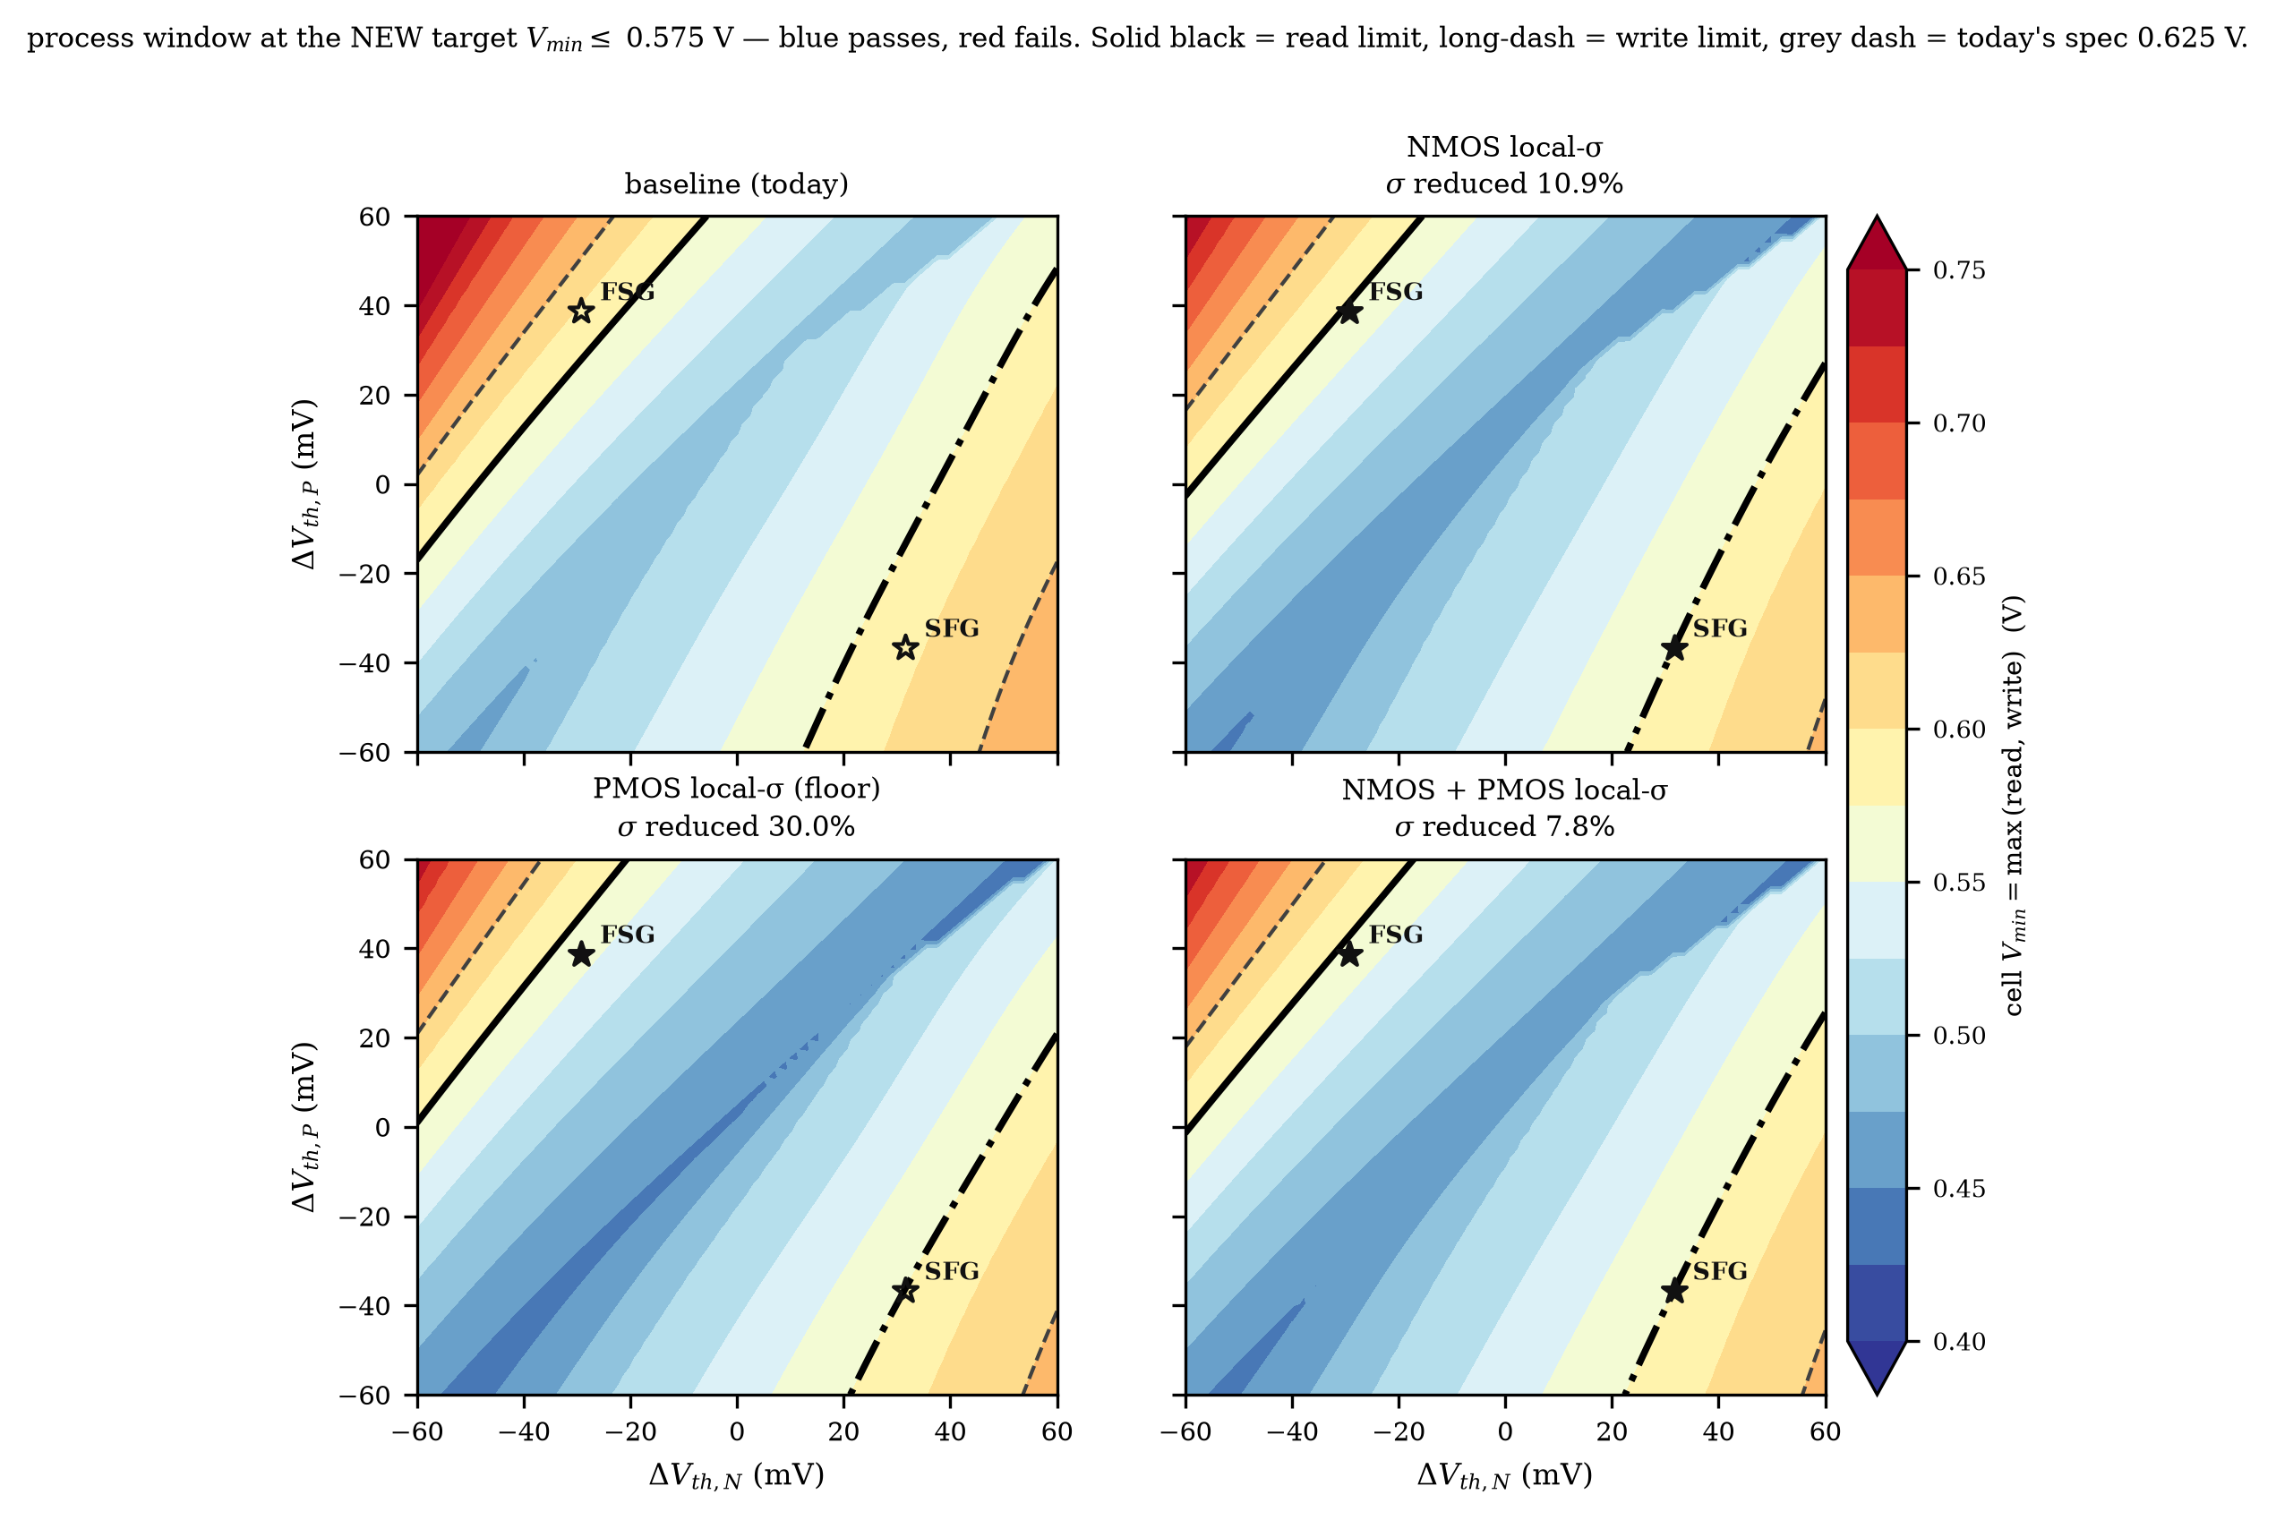
Fig. 5. Passing window at V_{min} = 0.575 V for the baseline and each improvement case, over the (ΔV_{th,N}, ΔV_{th,P}) plane. Red is the read boundary, yellow the write boundary, and the hatched region is where both modes clear the target. Stars mark the two limiting PDK corners; a filled star means that corner now passes.

V. Key Insight: Exposing the Blind Spots of Corner Analysis
The most significant contribution of this work is a quantitative demonstration of the limits of corner-only verification. Using total-order Sobol global sensitivity analysis [13], [14] on the surrogate output, we compared the variance contribution of the conventional global corner axes against the local-mismatch axes over the allowed process range, interactions included. Total-order indices are the right instrument here: an ARD lengthscale describes how smooth the function is, whereas a Sobol index measures how much of the output variance an axis actually carries.

TABLE V
TOTAL-ORDER SOBOL INDICES OF THE READ MARGIN
Process axis | Physical meaning | Corner axis? | S_{T}
ΔV_{th,N} | NMOS global threshold shift | yes | 0.413
k_{σN} | NMOS common local-σ (mismatch) | no | 0.272
ΔV_{th,P} | PMOS global threshold shift | yes | 0.200
ΔV_{th,skew} | N/P threshold skew | no | 0.065
k_{σP} | PMOS local-σ | no | 0.045
k_{μN} | NMOS mobility multiplier | no | 0.015
Δk_{μN} | NMOS mobility skew | no | 0.015
k_{μP} | PMOS mobility multiplier | no | 0.008
Δk_{σN} | NMOS local-σ skew | no | 0.001

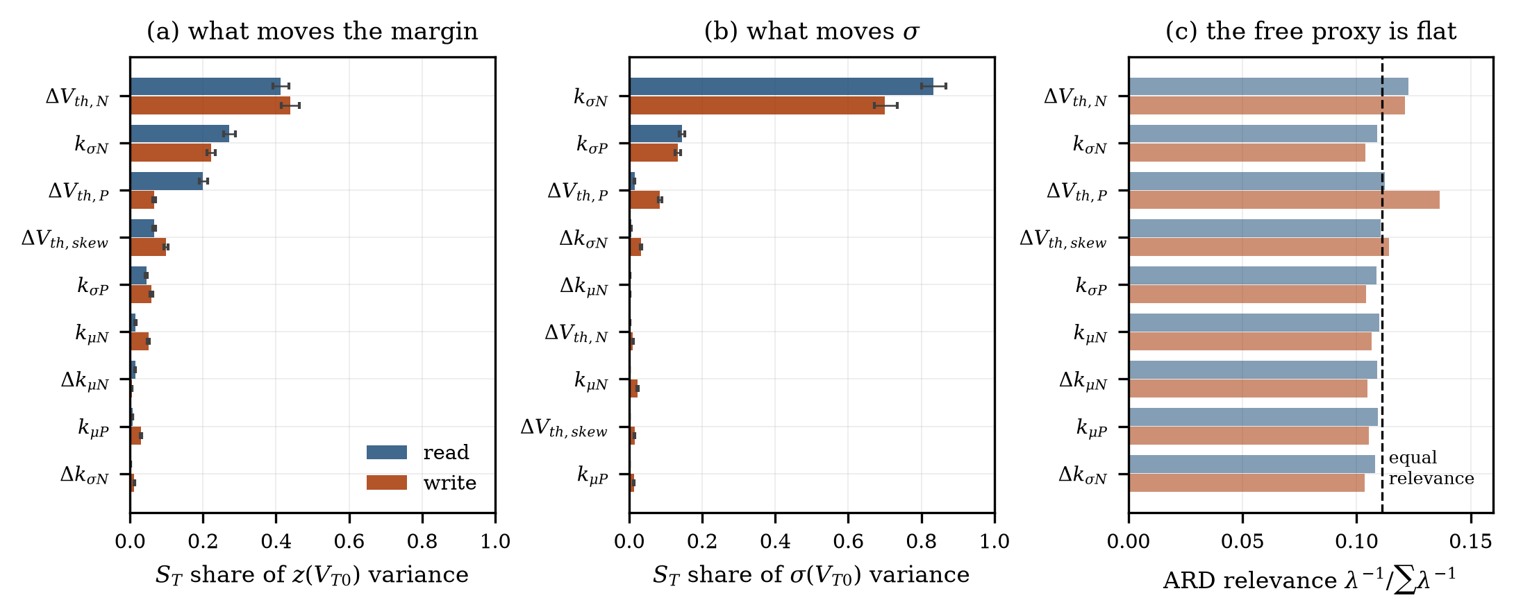
Fig. 6. Total-order Sobol indices with bootstrap confidence intervals for the read margin. The local-mismatch axis k_{σN} outranks the PMOS threshold-shift corner axis ΔV_{th,P}; the non-corner axes carry at least 38 % of the variance.

A. The Dominance of Local Mismatch
The analysis produces a counter-intuitive but critical finding: the local NMOS common-mismatch axis k_{σN} contributes more read-margin variance than the standard PMOS threshold-shift corner axis ΔV_{th,P} — total-order indices of 0.272 against 0.200 (Table V, Fig. 6). The ranking is a total-order statement; on first-order indices alone the two axes are close and the ordering can reverse, which is precisely why interactions must be included.
The bound this places on corner methods is quantitative. The two corner axes ΔV_{th,N} and ΔV_{th,P} sum to 0.61, and because total-order indices overlap through interactions that sum is an upper bound on their joint share. The remaining seven axes therefore carry at least 38 % of the read-margin variance — variance that lies in process directions orthogonal to the conventional corner set.

B. Implications for SRAM Sign-Off
This finding has three implications for SRAM verification.
1) Under-estimation of risk. Standard corner analysis captures shifts in the mean margin but systematically underestimates the spread driven by local mismatch. Since V_{min} is set by the distribution tail, V_{min} = μ − kσ, ignoring these axes yields non-conservative, optimistic V_{min} estimates.
2) Misleading worst-case identification. The worst-case corner identified by traditional methods may not be the true yield limiter when local mismatch is the dominant failure mechanism. Any V_{min} quoted at a corner is a worst case in corner space, hence a lower bound on the nine-dimensional worst case.
3) Recommendation. For advanced nodes, statistical analysis of local mismatch must be integrated alongside global corner checks. Relying solely on PDK corners is insufficient to guarantee yield.

VI. Practical Implications for Design and Process Integration
The proposed workflow maximizes the return on a simulation budget. A single calibration campaign enables:
1) Instant what-if analysis. Predicting V_{min} for any hypothetical process shift without re-simulation.
2) Data-driven spec setting. Deriving process-control limits directly from circuit yield targets through inverse queries.
3) Risk prioritization. Establishing that local mismatch, not the global corners, is the primary risk driver for read V_{min}, so mitigation effort — layout optimization, adaptive biasing — goes where it matters.
The budget itself is a design variable, and its price is measurable. Cutting the number of conditions, the supply levels, and the MC depth together reduces the campaign by 53× for read and 42.5× for write, at a cost of +7.0 mV and +10.2 mV in V_{min} RMSE respectively (Table VI, Fig. 7). Condition count and MC depth are not independent knobs — both enter the error through the σ estimate — so the combined penalty is smaller than the sum of the individual ones.
TABLE VI
COMBINED BUDGET REDUCTION, SAME HOLD-OUT SET
Quantity | Read | Write
Budget ratio | 53× | 42.5×
V_{min} RMSE, reduced | 10.95 mV | 15.83 mV
V_{min} RMSE, baseline | 3.98 mV | 5.65 mV
Degradation | +7.0 mV | +10.2 mV

For VLSI designers and process engineers this translates into reduced turn-around time, lower risk of silicon failure, and a deeper physical understanding of the variation-to-yield relationship.

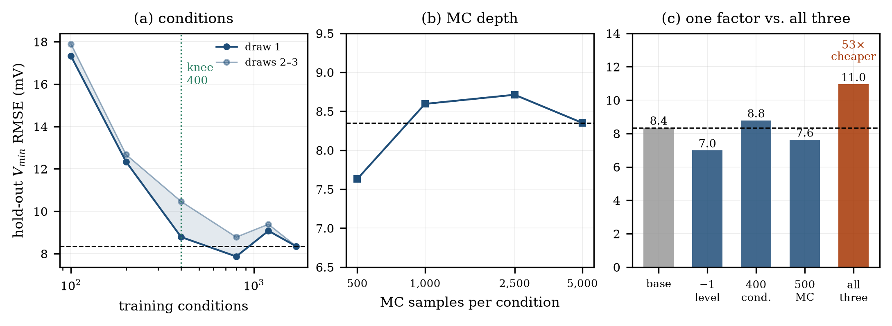
Fig. 7. Budget-reduction trade-off: (a) number of process conditions, (b) MC depth per condition, (c) one factor cut alone against all three cut together. The combined 53× reduction costs +7.0 mV of read V_{min} RMSE.

VII. Conclusion
We have presented a physics-guided framework for SRAM V_{min} estimation that overcomes the limitations of traditional corner analysis while avoiding the cost of exhaustive Monte Carlo sweeps. By modeling the margin statistics explicitly and retaining an analytic yield relation, the method achieves millivolt-level accuracy in both forward prediction — 3.98 mV RMSE for read and 5.65 mV for write, 8.5 mV and 5.8 mV on four unseen PDK corners with the limiting corner correctly identified — and inverse process recovery at 1.46–1.94 mV RMSE.
Most critically, the work provides a device-level insight: local mismatch is a dominant driver of read-margin variance, exceeding the impact of the global PMOS threshold shift, with at least 38 % of that variance lying off the conventional corner axes. This exposes a significant blind spot in corner-only verification flows, which may produce optimistic V_{min} estimates and yield loss. The Gaussian margin assumption, and whatever tail-shape correction it may eventually require, is left to future work; within it the proposed framework offers a robust, efficient, and interpretable foundation for design-technology co-optimization, connecting statistical variation, yield targets, and actionable process specifications.

References
[1] C. Bae, S. Pae, C.-S. Yu, K. Kim, Y. Kim, and J. Park, "SRAM stability design comprehending 14 nm FinFET reliability," in Proc. IEEE Int. Rel. Phys. Symp. (IRPS), 2015, pp. MY.13.1–MY.13.5.
[2] A. T. Krishnan et al., "SRAM cell static noise margin and V_{MIN} sensitivity to transistor degradation," in Proc. IEEE Int. Electron Devices Meeting (IEDM), 2006, pp. 1–4.
[3] T. Song et al., "A 14 nm FinFET 128 Mb SRAM with V_{MIN} enhancement techniques for low-power applications," IEEE J. Solid-State Circuits, vol. 50, no. 1, pp. 158–169, Jan. 2015.
[4] A. Singhee and R. A. Rutenbar, "Statistical blockade: Very fast statistical simulation and modeling of rare circuit events and its application to memory design," IEEE Trans. Comput.-Aided Design Integr. Circuits Syst., vol. 28, no. 8, pp. 1176–1189, Aug. 2009.
[5] R. Kanj, R. Joshi, and S. Nassif, "Mixture importance sampling and its application to the analysis of SRAM designs in the presence of rare failure events," in Proc. 43rd Design Autom. Conf. (DAC), 2006, pp. 69–72.
[6] A. Singhee and R. A. Rutenbar, "Why quasi-Monte Carlo is better than Monte Carlo or Latin hypercube sampling for statistical circuit analysis," IEEE Trans. Comput.-Aided Design Integr. Circuits Syst., vol. 29, no. 11, pp. 1763–1776, Nov. 2010.
[7] S. Yin, X. Jin, L. Shi, K. Wang, and W. W. Xing, "Efficient Bayesian yield analysis and optimization with active learning," in Proc. 59th ACM/IEEE Design Autom. Conf. (DAC), 2022, pp. 1195–1200.
[8] Y. Liu, G. Dai, and W. W. Xing, "Seeking the yield barrier: High-dimensional SRAM evaluation through optimal manifold," in Proc. 60th ACM/IEEE Design Autom. Conf. (DAC), 2023, pp. 1–6.
[9] Z. Guo, W. Sun, Z. Wang, Y. Cai, and L. Shi, "An efficient SRAM yield analysis method using multi-fidelity neural network," in Proc. 2nd Int. Symp. Electron. Design Autom. (ISEDA), 2024, pp. 547–551.
[10] C. E. Rasmussen and C. K. I. Williams, Gaussian Processes for Machine Learning. Cambridge, MA, USA: MIT Press, 2006.
[11] J. R. Gardner, G. Pleiss, D. Bindel, K. Q. Weinberger, and A. G. Wilson, "GPyTorch: Blackbox matrix-matrix Gaussian process inference with GPU acceleration," in Proc. Adv. Neural Inf. Process. Syst. (NeurIPS), vol. 31, 2018, pp. 7576–7586.
[12] M. J. M. Pelgrom, A. C. J. Duinmaijer, and A. P. G. Welbers, "Matching properties of MOS transistors," IEEE J. Solid-State Circuits, vol. 24, no. 5, pp. 1433–1439, Oct. 1989.
[13] I. M. Sobol', "Global sensitivity indices for nonlinear mathematical models and their Monte Carlo estimates," Math. Comput. Simul., vol. 55, no. 1–3, pp. 271–280, Feb. 2001.
[14] A. Saltelli, P. Annoni, I. Azzini, F. Campolongo, M. Ratto, and S. Tarantola, "Variance based sensitivity analysis of model output. Design and estimator for the total sensitivity index," Comput. Phys. Commun., vol. 181, no. 2, pp. 259–270, Feb. 2010.
[15] S. Gupta and B. H. Calhoun, "Dynamic read V_{min} and yield estimation for nanoscale SRAMs," IEEE Trans. Circuits Syst. I, Reg. Papers, vol. 68, no. 3, pp. 1171–1182, Mar. 2021.
[16] E. Seevinck, F. J. List, and J. Lohstroh, "Static-noise margin analysis of MOS SRAM cells," IEEE J. Solid-State Circuits, vol. SC-22, no. 5, pp. 748–754, Oct. 1987.

