Grasp-Conditioned Spill-Free Mug Transport
Jihoon Yoon · Motion Planning Term Project
Abstract — Given a dexterous grasp of a mug, we generate a 6-DoF arm trajectory that transports it without spilling. We embed a differentiable spill cost—derived from the apparent-gravity (“waiter”) model—into CHOMP and evaluate it on each grasp (77 reachable grasps). At a hardware-feasible budget our planner is the only method that is both nearly spill-free (1.1% mean spill) and within joint limits (94% feasible), where baselines either spill (chomp-smooth 14%, min-jerk 70%) or violate joint limits (vanilla-grad / STOMP 0% feasible). The fastest feasible spill-free transport time is a property of the grasp—it ranges 0.7–1.6 s and is not predicted by grasp geometry (r = +0.12); 36% of grasps cannot reach the task at all—so spill-robustness must be measured by planning. We also characterize a degenerate high-acceleration mode of the spill cost and the spill–feasibility trade-off in the cost weight.

1 Introduction
Dexterous grasp synthesis has matured: modern affordance- and taxonomy-aware methods produce a suitable multi-finger hand pose for an object and task; my thesis is one such generator. A largely unanswered question is what happens after the grasp—whether the grasped object can be manipulated safely. We study the canonical instance: transporting a mug of liquid. Given a grasp, produce a 6-DoF arm trajectory that moves the mug from A to B without spilling.
The governing physics is the waiter problem. A cup spills not only when geometrically tilted but whenever it accelerates, because in the cup’s quasi-static frame the liquid aligns with the effective gravity g − a rather than g; spilling occurs when this apparent-gravity vector leaves the cone subtended by the rim. The safe envelope depends on how the cup is held—on the grasp.
Contributions: (i) a differentiable spill cost in CHOMP that produces hardware-feasible spill-free transport, with a characterized degenerate high-acceleration mode avoided by a moderate weight; (ii) a grasp-conditioned analysis showing the fastest feasible spill-free time is a grasp property not predictable from geometry; and (iii) a feasibility analysis of when each method violates joint limits.

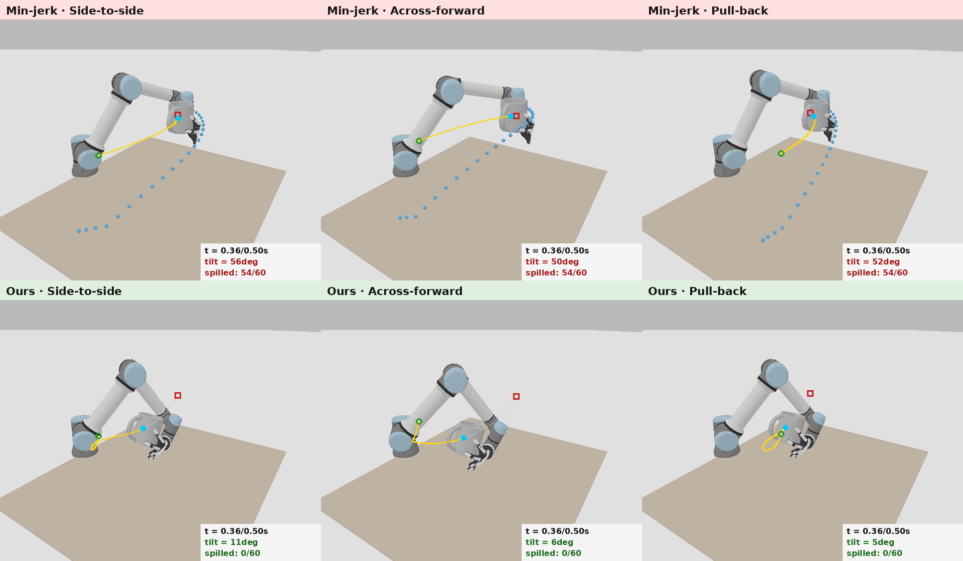
Figure 1. The same three transport tasks at the same time budget. Top: min-jerk spills; bottom: ours keeps the water in. Gold curves are mug-center paths.

2 Related Work
2.1 Waiter-problem / non-prehensile transport
Work transporting an ungrasped object on the end-effector enforces no-tip/no-slip via the friction cone: Heins and Schoellig [1] balance an object with obstacle avoidance via constrained MPC; Selvaggio et al. [2] enforce non-sliding contact during fast transport. These fix the contact and reason about rigid tipping, not fluid slosh.
2.2 Slosh-free liquid transport
Muchacho et al. [3] model the end-effector as a spherical pendulum and compute slosh-free trajectories via a QP—the reduced-order slosh model we build on, for a fixed container pose. Moriello et al. [4] use input shaping; Di Lillo et al. [6] keep the surface within container limits; Gandhi et al. [5] learn liquid dynamics through clutter. All are grasp-agnostic.
2.3 Trajectory optimization with task costs
Our optimizer is CHOMP [7]; the spill cost is an added differentiable term. STOMP [8] is the sampling counterpart and TrajOpt [9] the sequential-convex one; as slosh is acceleration-dependent, space-time CHOMP [10] is relevant. We compare optimizers and ablate the covariant metric.
2.4 Tilt-constrained planning and task-oriented grasping
Orientation-constrained planners impose a static bounded tilt—Task Space Regions [11], task-constrained RRT [12] (carry a glass level)—whereas ours is a dynamic spill margin. Task-oriented and semantic grasping select grasps for a task [13,14], gate kinematic feasibility [16], or co-optimize grasp and motion [15], but never via a physical spill margin.
2.5 Gap
Spill-free transport [3–6] and waiter balancing [1,2] fix the grasp and optimize the trajectory; task-oriented grasping [13–16] stops at grasp selection with a kinematic metric. No work closes the loop grasp → spill margin → trajectory. We take a first step and quantify how the grasp sets the feasible spill margin.
3 Method
3.1 Problem formulation
Let q(t) denote the 6-DoF UR5e configuration; the hand joints are frozen, so the grasp fixes the rigid transform T_{em} and the mug world pose is FK(q)·T_{em}. With upright start/goal we seek a waypoint trajectory ξ = (q₀, …, q_{N−1}) with fixed endpoints that keeps the apparent-gravity vector inside the rim cone, is smooth, collision-free, and within joint limits.
3.2 Differentiable kinematics
A differentiable FK chain walker (autograd through SE(3)) matches SAPIEN to 1e-7. IK minimizes ‖p − p*‖² + λ(3 − tr(R R*^{T})) by Adam from multiple seeds; an IK failure then indicates genuine unreachability.
3.3 Spill model (apparent-gravity cone)
Under the quasi-static assumption the liquid surface is normal to the effective gravity g_{eff} = g − a (a = mug-center acceleration); with n the opening axis the cup does not spill iff
align(t) = − ĝ_{eff}(t) · n(t) ≥ cos θ_{max} ,
where θ_{max} is set by the fill level (≈ atan((rim − liquid)/radius); 18° ≈ half-full). The penalty is c_{spill} = max(0, cos θ_{max} − align)². The acceleration is the second finite difference of p_{mug} = FK(q)·T_{em}, so the per-grasp lever arm (α×r, ω×(ω×r)) is captured exactly: identical arm motions with different T_{em} give different mug accelerations.
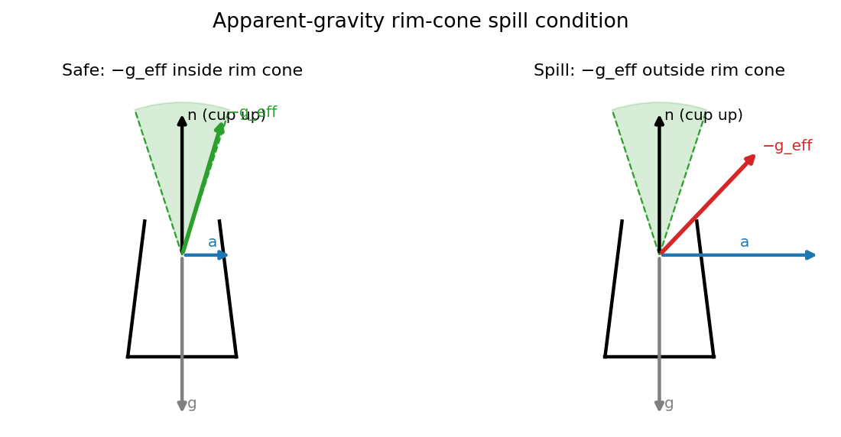
Figure 2. Spill condition. Left: −g_eff inside the rim cone (safe). Right: acceleration tilts −g_eff out of the cone (spill).
3.4 Cost functional and covariant update
J = α J_{smooth} + β J_{obs} + γ J_{spill}, with J_{smooth} = ‖Aξ‖² (A the second-difference operator) inducing the CHOMP metric M = A^{T}A. CHOMP descends the covariant gradient
ξ ← ξ − η · M⁻¹ · ∇J(ξ) ,
fed to Adam with gradient clipping. The spill cost constrains only the direction of g_eff, so a large γ admits a degenerate solution that injects a huge upward acceleration to align g_eff at the cost of joint-limit-violating motion; a moderate γ (1.0), where smoothness bounds acceleration, avoids it (§4.2).
3.5 Per-grasp spill-aware planning
Algorithm 1 Per-grasp spill-aware transport
Input: grasp G (T_em), start/goal, budget T,
theta_max, weight gamma
1: q_s <- IK(T_start . T_em^-1) (multi-seed)
2: q_g <- IK(T_goal . T_em^-1)
3: if IK error > tol: return UNREACHABLE
4: xi <- minjerk(q_s, q_g, N)
5: for k = 1..K do
6: p <- FK(xi).T_em; a <- d2 p / dt2
7: J <- a Jsm + b Jobs + g Jspill(a,n)
8: grad <- M^-1 dJ/dxi; clip; xi<-Adam(xi,grad)
9: return xi, spill_ratio(xi; theta_max)

4 Experiments
Setup. A mug with 120 sampled grasps (2-finger / 3-finger / whole-hand). Default task: 70 cm lateral + 15 cm lift, upright endpoints. Metric: spill ratio = fraction of waypoints whose effective tilt exceeds θ_{max}. Feasible = max joint velocity < 3.3 rad/s and acceleration < 20 rad/s².
4.1 Method comparison and feasibility
Five methods, each changing one ingredient, on 77 reachable grasps at a hardware-feasible budget T = 1.0 s (γ = 1.0 for spill-aware methods).
Method | mean spill | feasible
min-jerk | 69.9% | 61%
chomp-smooth | 14.1% | 100%
stomp-spill | 50.2% | 0%
vanilla-grad | 73.8% | 0%
ours | 1.1% | 94%

Ours is the only method that is both nearly spill-free (1.1%) and feasible (94%). Smoothness alone (chomp-smooth) is feasible but spills (14%). Without the CHOMP metric the gradient and sampling baselines (vanilla-grad, STOMP) are near-0% feasible—they reduce spill only by injecting joint-limit-violating accelerations (Fig. 4)—and still spill heavily. The metric is thus essential for both spill and feasibility, and at far lower compute than sampling (ours plans in 3 s vs 13 s for STOMP).
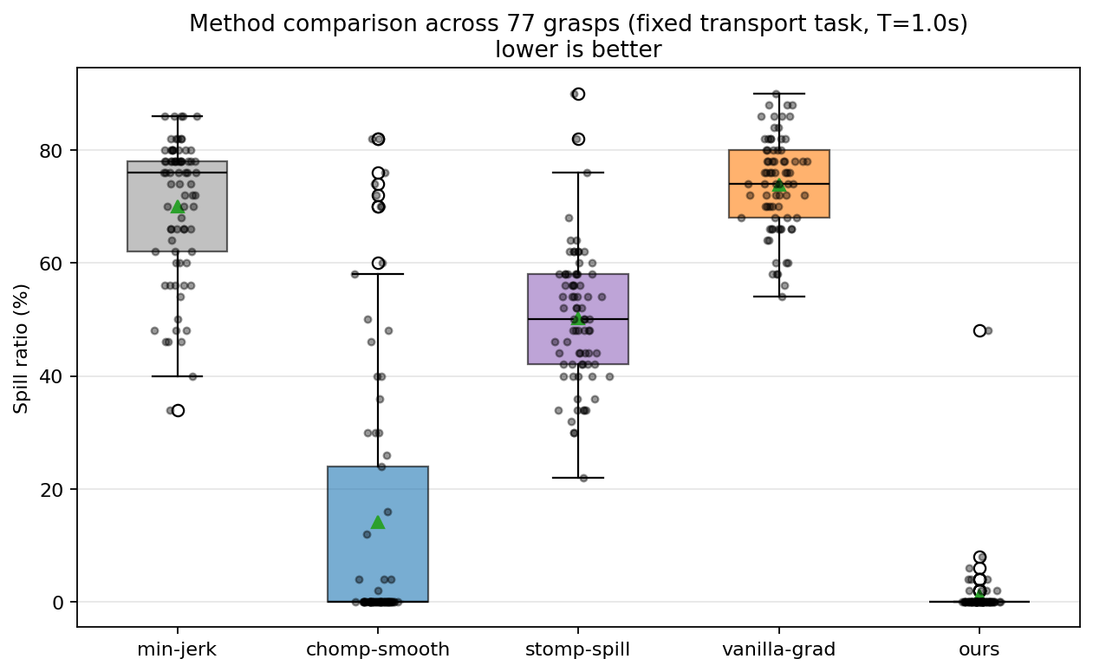
Figure 3. Spill distribution over 77 grasps at the feasible budget T = 1.0 s.
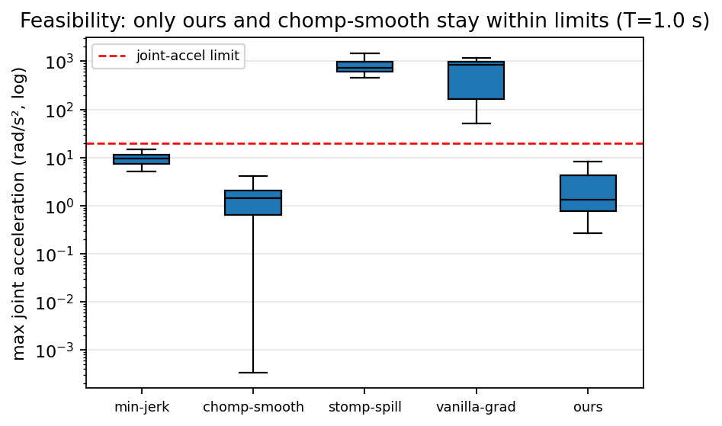
Figure 4. Max joint acceleration per method (log). vanilla-grad and STOMP exceed the limit; ours and chomp-smooth stay within it.
4.2 Spill–feasibility trade-off and fill level
Sweeping the spill weight γ exposes the trade-off (Fig. 5): small γ leaves residual spill, while large γ triggers the degenerate high-acceleration mode and feasibility collapses. γ ≈ 1 is the knee—low spill while staying feasible.
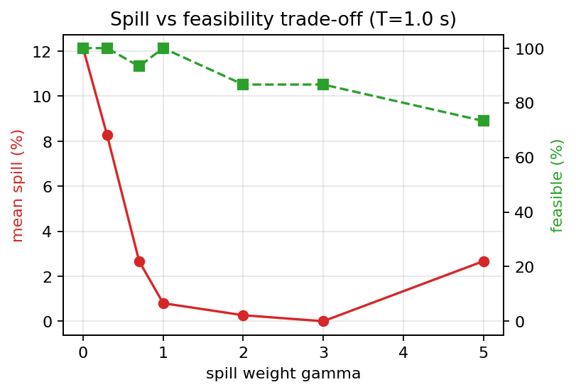
Figure 5. Spill (red) and feasibility (green) vs the spill weight γ at T = 1.0 s. γ≈1 is the knee of the trade-off.
Because θ_{max} encodes the fill level (a fuller cup ⇒ smaller θ_{max}), Fig. 6 shows how many grasps ours keeps spill-free as the cup is filled: nearly all at moderate fill, degrading gracefully as the cup approaches the brim.
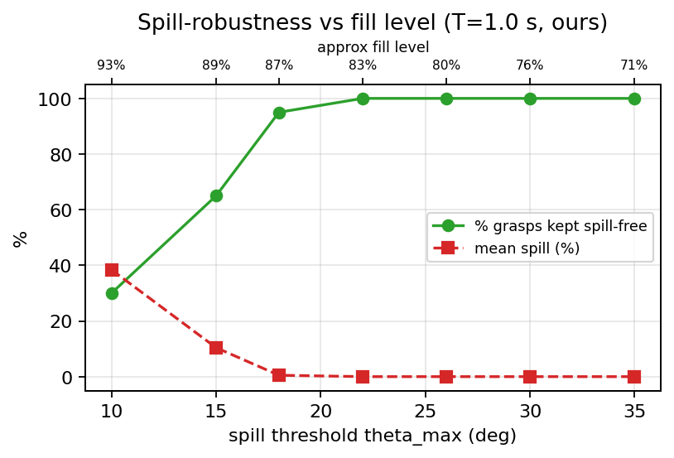
Figure 6. Spill-robustness vs spill threshold / fill level (T = 1.0 s, ours).
4.3 Spill-robustness is a property of the grasp
Of 120 grasps, 36% cannot reach the transport workspace (Fig. 9). For reachable grasps we define T* as the fastest budget that is both spill-free and feasible. With γ = 1.0 spill is monotone in T for 75% of grasps, so T* is well-defined; it ranges 0.7–1.6 s (median 0.9 s) and is not predicted by grasp offset (r = +0.12, Fig. 8). A spill-robust grasp thus cannot be chosen by a geometric heuristic—it must be measured by planning.
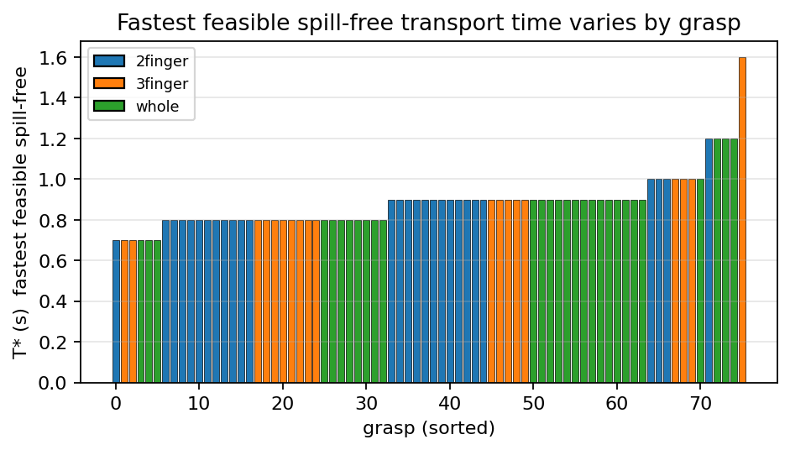
Figure 7. Fastest feasible spill-free transport time T* per grasp; it varies across grasps.
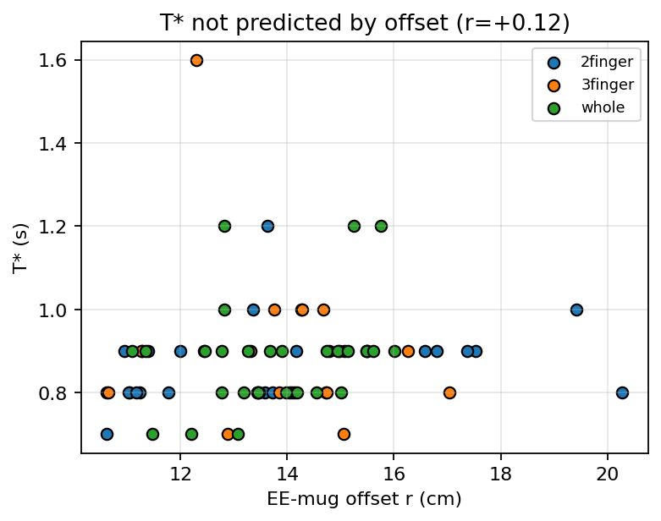
Figure 8. T* vs EE–mug offset (r = +0.12): grasp geometry does not predict it.
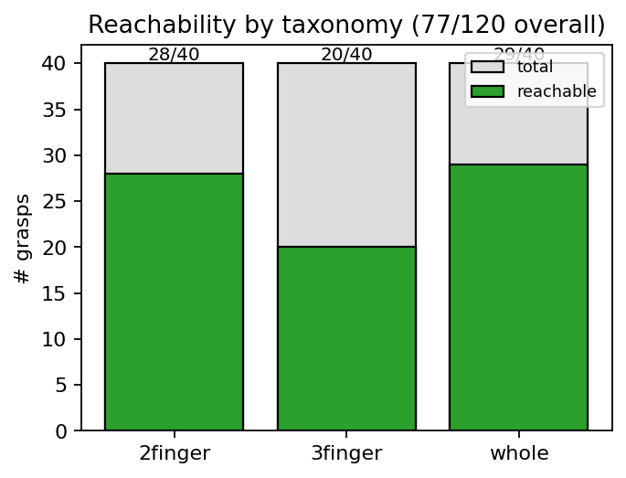
Figure 9. Reachability by taxonomy: 36% of grasps cannot reach the task.
4.4 Qualitative
Figure 10 shows the five methods on one task; only ours and chomp-smooth stay below the spill threshold, but the spill-aware baselines do so only via infeasible motion (Fig. 4).

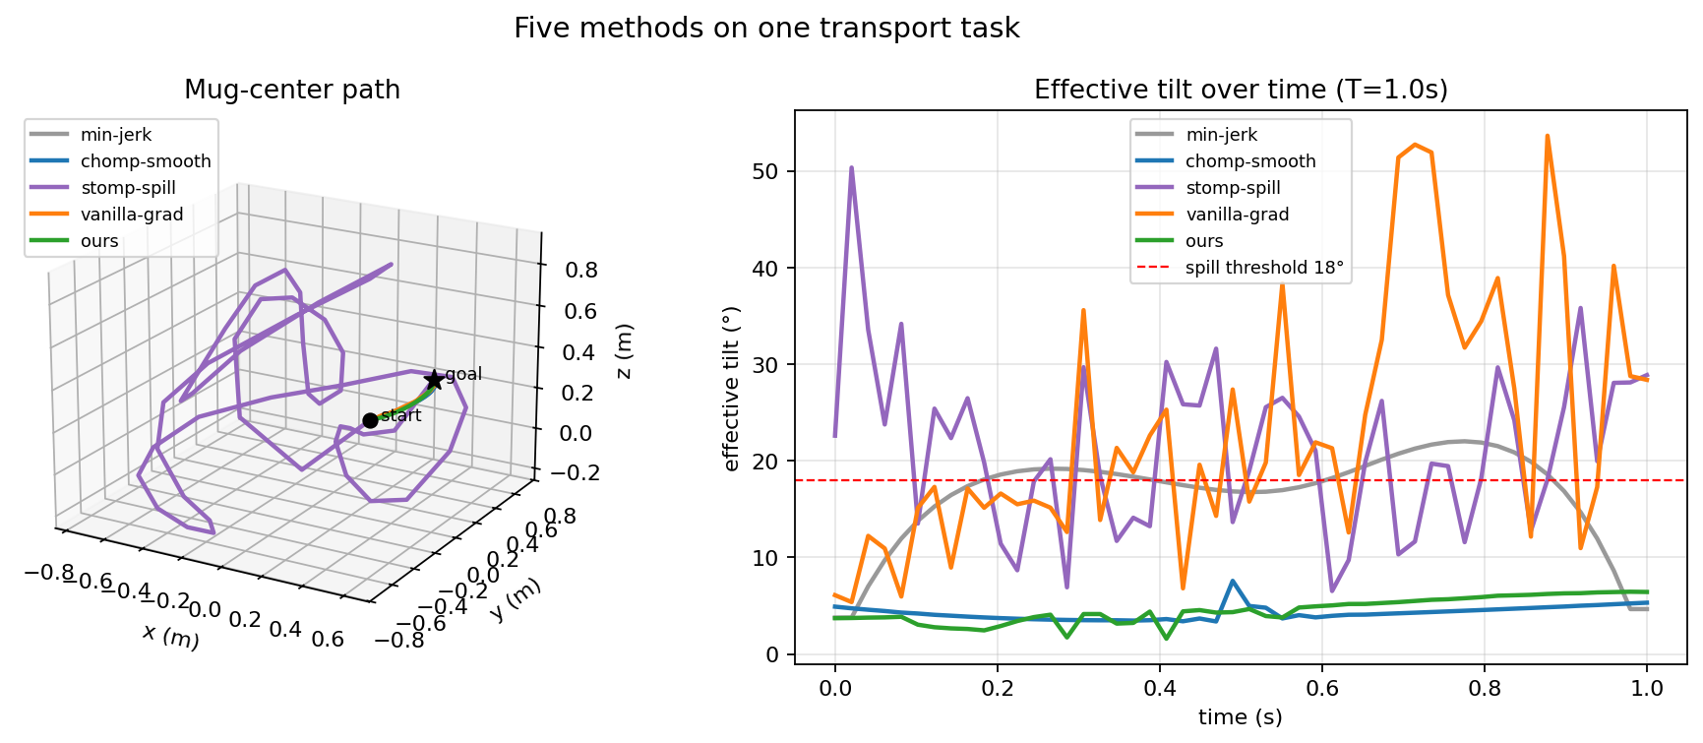
Figure 10. Five methods on one task: mug-center paths (left) and effective tilt over time (right).

5 Discussion and Limitations
Feasibility is the central subtlety. The spill cost constrains only the direction of effective gravity, so an aggressive weight or over-fast budget yields trajectories that are nominally spill-free but violate joint limits (up to ~10 rad/s and ~330 rad/s², far above the UR5e limits). We report at a feasible budget with a moderate weight and include a feasibility metric; properly coupling dynamic limits (time-optimal reparameterization or hard constraints) is future work. We use the quasi-static apparent-gravity cone [3], not full CFD; a rigid-body particle simulation we built behaves granularly and is not used quantitatively. CHOMP non-convexity makes spill only weakly monotone in T, so we treat T* statistically. Scope: a single mug instance. We found and fixed an inverted cup up-axis convention midway; all numbers use the corrected convention.
6 Conclusion and Future Work
We built a spill-aware planner that, at a feasible budget, uniquely achieves both spill-free and joint-limit-feasible transport, and showed that the fastest feasible spill-free transport time is a grasp property not predictable from geometry, so it must be measured. This is the signal a grasp generator could consume: future work is to feed the measured spill margin back into grasp selection, couple dynamic limits and obstacles, and extend to more objects and a learned spill model.
References
[1] M. Heins, A. P. Schoellig, “Keep It Upright: MPC for Nonprehensile Object Transportation with Obstacle Avoidance,” IEEE RA-L, 2023.
[2] M. Selvaggio et al., “Non-Prehensile Object Transportation via MPC Non-Sliding Manipulation Control,” IEEE TCST, 2023.
[3] T. P. Muchacho, R. Laha, L. Figueredo, S. Haddadin, “A Solution to Slosh-free Robot Trajectory Optimization,” IROS, 2022.
[4] L. Moriello, L. Biagiotti, C. Melchiorri, A. Paoli, “Manipulating liquids with robots: a sloshing-free solution,” Control Eng. Practice, 2018.
[5] G. Gandhi, B. Sundaralingam, J. Pan et al., “Clutter-Aware Spill-Free Liquid Transport via Learned Dynamics,” arXiv:2408.00215, 2024.
[6] C. Di Lillo, Q.-C. Pham et al., “Robotic Handling of Liquids with Spilling Avoidance,” ICRA, 2019.
[7] M. Zucker, N. Ratliff, A. Dragan et al., “CHOMP,” IJRR, 2013.
[8] M. Kalakrishnan, S. Chitta, E. Theodorou, P. Pastor, S. Schaal, “STOMP,” ICRA, 2011.
[9] J. Schulman et al., “Motion planning with sequential convex optimization and convex collision checking,” IJRR, 2014.
[10] A. Byravan, B. Boots, S. Srinivasa, D. Fox, “Space-Time Functional Gradient Optimization for Motion Planning,” ICRA, 2014.
[11] D. Berenson, S. Srinivasa, J. Kuffner, “Task Space Regions,” IJRR, 2011.
[12] M. Stilman, “Global Manipulation Planning in Robot Joint Space with Task Constraints,” IEEE T-RO, 2010.
[13] H. Dang, P. K. Allen, “Semantic grasping,” Autonomous Robots, 2014.
[14] K. Fang, Y. Zhu, A. Garg et al., “Learning Task-Oriented Grasping,” IJRR, 2020.
[15] M. Toussaint, K. Allen, K. Smith, J. Tenenbaum, “Differentiable Physics and Stable Modes for Tool-Use and Manipulation Planning,” RSS, 2018.
[16] J. Fontanals et al., “Grasping for a Purpose,” ICRA, 2014.

