Students do not enjoy their learning and need to sleep more
The message I want to convey in this infographic is that the students who have submitted their time diaries do not enjoy their learning with lectures and coursework although they spend a considerable amount of time on it. They should allocate more time on sleeping and spend more time on leisure or something else to balance their work and life.
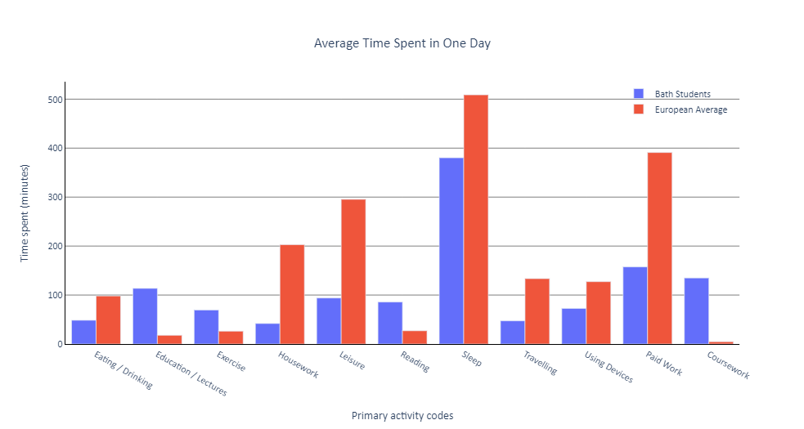
Figure 1 A bar plot for average time consumption comparison between the students and the European average in one day
The histogram is plotted in Figure 1 for identifying if there are any activities that the students who have submitted their time diary datasets have spent more or less time compared to the average of Europeans. For this comparison, the additional dataset by (Eurostat, 2010) and organised by (Dai, 2019) was used. This dataset includes all age group. The students have spent significantly more time on Education/Lectures, Reading and Coursework as expected, whereas they spent less time on Eating, Housework or Leisure. Also, the difference in sleep time is significant - the University of Bath students who submitted their time diaries slept 7 hours and 4 minutes on average, which is more than an hour less than the European average. This is worrying as the recommended sleep time by The US National Sleep Foundation is 7 to 9 hours for young adults and adults, and also states that sleeping less than this recommended time may cause serious health problems (Hirshkowitz et al., 2015). The students’ sleep time barely meet this recommendation.
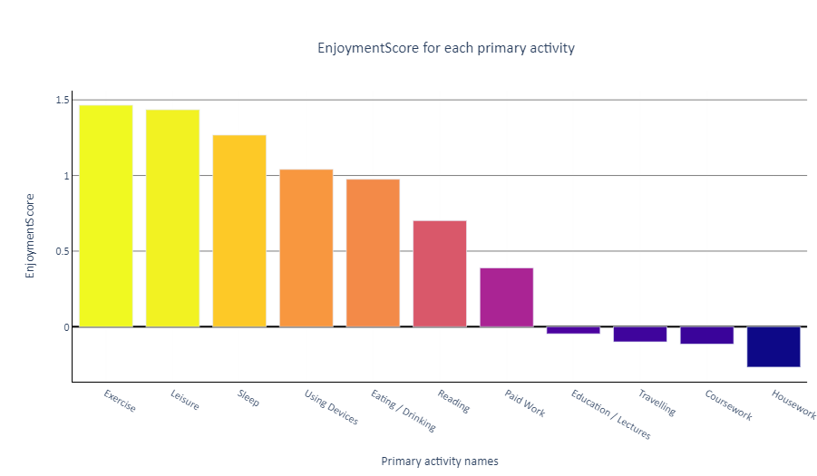
Figure 2 A bar plot of the average EnjoymentScore recorded by the students for the primary activities
A bar plot of EnjoymentScore for different primary activities recorded by the students is plotted in Figure 2. It is clearly shown that the students did not enjoy housework, and unsurprisingly, doing their coursework and listening to lectures. The students rather enjoyed doing exercise and leisure.

Design principles
This infographic aimed to follow the effective design principles discussed within this unit. For instance, the produced figures were plotted as a bar chart as the data for comparison were quantitative and length is one of the most suitable presentation for this kind of data. Further, the infographic clearly shows its title at top and shows comparisons with multivariate data as recommended by (Jones, 2020).

Reference
Dai, S 2019, European Time Use, viewed 28 March 2021, https://www.kaggle.com/yuchendai/european-time-use.
Eurostat 2010, Time spent, participation time and participation rate in the main activity by sex and day of the week, viewed 28 March 2021, https://ec.europa.eu/eurostat/data/database?node_code=tus_00week.
Jones, S 2020, Data Visualisation II, lecture notes, Applied Data Science CM50266, University of Bath.
Mackinlay, J., 1988, January. Applying a theory of graphical presentation to the graphic design of user interfaces. In Proceedings of the 1st annual ACM SIGGRAPH symposium on User Interface Software (pp. 179-189).
Max Hirshkowitz, Kaitlyn Whiton, Steven M. Albert, Cathy Alessi, Oliviero Bruni, Lydia DonCarlos, Nancy Hazen, John Herman, Eliot S. Katz, Leila Kheirandish-Gozal, David N. Neubauer, Anne E. O’Donnell, Maurice Ohayon, John Peever, Robert Rawding, Ramesh C. Sachdeva, Belinda Setters, Michael V. Vitiello, J. Catesby Ware, Paula J. Adams Hillard, National Sleep Foundation’s sleep time duration recommendations: methodology and results summary, Sleep Health, Volume 1, Issue 1, 2015, Pages 40-43, ISSN 2352-7218, https://doi.org/10.1016/j.sleh.2014.12.010. (https://www.sciencedirect.com/science/article/pii/S2352721815000157)

