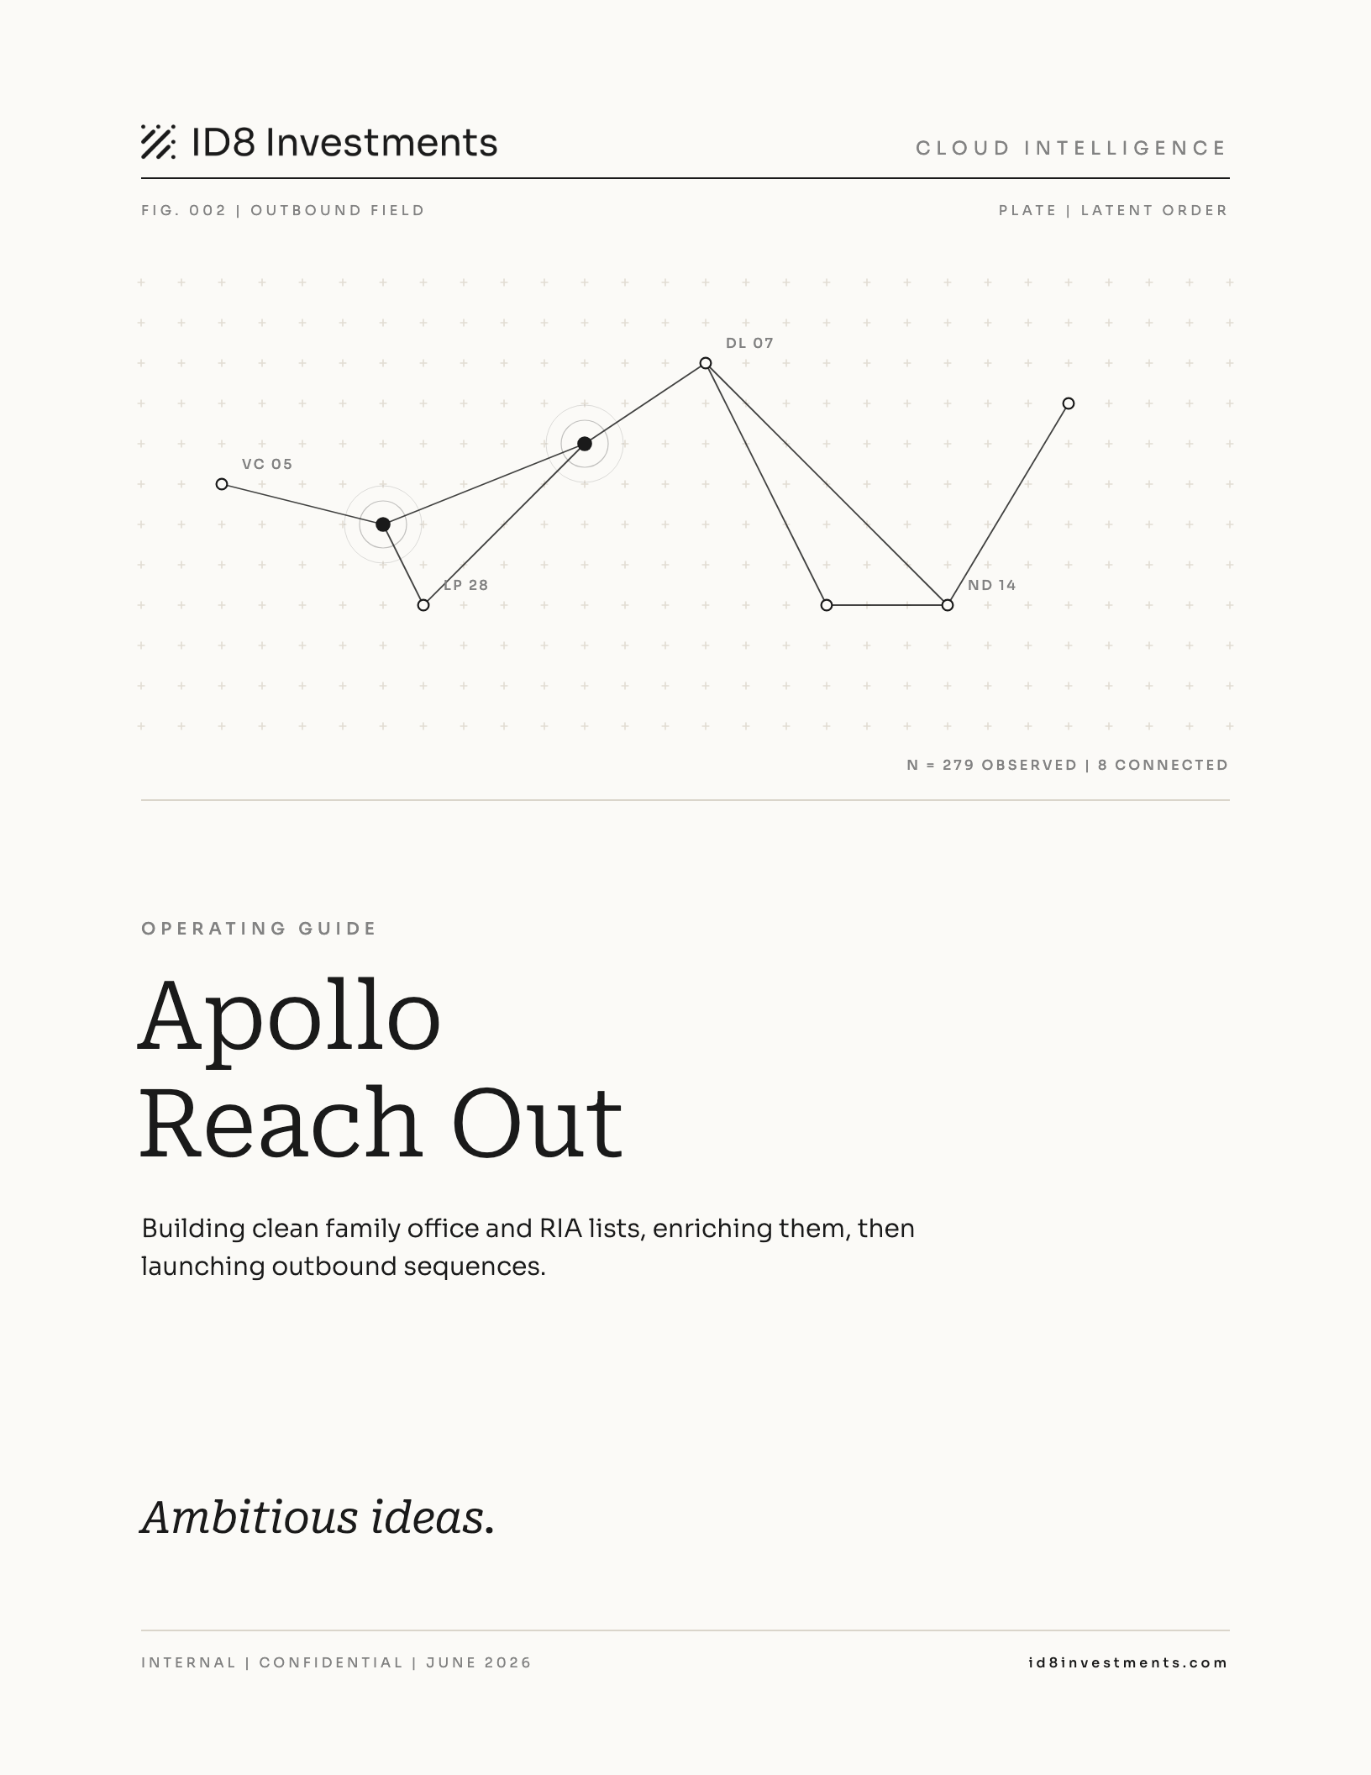

Contents

01 Overview
Apollo Reach Out turns Apollo's contact database into a short, clean list of real family office and RIA decision-makers. It enriches each one and loads them into a managed outbound sequence.
The hard part is filtering. A broad search for financial services in Los Angeles returns about 61,889 people. That is every banker, broker, and fintech employee in the city. This guide is the recipe that gets you down to 50 to 300 real prospects.

When to use it
- You are preparing an outbound push for a city or an event, like the LA trip.
- You need a fresh list of prospects to feed the LP screener.
- You want to load qualified contacts into a sequence without touching anyone already in a live campaign.

What you get
Stage | Output
Filtered search | 50 to 300 clean FO and RIA decision-makers in the target city
Enrichment | Research and a 0 to 100 LP fit score per firm
Sequence load | Contacts mirrored into Apollo and enrolled in the managed sequence
Note Quality beats quantity here. A hundred precise contacts outperform five thousand broad ones. If loosening a filter grows the list, the list usually got worse.

02 Building the target list
Set the filters in this order. Each layer removes a category of bad results. The employee count filter in step 3 does most of the work on its own.

Step 1. Company keywords to include
Set the keyword type to ANY so a contact matches on any single term. Use only the terms real family offices use about themselves. Large asset managers never call themselves a family office.
- family office
- single family office
- multi-family office
- private family office
- family wealth
- private wealth
Note Skip the broad terms wealth management, investment management, and financial services. They pull in large platforms like Mercer, Edward Jones, and Raymond James.

Step 2. Company keywords to exclude
Exclusions do more work than inclusions. Paste these into the exclude box.
Category | Exclude terms
Banks and wirehouses | bank, banking, brokerage, broker dealer, Raymond James, Edward Jones, Morgan Stanley, Wells Fargo, Merrill Lynch, UBS, Charles Schwab, Ameriprise, LPL Financial
Large platforms | Fidelity, Vanguard, BlackRock, asset management, fund administration
Insurance | insurance, Northwestern Mutual
Wrong asset class | hedge fund, private equity, venture capital, real estate
Wrong kind of finance | accounting, tax, payroll
Tech in finance | fintech, software, technology

Step 3. Employee count
Real family offices have 2 to 30 employees. Platforms have hundreds or thousands. Under Company Headcount, select 1 to 10 and 11 to 50.
Note This one filter removes about 90 percent of the wrong results. If you do nothing else, do this.

Step 4. Job titles
Under Job Title, add the decision-maker titles.
- Partner, Managing Partner, Principal
- Chief Investment Officer, Head of Investments, Director of Investments
- Managing Director, Investment Director, Portfolio Manager

Step 5. Seniority
Under Seniority, select Owner or Partner, C-Suite, VP, and Director.

Step 6. Location
Keep the geography tight to the campaign. For the current effort this is Los Angeles.

RIA sub-search
RIAs that serve high-net-worth clients are small firms. Run them as a separate search.
Filter | Value
Keywords | registered investment advisor OR RIA
Headcount | 1 to 50
Titles | Partner, CIO, Managing Director, Principal
Any RIA with 500 or more employees is a retail platform, not what you want.

What good looks like
After all layers you should land between 50 and 300 results.
Keep Unfamiliar, generic names like Westlake Capital or Meridian Family Office.
Drop Names you recognize. If you know the firm, it is too big.

03 Enrich and launch

Enrich with Perplexity
Research each firm before you reach out. The enrichment step scores each firm against the ID8 Growth Opportunities Fund I rubric.
Script | Role
perplexity_lp_screener.py | Per-firm web research and structured notes
lp_screener_hybrid.py | Applies the 0 to 100 rubric and tiers firms
These also back the lp-prospect-screener skill. Hand it a CSV of contacts and it returns a scored, tiered CSV.
Note Screen before you load the sequence. Enroll only Tier 1 and Tier 2 firms.

Load the sequence
The sync mirrors your Attio People into Apollo and parks them in a dormant holding sequence. Any later Apollo search then flags those people as already sequenced, so you never double-touch a contact.
It lives in attio_apollo_sync.py and runs from /sync-apollo, with /sync-apollo/status for progress.
curl -X POST https://<your-app>/sync-apollo
curl https://<your-app>/sync-apollo/status

Configuration
Env var | Notes
APOLLO_API_KEY | Must be a master key. add_contact_ids returns 403 otherwise
APOLLO_HOLDING_SEQUENCE_ID | A dormant sequence with no active email steps
APOLLO_MAILBOX_ID | Optional mailbox for the sequence

API gotchas
These fail silently with no error, so they are easy to miss.
- add_contact_ids needs a master API key.
- Sequence flags are snake_case: sequence_active_in_other_campaigns and sequence_finished_in_other_campaigns. CamelCase is ignored. Keep both false so live contacts stay put.
- The mailbox param is send_email_from_email_account_id, and emailer_campaign_id must echo the sequence id.
- Upsert with POST /contacts and run_dedupe=true. The lookup fallback is POST /contacts/search.
- Contact search cannot filter by sequence membership. Re-running is safe because Apollo dedupes and a contact can only sit in a sequence once.

04 Reference

Include keywords, type ANY
family office, single family office, multi-family office,
private family office, family wealth, private wealth

Exclude keywords
bank, banking, brokerage, broker dealer, insurance,
asset management, fund administration, hedge fund,
private equity, venture capital, real estate, accounting,
tax, payroll, fintech, software, technology, Raymond James,
Edward Jones, Morgan Stanley, Wells Fargo, Merrill Lynch, UBS,
Fidelity, Vanguard, BlackRock, Charles Schwab, Ameriprise,
Northwestern Mutual, LPL Financial

Other layers
Filter | Value
Employee count | 1 to 10 and 11 to 50
Titles | Partner, Managing Partner, CIO, Managing Director, Head of Investments, Director of Investments, Portfolio Manager, Principal, Investment Director
Seniority | Owner or Partner, C-Suite, VP, Director
Location | Los Angeles for the current campaign

Checklist
- Include keywords set to ANY, only self-descriptive family office terms
- Exclude list pasted in full
- Headcount limited to 1 to 10 and 11 to 50
- Decision-maker titles and seniority added
- Location tight to the campaign
- Result is 50 to 300 and full of unfamiliar firm names
- Screened, kept Tier 1 and Tier 2, then ran /sync-apollo

Troubleshooting

Search returns big recognizable firms
Your include keywords are too broad or the headcount filter is off. Remove wealth and investment management, confirm headcount 1 to 10 and 11 to 50, and add the exclude list.

Sequence enroll seems to do nothing
Usually camelCase sequence flags, which Apollo ignores, or a non-master API key. Use snake_case flags and a master key.

Contacts come through blank for title, LinkedIn, or phone
The People slugs in extract_contact are best guesses. Confirm them against the live Attio People object if those fields are empty.

Ambitious ideas.
id8investments.com

