Q1-1)

The Adaptive Trapezoidal Rule had been used to calculate the result with an error less than 1e-6. This result would then be treated as a ‘correct’ value and be used as a reference theoretical value in the upcoming calculations.

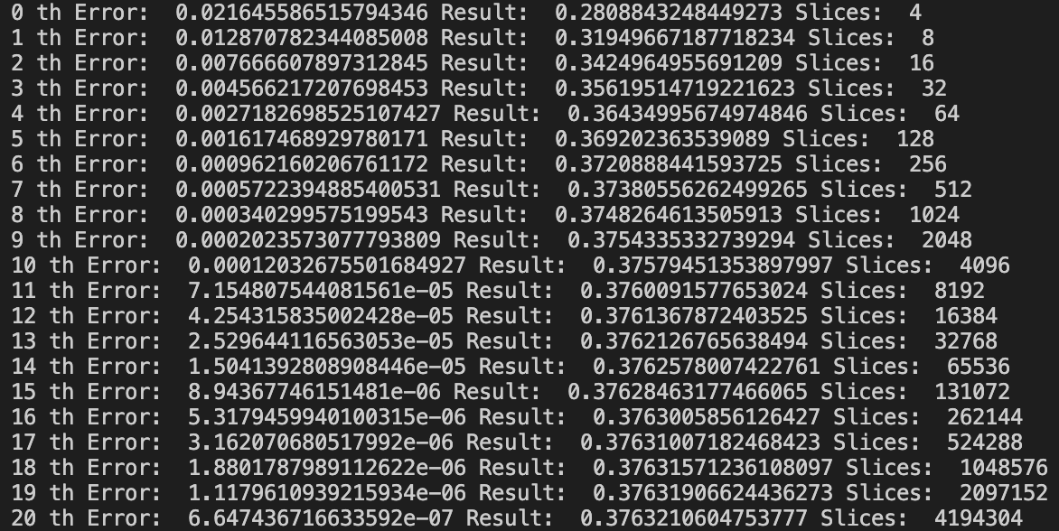

Q1-2)

Using direct sampling, mean value method and 1000 uniform random x points, the result had been calculated.

SE_x refers to the error and had been calculated with reference to the standard deviation. It was used to figure out the confidence interval, which was relatively close to the theoretical value at $δ_{1}$, $δ_{2},$ and $δ_{3}.$ Again, the values referenced the more accurate result from question 1.



Q1-3)

The same methodology used in assignment 4 had been used with tweaked codes to suit the needs of the question.

$δ_{2}$ had been calculated using Error, which was calculated using the standard deviation. The theoretical value of the confidence interval and the experimental value is extremely close, which shows that the results are well behaved. The integral value is also much closer to the theoretical value using importance method as expected.



Q1-3-2)

The MCMC method was used to do importance sampling on the points similar to the previous part. However, the confidence interval deviated significantly from the theoretical value, and the integral result was also less accurate compared to the previous method. This may be explained because of the random nature of the Monte Carlo method, and is likely to be improved by increasing the number of repetition in the loops, but it would take much longer for the computer to process.



Q1-4)

$I_{0}$ has the value of 0.3763210604753777. Since this value was used to calculate the confidence intervals in the questions, the confidence intervals can tell us whether $I_{0}$ will be included in the specified ranged in the question. For [$I_{1}$-3 $δ_{1}$, $I_{1}$ +3 $δ_{1}$], results show confidence interval of 0.9480. Therefore this shows that $I_{0}$ is within the range ~94.8% of the time. Likewise, for [$I_{2}$-3 $δ_{2}$, $I_{2}$ +3 $δ_{2}$], results show confidence interval of 0.997. This shows that $I_{0}$ is within the range ~99.7% of the time. For [$I_{3}$-3 $δ_{3}$, $I_{3}$ +3 $δ_{3}$], results show confidence interval of 0.815. This shows that $I_{0}$ is within the range ~81.5% of the time.

Q1-5)

$δ_{1}$ = 0.040865259001783

$δ_{2}$ = 0.0015264881939962944

$δ_{3}$ = 0.002303666643682771

$δ_{2}$ and $δ_{3}$ are closer to each other relative to $δ_{1}$. This may be because of the difference in the sampling method of the calculations. $δ_{1}$ involved direct sampling of non-uniform random variables, and therefore it is natural for it to have a larger error. However, $δ_{2}$ and $δ_{3}$ involved carefully selected importance sampling, and hence it is natural for it to show smaller errors. The results agree with this prediction.

Q2)

The computation time took very long, but the results seem to be correct, although some anomalies and noise exist especially for the plot for susceptibility vs temperature. The results of the code outputted the plots below: