4) Display all faculty members, in alphabetical order, for those people who work in departments 1, 2, and 4.

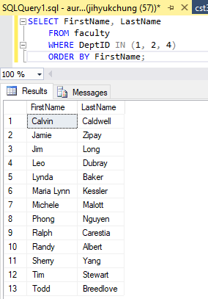

7) Display the name, salary, and stipend for all faculty who earn stipends. Sort the data by ascending order on salary and stipend.

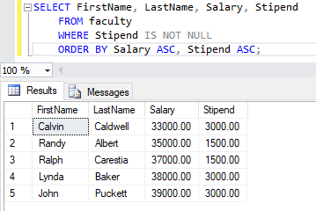

10) Display the name, salary for all faculty whose salary is not equal to $10000, $20000, or $30000.

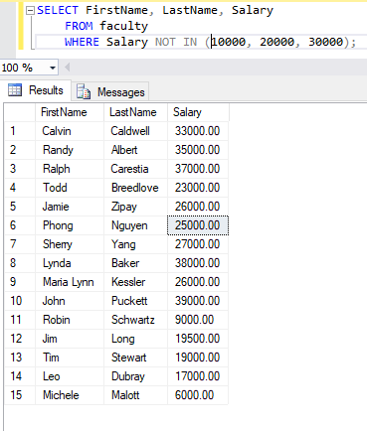

14) Show the number of months worked for all employees. The number of months should be rounded to the nearest whole number. Sort, in ascending order, by the number of months worked. Label the column MONTHS_WORKED.

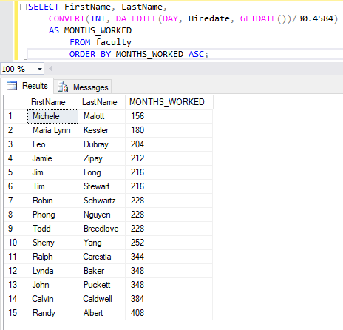

15) Display the all faculty members in the following format: Caldwell earns $3,000.00 monthly but wants $15,000.00. (3 times their current monthly salary) Give the column the name Pipe Dream.

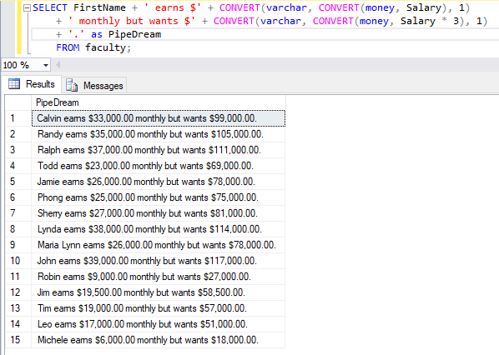

17) Display the names, with only the first letter capitalized, and the length of their name for all faculty members whose last name starts with a C, A, or D.

