2) What faculty members are advisors?

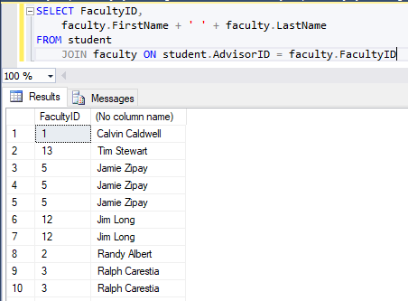

5) Show the student’s name, major(s), advisor name for all students in the CSET department.

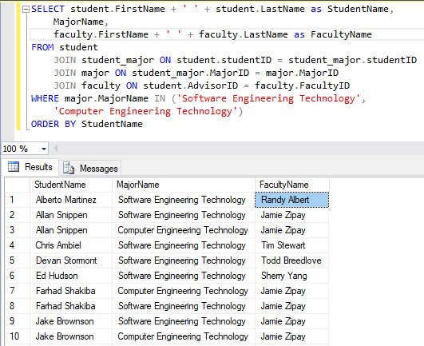

8) Display the faculty name, department name and rank for all faculty.

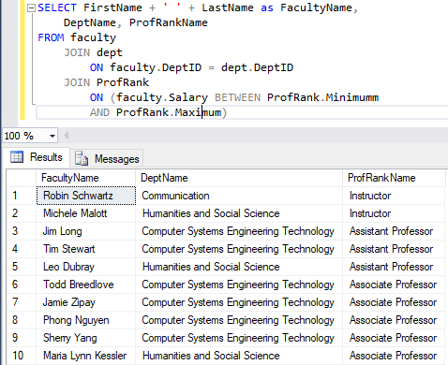

13) Show rank and the number of people with the same rank.

