**CST 324**

**Lab 2**

1. Show the faculty name, department number, and department name for all faculty.

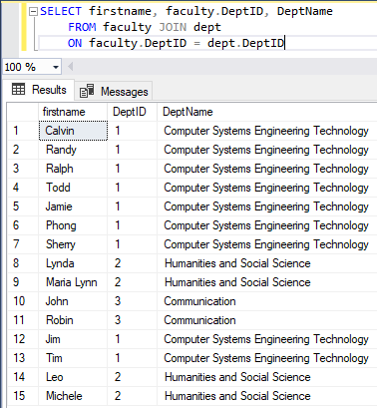

1. What faculty members are advisors?

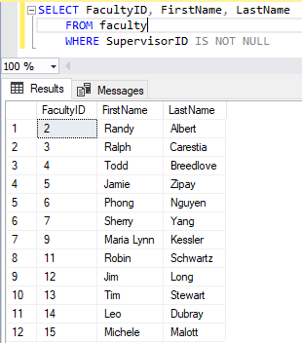

1. Show the faculty name, department name, and salary for all faculty members that earn a stipend.

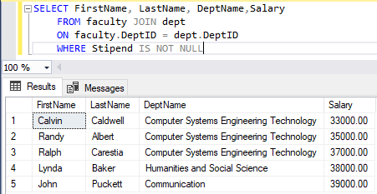

1. Show the faculty name and department name for all employees who have an "a" in their name.

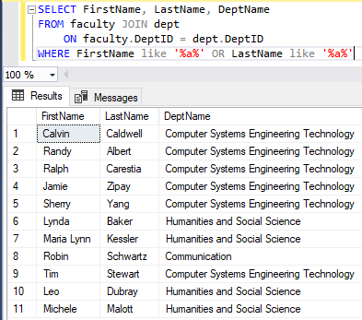

1. Show the student’s name, major(s), advisor name for all students in the CSET department.

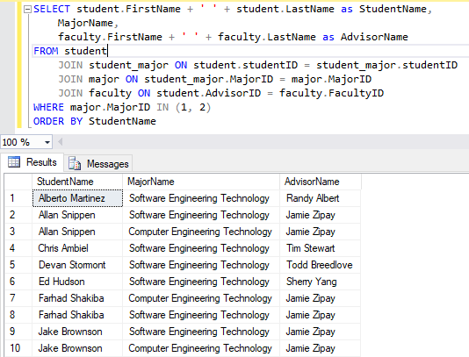

1. Show the faculty name and their supervisor name. Include all people who don't have a supervisor.

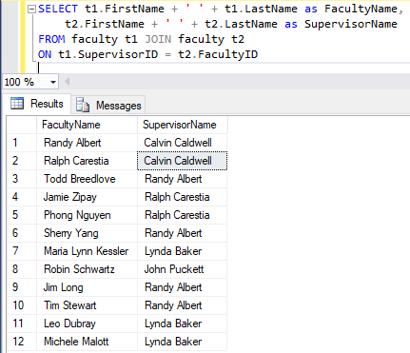

1. Show the faculty name and all of their co-workers (same department). A person is not considered their own co-worker.

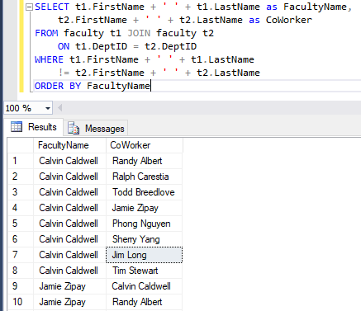

1. Display the faculty name, department name and rank for all faculty.

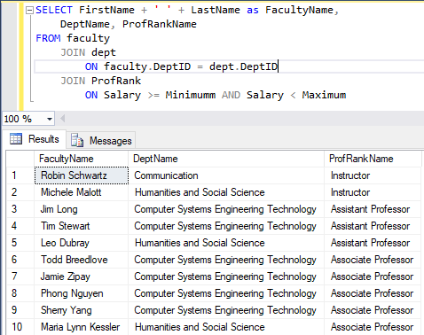



1. Show the faculty name and hire date of any faculty member that was hired after Breedlove. DON'T hardcode the date into your query.

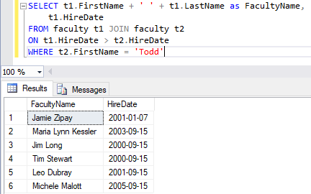

1. Show the faculty name and hire date for all faculty members that were hired before their supervisor.

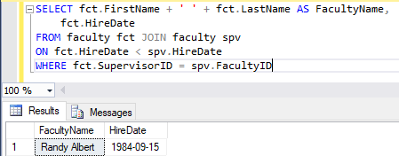

1. Display the highest, lowest, average and sum of the salaries for all faculty members. Give the columns meaningful names.

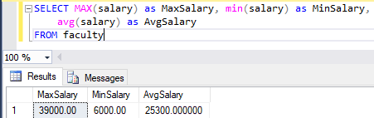

1. Show the minimum, maximum, and average salary for each department.

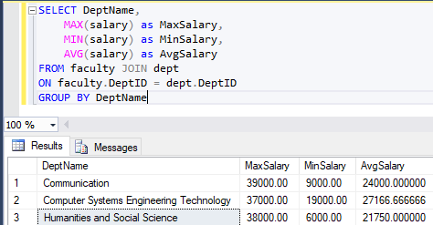

1. Show rank and the number of people with the same rank.

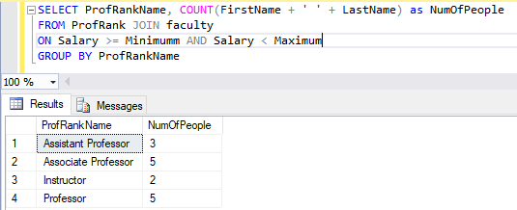

1. Show the number of supervisors.

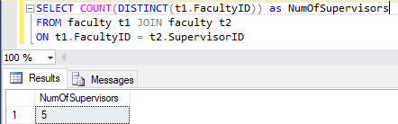

1. Show the difference between the highest and lowest salaries.

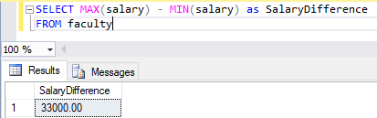

1. Show the department chair’s name and the lowest salary of the people they supervise.

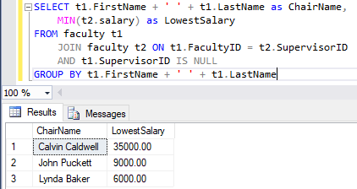

1. Show the department name, number of employees and the average salary for all employees in that department. Round the average salary to two decimal places.

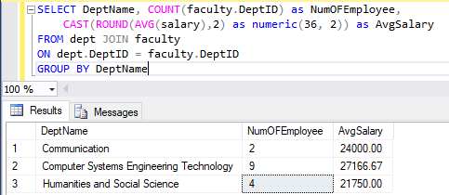

**Use Subqueries Where appropriate**

1. Show the faculty name and hire date for all employees in the same department as Albert, not including Albert.

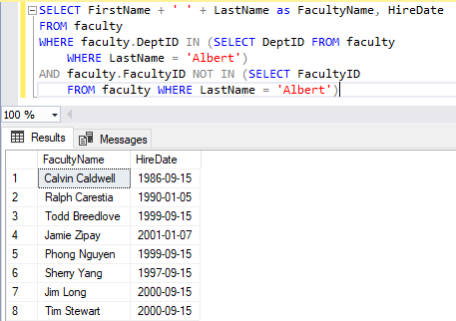

1. Show the faculty id, salary and name for all faculty members who earn more than the average salary. Sort the results in descending order of salary.

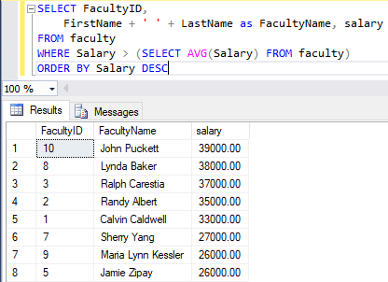

1. Show the faculty id and name of all faculty members that work in any department with an employee who is an instructor.

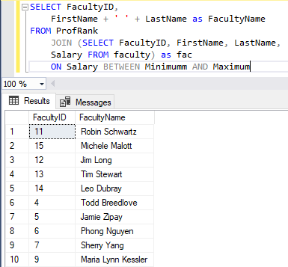

1. Show the faculty name, department number and rank for all faculty members whose department is the Communication department.

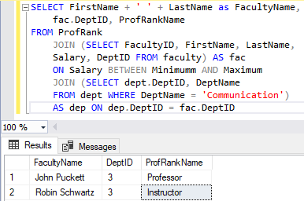

1. Show the faculty member’s name and salary for those employees whose supervisor is Carestia.

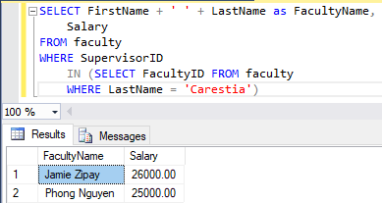

1. Show the department number, faculty name, and rank for all employees in the CSET department.

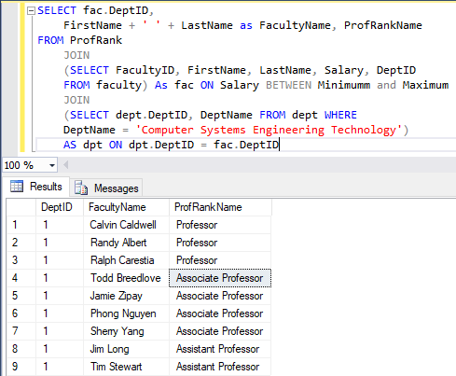

1. Show the faculty id, name, and salary for all employees who earn more than the average salary and who work in a department with any employee with a “t” in their last name.

