**APP BASED CRIME DETERRENT IN HOME SECURITY SYSTEM USING RASPBERRY PI – AN IOT**

**INDEX**

|  |  |  |
| --- | --- | --- |
| **SL.NO** | **CONTENT** | **PAGE NO** |
| 1 | ABSTRACT | 4 |
| 2 | INTRODUCTION | 5 |
| 3 | HARDWARE REQUIREMENTS | 5 |
| 4 | LANGUAGES USED | 6 |
| 5 | OBJECTIVE | 6 |
| 6 | DIAGRAMATIC REPRESENTATION | 7 |
| 7 | WORKING FLOWCHART | 8 |
| 8 | SCOPE | 9 |
| 9 | IMAGE OF MODULE | 10 |

**LIST OF FIGURES**

|  |  |  |
| --- | --- | --- |
| **FIG.NO** | **FIGURE NAME** | **PAGE NO** |
| 1 | SAMPLE MODULE IN FRONT | 7 |
| 2 | SAMPLE MODULE BEHIND THE DOOR | 7 |
| 3 | WORKING DIAGRAM | 8 |
| 4 | WORKING ARCHITECTURE | 9 |
| 5 | COMPLETE DESIGN | 10 |

**APP BASED CRIME DETTERENT HOME SECURITY SYSTEM RASPBERRY PI – AN IOT**

1. **ABSTRACT:**

In recent trends automation is all of our wish, so this project puts on idea to establish a secured home safety system. The proposed IOT project   made for dual security system to unlock the door, with the controlling of electrical appliances under explosive gas leakage. Working of the proposal composed of two phases. Phase A: Dual door locking management. Sub Phase 1: Face detection technology. Sub Phase 2: Finger print scanner. Sub Phase 3: Sound and Vibration. Phase B: Controlling Electrical appliances. There is a camera to capture the image of the person who access the door and try to access the door, the device will not keep on running, in order to avoid more energy consumption, device is composed of an IR sensor, whenever any object crosses over the IR rays device will get activated and capture the image of intruder, and will send a message along with the photo of intruder to the home owner.

                                    There is a push button behind the door to lock from inside by a click, it consist of a gas detector, which will turn off all electrical components when any explosive gas leakage has been sensed and make it switch on when no gas have been sensed, there is also a vibration sensor which will make an alarm and capture the image, when any one try to break it. Another device will be fixed to the window to check the entry from the window, it composed of vibration sensor and camera when any one try to break it , it works similar to the device mentioned above. One of the most special and encrypted future enhancement of the project is an E- NOSE, this will store the smell of the intruder, this is used to find out the correct person who try to break the security system. The device will definitely encrypt your home or office from unwanted person.

1. **INTRODUCTION:**

Enhancement of technologies also enhances technic of theft. Most of the Indian population let their home alone for hours, they also ensure their security by installing a door lock or security camera etc. Here is your real time security system is ready. Stay satisfied with the project ‘SMART SHIELD’, it works in two phases.

                                Phase 1: Dual door locking management. Sub Phase 1: Face detection technology. Sub Phase 2: Finger print scanner. Sub Phase 3: Sound and Vibration. Phase 2: Controlling Electrical appliances. User has to store his face and finger print previously to control and unlock the door. Whenever a person accessing the door, camera fixed in that will capture his /her image and notifies the actual user with the image. Example: (image) He/she entered your home now. When an unauthorized person try to access the door. Example: (image) He/she  try to open your door. When someone try to break it, the vibration sensor present there will sense the vibration and notifies as, Example: (image) He/she try to break your door.

                                 One more component is fixed with the window will composed of vibration sensor and a camera to capture the person who tries to break the window and user get notified. There is no password required to lock from inside, it is done by an one click push button. In this project all electrical appliances were controlled by a gas sensor whenever any explosive gas leakage was found automatically they’ll get switched off till the gas have been sensed, as soon as the sensation was not detected, sensor automatically switch on all appliances. As a part of the project an electronic nose was fixed to the door, it smells the person who tries to break the system.

1. **HARDWARE REQUIREMENTS:**

* Raspberry Pi – 3
* Finger print scanner
* Step down transformer
* USB camera
* Magnetic door lock
* Analog to Digital convertor
* On/Off relay
* Push buttons
* Vibration sensor
* Gas sensor

1. **LANGUAGES USED:**

* C++ (Back end)
* Python (Front end)
* Java (Android application)

1. **OBJECTIVE:**

Here the project   made for dual security system to unlock the door, with the controlling of electrical appliances under explosive gas leakage. There is no chance of losing your key as there is no physical key. Face and finger impression only the access. You will get notified on every moment, when the door was intimated by a person. The main objective of the home security system is to introduce the system to the user to monitor the safety of their homes from burglary.

This is objectives of the project will be implemented:

    • To create and developed a effective home security system.

    • To design home security system using PIC Microcontroller.

    • To find suitable circuit and electronic component to build that system.

    • To know how the operation of circuit home security system.

    • To prove how that system can be used in the house.

1. **DIAGRAMATIC REPRESENTATION OF SAMPLE MODULE:**

FACE DETECTION

**PIR SENSOR**

FLASH

CAMERA

**FIG.1:** **(MAIN DEVIECE)**

**FINGER PRINT**

**VIBRATION SENSOR**

**PUSH BUTTON**

**ROTATE TO OPEN**

**LEVER LOCK**

**GAS DETECTOR**

**FIG.2:** **(BEHIND THE DOOR)**

1. **WORKING FLOWCHART:**

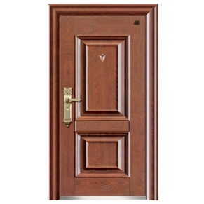

WHEN THE **IR** RAYS CUT OFF, IT CAPTURES THE IMAGE OF THE PERSON ACCESS/TRY TO ACCESS THE DOOR.

FUNCTION : 2

FUNCTION : 3

FUNCTION : 1

DETECT LEAKAGE OF GAS

DETECT VIBRATIONS FROM DOOR

DETECT FINGER PRINT/FACE

IF MIS MATCHED

IF CORRECTLY MATCHED

 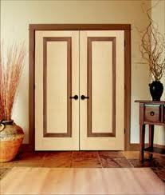

USER GET THE NOTIFIED AS SOMEONE TRY TO BREAK THE DOOR

SWITCH OFF ALL ELECTRICAL COMPONENT

(DOORS OPENED) (DOORS CLOSED)

**RASPBERRY PI-3**

 AUTHORISED PERSON ENTERS

Notification:



**FIG.3: WORKING CONCEPT**

1. **SCOPE OF THE PROJECT:**

The main scope of the project is to establish a complete home security system. The proposed project focused on ensuring the security by sending notifications. It composed of three major roles; firstly accessing door with face and finger print; secondly , controlling of all electrical appliances when any gas leakage was found; finally while breaking the system, user will get notified for each aspect. Beyond this an electronic nose has been soon implemented as a part of the proposal to capture the smell of the person who tries to access the security system and to track the person if he tries to break the system. Hence the concept E-Nose is enhanced in future.

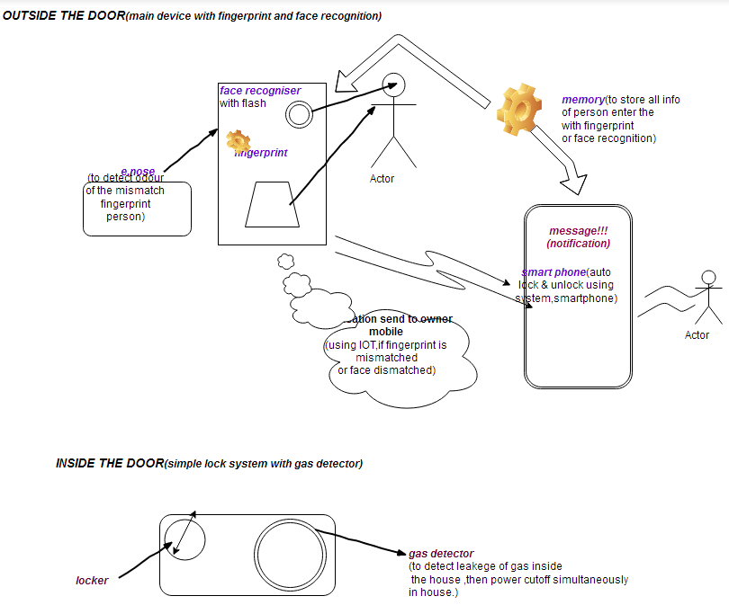

**FIG.4: WORKING ARCHITECTURE**

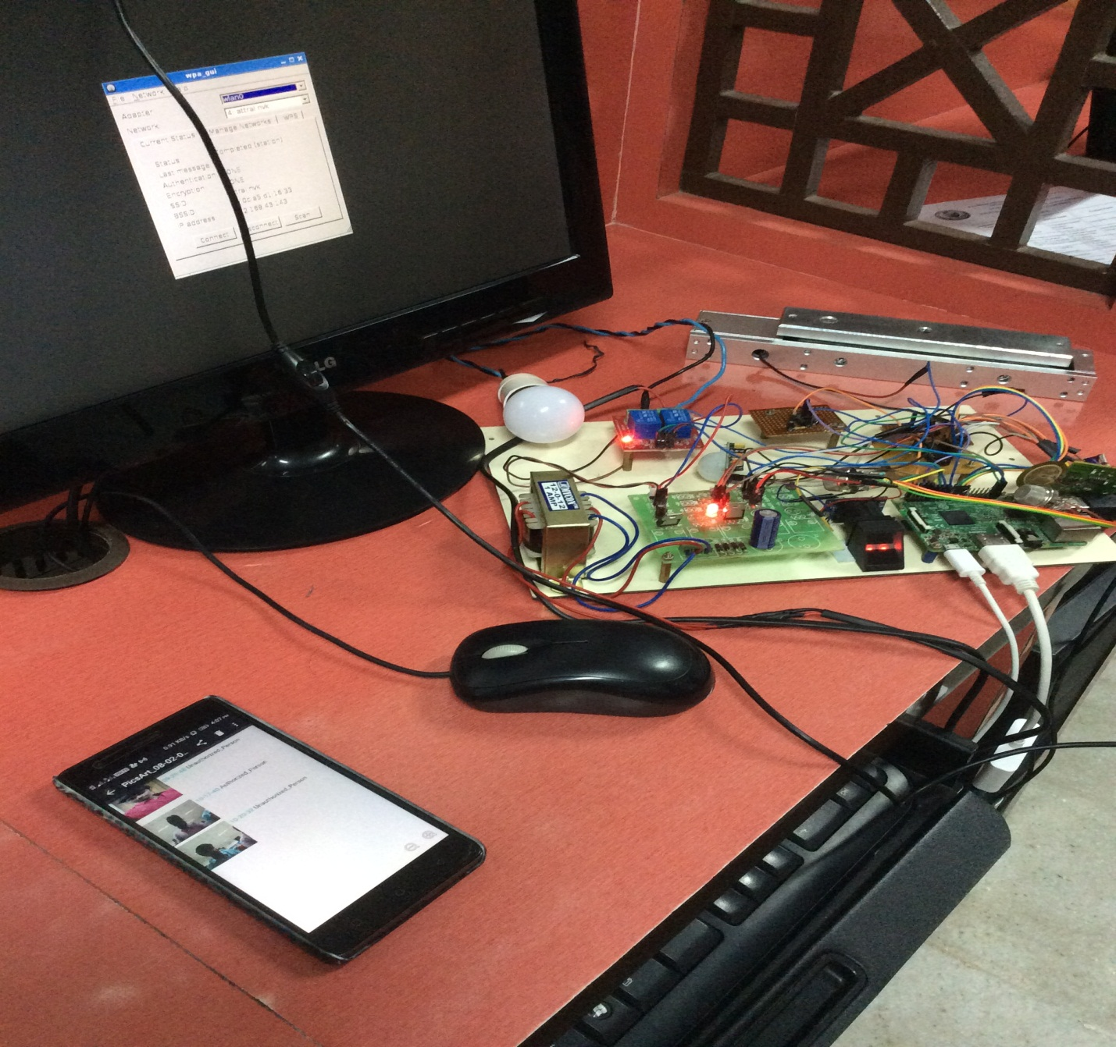

**FIG.5:** Crime Deterrent Home Security System

(ENTIRE MODULE)