Django-Built in login system

1. Create Project
If you’re starting a new project, firstly create a new Django project. The command to create a new project is as follow:
django-admin startproject LoginSystem

2. Check Necessary Settings
Before creating a login system, make sure you have django.contrib.auth in your INSTALLED APPS and that your authentication middleware is configured properly in the MIDDLEWARE settings.

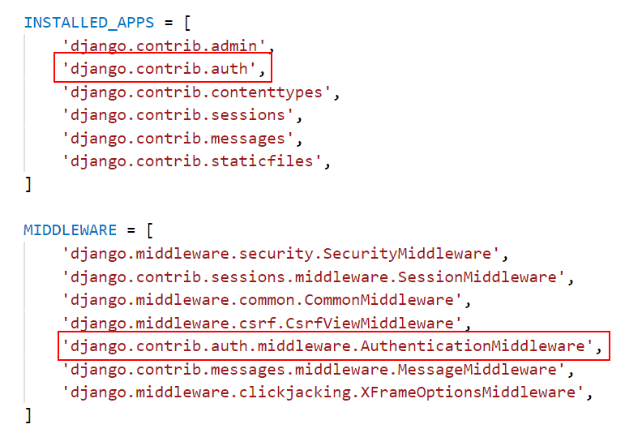

3. Make Migration
Migration is a means of applying changes that we have made to a model, into the database schema. To create all tables according to the schema defined in the migration file, we run the following command.
python manage.py migrate

4. Define Project URLs
A web address is referred to as a URL. Every time you visit a website, you can see the URL in your browser’s address bar. Every web page must have its own unique URL. As a result, your application will know what to show a user that visits that URL.
Open your’s project’s urls.py file and specify the particular URLs.
from django.contrib import admin
from django.urls import path, include
from django.contrib.auth import views as auth_views

urlpatterns = [
path('admin/', admin.site.urls),
path('login/', auth_views.LoginView.as_view(), name='login'),
path('login/',include('appname.urls')),
]

5. Login Template
Basically, Django Templates are used to generate dynamic HTML web pages that are visible to the end-user. A template in Django is written in HTML, CSS, and Javascript in a .html file.LoginView will attempt to render registration/login.html by default. Create a registration folder in your templates folder and a login.html page inside it.

<!DOCTYPE html>
<html lang="en">
<head>
<meta charset="UTF-8">
<meta http-equiv="X-UA-Compatible" content="IE=edge">
<meta name="viewport" content="width=device-width, initial-scale=1.0">
<title>LoginSystem</title>
</head>
<body>
<form method="post">
{% csrf_token %}
{{form.as_p}}
<input type="submit" value="Login"/>

</form>

</body>
</html>

6. Template Configuration
To configure the template system, we must specify several items in the settings.py file. The name of our template directory is templates. Django Templates searches each of the INSTALLED APPS subdirectories by default for a templates subdirectory.
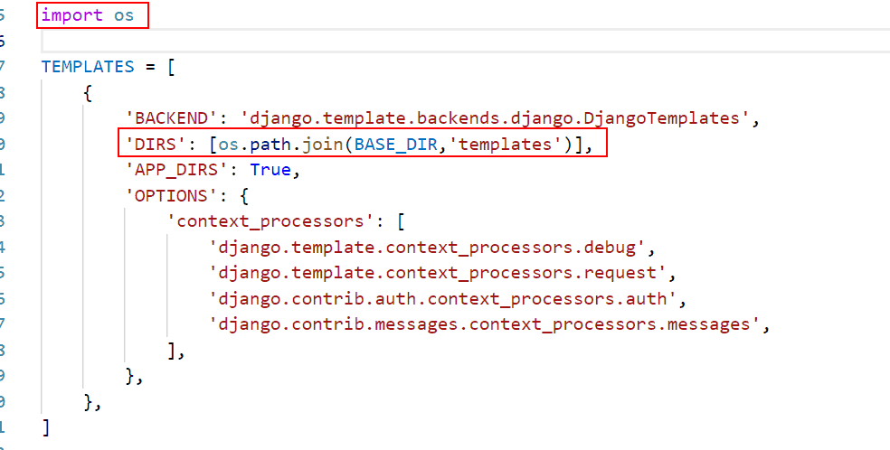

7.Add app in your settings.py
Now, we to include the app in your project, add your app name to the INSTALLED APPS list in settings.py of the project.

INSTALLED_APPS = [
'appname',
]

After this, define the view of the app.

# builtapp/views.py
from django.shortcuts import render, redirect
from django.contrib.auth.forms import AuthenticationForm
from django.contrib.auth import login
from django.shortcuts import render
from django.contrib.auth import logout
def login_view(request):
if request.method == 'POST':
form = AuthenticationForm(request, data=request.POST)
if form.is_valid():
login(request, form.get_user())
return redirect('home') # Replace 'home' with the name of your home view
else:
form = AuthenticationForm()
return render(request, 'builtapp/login.html', {'form': form})
def home(request):
return render(request, 'home.html')
def logout_view(request):
logout(request)
return redirect('home') # Redirect to the home page after logout

Next, create a home.html file inside the template folder of the Home app.

<!-- home/templates/home/home.html -->
<!DOCTYPE html>
<html lang="en">
<head>
<meta charset="UTF-8">
<meta http-equiv="X-UA-Compatible" content="IE=edge">
<meta name="viewport" content="width=device-width, initial-scale=1.0">
<title>Home</title>
</head>
<body>
<h1>Welcome to the Home Page!</h1>
{% if user.is_authenticated %}
<p>Hello, {{ user.username }}!</p>
<form method="post" action="{% url 'logout' %}">
{% csrf_token %}
<input type="submit" value="Logout"/>
</form>
{% else %}
<p>You are not logged in.</p>
Add a link to the login page or any other login mechanism -->
<a href="{% url 'login' %}">Login</a>
{% endif %}
</body>
</html>

We now require a redirect to the next page. The following code can be added to settings.py to set the next page:
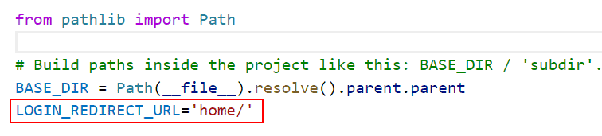
If no login redirect URL is specified, the default URL of /accounts/profile/ will be used, resulting in a TemplateDoesNotExist problem.

Next add path to your app’s urls.py

# home/urls.py
from django.urls import path

from . import views # Corrected import statement
from .views import login_view
urlpatterns = [
path('home/', views.home, name='home'),
path('login/', login_view, name='registration/login'),
path('logout/', views.logout_view, name='logout'), # Added the view parameter
]

8. Create Super User
Till now, we have not created any users for this. So, we are going to create a user. So see, how we can do that.
To create a superuser run the following command:
python manage.py createsuperuser
Then enter the username of your choice, if you want. Otherwise, it takes the default system name.
- Then enter the email address and press enter. You can leave it blank also.
- Then, in front of the Password field, type the password and hit enter. To keep it safe, enter a strong password.
- Then again enter the same Password for confirmation.

9. Run Server
In this section, we’ll learn how to run the server in Django. To start the server, use the following command in the terminal.
python manage.py runserver
The output is as below:
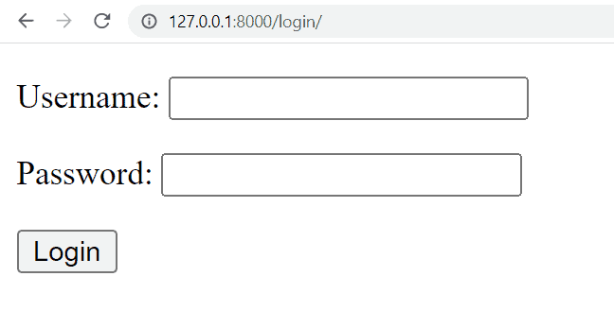

Now, enter the username and password and click on the login button. After successful login, you will redirect to the home page.

