**Swathanthra Conference Website Documentation**

**Objective:** Designing and Development of “*Swathanthra Conference*” website.

**Overview:** This is the official website for ***“****Swathanthra Conference****''*** that provides the details of the paper submission and conference such as speakers, schedules, awards and venue. Participants and Authors can register through this website. In addition to that users can also send their queries and concerns via the help module.

**Prototype Link**[:https://bit.ly/conferenceWebsitePrototype](https://bit.ly/conferenceWebsitePrototype)

**Sitemap**

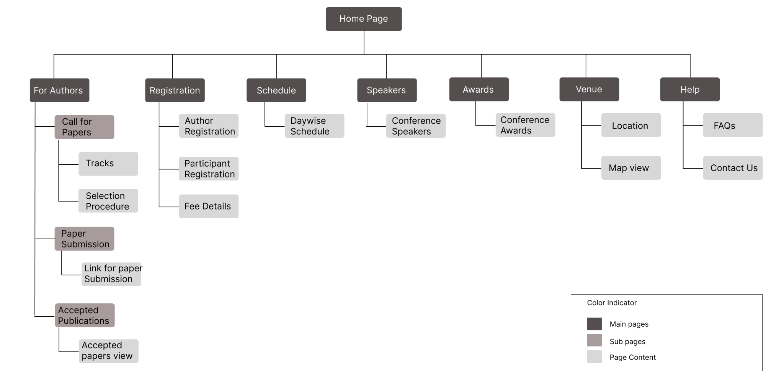

The website includes 8 pages, they are:

1. Home
2. For Authors

**a)** Call for authors

**b)** Paper submission

**c)** Accepted publications

1. Registration
2. Schedule
3. Awards
4. Venue
5. Help

**1. Home**

The home page contains the details about the Swathanthra Conference and ICFOSS.

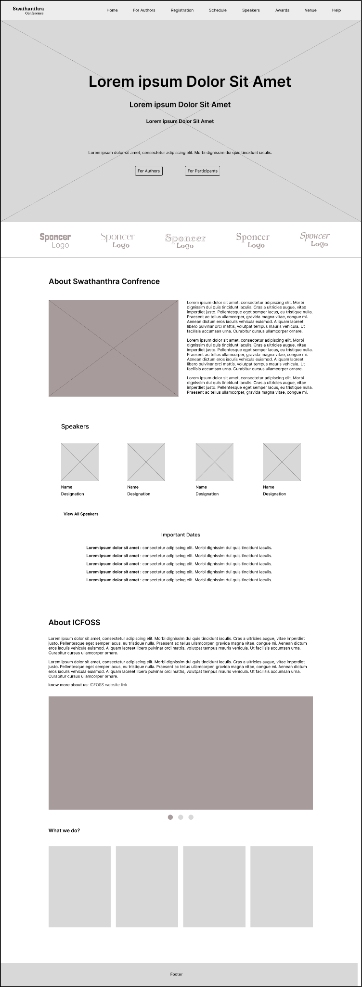

* Home page opens with a featured image and registration links are also provided
* Conference sponsor’s logos included in homepage
* Brief description about swathanthra conference and ICFOSS,the organizer are added.

**1. For Authors**

This module is mainly focused on authors. Here authors can view the given paper submission guidelines, tracks (areas of studies/research topics), and they can submit their works. Along with that the users can view the abstract of the accepted publications.

When we hover over the *“For Authors”* module it displays 3 options they are:

1. *Call For Papers*

*b) Paper Submission*

*c) Accepted Publications*

**i. Call For Papers:** It represents different tracks. Each track holds different areas in publications. This also contains paper selection criteria details.

* Tracks
* Selection procedure
* Important dates

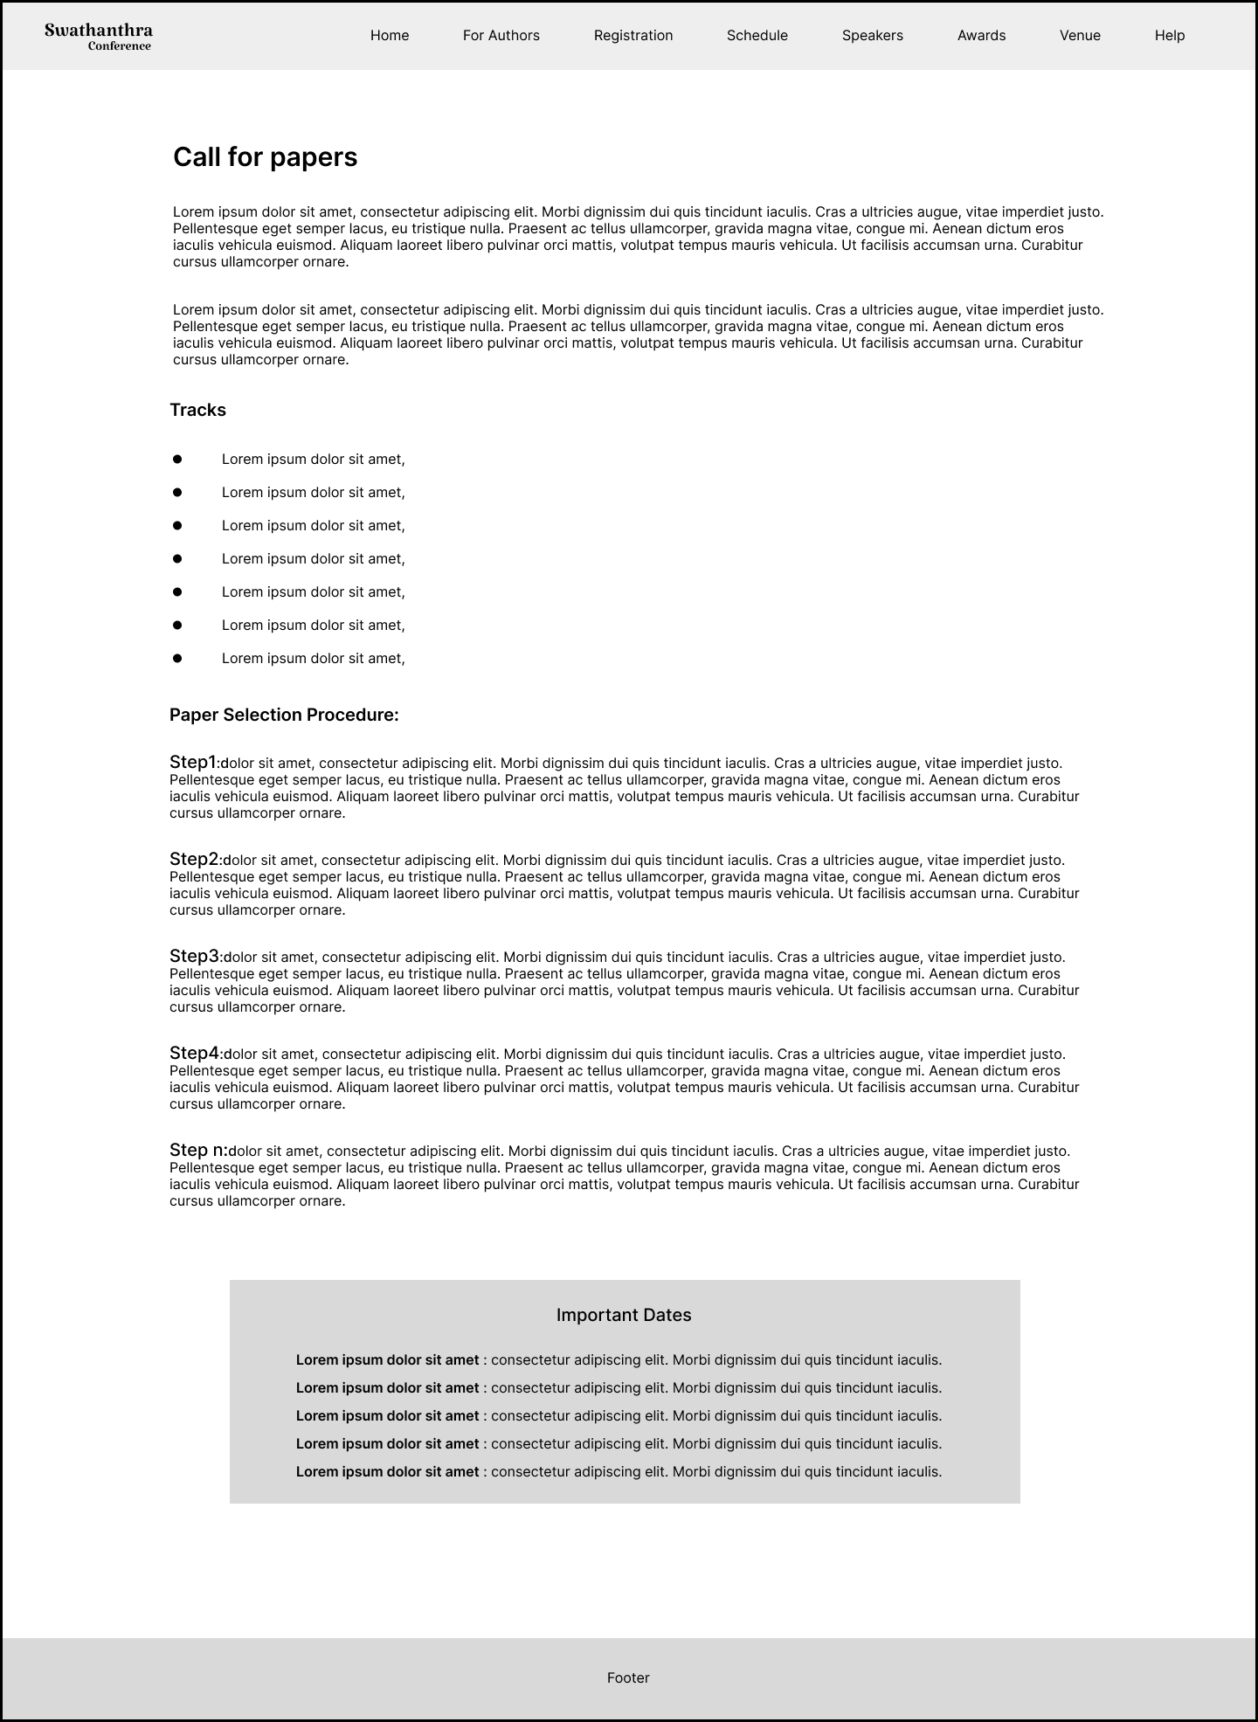

**ii. Paper Submission:** This page carries the link for submitting papers, and the steps to submit papers.

* Paper submission description
* Link for paper submission
* Important dates

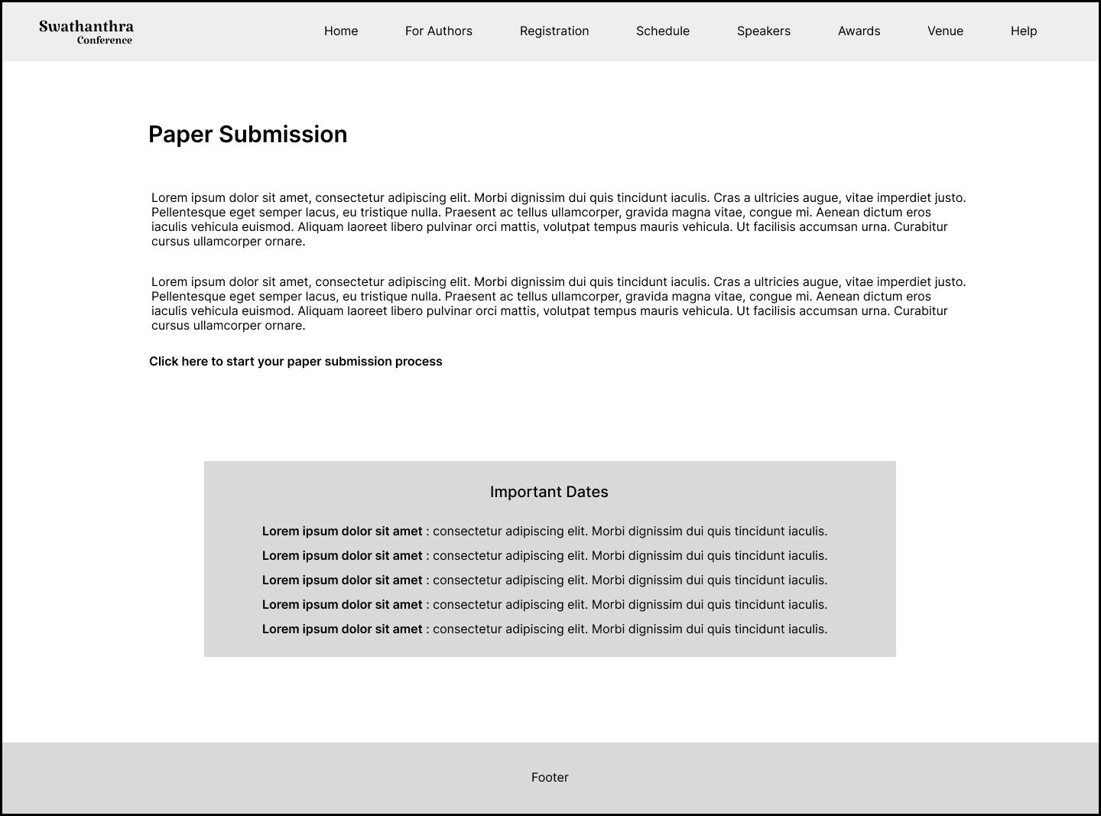

**iii. Accepted Publications**: This page keeps the list of published papers.

* Search option is provided for searching publications.
* Pagination

.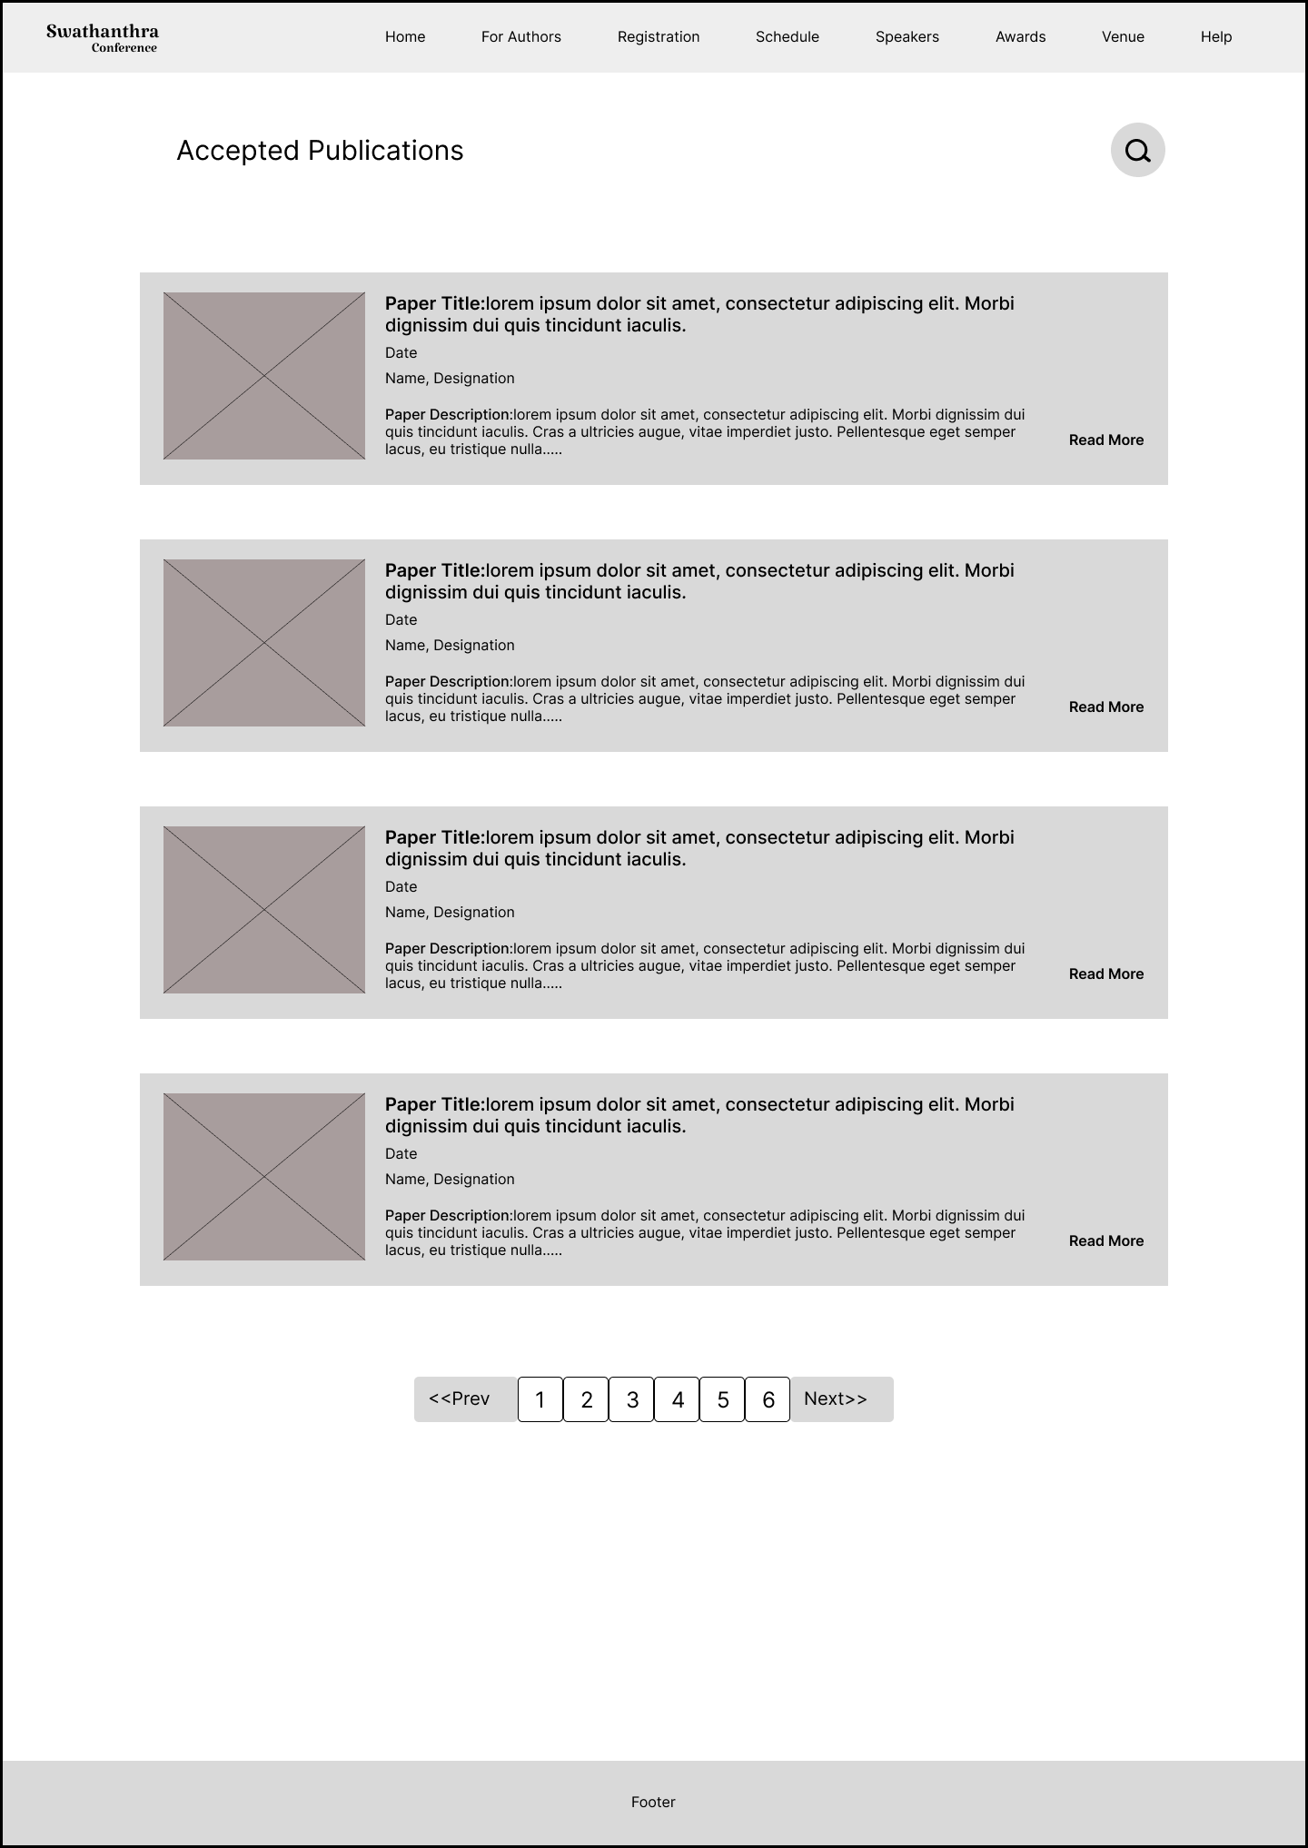

**3.Registration**

This module contains registration details, fee description for authors and participants .has two sbuttons for author and participant registration.

* Registration link
* Fee details

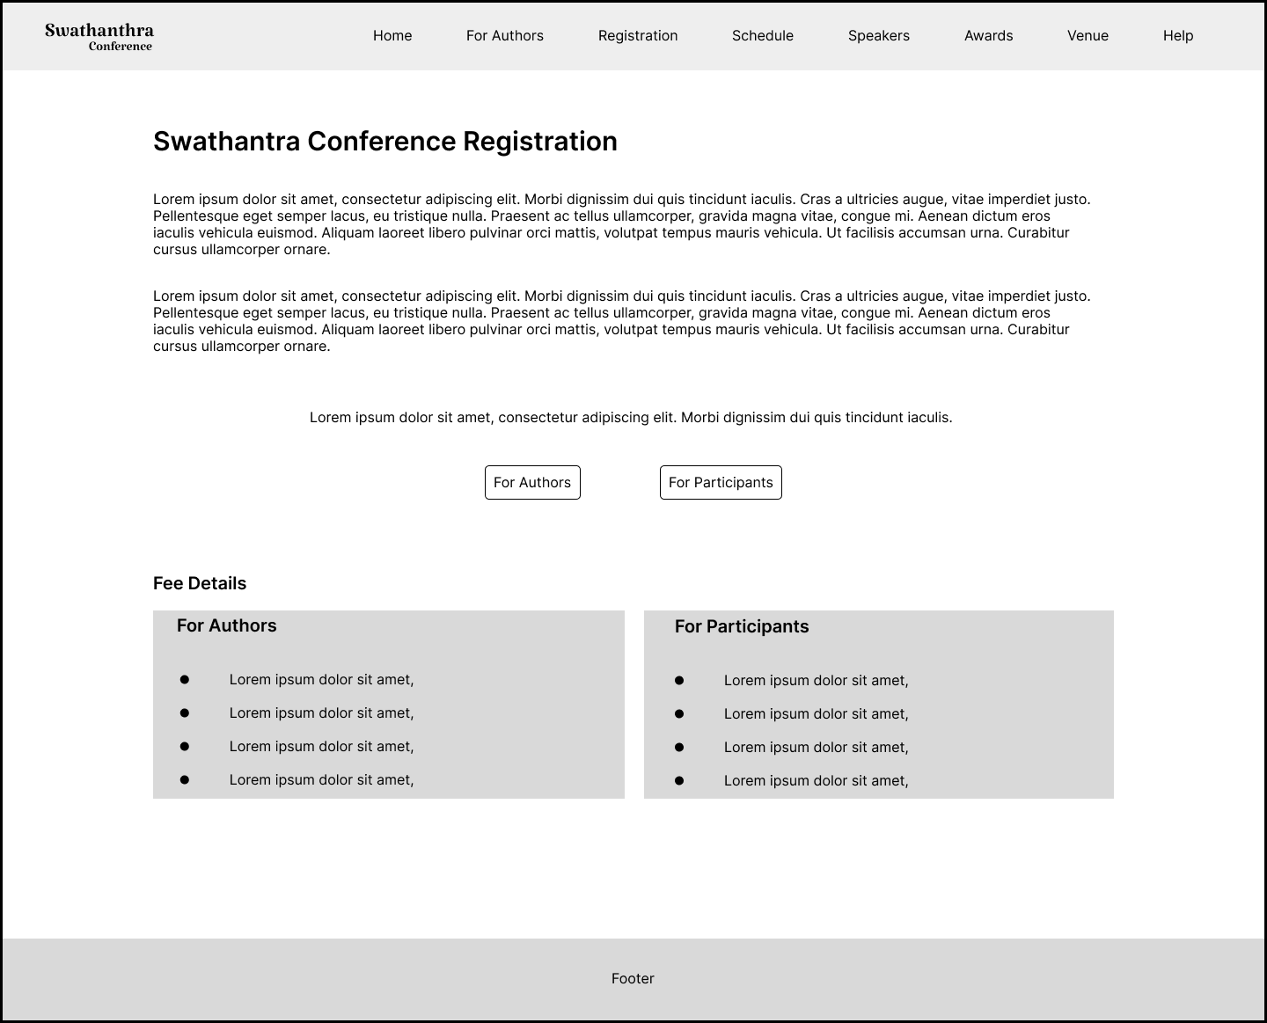

**4.Schedule**

This module consists of an agenda and important dates. It’s Included tab bar for choosing each day’s program details.

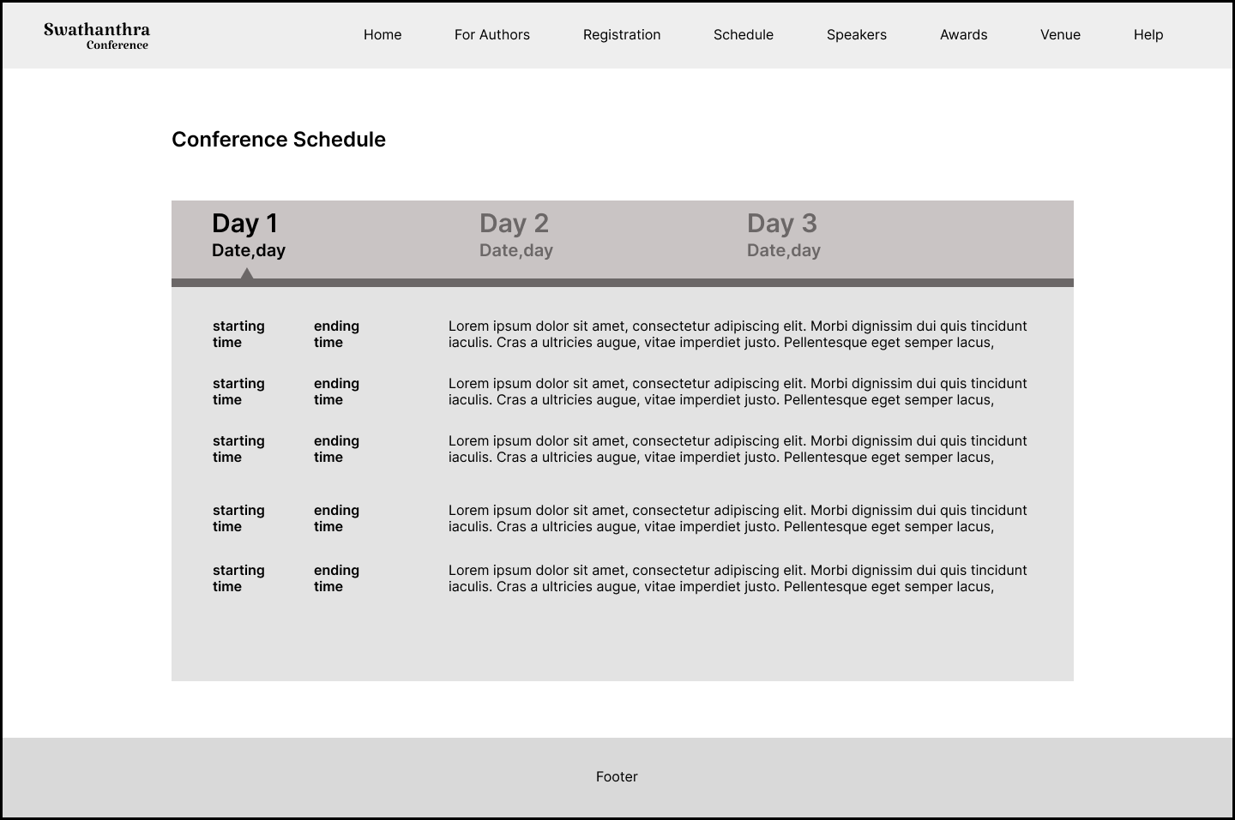

**5.Speakers**

This page displays the details of conference speakers along with their image and designation.

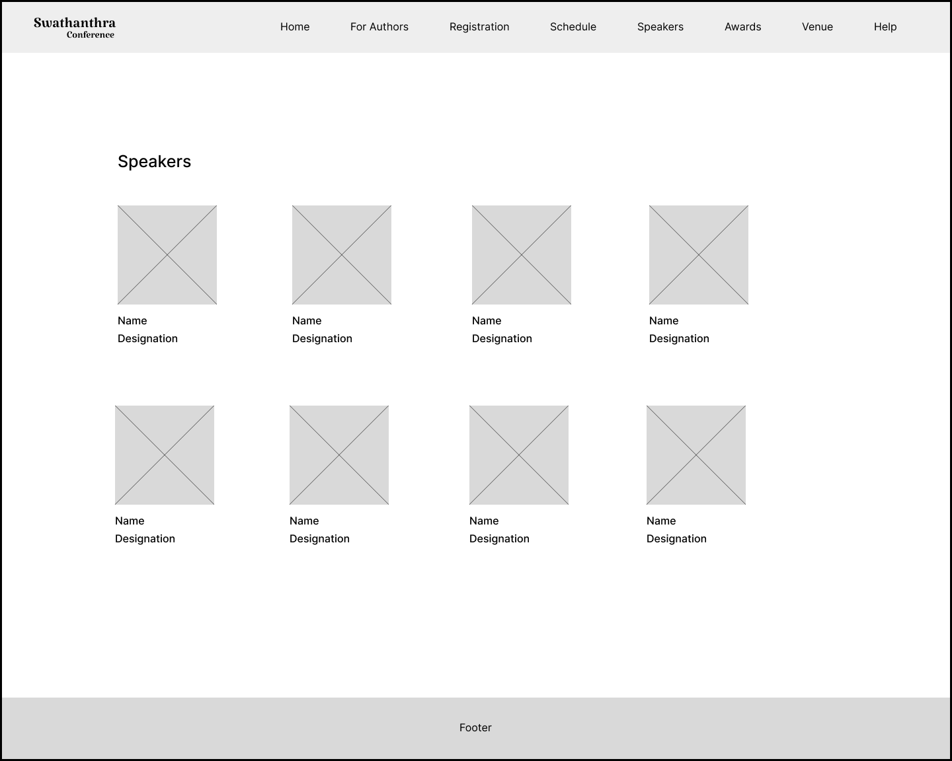

**6.Awards**

The following page exhibits the Swathantra Conference’s awards.

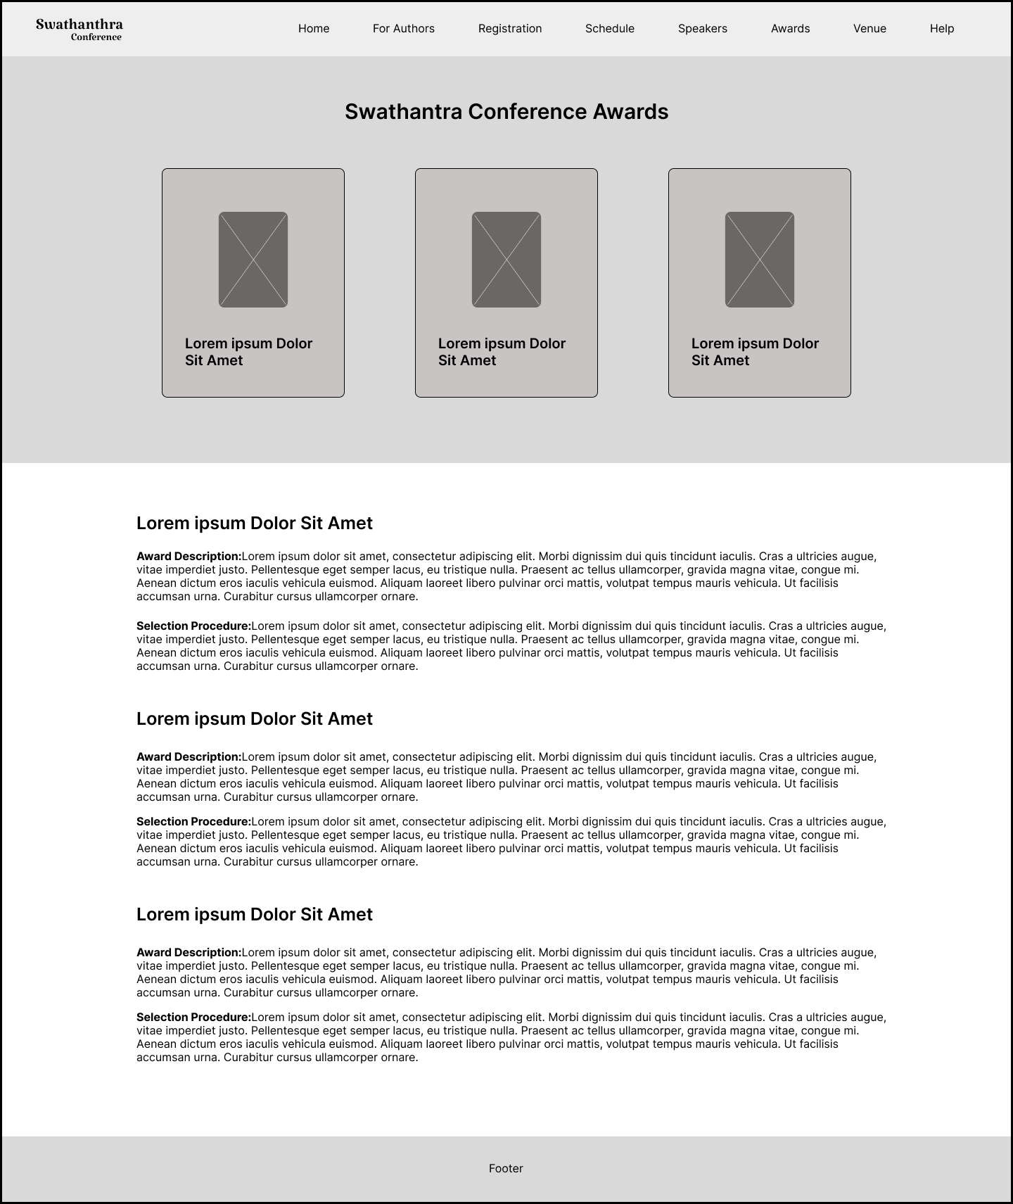

**7.Venue**

We can view the venue address and map view in this venue module.

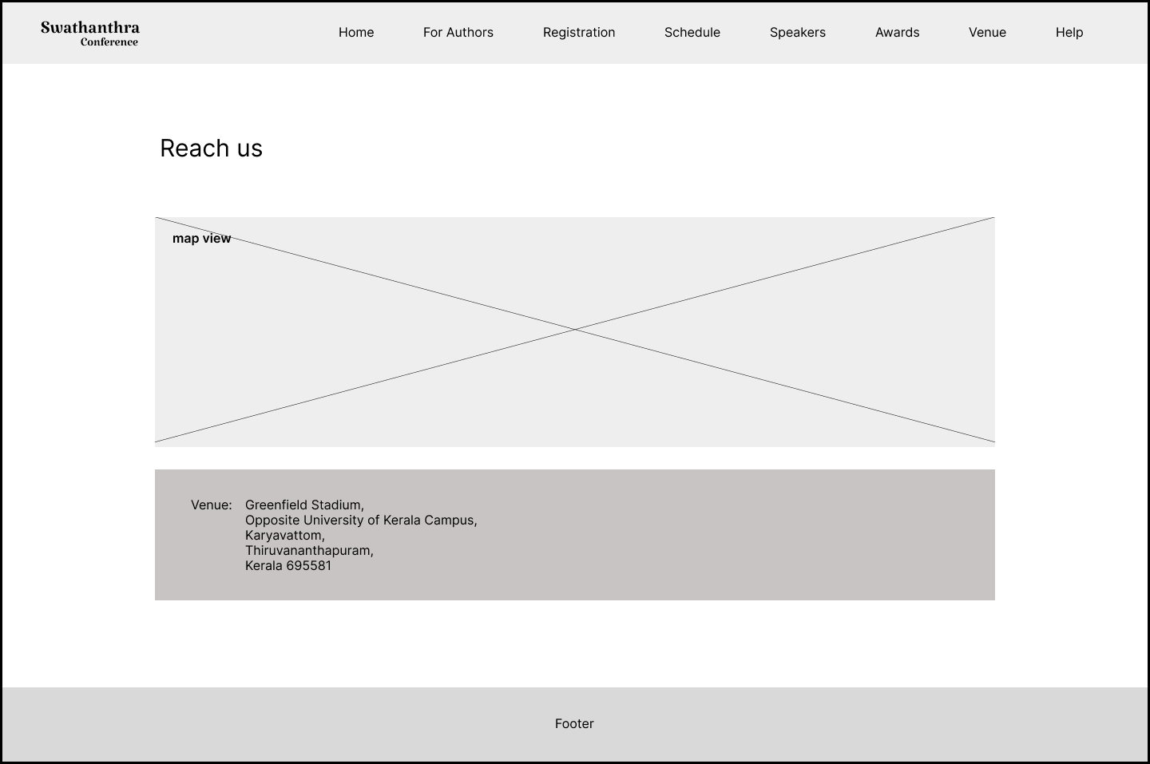

**8.Help**

The help page is divided into two categories, FAQ(frequently asked questions) and Interaction section (sending queries ).

Participant’s common questions about the conference are added in the FAQ section.Other concerns are included in the query section.

Name, E- mail, Contact Number, Message of user and queries fields are provided for interaction.

