SQL Assignment
Create the following Tables and insert the values accordingly and
Perform the tasks mentioned below.

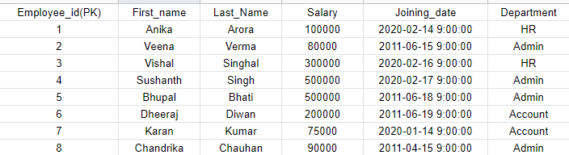
Employee Table

Employee Bonus Table
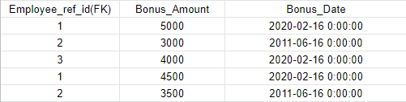

Employee Title Table

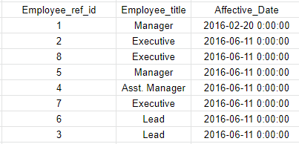

create table emp_table(
employee_id int primary key,
First_name varchar(50),
Last_Name varchar(50),
Salary numeric,
Joining_Date DateTime,
Department varchar(20)
)
insert into emp_table(employee_id,First_name,Last_Name,Salary,Joining_Date,Department)
values(1,'Anika','Arora',100000,'2020-02-14 9:00:00','HR')
insert into emp_table(employee_id,First_name,Last_Name,Salary,Joining_Date,Department)
values(2,'Veena','Verma',80000,'2011-06-15 9:00:00','Admin')
insert into emp_table(employee_id,First_name,Last_Name,Salary,Joining_Date,Department)
values(3,'Vishal','SinghL',300000,'2020-02-16 9:00:00','HR')
insert into emp_table(employee_id,First_name,Last_Name,Salary,Joining_Date,Department)
values(4,'Sushanth','Singh',500000,'2020-02-17 9:00:00','Admin')
insert into emp_table(employee_id,First_name,Last_Name,Salary,Joining_Date,Department)
values(5,'Bhupal','Bhati',500000,'2011-06-18 9:00:00','Admin')
insert into emp_table(employee_id,First_name,Last_Name,Salary,Joining_Date,Department)
values(6,'Dheeraj','Diwan',200000,'2011-06-19 9:00:00','Account')
insert into emp_table(employee_id,First_name,Last_Name,Salary,Joining_Date,Department)
values(7,'Karan','Kumar',75000,'2020-01-14 9:00:00','Account')
insert into emp_table(employee_id,First_name,Last_Name,Salary,Joining_Date,Department)
values(8,'Chandrika','Chauhan',90000,'2011-04-15 9:00:00','Admin')

create table emp_bonus(
emp_ref_id int references emp_table(employee_id),
Bonus_Amount numeric,
Bonus_date DateTime)

insert into emp_bonus(emp_ref_id,Bonus_Amount,Bonus_date) values(1,5000,'2020-02-16 0:00:00')
insert into emp_bonus(emp_ref_id,Bonus_Amount,Bonus_date) values(2,3000,'2011-06-16 0:00:00')
insert into emp_bonus(emp_ref_id,Bonus_Amount,Bonus_date) values(3,4000,'2020-02-16 0:00:00')
insert into emp_bonus(emp_ref_id,Bonus_Amount,Bonus_date) values(1,4500,'2020-02-16 0:00:00')
insert into emp_bonus(emp_ref_id,Bonus_Amount,Bonus_date) values(2,3500,'2011-06-16 0:00:00')

create table emp_title(
Emloye_ref_id int ,
Employee_Title varchar(50),
Affective_Date DateTime)
insert into emp_title(Emloye_ref_id,Employee_Title,Affective_Date) values(1,'Manager','2016-02-20 0:00:00')
insert into emp_title(Emloye_ref_id,Employee_Title,Affective_Date) values(2,'Executive','2016-06-11 0:00:00')
insert into emp_title(Emloye_ref_id,Employee_Title,Affective_Date) values(8,'Executive','2016-06-11 0:00:00')
insert into emp_title(Emloye_ref_id,Employee_Title,Affective_Date) values(5,'Manager','2016-06-11 0:00:00')
insert into emp_title(Emloye_ref_id,Employee_Title,Affective_Date) values(4,'Asst.Manager','2016-06-11 0:00:00')
insert into emp_title(Emloye_ref_id,Employee_Title,Affective_Date) values(7,'Executive','2016-06-11 0:00:00')
insert into emp_title(Emloye_ref_id,Employee_Title,Affective_Date) values(6,'Lead','2016-06-11 0:00:00')
insert into emp_title(Emloye_ref_id,Employee_Title,Affective_Date) values(3,'Lead','2016-06-11 0:00:00')

Tasks To Be Performed:
1 Display the “FIRST_NAME” from Employee table using the alias name
as Employee_name.

select First_name as Employee_name from emp_table

2 Display “LAST_NAME” from Employee table in upper case.
select UPPER(Last_Name) as Employee_name from emp_table

3 Display unique values of DEPARTMENT from EMPLOYEE table.
select distinct Department from emp_table

4 Display the first three characters of LAST_NAME from EMPLOYEE table.
select substring(Last_Name,1,3) as Employee_name from emp_table

5 Display the unique values of DEPARTMENT from EMPLOYEE table and
prints its length.
select distinct Department,len(department) from emp_table

6 Display the FIRST_NAME and LAST_NAME from EMPLOYEE table into a
single column AS FULL_NAME.
a space char should separate them.
select concat(First_name,' ',Last_Name) as Full_Name from emp_table

7 DISPLAY all EMPLOYEE details from the employee table
order by FIRST_NAME Ascending.
select * from emp_table order by first_name asc

8. Display all EMPLOYEE details order by FIRST_NAME Ascending and
DEPARTMENT Descending.
select * from emp_table order by Department desc,first_name asc

9 Display details for EMPLOYEE with the first name as “VEENA” and
“KARAN” from EMPLOYEE table.
select * from emp_table where First_name in ('veena' ,'karan')

10 Display details of EMPLOYEE with DEPARTMENT name as “Admin”.
select * from emp_table where Department ='Admin'

11 DISPLAY details of the EMPLOYEES whose FIRST_NAME contains ‘V’.
select * from emp_table where First_name like '%v%'

12 DISPLAY details of the EMPLOYEES whose SALARY lies between
100000 and 500000.
select * from emp_table where Salary between 100000 and 500000

13 Display details of the employees who have joined in Feb-2020.
select * from emp_table where month(Joining_Date)=2 and year(Joining_Date)=2020

14 Display employee names with salaries >= 50000 and <= 100000.
select * from emp_table where salary>=50000 and Salary<=100000

16 DISPLAY details of the EMPLOYEES who are also Managers.
select em.* from emp_table em inner join emp_title tit on em.employee_id=tit.Emloye_ref_id where Employee_Title='Manager'

17 DISPLAY duplicate records having matching data in some fields of a
table.
select first_name,count(First_name) as cnt from emp_table group by First_name having count(First_name)>1
18 Display only odd rows from a table.
SELECT * FROM emp_table WHERE employee_id%2 <> 0

19 Clone a new table from EMPLOYEE table.
select * into newemp_table from emp_table

20 DISPLAY the TOP 2 highest salary from a table.
select top 2 with ties salary from emp_table group by salary order by salary desc

21. DISPLAY the list of employees with the same salary.
select a.* from emp_table a inner join emp_table b on a.Salary=b.Salary where a.First_name<>b.First_name and a.Last_Name<>b.Last_Name
order by a.Salary

22 Display the second highest salary from a table.
select * from (SELECT *,DENSE_RANK() OVER (ORDER BY Salary Desc) AS Rnk FROM emp_table) x where Rnk=2

23 Display the first 50% records from a table.
select top 50 percent * from emp_table

24. Display the departments that have less than 4 people in it.
select * from (select Department,count(first_name) as cnt from emp_table group by Department ) x where cnt<4

25. Display all departments along with the number of people in there.
select Department,count(first_name) as cnt from emp_table group by Department

26 Display the name of employees having the highest salary in each
department.
select * from emp_table emp inner join (select department,max(salary) as maxsalary from emp_table group by Department) dept on
emp.department=dept.department and emp.salary=dept.maxsalary

27 Display the names of employees who earn the highest salary.
select * from emp_table emp inner join (select max(salary) as maxsalary from emp_table ) dept on
emp.salary=dept.maxsalary

28 Diplay the average salaries for each department
select department,avg(salary) as avgsalary from emp_table group by Department

29 display the name of the employee who has got maximum bonus
select * from emp_bonus emp inner join (select max(Bonus_Amount) as maxbonus from emp_bonus ) bon on
emp.Bonus_Amount=bon.maxbonus

30 Display the first name and title of all the employees
select emp.First_name,tit.Employee_Title from emp_table emp inner join emp_title tit on emp.employee_id=tit.emloye_ref_id

