

**B202 : PetSure**

삼성SW청년아카데미 대전캠퍼스 7기

특화프로젝트 6주, 2022/08/29 ~ 2022/10/07

**포팅 매뉴얼**

**담당 컨설턴트 : 최인국**

**김지수(팀장), 권예슬, 전지수, 이성재, 김채윤**

**<프로젝트 기술 스택>**

1. 이슈관리 : Jira
2. 형상관리 : Git
3. 커뮤니케이션 : Mattermost, Notion
4. 개발환경
   1. OS : Window 10
   2. IDE :
      1. Visual Studio Code
      2. Figma
   3. Database : MySql
   4. Server : AWS EC2
      1. Ubuntu 20.04.2 LTS
      2. NGINX 1.18.0
      3. Jenkins
      4. Docker
   5. 상세 사용
      1. Backend
         1. Python 3.9.7
         2. Django 3.2.12
      2. Frontend
         1. React
         2. MUI
         3. JavaScript
         4. Chart.js

**<빌드 상세내용>**

1. 서버 접속(Teramius)
   1. Session => SSH
      1. Address : j7b202.p.ssafy.io
      2. Advanced SSH settings : key에 .pem파일 추가
   2. login as : ubuntu
   3. 서버 접속 완료
2. 백엔드 빌드 방법
   1. python –m venv venv
   2. source venv/Scripts/activate
   3. pip install –r requirements.txt
   4. python manage.py migrate
   5. python manage.py makemigrations
   6. python manage.py runserver
3. 프론트엔드 빌드 방법
   1. npm install
   2. npm start
4. 배포 명령어
   1. cd S07P22B202/back/dipping/build/libs

**<배포 특이사항>**

1. 백엔드
   1. Dockerfile 추가

* Gunicorn 이용

FROM python:3.9.7

WORKDIR /var/jenkins_home/workspace/petsure/backend

COPY requirements.txt ./

RUN pip install --upgrade pip

RUN pip install -r requirements.txt

COPY . .

CMD ["gunicorn", "petsure.wsgi", "--bind", "0.0.0.0:8080"]

* 1. 데이터베이스 연결

DATABASES = {

    'default': {

        'ENGINE': 'django.db.backends.mysql',

        'NAME': 'omokjomok',

        'USER': 'omokjomok',

        'PASSWORD': 'petsure',

        'HOST': 'j7b202.p.ssafy.io',

        'PORT': '3306',

        'OPTIONS': {"charset": "utf8mb4"}

    }

}

1. 프론트엔드
   1. Dockerfile 추가

FROM node:16.16.0 as build-stage

WORKDIR /jenkins_home/workspace/petsure/front

COPY package*.json ./

RUN npm install --force

COPY . .

RUN npm run build

FROM nginx:alpine

RUN rm /etc/nginx/conf.d/default.conf

RUN mkdir /app

WORKDIR /app

RUN mkdir ./build

COPY --from=build-stage /jenkins_home/workspace/petsure/front/build ./build

COPY ./nginx.conf /etc/nginx/conf.d

EXPOSE 3000

CMD ["nginx", "-g","daemon off;"]

1. Docker-compose.yml

version: '3'

services:

jenkins:

image: jenkins/jenkins:lts

container_name: jenkins

volumes:

- /var/run/docker.sock:/var/run/docker.sock

- /jenkins:/var/jenkins_home

ports:

- "9090:8080"

privileged: true

user: root

1. Jenkins 설정

Build execute shell

docker image prune -a --force

mkdir -p /var/jenkins_home/images_tar

cd /var/jenkins_home/workspace/deploytest/testproject_react/

docker build -t react .

docker save react > /var/jenkins_home/images_tar/react.tar

cd /var/jenkins_home/workspace/deploytest/testproject/

docker build -t django .

docker save django > /var/jenkins_home/images_tar/django.tar

ls /var/jenkins_home/images_tar

**<DB 계정>**

#MySQL 워크벤치 사용방법

1. MySql workbench 다운로드
2. root가 아닌 새로운 연결 생성

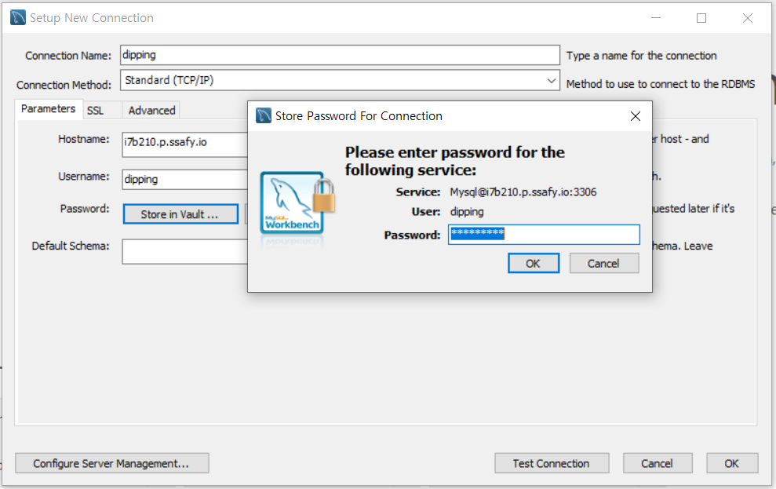

username: omokjomok, password: petsure