Software Requirements Specification (SRS)

Project Name: UniPact Escrow Engine (AI-Audited Freelance Milestone & Settlement Protocol)
Document Version: 1.0.0
Target Competition: MUBA Hacks 2026 (Sui Track 01, Sui Track 02, Gonka Track)
Submission Deadline: 5 September 2026, 11:59 PM MYT
Demo / Pitch Date: 6 September 2026 at Asia Pacific University (APU)

1. Introduction

1.1 Purpose
This document specifies the software architecture, functional requirements, smart contract interfaces, and user workflows for the UniPact Escrow Engine. The system provides trustless milestone escrow, automated proof-of-work auditing, and gasless stablecoin settlement for university students freelancing with small-to-medium enterprises (SMEs) and corporate partners.

1.2 Multi-Track Hackathon Alignment
UniPact Escrow Engine qualifies for three tracks under a single repository submission:
- Sui Track 01 (Payments & Stablecoins): Zero-friction onboarding via zkLogin (Google auth), gasless payouts via Sponsored Transactions, and atomic $1 \rightarrow N$ payout routing using Programmable Transaction Blocks (PTBs) in testnet USDC.
- Sui Track 02 (AI × Sui): An autonomous execution copilot that translates unstructured milestone deliverables into valid Sui PTB execution blocks without manual blockchain configuration.
- Gonka Track (AI for Society): Impartial milestone verification using Gonka Router (gonkarouter.io). Cross-evaluates student deliverables against SME project specifications, outputting a Truth/Completion Score (0–100%), structured reasoning trace, and audit-verifiable Gonka Request IDs.

1.3 Scope & Boundaries
- Included: zkLogin authentication, client deposit escrow, student deliverable submission, Gonka Router multi-model audit pipeline, PTB fee splitting, and gas-sponsored transaction dispatch.
- Excluded: Fiat-to-crypto banking on-ramps, cross-chain bridges, and proprietary native mobile app distribution (delivered as a mobile-responsive Progressive Web Application).
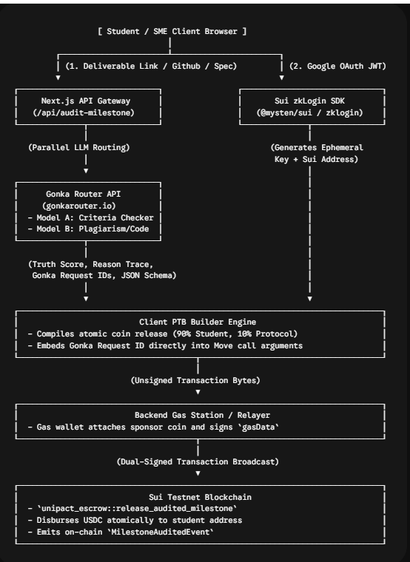

3. Functional Requirements

3.1 Module 1: Authentication & Onboarding (zkLogin)
- FR-1.1 Session Initialization: On load, the client runtime generates an ephemeral Ed25519 keypair and creates a maximum-epoch expiration constraint.
- FR-1.2 OpenID Connect Authentication: The client redirects the user to Google OAuth 2.0 to retrieve a signed JSON Web Token (JWT).
- FR-1.3 Zero-Knowledge Proof Generation: The system passes the JWT, randomness salt, and ephemeral public key to a prover service, deriving the user's permanent Sui address without exposing their email on-chain.
- FR-1.4 Zero-Key Interaction: The user performs all signatures via the ephemeral private key stored in local session memory; no browser extension (e.g., Sui Wallet) is required.

3.2 Module 2: AI Milestone Audit Engine (Gonka Router Integration)
- FR-2.1 Input Data Ingestion: Ingests the SME’s initial milestone acceptance criteria and the student’s proof-of-work (GitHub PR link, Figma design link, live URL, and summary notes).
- FR-2.2 Dual-Model Gonka Routing: Dispatches parallel prompts to gonkarouter.io:
  - Audit Call 1 (Scope Compliance): Evaluates whether the submission meets technical requirements and acceptance criteria.
  - Audit Call 2 (Code/Content Quality): Flags placeholder code, broken links, direct template duplication, or missing core assets.
- FR-2.3 Verification Output Format: Returns a strictly formatted payload:
  - Truth Score: Integer ($0 \le \text{Score} \le 100$).
  - Reasoning Trace: Bulleted list of verified items and remaining deficiencies.
  - Gonka Request ID: Canonical audit string returned by the Gonka Router (e.g., gnk-req-2026-unipact-4981).
- FR-2.4 Settlement Gate:
  - If $\text{Score} \ge 80$, the UI automatically enables the "Authorize Audited Release" button.
  - If $\text{Score} < 80$, the release button is locked, displaying actionable feedback from the reasoning trace to the student.

3.3 Module 3: Programmable Transaction Block (PTB) Builder
- FR-3.1 Payload Generation: Dynamically converts approved audit results into a Sui PTB containing:
  - Verification score verification check.
  - Protocol fee deduction ($10\%$ routed to UniPact Treasury).
  - Milestone payout ($90\%$ routed to student zkLogin address).
  - Recording of the Gonka Request ID inside the smart contract event log.
- FR-3.2 Atomic Guarantee: The PTB must execute atomically; any failure in fee routing or balance splits reverts the entire transaction.

3.4 Module 4: Gas Sponsoring Relayer
- FR-4.1 Gasless Execution: The user client generates the transaction kind bytes without specifying gas payment objects.
- FR-4.2 Sponsor Signing: The backend relayer (/api/sponsor) attaches a sponsor gas coin, signs the transaction as gas_payer, and returns the sponsor signature.
- FR-4.3 Dual-Sign Broadcast: The client appends the user's zkLogin signature and broadcasts the complete transaction via the Sui RPC node.

4. Smart Contract Specification (Sui Move)

4.1 Data Structure Definitions (sources/unipact_escrow.move)
module unipact::escrow {
use sui::object::{Self, UID};
use sui::tx_context::{Self, TxContext};
use sui::coin::{Self, Coin};
use sui::transfer;
use sui::event;
use std::string::String;

// Error Codes
const EINVALID_CALLER: u64 = 100;
const ESCORE_TOO_LOW: u64 = 101;
const EINSUFFICIENT_FUNDS: u64 = 102;

public struct EscrowVault has key {
id: UID,
client: address,
student: address,
treasury: address,
total_locked: u64,
is_active: bool,
}

public struct MilestoneAuditedEvent has copy, drop {
escrow_id: address,
gonka_request_id: String,
truth_score: u8,
payout_amount: u64,
fee_amount: u64,
student: address,
}

/// Initializes a new project escrow
public entry fun create_escrow(
student: address,
treasury: address,
ctx: &mut TxContext
) {
let vault = EscrowVault {
id: object::new(ctx),
client: tx_context::sender(ctx),
student,
treasury,
total_locked: 0,
is_active: true,
};
transfer::share_object(vault);
}

/// SME deposits milestone funds into the escrow
public entry fun deposit_milestone<T>(
vault: &mut EscrowVault,
deposit: Coin<T>,
ctx: &mut TxContext
) {
assert!(vault.client == tx_context::sender(ctx), EINVALID_CALLER);
let amount = coin::value(&deposit);
vault.total_locked = vault.total_locked + amount;
transfer::public_transfer(deposit, object::uid_to_address(&vault.id));
}

/// Releases funds atomically upon passing Gonka AI audit
public entry fun release_audited_milestone<T>(
vault: &mut EscrowVault,
mut payment: Coin<T>,
gonka_request_id: String,
truth_score: u8,
ctx: &mut TxContext
) {
// Enforce minimum AI verification threshold
assert!(truth_score >= 80, ESCORE_TOO_LOW);
assert!(vault.is_active, 103);

let total_val = coin::value(&payment);
assert!(total_val > 0, EINSUFFICIENT_FUNDS);

// Calculate 10% Protocol Fee / 90% Student Payout
let fee_amount = total_val / 10;
let student_amount = total_val - fee_amount;

let fee_coin = coin::split(&mut payment, fee_amount, ctx);
let student_coin = coin::split(&mut payment, student_amount, ctx);

transfer::public_transfer(fee_coin, vault.treasury);
transfer::public_transfer(student_coin, vault.student);

// Return remainder if any
transfer::public_transfer(payment, vault.client);

vault.is_active = false;

// Emit on-chain proof of Gonka verification
event::emit(MilestoneAuditedEvent {
escrow_id: object::uid_to_address(&vault.id),
gonka_request_id,
truth_score,
payout_amount: student_amount,
fee_amount,
student: vault.student,
});
}
}

5. API & Integration Contracts

5.1 Gonka Router Audit Service (lib/gonka.ts)
import OpenAI from "openai";

const gonka = new OpenAI({
baseURL: "https://gonkarouter.io/v1", // Gonka Router API endpoint
apiKey: process.env.GONKA_ROUTER_API_KEY,
});

export interface MilestoneAuditResponse {
truthScore: number;
reasoningTrace: string[];
gonkaRequestId: string;
isApproved: boolean;
}

export async function auditDeliverable(
milestoneSpec: string,
submissionContent: string
): Promise<MilestoneAuditResponse> {
const response = await gonka.chat.completions.create({
model: "deepseek-v4-flash",
messages: [
{
role: "system",
content: `You are an impartial corporate project auditor. Compare the student submission against the agreed project specification.
Evaluate functional completeness, quality, and authenticity. Output ONLY raw JSON matching:
{
"truth_score": number (0-100),
"reasoning": string[],
"approved": boolean
}`
},
{
role: "user",
content: `SPECIFICATION:\n${milestoneSpec}\n\nSUBMISSION:\n${submissionContent}`
}
],
response_format: { type: "json_object" }
});

const gonkaRequestId = response.id || `gnk-req-${Date.now()}`;
const data = JSON.parse(response.choices[0].message.content || "{}");

return {
truthScore: data.truth_score,
reasoningTrace: data.reasoning,
gonkaRequestId: gonkaRequestId,
isApproved: data.approved && data.truth_score >= 80,
};
}

5.2 Sponsored PTB Construction (lib/suiPtb.ts)

import { Transaction } from "@mysten/sui/transactions";

export function buildAuditedPayoutTx(
packageId: string,
vaultId: string,
usdcCoinId: string,
gonkaReqId: string,
truthScore: number
): Transaction {
const tx = new Transaction();

tx.moveCall({
target: `${packageId}::escrow::release_audited_milestone`,
typeArguments: ["0x2::sui::SUI"], // Swap with testnet USDC Coin Type
arguments: [
tx.object(vaultId),
tx.object(usdcCoinId),
tx.pure.string(gonkaReqId),
tx.pure.u8(truthScore),
],
});

return tx;
}

6. Frontend UI Wireframe Specifications
