

Frontend Coding Test

Alongside this Requirements document, you will see two images called **Design**. One of animated the other is not. This is a design that allows a customer to withdraw money from one of their pots.

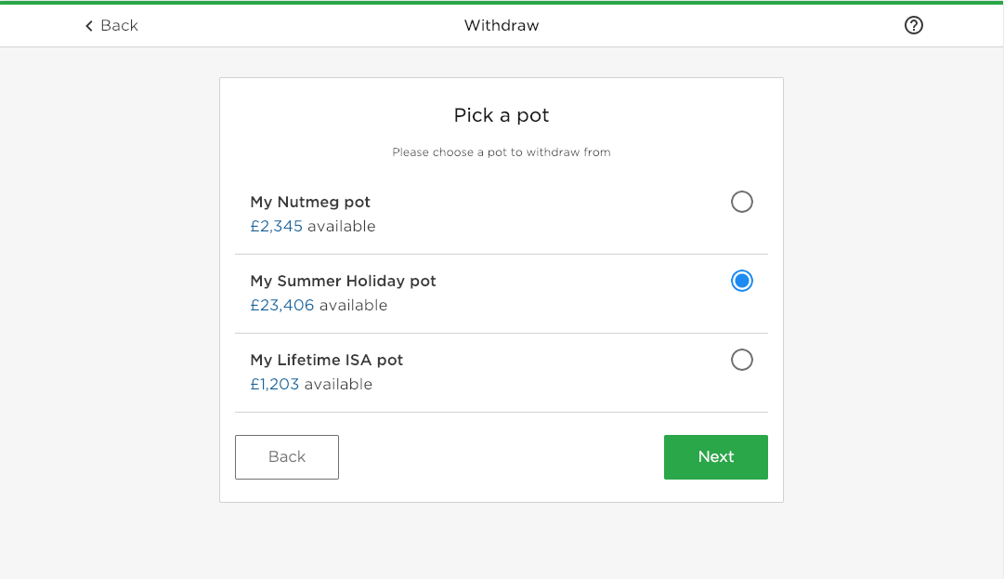

We have set up a skeleton application that includes just the header at the top. Everything below the header does not exist in the codebase.

The react application when you **npm run start** will show like below.

[*Check the README steps to get the application ready for development.]*

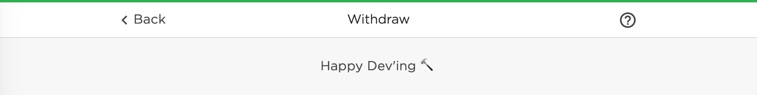

We’d like you to spend as little or as long as you would like on building the rest of the design. The main things we are looking for are:

1. Code structure
2. Semantics
3. Best practices
4. Styling approach
5. Accessibility standards
6. Documentation
7. Optimisation
8. Code Reusability

We will also be identifying any: code smells, unorganised markup, overengineering, inconsistent code formatting and bad naming conventions so please be mindful of this.

|  |
| --- |
| *You can retrieve the array of pots when running server in application* [*http://localhost:3004/pots*](http://localhost:3004/pots)  ***Only pots that are withdrawable should show.*** |

**As a visual reference, you can find our style guide here:** <https://www.nutmeg.com/guidelines>. We’ve also included our primary font, Gotham, for your use in the application so you don’t need to spend time importing it.

**Please bear in mind the following:**

* The **index.css** should be ignored as it’s just compiled CSS taken from our Design system.
* The Header component is also just wrapping compiled HTML and should not be considered good practice.

## When you’re done:

* Send us your code via CVS, Bitbucket [private repo], Github or zip, so that we can review your work.
* Make a note for yourself of your reasoning behind how you approached the problem — we’ll discuss it all with you in your final interview.

Good luck! – Nutmeg team