**BINARY INSERTION SORT**

**Submitted by**

**U K SNEHA-M19CS01**

**PROBLEM STATEMENT**

**Program to store the loan amount taken by various customers of XYZ bank in the month of January. And the sort the loan amount taken in order to help the bank to analyze and keep track of the smaller and larger amount of loan given by them.**

**SOURCE CODE**

**// C program for implementation of**

**// binary insertion sort**

**#include <stdio.h>**

**// A binary search based function**

**// to find the position**

**// where item should be inserted**

**// in a[low..high]**

**int binarySearch(int a[], int item,**

**int low, int high)**

**{**

**if (high <= low)**

**return (item > a[low]) ?**

**(low + 1) : low;**

**int mid = (low + high) / 2;**

**if (item == a[mid])**

**return mid + 1;**

**if (item > a[mid])**

**return binarySearch(a, item,**

**mid + 1, high);**

**return binarySearch(a, item, low,**

**mid - 1);**

**}**

**// Function to sort an array a[] of size 'n'**

**void insertionSort(int a[], int n)**

**{**

**int i, loc, j, k, selected;**

**for (i = 1; i < n; ++i)**

**{**

**j = i - 1;**

**selected = a[i];**

**// find location where selected sould be inseretd**

**loc = binarySearch(a, selected, 0, j);**

**// Move all elements after location to create space**

**while (j >= loc)**

**{**

**a[j + 1] = a[j];**

**j--;**

**}**

**a[j + 1] = selected;**

**}**

**}**

**// Driver Code**

**int main()**

**{**

**int a[50];**

**int n;**

**int i;**

**printf("\nProgram to store the loan amount taken by various customers of XYZ bank in the month of january in a sorted manner");**

**printf("\n Enter the number of customers who had taken loan in the month of january");**

**scanf("%d",&n);**

**for(i=0;i<n;i++)**

**{**

**printf("\nEnter loan taken by customer %d :",i+1);**

**scanf("%d",&a[i]);**

**}**

**printf("\n Loan taken by customers: \n");**

**for (i = 0; i <n; i++)**

**printf("\n customer %d loan taken =%d ", i+1,a[i]);**

**insertionSort(a, n);**

**printf("\n The range of loan amount taken in the month of january");**

**printf(" \n To analyse & keep track of the smaller and larger amount of loan taken : ");**

**for (i = 0; i < n; i++)**

**printf("\n %d ", a[i]);**

**return 0;**

**}**

**OUTPUT**

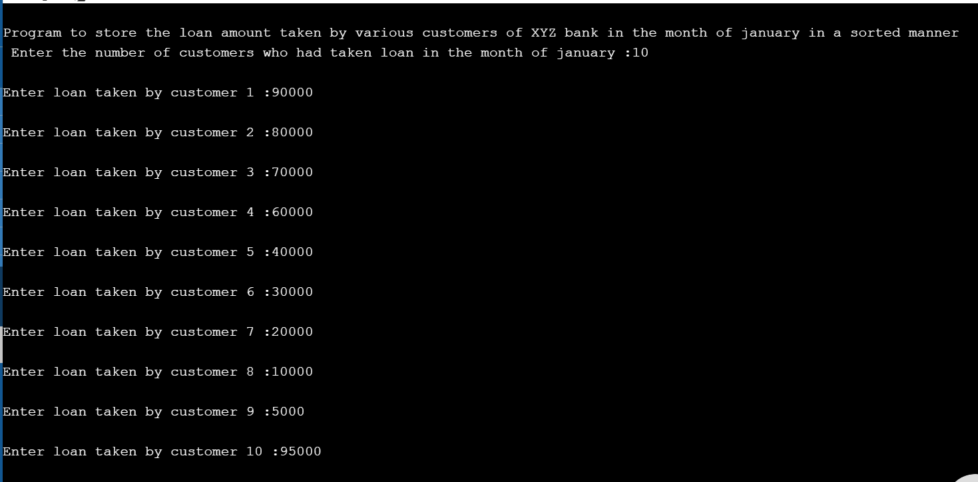

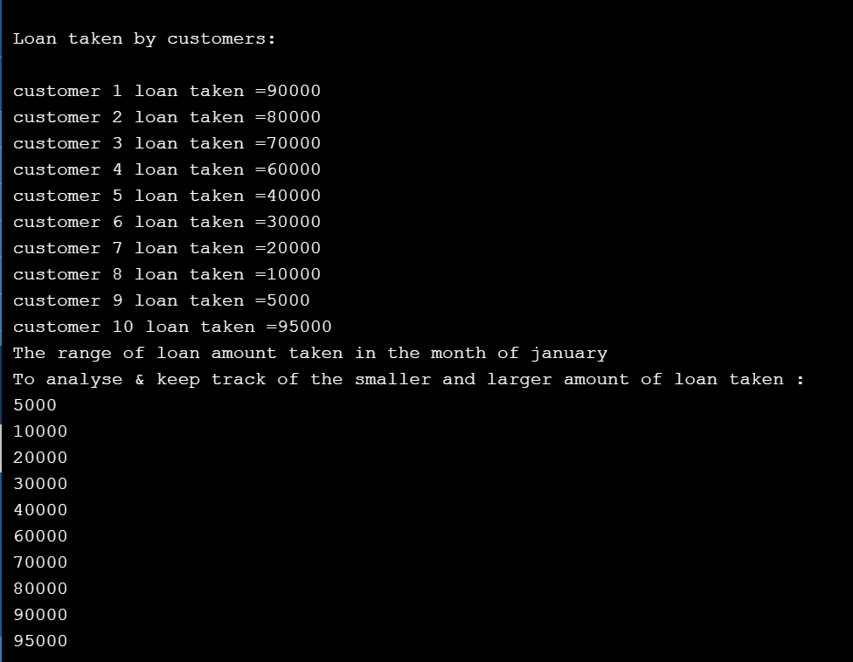

We can use binary search to reduce the number of comparisons in [normal insertion sort](http://quiz.geeksforgeeks.org/insertion-sort/). Binary Insertion Sort uses binary search to find the proper location to insert the selected item at each iteration.   
In normal insertion sort, it takes O(n) comparisons (at nth iteration) in the worst case. We can reduce it to O(log n) by using [binary search](http://quiz.geeksforgeeks.org/binary-search/)