Setup firewall rule for VNCviewer connections

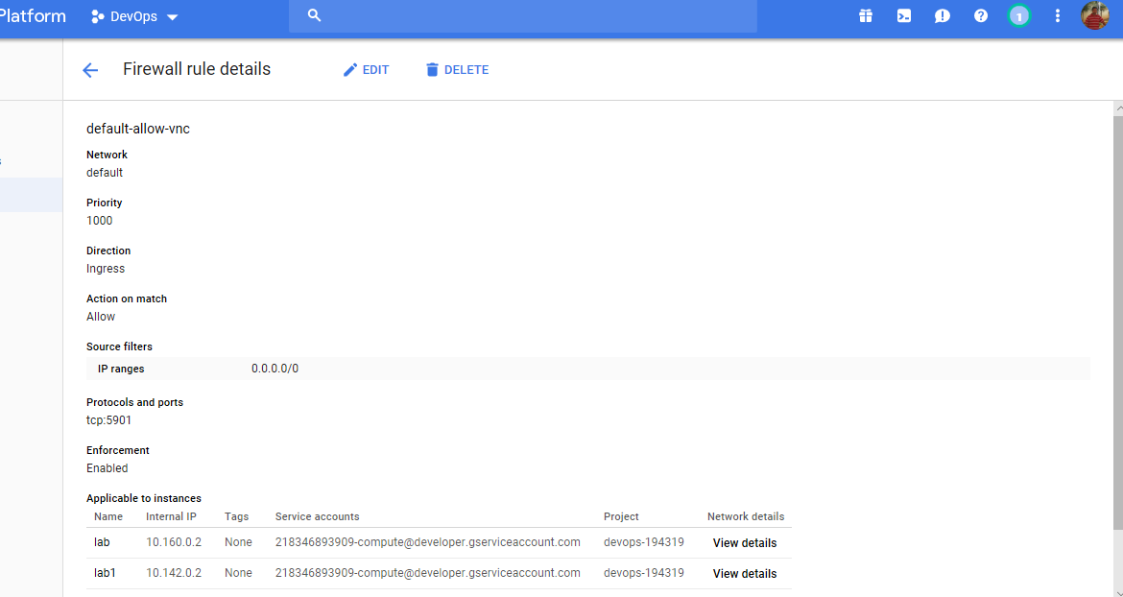

Developed a small bank application

Technologies used

Spring

Java8,Spring boot

Screen showing unit test case