**Implement Azure IaaS**

### **Business Scenario**

The OSS Corporation is a globally distributed firm. They have their headquarters in **East US** with another branch office in **SouthEast Asia**. Currently, they are working on a project and decided that the application tier of this project will reside in one of its branch regions. For security reasons, OSS Corporation management is adamant on keeping their data tier in the headquarter region.

As an organization, they are open to suggestions and are currently evaluating Azure as a deployment platform. To prepare for deployment of IaaS **Standard DS1 v2**, OSS Corporation must deploy an IaaS v2 virtual network in the headquarter region for its database. But for the application, it should create another IaaS v2 virtual network in the branch region. In addition, because the communication between App and data should happen over a private channel, one needs to prepare their branch office virtual network for establishing connectivity to the headquarter’s IaaS v2 virtual network by creating a virtual network gateway and deploy a test IaaS **Standard DS1 v2 VM** to the virtual networks for verifying the connection.

After the deployment team ensures the connectivity between both the networks, you can validate the same using Ping.

### **Overview**

The major activities for this exercise are as follows:

1. Create virtual networks in the aforementioned region
2. Create test virtual machines in both the virtual networks
3. Establish the connectivity between both the networks via VNet peering
4. Ensure connectivity is established properly

Create virtual networks in the aforementioned region

Let the application which is developed is insuranceApp. Resource group created is insuranceAppRG. All resource groups in two regions are organised under this RG

Steps to create virtual networks

1. insdata_nw in region Eastus

2.insapp_nw in region southeastasia

First network creation(insdata_nw) in eastus

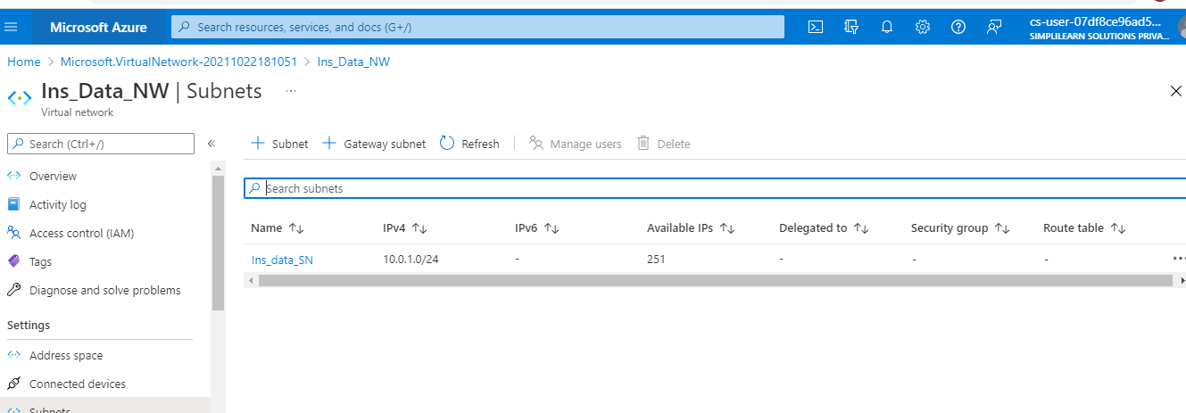

Creating a VM to install DB in Vnet(Ins_Data_NW)

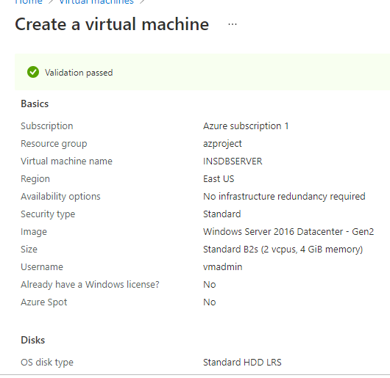

Server created in network in eastUS

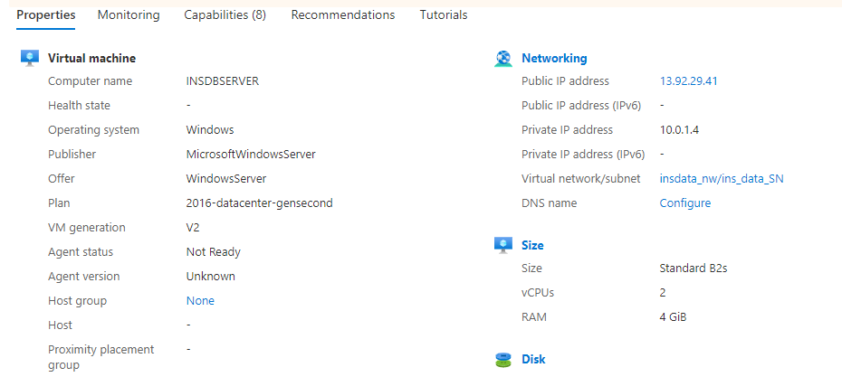

Second network for app server is created in southeast asia. Screenshot from ARM is below

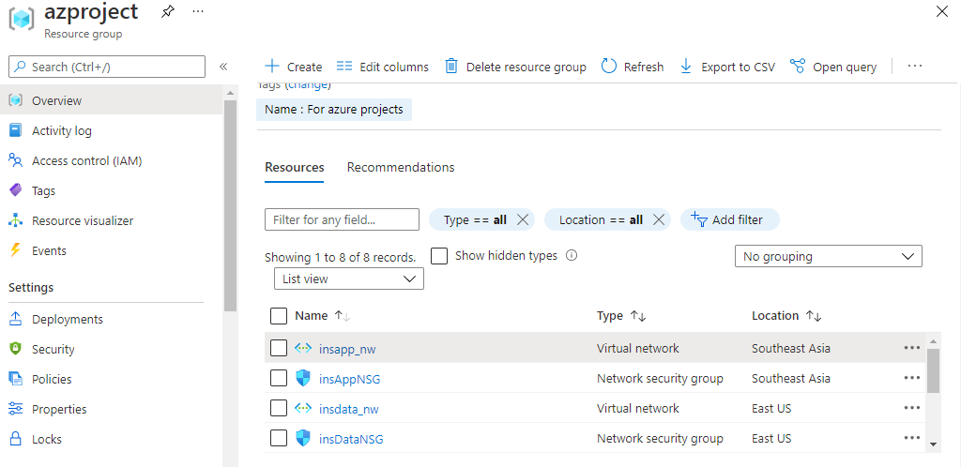

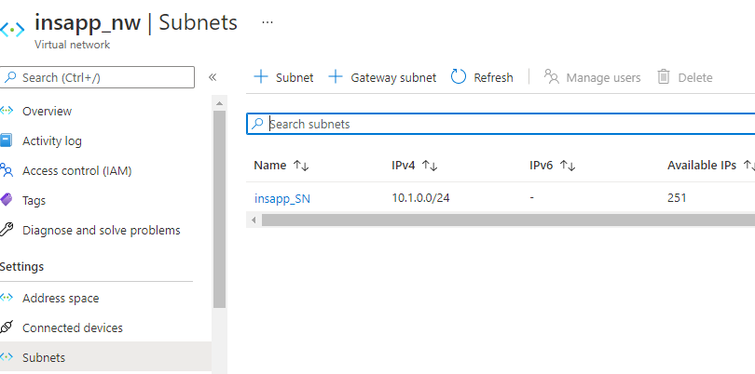

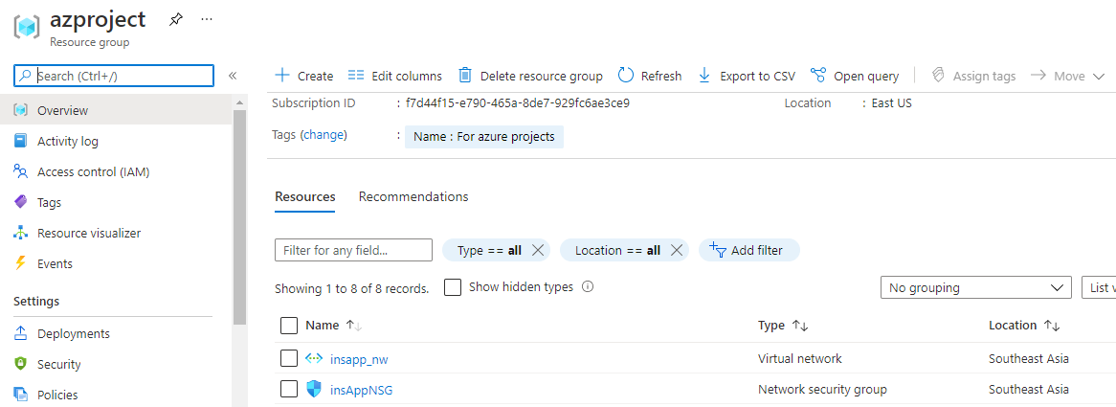

Step 10:Create a app server in southeastasia network

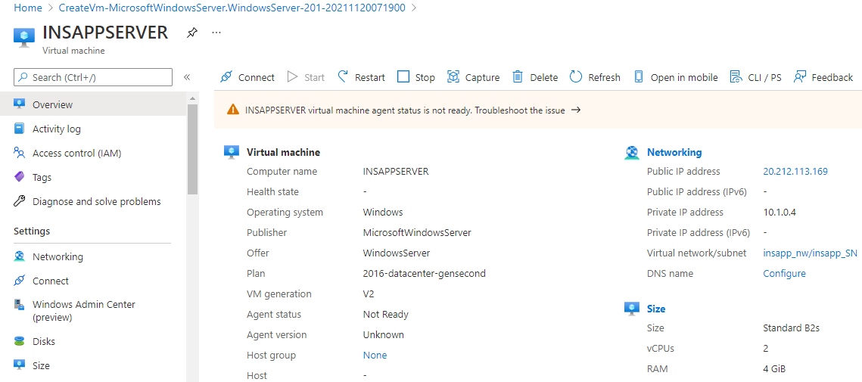

Step 11: Created two NSG and associated with two networks for network security

Step12. Created a peering between networks in two regions

insapp_nw is connected to insdata_nw

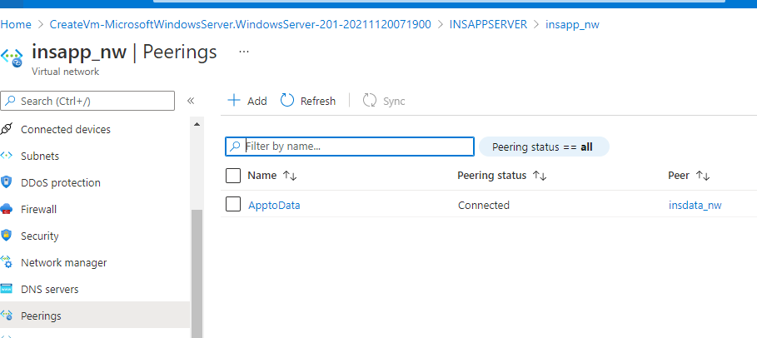

insdata_nw(useast) peering status shows connected to ins_app_nw(southeastasia)

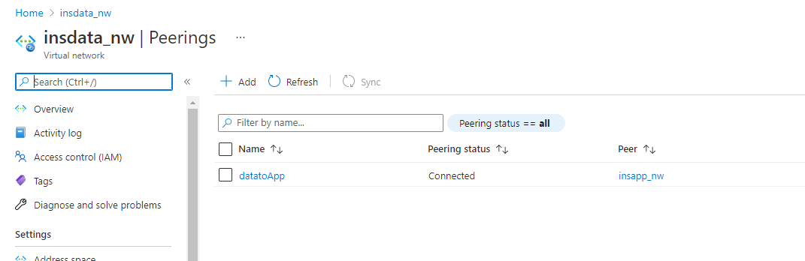

Ping test between Vms

internal Ip address of DB server in datanw(eastus) is 10.0.1.4

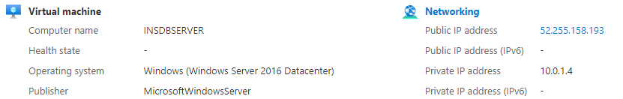

internal Ip address of app server in southeastasia is 10.1.0.4

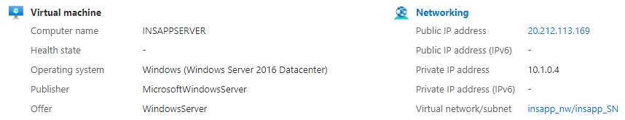

Log into appsever with publicIp(20.212.113.169), ping db server using IP address

