USER MANUAL

Login Page:

A person holding a baby

Description generated with high confidence

Input Username and Password. Then click sign in button

Dashboard:

A screenshot of a cell phone

Description generated with very high confidence

Click to show Dashboard

Click to show notifications

Click to show page alerts

Statistics

A screenshot of a cell phone

Description generated with very high confidence

Click to print charts

Click to show statistics and charts

Barangays:

A screenshot of a computer

Description generated with very high confidence

Click to Modify

Click to Delete

Click to register a barangay

Click to show the list of all barangays

Child Information Table:

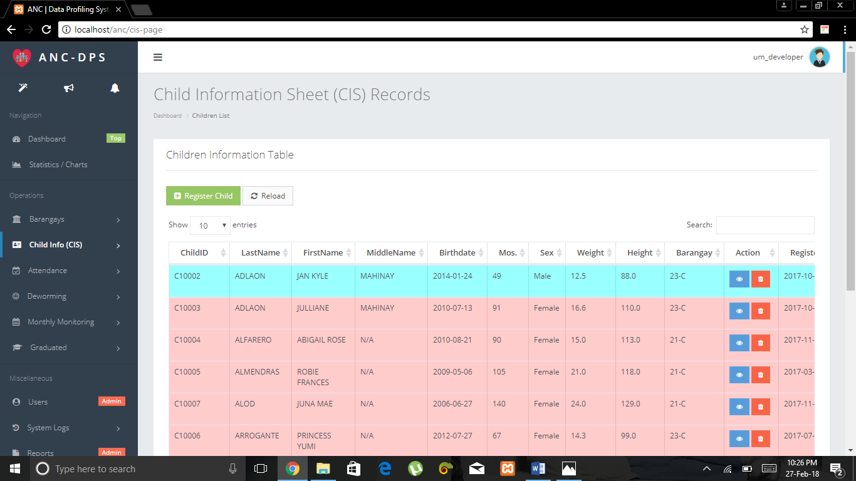

Click to Delete

Click to open child profile

Click to register a child

Click to show the list of all registered children

Child Profile:

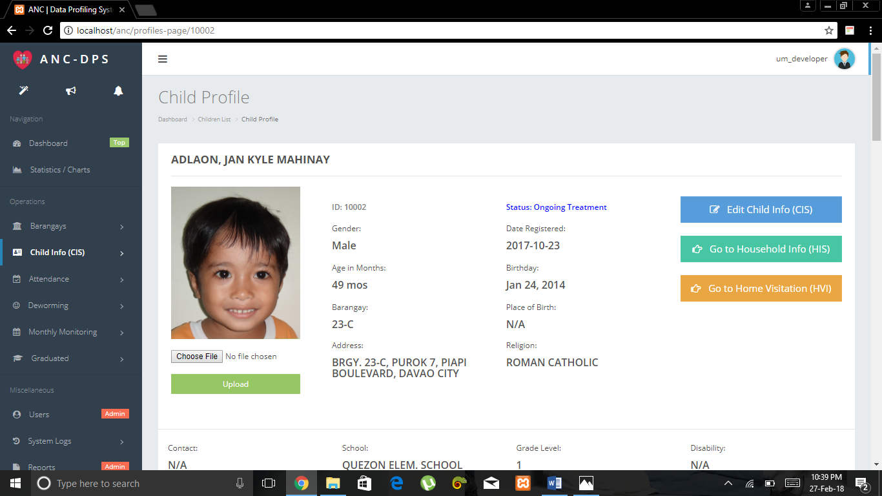

Click to modify child info

Click to add or modify Household info

Click to go to Home Visitation

Choose a file then click button to upload picture

Child Profile:

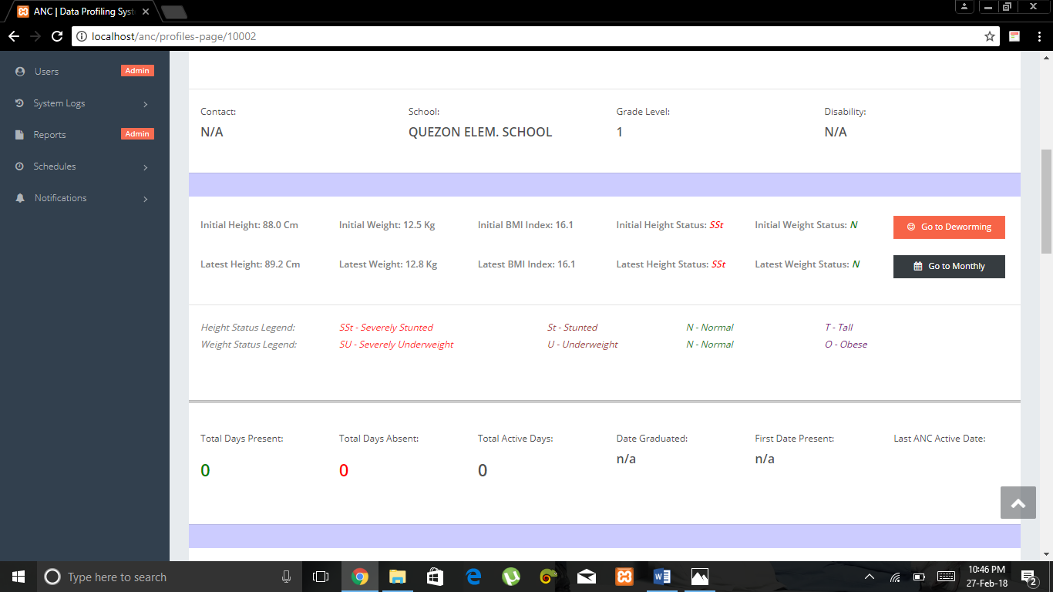

Click to go to Deworming Information Records

Click to go to Deworming Information Records

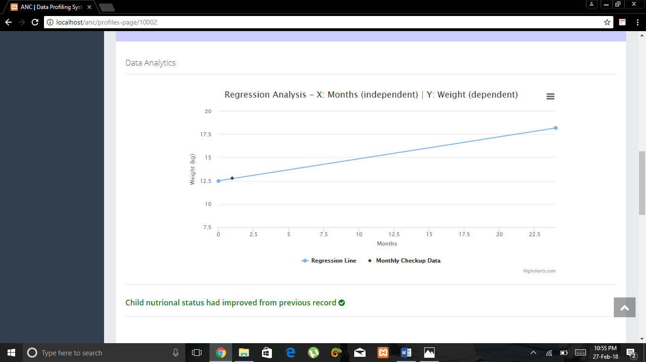

Click to print chart

Child Profile:

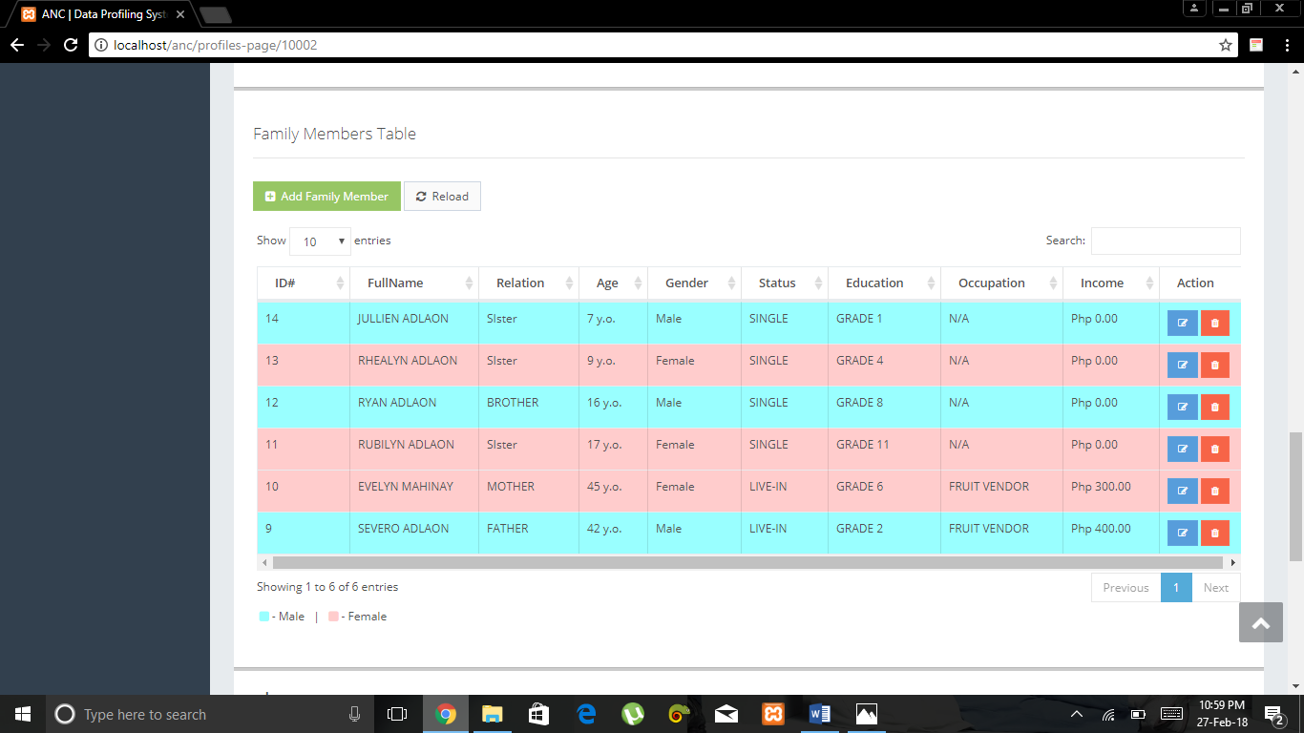

Click to delete

Click to add family member

Click to modify info

A screenshot of a cell phone

Description generated with very high confidence

Choose a file and click upload button to add pictures of the child

Child Profile > Add or Edit Household Information Sheet:

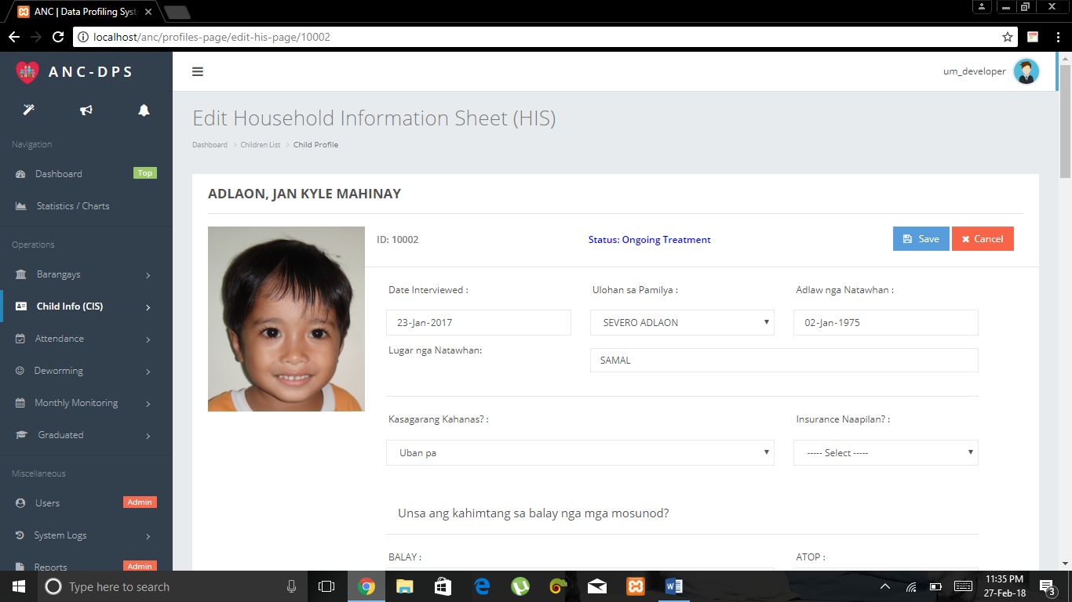

Click Cancel to go back to child profile

Fill up or modify the fields then click button to save

Child Profile > Home Visitation Interview:

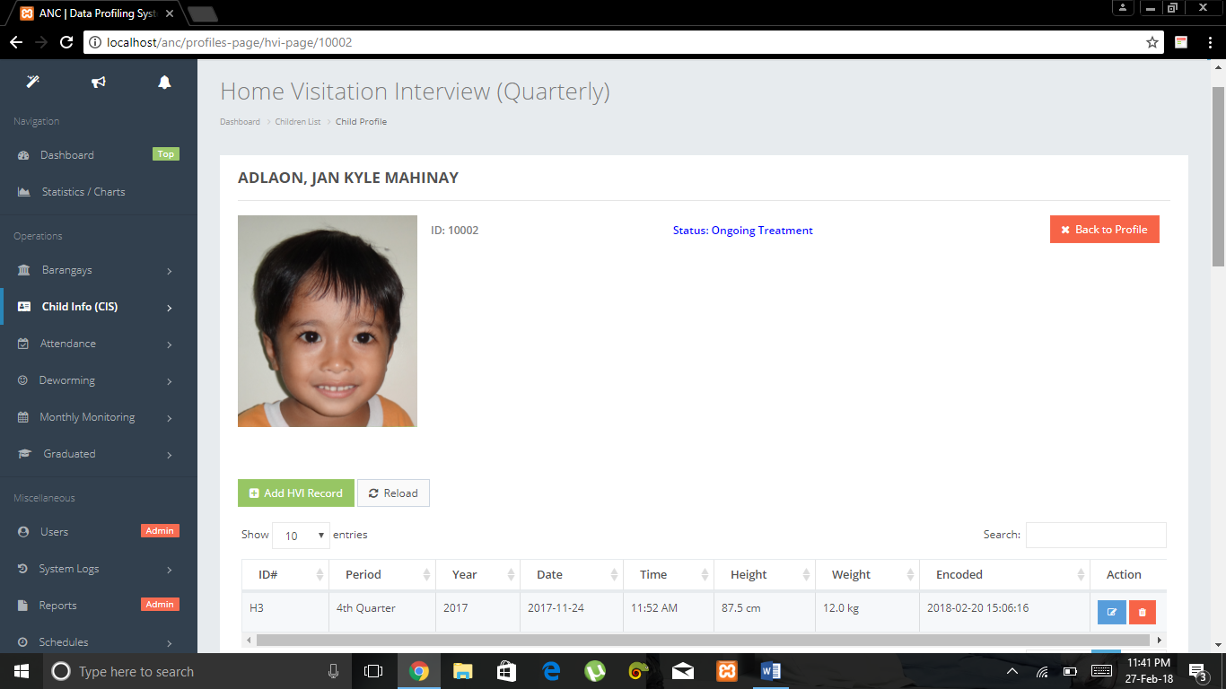

Click to modify

Click to delete

Click to go back to child profile

Click to add deworming record

Click to add HVI Record  record

Click to add deworming record

Child Profile > Deworming Information Records:

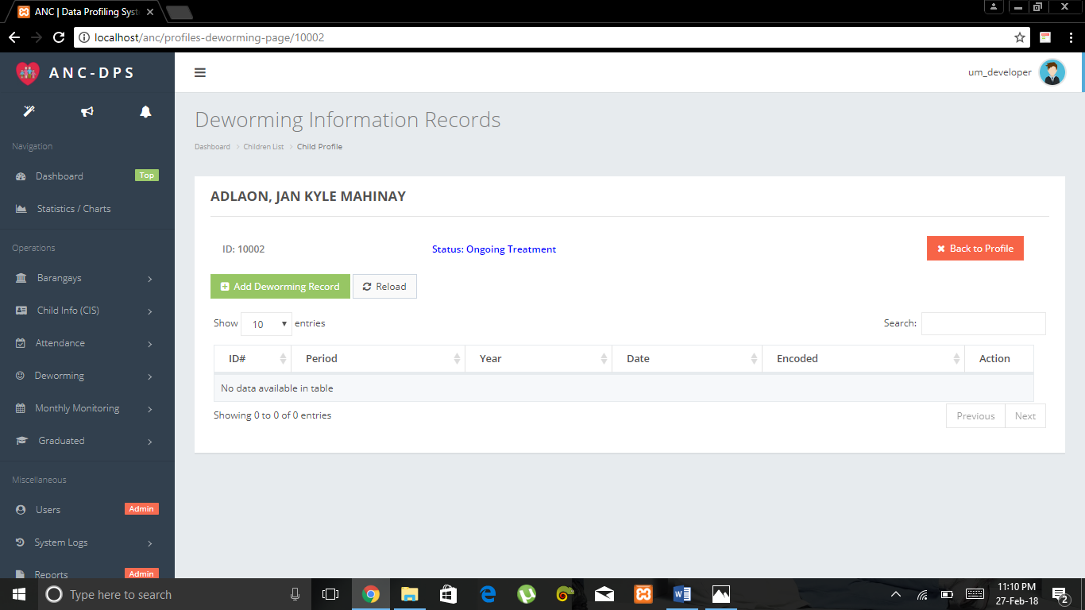

Click to go back to child profile

Click to add deworming record

Click to add deworming record

Click to add deworming record

Child Profile > Monthly Checkup Information Records:

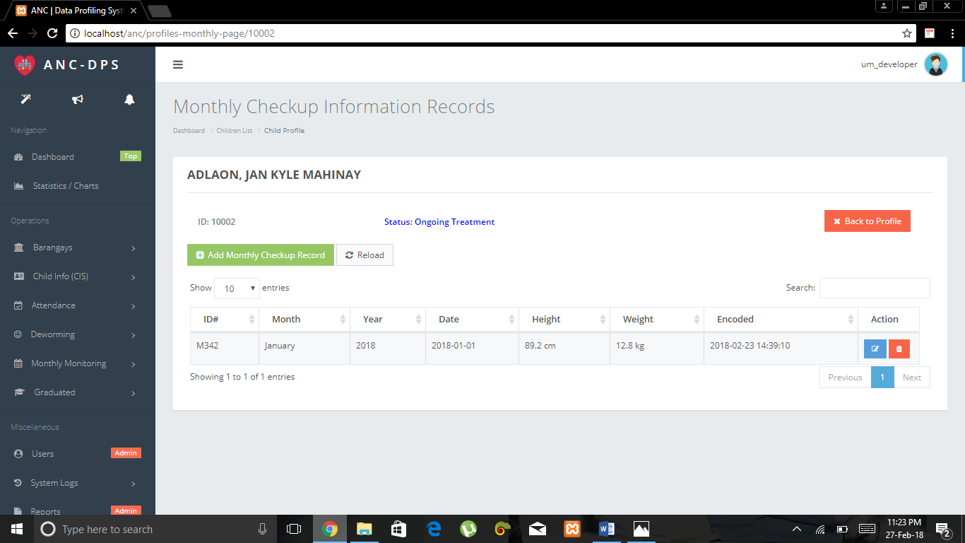

Click to add Monthly checkup record

Click to add deworming record

Click to modify

Click to delete

Click to go back to child profile

Click to add deworming record

Attendance:

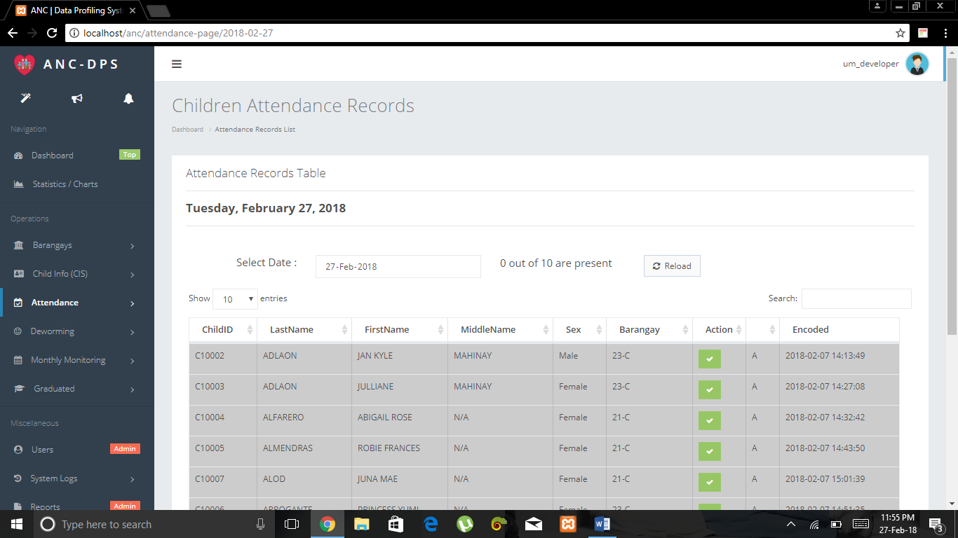

Click to if child is present

Click to add deworming record

Click to show Attendance Table

Click to add deworming record

Deworming:

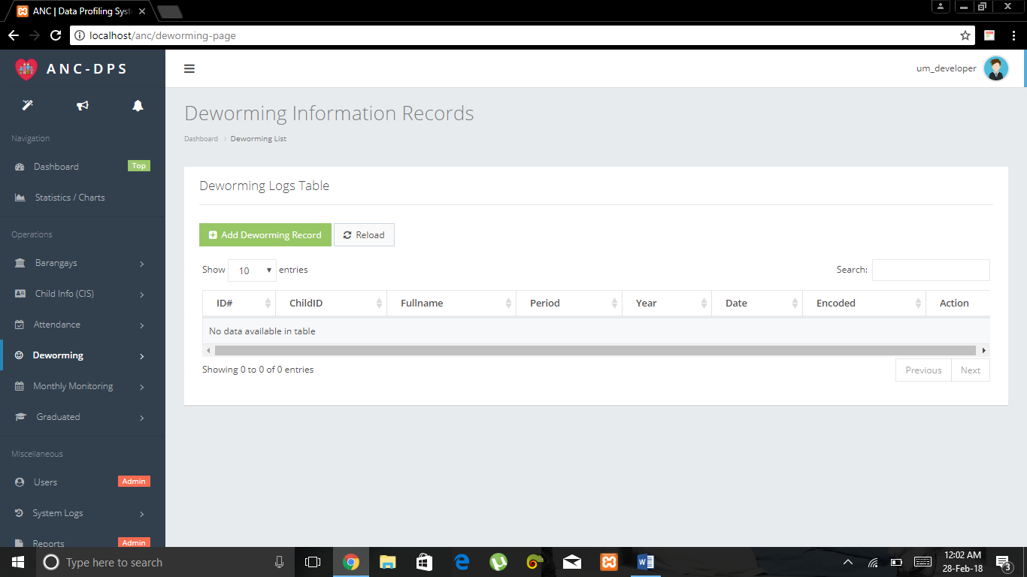

Click to Deworming Logs Table

Click to add deworming record

Click to add deworming record

Click to add deworming record

Monthly Monitoring:

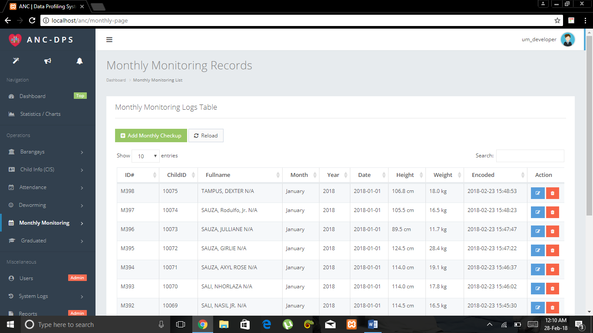

Click to delete

Click to modify

Click to add monthly record

Click to add deworming record

Click to Monitoring Logs Table

Click to add deworming record

Graduated:

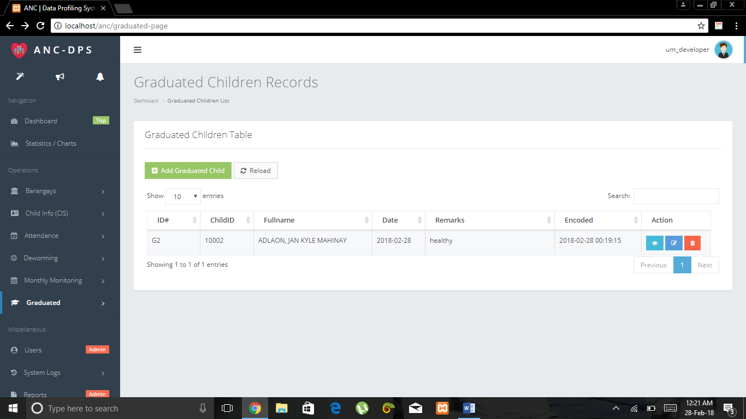

Click to undo graduate

Click to modify

Click to view child profile

Click to show list of graduated children

Click to add deworming record

Click to add graduated child

Click to add deworming record

Users:

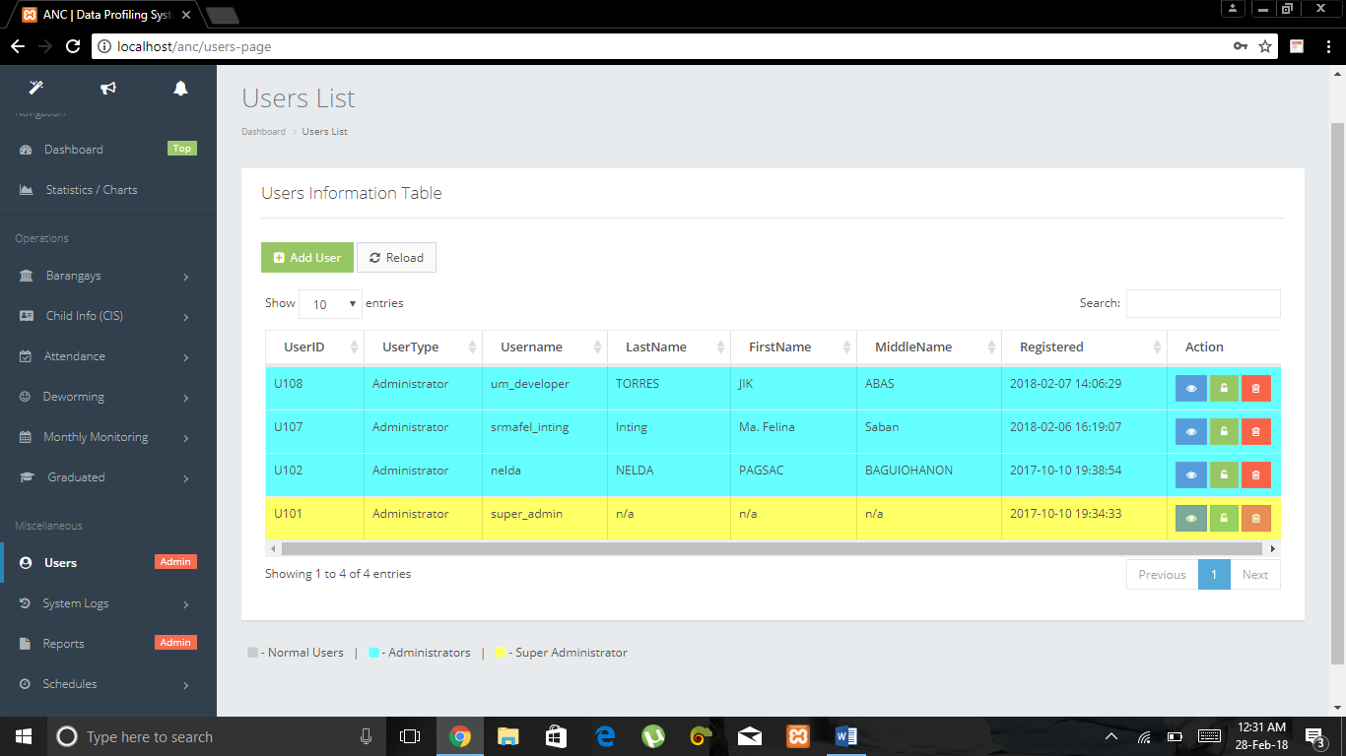

Click to set privileges (admin or not)

Click to view or modify

Click to delete

Click to add user

Click to add deworming record

Click to show users list

Click to add deworming record

System Logs:

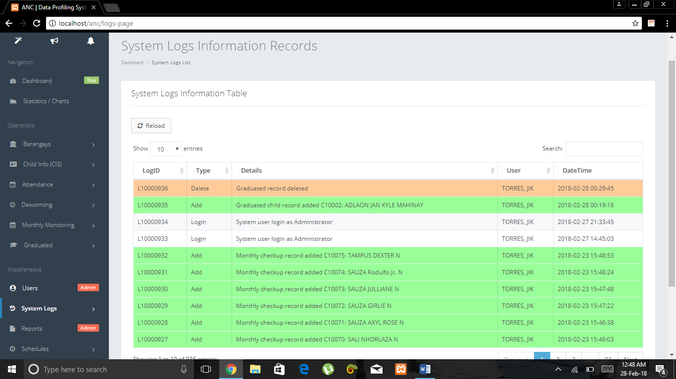

Click to Show System Logs Information Table

Click to add deworming record

Reports: