RESEARCH TOPIC/TITLE

Archdiocesan Nourishment Center – An Accounting, Inventory, and Data Profiling with Data Analytics System for A Non Profit Charitable Organization.

- Description of the Project

- Rationale

Archdiocesan Nourishment Center is a non-profit charitable institution for children and it is handled by nuns and priests. Every day they welcome children who visit the center to have their meal. A nutritionist also helps them monitor the health of each of the children who visits them, every quarter they conduct check-ups to see if the children improved their health or not, they record details such as height, weight, appetite, water intake, bowel movement and general hygiene, having all these details and having a lot of children to cater gives them a hard time to organize and keep all these records. In every check-up finding, the retrieval of the previous record of each child consumes a lot of their time. There are also instances where the records are misplaced or loss.

This organization also receives donations from anyone in cash or in kind. Currently they have a manual accounting system where they list and tally all their received donations and expenses. There are a lot of people who lend help to them and it is hard to keep track to all of them. According to them having manual system gives them some problems such as having a hard time recording all the details because it consumes too much of their time, and balancing the received donations and the expenses.

Also, they have a small business where they sell small products which helps them profit. Like some businesses they are also experiencing problems. Given that there are a lot of things to do in inventory and they must do it manually, which gives them a hard time to determine if they gained or loss in their business.

Lastly, they are experiencing problems in monitoring their supplies. They have supplies such as dishwashing liquid, hand soap, powder soap, downy, magic sarap etc. Details like Date, requested by, No. of items and balance are being recorded. Recording it in a notebook gives them a hard time in organizing it properly given that they have a lot of supplies.

Given that they are experiencing a lot of problems, they need something that will address these.

- Objectives of the Study

  - General
The researchers aim to create a multi-functional system for the Archdiocesan Nourishment Center that will address some of their problems in Accounting, Inventory and Children Data Profiling. Plus an additional Data Analytics feature that can analyze and produce conclusive data regarding the nutritional status of a child. Having an automated system will help them lessen problems and will help them easily generate statistical and infromational reports.

  - Specific
To accomplish the general objectives, the researchers aims to:
- Conduct a thorough research and analysis about the operations. Gather sample forms, data, and documents related to their current system.
- Create a stand-alone Accounting, Inventory and Children Data Profiling using web framework and langauges such as Codeigniter/Laravel, Javascript, PHP, HTML, and CSS.
- Implement the system and provide tutorial for them to adapt to the newly made automated system created by the researchers.

- Conceptual Framework

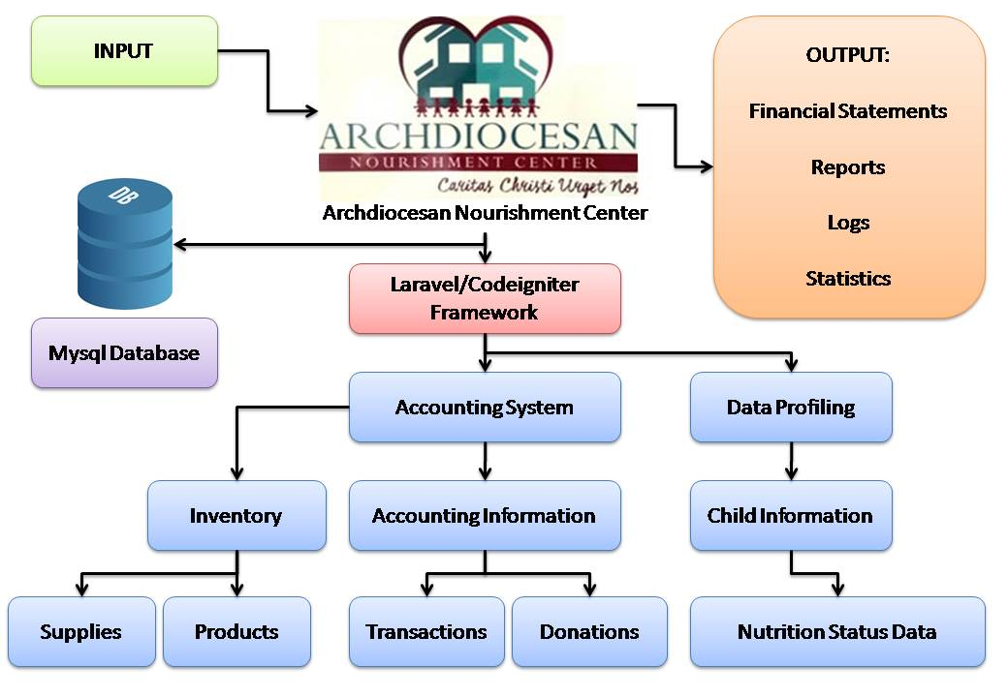

- Methodology

The researchers agreed to finish each processes of the proposed system using Agile Scrum methods in the form of sprint.

Sprint 1: Initiation
In this stage, the researchers will develop the project proposal. The researchers will identify the problems and what would be the objectives, scope and limitation of the project. Also, the developing team will create a schedule of all the activities during the project development.

Sprint 2: Planning
In this stage, work plan of the project will be created and role of each member will be identified. Team leader and members will meet to gather ideas.

Sprint 3: Analysis and Designing
In this stage, developing team will analyze and classify the needs in developing the proposed system. The feasibility study for the proposed system will also be conducted. And lastly prototype design of the system will be developed.

Sprint 4: Project Execution
In this stage, meeting for the development of the system will be conducted. The developing team will start to find the possible things that they can use to develop the system. The developing team will install applications that they will use and start to implement codes of the prototype they developed during analysis and design stage of the project. They will start to develop the proposed system that will address the problems of the organization. After developing the system, the developing team will test the performance and functionalities of the system to see if there are still things the needs to be fixed and improved. After testing and fixing, the developing team will present the system to the organization. They will ask users with regards to the design and functionalities of the system and will try to ask for suggestions or changes, they will immediately administer it. After addressing the issues of the system, they will implement the user’s needs, they will now prepare the documentation of the project and prepare the user’s guide. And lastly, user’s training of the system will be conducted.

Sprint 5: Project Implementation
In this phase, the developing team will deploy the system in the organization and conduct pilot testing. Lastly, the developing team will formally turn over the system to the organization and formally closed the project.

- Research Project Duration

Milestone | Activity | Duration
1 | Initiation | 7 days
2 | Planning | 7 Days
3 | Analysis and Designing | 40 days
4 | Execution | 150 days
5 | Implementation | 40 Days

Prepared by:
Date:

GILBANG, LADY SHEEN A.
TORRES, MICHAEL JASON A.
YBIERNAS, IVY V.

Prepared by:

Date: JULY 10, 2017

Endorsed by:

EFRHAIN LOUIS PAJOTA
RAMCIS N. VILCHEZ, MIT

Dept. Research Coordinator Dean of College

