Data Profiling and Progress Monitoring Application with Data Analytics Technique for Archdiocesan Nourishment Center

Michael Jason A. Torres
BS in Information Technology
University of Mindanao
09228081290, Philippines 8000
michaeljason_torres@umindano.com
Ivy V. Ybiernas
BS in Information Technology
University of Mindanao
09096576547, Philippines 8000
ivyybiernas@outlook.com
Lady Sheen A. Gilbang
BS in Information Technology
University of Mindanao
09103572769, Philippines 8000
lsgilbang@gmail.com

EXECUTIVE SUMMARY
In this paper, we describe the formatting guidelines for ACM SIG Proceedings.
Categories and Subject Descriptors
D.3.3 [Programming Languages]: Language Contructs and Features – abstract data types, polymorphism, control structures. This is just an example, please use the correct category and subject descriptors for your submission. The ACM Computing Classification Scheme: http://www.acm.org/class/1998/
General Terms
Your general terms must be any of the following 16 designated terms: Algorithms, Management, Measurement, Documentation, Performance, Design, Economics, Reliability, Experimentation, Security, Human Factors, Standardization, Languages, Theory, Legal Aspects, Verification.
Keywords
Keywords are your own designated keywords.

INTRODUCTION

Project Context

Because of the existence of technology, Organizations with many transactions use automated system. Upgrading into automated system helps not only the synchronization of data but also the accuracy. Systems are created to address problems in some organization. Having these systems helped organizations for an easier daily transaction.
Archdiocesan Nourishment Center(ANC) located at Pag-asa St. Davao City is a non-profit charitable organization for children handled by nuns and priests. This organization is supported by volunteers and is given donations by donors. Every day they welcome children who visit the center to have meal. A nutritionist helps them monitor the health progress of each child who visits them, every month they conduct check-ups to see if the children has improved their health or not, and house vistations quarterly to monitor their family.
The problem is ANC has difficulty in monitoring the progress of each child and come up with possible diagnosis based on their current results examined by their medical staffs. They currently don’t have the technology that would help them for such problems.
Data analytics is a helpful platform that would leverage conventional and untraditional data sources. Since the problems of the organization require comparison and progression of data because they need to monitor the children’s status, data analytics is a secure platform and informed tool selection that would give accurate analysis to the children’s nutritional status and progress. How this is done is through a data integration and visualization which combine and dynamically present data to understand trends and relationship. The type of data analytics the researchers will make is a quantitative data analysis. It would provide a numerical value that would compare and measure statistically. This analysis would compare the historical data of the children and the current data with the use of analysis. With the help of data analytics, there is a quality in the data assessed since those are valid robust supporting data.
Therefore, data analytics technologies and techniques will help them because it is widely used in commercial industries to enable organizations to make more-informed decisions. The data that are analyzed are consist of both previous and current information that has been processed for real-time analytics.

Purpose and Description

Because of the overwhelming tasks they tend to encounter problems such as:

Difficulty in monitoring child’s nutritional progress
- They record details such as height, weight, appetite, water intake, bowel movement and general hygiene, having all these details and having a lot of children to cater give them a hard time to organize and keep all the records. In every check-up, finding the previous record of each children consumes a lot of their time, there are also instances where the records are misplaced or loss so it is difficult to monitor their nutrition.

Difficulty in determining and comparing statistic reports
- They do determine and compare statistic reports such as range of boys and girls enrolled in their nutritional program, diseases or illnesses by age in months, number of children with diseases, location affected by diseases, number of children that has improved or worsen their nutritional status, and comparison of diseases in every child. however it is difficult for them because of so much time and resources needed to perform the whole processes considering that they have lots of file stored in separate file storages.

Difficulty in analyzing medical and nutritional status of children
- It is difficult for them to know if a certain disease of a child is recurring or not because they find it difficult to keep a report or disease history in order due to multiple files they store in separate file storages. It is also difficult for them to analyze why the BMI of a child increases or decreases and what are the possible causes for these children’s nutritional problems.

Difficulty in determining children that requires the most medical attention and are in critical alert status.
- There are cases when a child requires immediate medical attention due to various reasons like worsen nutritional status, illnesses, loss of appetite, etc. Sometimes, they have difficulty in monitoring such cases because each of these records requires assessment by looking at their previous data which are stored separately. Moreover, they currently don’t have a notification device or technology for such cases.

Objectives

GENEREAL OBJECTIVES
The main goal of the researchers is to develop a Data Profiling and Progress Monitoring Application with Data Analytics Technique for Archdiocesan Nourishment Center.

SPECIFIC OBJECTIVES
To accomplish the general objective, the group aim to develop an application specifically to:
- Analyze the medical and nutritional status of the Archdiocesan Nourishment Center (ANC) children using Data Analytics Techniques.
- Generate recommendations for possible treatment and proper nutritional diet using Decision Support System.
- Generate statistical report in graphical representation using Highcharts Interactive JavaScript charts.
- Notify the medical staffs regarding children that requires immediate medical attention, prioritization and medical schedules using JQUERY tool.

REVIEW OF RELATED LITERATURE

GEMINI: An Integrative Healthcare Analytics System

[1] Healthcare systems around the world are facing the challenge of information overload in caring for patients in an affordable, safe and high-quality manner in a system with limited healthcare resources and increasing costs.
The researchers developed a system for integrated healthcare analytics called GEMINI. GEMINI extracts data of each patient from various data sources and stores them as information in a patient profile graph. The data sources are complex and varied consisting of both structured data (such as, patients’ demographic data, laboratory results and medications) and unstructured data (such as, doctors’ notes). Hence, the patient profile graph provides a holistic and comprehensive information of patients’ healthcare profile, from which GEMINI can infer implicit information useful for administrative and clinical purposes, and extract relevant information for performing predictive analytics.
This system components are Patient Profiling, healthcare analytics, and Supporting Platforms. In Patient Profiling component each patient has a profile graph which came from clinical data. In Healthcare Analytics component is where after creating a profile graph of patient it provides healthcare analytics capabilities. It performs analytics tasks such as predicting whether a condition can be controlled or not. Lastly, in Supporting Platforms is where Profiling and Analytics components gets supports such as getting suggestions.
The researchers presented this study (GEMINI) to predict the risk of unplanned patient Readmissions.

Toward a Big Data Healthcare Analytics System: A Mathematical Modeling Perspective

[2] High speed physiological data produced by medical devices at intensive care units (ICUs) has all the characteristics of Big Data. The proper use and management of such data can promote the health and reduces mortality and disability rates of critical condition patients. The effective use of Big Data within ICUs has great potential to create new cloud-based health analytics solutions for disease prevention or earlier condition onset detection. The Artemis project aims to achieve the above goals in the area of neonatal intensive care units (NICU).
[3] Premature birth, also known as Preterm birth, defined as birth before 37 weeks gestational age, has been identified as one of the most important perinatal health problems in industrialized nations. Neonatal Intensive Care Units (NICUs) internationally provide critical care for premature and ill term infants. Premature infants in NICUs can be as young as 23 weeks gestation.
The researchers proposed a system with cloud framework. Artemis cloud was created in a way that it is capable of gathering physiological data from different medical devices and monitors to perform online analytics within the cloud. The proposed system used Analytical Modelling and Data Storage Modelling.

Data Processing System (DPS) software with experimental design, statistical analysis and data mining developed for use in entomological research

[4] A comprehensive but simple-to-use software package called DPS (Data Processing System) has been developed to execute a range of standard numerical analyses and operations used in experimental design, statistics and data mining. This program runs on standard Windows computers. Many of the functions are specific to entomological and other biological research and are not found in standard statistical software. This paper presents applications of DPS to experimental design, statistical analysis and data mining in entomology.

2.4 A platform for secure monitoring and sharing of generic health data in the Cloud

[5] The growing need for the remote caring of patients at home combined with the ever-increasing popularity of mobile devices due to their ubiquitous nature has resulted in many apps being developed to enable mobile telecare. The Cloud, in combination with mobile technologies has enabled doctors to conveniently monitor and assess a patient’s health while the patient is at the comfort of their own home.
The researchers developed a system that enables mobile telecare thru the combination of smartphones, Bluetooth and cloud. One of the features of their system is that it remotely monitors patients for cardiac arrhythmias. This system allows doctors to remotely monitor patients’ health information using cloud.

Leveraging the capabilities of service-oriented decision support systems: Putting analytics and big data in cloud

[6] Using service-oriented decision support systems (DSS in cloud) is one of the major trends for many organizations in hopes of becoming more agile.
This article discussed the requirements for service oriented DSS such as Accuracy, Security, Governance, Compliance, Collaborative, Intra and inter- organizational synchronous, agile accommodation, adaptive, reuse and integration, virtual and service oriented. They proposed a conceptual framework for DSS in cloud. SODSS has four major components such as Operational System, Data Warehousing, Online Analytic Processing and End-user components. Each component is essential in completing the whole concept of SODSS.

BRINGING HEALTHCARE ANALYTICS TO WHERE BIG DATA RESIDES USING A DISTRIBUTED QUERY SYSTEM.

[7] It is generally difficult to move Big Data and put it into a central location. Ordinarily this would prevent one from querying several repositories of patient-oriented Big Data as a unified whole. However, we have been developing a distributed query system where the Big Data is indexed in the location where it typically lies, and surrounding each index we have created software based upon the Informatics for Integrating Biology and the Bedside (i2b2) project to access the index used to organize the Big Data. We have applied this to allow us to query Genomics, Imaging, and Textual data to be queried along with traditional coded Healthcare data.
The researchers created an API or Application Programming Interface which allows patient-centric queries to be formulated across these Big Data resources in our Healthcare system with the goal of performing research on the Healthcare Data, incorporating novel approaches to sharing common ontologies that represent the Big Data and novel approaches to linking the patients across the participating Big Data sites.

Big data analytics in healthcare: promise and potential

[8] Big data analytics and application in healthcare is now at the level where it is starting to exist in development. In healthcare industry, large amounts of data have been generated. While most data were stored in hard copy form, the current trend is the computerization of large amount of data. Big data in healthcare is overwhelming because of its dimensions that needs to be managed. Thru understanding patterns and trends of data, big data analytics can improve care, save lives and lower costs. Because of this large amount of data, big data analytics applications can take advantage and make a better-informed decision.

Big data analytics for healthcare

[9] There are a lot of various healthcare organizations and it has a large amount of different medical data (pharmaceuticals, providers and payers). Those data are converted into a resource needed for insights for improving healthcare delivery. The enormity and complexity of these datasets present great challenges in analyses and subsequent applications to a practical clinical environment.
This article tackled about tutorials where they introduce the features and related mining challenges on dealing with medical data. Most of their insights came from medical informatics community, which is highly related to data mining but focuses on biomedical specifics. The researchers in this article performed surveys to discuss with the audiences the key problems and trends in healthcare analytics research, with different applications ranging from clinical text mining, predictive modelling, survival analytics, patient similarity, genetic data analysis, and public health.

Distributed data networks: a blueprint for Big Data sharing and healthcare analytics

[10] There is a growing body of literature on the use of non-hypothesis-driven analytic approaches to identify patterns in the burgeoning volume of healthcare and clinical data. These approaches have recently been used in a number of different types of patient health studies to date, for example, to identify high-cost patients, aid in the reconciliation of potentially erroneous entries in medication lists in patients’ medical records, and identify patients at high risk for developing specific clinical conditions.
In this article, the researcher discussed that by focusing on the six pillars of analytic infrastructure: consistency, reusability, flexibility, scalability, transparency and reproducibility, distributed data network has made to the healthcare analytics community. Lastly, it introduces the machine learning algorithm development as an evolving analytic framework to further advance the portfolio of population health analytics [11].

Big Data and Analytics in Healthcare
This article discussed the Methods of Information in Medicine on “Big Data and Analytics in Healthcare”. A large amount of date being generated in the healthcare industry is growing. this data is being used to improve health outcomes and lower costs. Challenges are present in processing and analyzing given that there is big amount of data in healthcare. This article focused on giving information and method that would address those problems. More specifically, efficient methods of processing large clinical data to predictive models that could generate better predictions from healthcare data are presented. [12]

TECHNICAL BACKGROUND

Conceptual Framework

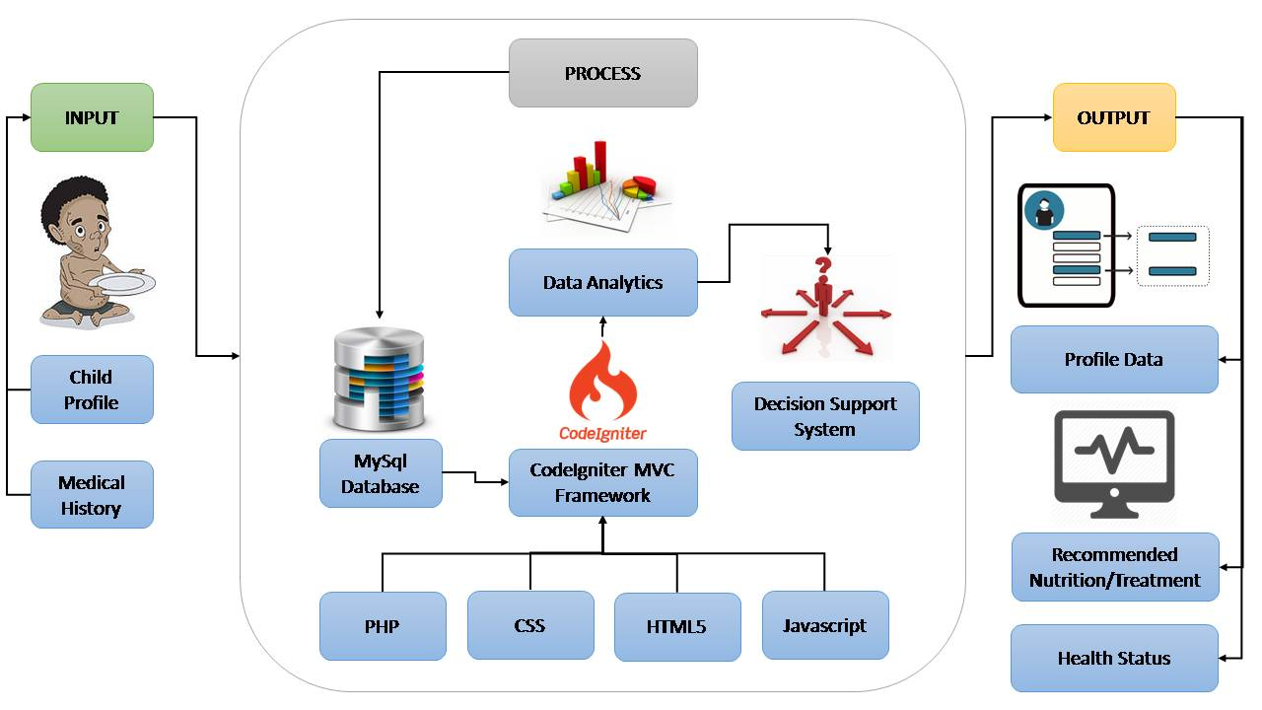

Figure 1: Input, process and output of the system

The first step of the proposed system is, the user will input the child’s basic information such as Name, date of birth, place of birth, age, sex, religion, initial weight, initial height, disability (if any), contact number, school the child is enrolled, home address, grade level, etc. Inputting family member’s information is also included in the system such as name, sex, relation to the child, age, marital status, educational attainment, occupation and income. Medical history of the child is a factor in data analytics as well as the weight and height so it should be properly inputted in the system for analysis. After all the information are being recorded, the next step is the system will process the records and will be stored in the database MYSQL. Then, the CodeIgniter MVC Framework which is a tool for Data Analytics that is composed of programming languages such as PHP, CSS, HTML5, JavaScript will access the Database then it would generate a Decision Support System. The system will then output a profile data of the child with the health status and recommended Nutrition/Treatment.

Data Analytics and Decision Support System Process

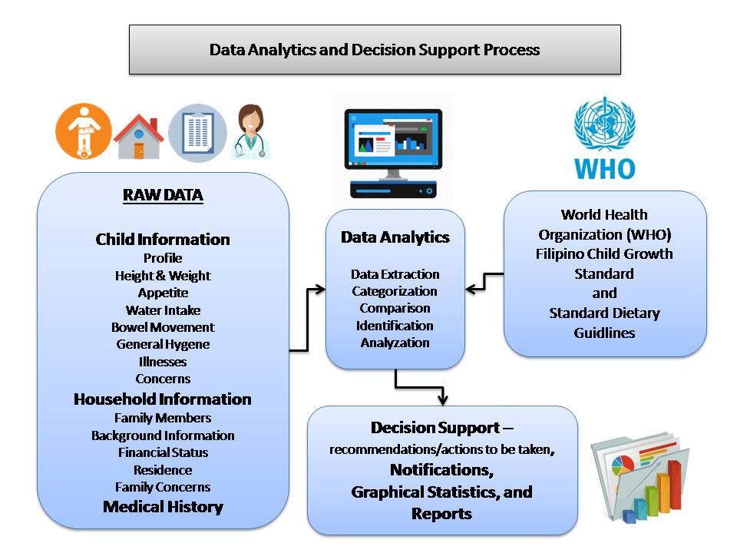
Figure 2 shows the process of data analytics and decision support system.

Based from the World Health Organization(WHO) Filipino Child Growth Standard and Standard Dietary Guidelines as baseline and from the raw data gathered such as Child Information, Household Information and Medical History. Data Analytics will be applied by Data Extraction, Categorization, Comparison, Identification and Analyzation. Also by using Decision Support System, recommendations will be given. Lastly, Notifications, Graphical Statistics and Reports will be generated.

Current System

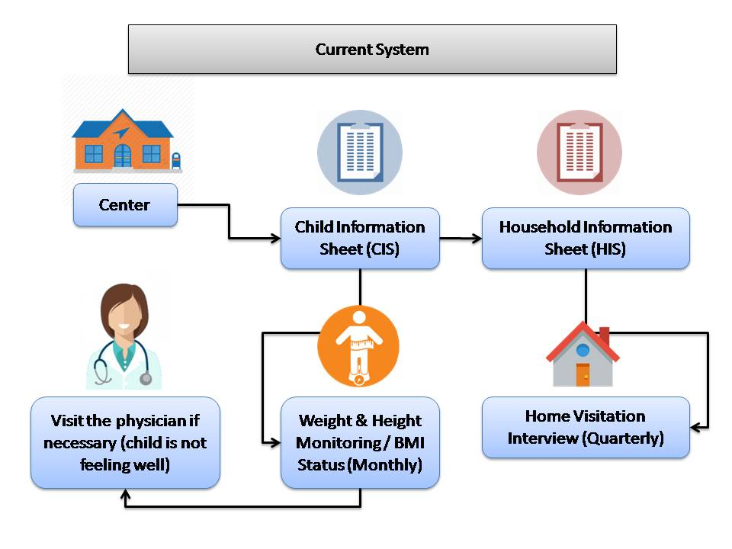

Figure 3 shows the current process in Data profiling of children of Archdiocesan Nourishment Center:

The first step is that children will visit the ANC, and children will enroll in their nutritional program, Information such as Name, Birthday, Place of birth, Age, Sex, Religion, Initial Weight, Initial Height, Disability (if any), Contact number, Home Address and Date of registration of the children will be written in their Child’s Information Sheet(CIS).
The next step is that ANC’s volunteers particularly social workers will visit the house of the child enrolled in their program to gather the household information, Information such as Ngalan sa Ulohan sa Pamilya (Head of the Family), Address, Mga Meyembro sa Pamilya (Members of the Family) and Date Interviewed will be Written in their Household Information Sheet(HIS). Then every quarter they will visit the household again to do Home Visitation Interview. Each quarter, they will gather and record information such as height, weight, appetite, water intake, bowel movement, general hygiene, date and time of the visit.

Lastly, monthly monitoring of height and weight of the child will be conducted to check BMI status. They can also visit the physician anytime if necessary, for example if the child is not feeling well.

Proposed System

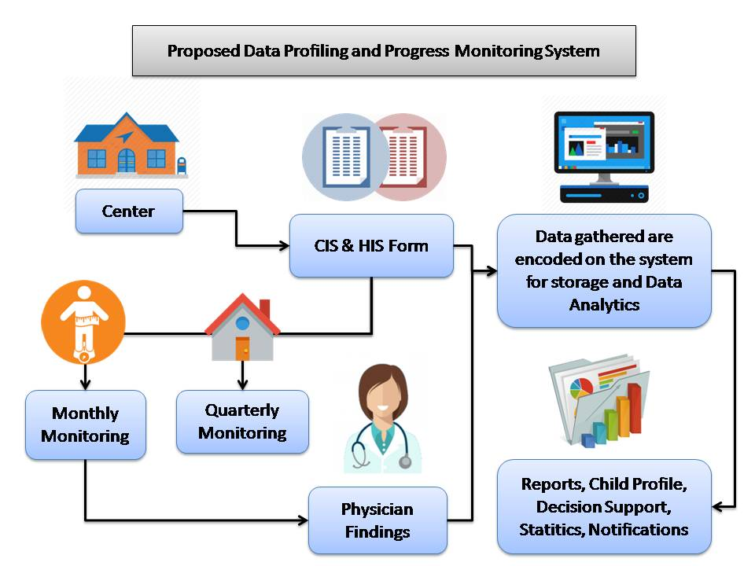

Figure 4 shows the proposed data profiling and progress monitoring application for Archdiocesan Nourishment Center:

The proposed system will help ANC in terms of data profiling and progress monitoring of each child under their program. Data gathered from the Child Information Sheet, Household Information Sheet, Monthly monitoring, Quarterly monitoring and Physician’s findings during check-ups will be encoded on the system for storage and Data Analytics. All data gathered will be stored in a centralized database. This proposed system will analyze the medical and nutritional status of the child, generate recommendations of possible treatments and proper nutritional diet, generate statistical reports in graphical representation, and will give notifications regarding the children that requires immediate medical attention, prioritization and medical schedules.

Development tools

PHP
Information technology is playing an important role in creating innovation in business. Due to increase in demand of information technology, web development has become an important field. PHP is an open source language, which is widely used in web development. PHP is used to develop dynamic web pages and it can connect with database. PHP has some good features i.e. cross platform compatibility, scalability, efficient execution and is an open source technology. These features make it a good choice for developers to choose PHP for web development. [1]
PHP is a popular open source scripting language which is suitable for web development. Moreover, PHP is different from JavaScript because the code is executed on the server and the output is sent to the client-side which makes the important code unknown. In addition, instead of complicated HTML, the PHP code has special processing commands which allow newcomers to use PHP easily, and provide advanced features for professionals. [2]

HTML
Hypertext Markup Language or HTML is a computer language which allows you to create websites. HTML has a text file short codes or simply called as tags. Tags separates simple text from HTML codes by using angle-brackets. And it allows you to have images and tables in you page.

The basis of every web site is the specification language it uses, HTML (Hypertext Markup Language). It structures the sites, and the current version HTML5 can access hierarchical object models of the site, which are accessed via JavaScript. CSS (Cascading Style Sheets) organize the graphic contents of the site.

CSS
Cascading Style Sheets or CSS offers complete coverage of this dynamic style language which allows you to design web pages. Using CSS, adding styles such as fonts and colors to your HTML documents will be easy and will help you create an appealing web pages. [4]

Cascading Style Sheet is a style sheet language used to layout web pages and allows you to line up and place HTML element in any position.

JavaScript
JavaScript was developed by Brendan Eich in 1995. It is a programming language that used by most browsers. And it was created to support object-oriented programming. This allows users to interact with web pages or control web pages.
JavaScript is rapidly becoming a universal language for every type of application, whether on the web, on the desktop, in the cloud, or on mobile devices. [5]

MYSQL
MySQL is the most widely-used open source SQL database management system, is developed, distributed, and supported by Oracle Corporation. Database Management System such as MySQL server is needed to add, access, and maintain data stored in a database which is a structured collection of data. [2]

CodeIgniter
CodeIgniter is a Model View Controller (MVC) framework which provides many remarkable features for programmers who implement their web sites using PHP. Not only CodeIgniter is a free, light, and fast framework, but also contains a specific set of libraries which are basically used such as accessing a database, sending emails, manipulating images, etc., also simple interfaces and logical structures. Moreover, it can generate clean URLs-, The 2014 Third ICT International Student Project Conference (ICT-ISPC2014) which easy to be searched by search-engines using segment based approach.

Page Numbering, Headers and Footers
Do not include headers, footers or page numbers in your submission. These will be added when the publications are assembled.

FIGURES/CAPTIONS
Place Tables/Figures/Images in text as close to the reference as possible (see Figure 1). It may extend across both columns to a maximum width of 17.78 cm (7”).
Captions should be Times New Roman 9-point bold. They should be numbered (e.g., “Table 1” or “Figure 2”), please note that the word for Table and Figure are spelled out. Figure’s captions should be centered beneath the image or picture, and Table captions should be centered above the table body.

SECTIONS
The heading of a section should be in Times New Roman 12-point bold in all-capitals flush left with an additional 6-points of white space above the section head. Sections and subsequent sub- sections should be numbered and flush left. For a section head and a subsection head together (such as Section 3 and subsection 3.1), use no additional space above the subsection head.

Subsections
The heading of subsections should be in Times New Roman 12-point bold with only the initial letters capitalized. (Note: For subsections and subsubsections, a word like the or a is not capitalized unless it is the first word of the header.)

Subsubsections
The heading for subsubsections should be in Times New Roman 11-point italic with initial letters capitalized and 6-points of white space above the subsubsection head.

Subsubsections
The heading for subsubsections should be in Times New Roman 11-point italic with initial letters capitalized.

Subsubsections
The heading for subsubsections should be in Times New Roman 11-point italic with initial letters capitalized.

ACKNOWLEDGMENTS
Our thanks to ACM SIGCHI for allowing us to modify templates they had developed.

REFERENCES

- Fayyaz, A. and Munir, M. 2014. Blekinge Institute of Technology, Faculty of Computing, Department of Computer Science and Engineering.
- Hathaiwichian, P., Siriwittayacharoen L., Wongwachirawanich, A. and Ragkhitwetsagul. 2014. Faculty of Information and Communication Technology Mahidol University Nakhonpathom, Thailand
- Krause, J. 2016. HTML: Hypertext Markup Language. Introducing Web Development. Apress, Berkeley, CA
- Sklar, J. 2001. Book Cascading Style Sheets. ACM DIGITAL LIBRARY. Boston, MA, United States ©2001
- Resig, J., Bibeault, B. and Maras, J. 2016. Secrets of the JavaScript Ninja. Manning Publications Co. Greenwich, CT, USA ©2016

Columns on Last Page Should Be Made As Close As Possible to Equal Length

