Real-Time Smoking Detection Using YOLOv11:
A Deep Learning-Based Surveillance Approach

Rahul Jilakara
Student Number: 20058017

Applied Research Project submitted in partial fulfilment of the requirements for the degree of
MSc in Computing
at Dublin Business School

Supervisor: [Supervisor Name]
May 2026

Declaration
I declare that this Applied Research Project that I have submitted to Dublin Business School for the award of MSc in Computing is the result of my own investigations, except where otherwise stated, where it is clearly acknowledged by references. Furthermore, this work has not been submitted for any other degree.

Signed: Rahul Jilakara
Student Number: 20058017
Date: May 2026

Acknowledgements
The author wishes to express sincere gratitude to the supervisor at Dublin Business School for their guidance and constructive feedback throughout the duration of this project. Appreciation is also extended to the open-source communities behind Ultralytics YOLO, Roboflow, and Streamlit, whose tools and publicly available datasets made this research feasible. Finally, gratitude is owed to family and friends for their continued encouragement and support.

Abstract
Tobacco use remains one of the most significant preventable causes of premature death globally, contributing to over eight million fatalities annually. Enforcing no-smoking regulations in public spaces presents considerable practical challenges, particularly when relying on manual human surveillance. This research addresses this gap by developing a real-time smoking detection system based on YOLOv11, a state-of-the-art convolutional object detection architecture. A core contribution of the study is the design of a two-class label strategy — distinguishing genuine cigarettes from visually similar objects such as pens and straws, termed cigarette_like_object — which substantially reduced false positive rates observed during live camera testing. Four experimental phases were conducted, including a comparative evaluation against YOLOv12, an attention-centric architecture released in early 2025. The final model, trained on a merged dataset of 4,398 images across 148 epochs, achieved a mean Average Precision at IoU threshold 0.50 (mAP@50) of 66.2% overall, with a cigarette-class mAP@50 of 78.4% and an inference speed of approximately 3.5 milliseconds per image. A functional Streamlit-based web application was developed as the artefact, supporting both image upload and live camera detection modes. Whilst full edge deployment on hardware such as Raspberry Pi or NVIDIA Jetson Nano was not achieved, the system demonstrated that a lightweight, practically deployable smoking detection model is attainable using transfer learning and carefully engineered training data.

Keywords: YOLOv11, smoking detection, object detection, deep learning, public health surveillance, computer vision, transfer learning, edge deployment

Table of Contents
Declaration ii
Acknowledgements iii
Abstract iv
List of Figures vi
List of Tables vii
1. Introduction and Overview 1
1.1 Research Aim 2
1.2 Research Objectives 2
1.3 Research Questions 3
1.4 Structure of the Report 3
2. Literature Review 4
2.1 Tobacco Use and the Need for Automated Surveillance 4
2.2 Evolution of the YOLO Architecture 5
2.3 Existing Smoking and Cigarette Detection Systems 5
2.4 Small Object Detection Challenges 6
2.5 YOLOv11 Architecture 7
2.6 YOLOv12 and Attention-Based Detection 7
2.7 Ethical and Legal Frameworks 8
3. Research Methodology and Design 9
3.1 Research Design and Paradigm 9
3.2 Dataset Sources and Collection 9
3.3 Data Preprocessing and Augmentation 11
3.4 Evaluation Metrics 11
3.5 Ethical Considerations 12
3.6 Deviations from the Original Proposal 12
4. Implementation and Development 13
4.1 Phase 1: YOLOv11s Baseline Model 13
4.2 Phase 2: YOLOv12s Comparative Evaluation 15
4.3 Phase 3: Multi-Class Merged Dataset 17
4.4 Phase 4: Final Two-Class Model 17
4.5 Artefact: Streamlit Web Application 21
5. Results and Findings 23
5.1 Model Comparison Summary 23
5.2 Final Model Performance 24
5.3 Confusion Matrix and Curve Analysis 25
5.4 Inference Speed and Deployment Suitability 27
5.5 Qualitative Results 27
5.6 Comparison with Prior Work 28
6. Conclusions and Future Work 29
References 33
Appendix A: Streamlit Application Screenshots 36

List of Figures
Figure 1.1: Overview of dataset label distribution (labels.jpg) 10
Figure 1.2: Sample training batch — Phase 4 merged dataset (train_batch0.jpg) 10
Figure 4.1: Box loss during training — Phase 1 YOLOv11s (box_loss_yolo_11.png) 14
Figure 4.2: Classification loss during training — Phase 1 YOLOv11s (class_loss_yolo11.png) 14
Figure 4.3: DFL (objectness) loss during training — Phase 1 YOLOv11s (object_loss_yolo_11.png) 14
Figure 4.4: Validation mAP and metric progression — Phase 1 YOLOv11s (model_performance_yolo11.png) 15
Figure 4.5: Advanced training plots — Phase 1 YOLOv11s (Advance_training_graphs_yolo_11.png) 15
Figure 4.6: Box loss during training — Phase 2 YOLOv12s (box_loss_yolo_26.png) 16
Figure 4.7: Classification loss during training — Phase 2 YOLOv12s (class_loss_yolo_26.png) 16
Figure 4.8: DFL (objectness) loss during training — Phase 2 YOLOv12s (object_loss_yolo_26.png) 17
Figure 4.9: Validation mAP and metric progression — Phase 2 YOLOv12s (model_performance_yolo26.png) 17
Figure 4.10: Advanced training plots — Phase 2 YOLOv12s (advance_plots_yolo_26.png) 17
Figure 4.11: Final model combined training and validation results overview (results.png) 20
Figure 5.1: Normalised confusion matrix — final two-class model (confusion_matrix_normalized.png) 25
Figure 5.2: Raw confusion matrix — final two-class model (confusion_matrix.png) 26
Figure 5.3: Box Precision-Recall curve — final model (BoxPR_curve.png) 26
Figure 5.4: Box F1-confidence curve — final model (BoxF1_curve.png) 26
Figure 5.5: Box Recall-confidence curve — final model (BoxR_curve.png) 27
Figure 5.6: Box Precision-confidence curve — final model (BoxP_curve.png) 27
Figure 5.7: Validation batch ground-truth labels — batch 0 (val_batch0_labels.jpg) 28
Figure 5.8: Validation batch model predictions — batch 0 (val_batch0_pred.jpg) 28
Figure 5.9: Validation batch ground-truth labels — batch 1 (val_batch1_labels.jpg) 28
Figure 5.10: Validation batch model predictions — batch 1 (val_batch1_pred.jpg) 28

List of Tables
Table 3.1: Dataset composition by source 10
Table 4.1: Phase 1 training configuration — YOLOv11s baseline 13
Table 4.2: Phase 1 internal and external validation results 14
Table 4.3: Phase 1 per-class mAP@50 on Roboflow external test set 15
Table 4.4: Phase 2 training configuration — YOLOv12s 16
Table 4.5: Phase 2 internal and external validation results 16
Table 4.6: Phase 4 final model training hyperparameters 18
Table 4.7: Phase 4 data augmentation configuration 19
Table 4.8: Training convergence — selected epoch checkpoints 20
Table 4.9: Key technical decisions and rationale 22
Table 5.1: Comparative results across all experimental phases 23
Table 5.2: Final model per-class performance (epoch 118 best checkpoint) 24

Chapter 1: Introduction and Overview
Tobacco use is one of the biggest public health problems of this time. There are more than eight million people who die prematurely each year because of tobacco use, of which over seven million die from direct tobacco consumption and around 1.3 million dies from exposure to second hand smoke, according to the World Health Organization (2023). In addition to the death toll, smoking has a clear link with the development of chronic conditions such as cardiovascular disease, chronic obstructive pulmonary disease (COPD) and lung cancer. Although world-wide measures have been taken to curb smoking prevalence through taxation, public awareness campaigns and legislative measures that prohibit smoking in shared areas, enforcement of these measures is a constant challenge especially in places with high foot traffic, like transport hubs, schools, hospitals, and commercial buildings.
The enforcement challenge of no-smoking rules is due to the labour-intensive aspect of conventional monitoring methods. Manual surveillance is dependent on the constant supervision of security guards and falls short in the areas of human error, fatigue and resources. Has poor scalability in large or multi-zoned environments, and no traceability of violations. The restrictions provide a strong motivation to consider automated, technology-based solutions that can identify smoking behavior in real-time, with high accuracy.
In recent years, the possibilities for automated visual surveillance have been broadened, with recent deep learning achievements, particularly in object detection. The myofamily of models, collectively known as the You Only Look Once (YOLO) family of models, has become a major paradigm for real-time detection tasks, with a good balance of detection accuracy and inference speed. YOLOv11, the latest member of the series as of this writing, released in late 2024 at the YOLO Vision conference, features architectural innovations such as the C3K2 block, Spatial Pyramid Pooling Fast (SPPF), and the C2PSA attention module, all of which enhance feature extraction efficiency and small-object detection capability (Khanam and Hussain, 2024). Even with these developments, as of mid-2025, there was no published study of using YOLOv11 for smoking detection specifically.As of mid-2025, however, no published research had been conducted on smoking detection using YOLOv11. To fill this gap, this study proposed and tested a real-time smoke detection system which utilizes YOLOv11 for detection. To meet this gap, this study proposed a real-time smoke detection system based on YOLOv11. The main research problem is divided into three parts: Firstly, is the fine-tuned YOLOv11 model able to detect the cigarettes and the smoking related behaviors within the desired accuracy in the desired dataset; Secondly, how does the model perform compared to the next version of the YOLO architecture, YOLOv12, under the same experimental set up; Thirdly, is there any meaningful difference in the number of false cigarette detections in real camera systems when using a carefully engineered two-class label strategy that differentiates true cigarettes from the visually similar elongated objects such as pens, pencils and straws.

1.1 Research Aim
This study aims at building a real-time smoking detection system based on the YOLOv11 model to accurately detect cigarette smoking and smoking behaviours in images and live videos and to create a working web-based artefact that will showcase the usefulness and applicability of the system for public health surveillance applications.

1.2 Research Objectives
The following goals were used to carry out this research:
To curate and construct a comprehensive training set where some of the pictures are from publicly available image collections on smoking and the others are collected by hand from visually similar objects that are not smoking.
- To optimise the model YOLOv11s to detect smoking and provide a performance baseline for a standard object detection evaluation.
- To make a comparative analysis between YOLOv11s and YOLOv12s on the same dataset, and study the architectural trade-offs in this detection scenario.
- To design and test a two-class labelling strategy that minimizes false positive labels of cigarette-like objects in real world environment.
- To create a working Streamlit web based artefact to assist with image and live video detection modes. To discuss ethical issues that can arise in the use of AI-powered surveillance systems, such as privacy, bias, and regulatory compliance.

1.3 Research Questions
RQ1: What is the accuracy of a fine-tuned YOLOv11s model in detecting cigarettes and smoking behaviours under various scenes?
RQ2: How is detection performance of YOLOv11s in comparison with that of YOLOv12s using the same two classes merged dataset?
RQ3: How would a two-class approach that includes the cigarette-like objects as a separate negative class affect the false positive count for live camera inference?
RQ4: What are the main ethical issues in the implementation of an automatic smoking detection system and what are the possible ways to address these issues?

1.4 Structure of the Report
The rest of this report will be structured as follows: The relevant literature is reviewed in Chapter 2, which includes the history of YOLO architectures, existing research on the detection of smoking and cigarettes, small object detection problems, and relevant ethical considerations. The research methodology and design, dataset preparation, experimental setup and evaluation criteria are detailed in Chapter 3. In Chapter 4, all the experimental phases are explained as well as the development of the Streamlit artefact. The findings from each experimental phase are presented and discussed in Chapter 5, in the context of previous studies. Chapter 6 offers conclusions, recognizes the study's limitations, and suggests directions for future studies.

Chapter 2: Literature Review

2.1 Tobacco Use and the Need for Automated Surveillance
The magnitude of tobacco-related deaths has continued to capture world policy attention in terms of effective enforcement mechanisms. However, despite progress toward measurable declines in smoking rates in a number of high income countries, the total number of people smoking in the world is around 1.3 billion, as reported on the World Health Organization's Global Tobacco Epidemic Report (WHO, 2023). The economic impact is also significant: PAHO/WHO estimated that the total health care expenditure and productivity losses associated with smoking cost USD 1.4 trillion per year (2022). The figures highlight the need for scalable and uniform systems to ensure that policies governing smoking in shared public areas are enforced.
Traditional enforcement based on human observation has its inherent limitations. It can be very difficult for surveillance staff to always be present, especially in a large or multi-zone facility, and manual enforcement is subject to possible bias and inconsistencies. A scalable and auditable option is computer vision-based detection systems that can function unattended and continuously monitor for violations, providing a hard copy of violations detected. The authors of Khan et al. (2022) showed that this is possible by designing a smoker classification system based on CNN with the architecture of InceptionResNetV2 on a curated indoor/outdoor dataset, which gave them a classification accuracy of 96.87%. They used an approach, however, that did not spatially localise, which meant that they performed binary classification (smoking vs non-smoking), and so was not suitable for real-time detection in continuous video streams. This research problem is also relevant as a comprehensive survey by Khan et al. (2025) showed that there is no single existing system that can perfectly balance the conflicting requirements of high accuracy and real-time edge performance.

2.2 Evolution of the YOLO Architecture
YOLO (You Only Look Once) models for object detection have been rapidly improving, through a series of iterations, since their introduction by Redmon et al. in 2016. Both versions have solved the limitations of the previous version, while keeping the single-stage detection paradigm that underpins the real-time capability. YOLOv3 added the multi-scale feature detection network based on Darknet-53, which enhances the ability of detecting smaller objects. YOLOv4 was built by incorporating the CSPDarknet backbone, the mosaic augmentation, and the CIoU loss to get around 65 FPS on a V100 GPU with 43.5% COCO AP. In 2023, Ultralytics published YOLOv8, which took the paradigm of detection and made it more anchor-free and developed a more modular training pipeline (Jocher et al., 2023). He et al. (2025) conducted an in-depth comparative study of YOLOv5 to YOLOv11 for power equipment object detection, and the results showed that the detection performance of YOLOv11 continued to improve, with the highest mean Average Precision (mAP) achieving 57.2% in the series.

2.3 Existing Smoking and Cigarette Detection Systems
Smoking detection using deep learning has gained a lot of interest recently, but most of the proposed systems are severely constrained by real-world deployability. YOLOv8-MNC, with the addition of multi-head spatial attention (MHSA) and enhanced upsampling, was introduced by Wang et al. (2023) to obtain a mAP of 85.9% on a smoking behaviour dataset. Although the model performed well with respect to accuracy, its inference speed and suitability for deployment on resource-constrained devices were not examined. Likewise, Pundhir et al. (2021) used region-based feature extraction methods with YOLOv3, which achieved classification accuracy of over 96%, but did not conduct any tests on edge hardware, so these results cannot be interpreted in practice.
Lakatos et al. (2024) used a multimodal approach using image and text data to detect smoking with the image classification algorithm EfficientNet B5, obtaining an accuracy of 74%. Even though the concept is novel, the computational burden of having two big pre-trained models run concurrently is prohibitive for the resource-limited setting in surveillance. Ma et al. (2022) modified the YOLOv5 backbone to incorporate fine-grained spatial pyramid pooling and multi-spatial attention to realize the YOLO-Cigarette model, which had an accuracy of 95.2% and 49 FPS. The existing system, however, was only tested under outdoor conditions and was not able to consider false positive susceptibility due to items with the same cylindrical shape as cigarettes. In 2025, a new idea was proposed (arxiv: 2508.11696) to use a CCTV system in the smoking areas of exits from the building. The authors showed how the YOLO-based frameworks could be adapted to specific surveillance scenarios, but they pointed out that there is a persistent lack of evaluation of the ability of these systems to be deployed on the edge across the literature.

2.4 Small Object Detection Challenges
Cigarettes are an especially difficult detection target because they are tiny, rotate in various orientations, are partially hidden, and are visually similar to other elongated objects. Liu et al. (2021) have got a comprehensive survey of deep learning algorithms for small objects detection, stating that most YOLO models don't perform well with small objects (less than 32 × 32 pixels) often seen in CCTV systems with subjects at a distance from the camera. Cheng et al. (2023) also confirmed the importance of context preservation and high feature resolution in reliable small object detection by conducting a large-scale benchmarking. There have been a few architectural solutions offered in the YOLO realm. YOLO-Z is an extension of YOLOv5 specially designed for small object localisation, introduced by Benjumea et al. (2021).
To solve the small target detection problem, Tang et al. (2024) introduced a new model named HIC-YOLOv5, which achieves even better performance by integrating hierarchical context information. These developments put into perspective the possible design options for a system for objects the size of a cigarette and justify the selection of the C2PSA (spatial attention) component of the YOLOv11 system as particularly relevant for this problem domain.

2.5 YOLOv11 Architecture
At the start of this research, the latest version of the YOLO series, YOLOv11, was introduced at the YOLO Vision 2024 conference, which is the newest CNN-based iteration. Khanam and Hussain (2024) present a detailed architectural analysis of the model, highlighting that it has three main improvements over YOLOv8: C3K2 (Cross Stage Partial with kernel size 2) block is introduced to enhance the efficiency of feature extraction with cross-stage partial connections; Spatial Pyramid Pooling Fast (SPPF) module is added to capture contextual information at different scales without a proportional increase in computational cost; C2PSA (Convolutional block with Parallel Spatial Attention) module is added to apply spatial attention to direct the model to focus on semantically relevant regions. These features enable YOLOv11 to outperform its predecessor, YOLOv8, in terms of mAP on the COCO benchmark while simultaneously having fewer parameters, which is crucial for deployments in latency-sensitive environments (Terven et al., 2023).

2.6 YOLOv12 and Attention-Based Object Detection
YOLOv12 is a new architecture from the paper: Tian et al., 2025 from Feb 2025, which is quite different from the CNN-based YOLO line. Instead of just convolutional operations, YOLOv12 also adds an Area Attention mechanism, which is a non-overlapping horizontal split of feature maps for large receptive fields and saves computation by cutting down on quadratic complexity. The model also adds Residual Efficient Layer Aggregation Networks (R-ELAN) to better aggregate features and solves the inefficiency problem of accessing memory by using FlashAttention. Later Khanam and Hussain (2025) released a comparative review to validate the above claims and the results indicated that YOLOv12 outperforms previous YOLO versions on the standard benchmarks with respect to the latency-accuracy trade-off. The current study was the first to test YOLOv12 for smoking detection, thereby offering another contribution opportunity.

2.7 Ethical and Legal Frameworks
Substantive ethical and legal issues need to be taken into consideration at the design stage because of the deployment of automated visual surveillance systems. One of the foremost of these is the privacy violation risk, as a surveillance system that can identify smoking activity has video footage of people in public areas, which could also be used inappropriately, for longer than necessary for the system to operate, or repurposed for other purposes. The General Data Protection Regulation (GDPR) has strict requirements in the European context regarding the processing of personal data, such as only collecting data which is required, and installing technical measures to prevent unauthorised access (Mittelstadt et al., 2021). A smoking detection system for use in the European Union would, therefore, must entirely process the video internally, retain only anonymized logs, and not allow for any kind of biometric identification. Another issue is algorithmic bias: the algorithm may perform differently for some groups than for others, particularly if it is trained on an insufficiently diverse sample of the demographic makeup of the surveillance area. The reality of such bias has been shown to have real-world impact for commercial facial analysis systems by Raji and Buolamwini (2019), who serve as a warning bell for surveillance AI more broadly. The use of a smoking detection system, therefore, needs to be responsible and must be done not only at the stage of training the dataset, but also at the stage of operating the system. These considerations were considered when developing the strategy for curating the data set (Chapter 3).

Chapter 3: Research Methodology and Design

3.1 Research Design and Paradigm
Discuss the research design and paradigm.Talk about Research Design and Research Paradigm. This study used applied experimental research with positivist epistemological paradigm. The main goal is to create and test a technical solution to a real-world problem rather than to build up a wealth of theory. The quantitative evaluation metrics are the main metrics for evaluating the performance of the model, namely mAP, Precision, Recall, F1-score, and inference speed. The experimental design is sequential multi-phase, with each phase providing feedback for the design of the subsequent phase, and with the experimental system being iterated across the phases to progressively enhance the detection system. The method is in line with the iterative and evidence-driven development that is used in applied machine learning research (Géron, 2022).

3.2 Dataset Sources and Collection
In this study, the data sets was collected from four different sources and then combined into a single training set. The smoking dataset used was the publicly accessible dataset Roboflow smoking (project identifier: smoking-tasfx-7knuj), which consists of 5,786 images labeled into five categories: Cigarette, Person, Smoke, Vape, and Smoking. This dataset was chosen due to its level of annotation, wide range of classes, and established usage in research on smoking detection, which was published in peer-reviewed journals (Wang et al., 2023; Khan et al., 2025). The other three sources were negative example datasets created specifically for the false positive problem during initial live camera testing. These were comprised of 615 straw images, 667 pen/pencil images from a variety of contexts and an additional set of 148 images of a pen/pencil variant, for a total of 1,430 images of negative examples for the pens/pencils. These negative examples were chosen with this in mind that they have the same thin, long, cylindrical shape of a cigarette. After merging, deduplication and splitting, the final set had 3478 images in the training set and 920 images in the validation set. The final training set is shown in Figure 1.1 with the distribution of the annotation labels.
Table 3.1: Dataset composition by source
Dataset | Images | Source / Description
Smoking (primary) | 5,786 | Roboflow — cigarettes, smoke, person, vape, smoking classes
Straw images | 615 | Custom collected — negative examples for false positive reduction
Pen dataset v1 | 667 | Custom collected — pen and pencil negative examples
Pen dataset v2 | 148 | Supplementary pen variation images
Total (raw) | 7,216 | Prior to merging, splitting, and deduplication
Training set (final) | 3,478 | 60 background images; 5,132 cigarette + 2,296 cigarette-like annotations
Validation set (final) | 920 | 84 background images; 1,097 total annotations

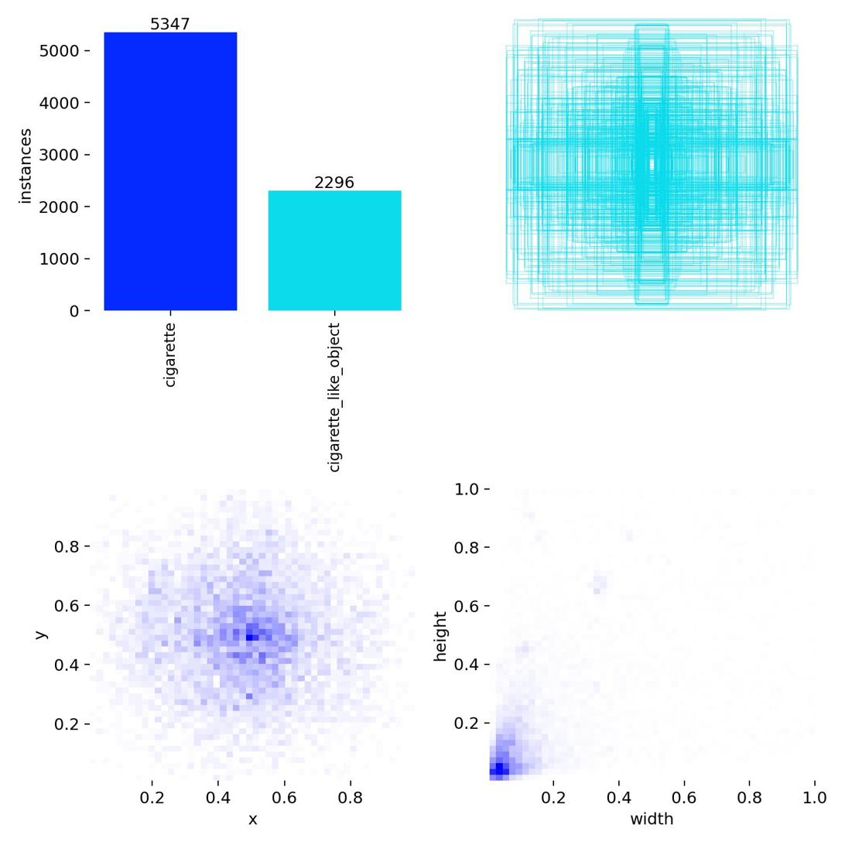
Figure 1.1: Overview of dataset label distribution — bounding box positions, class frequencies, and size distribution across the final training set
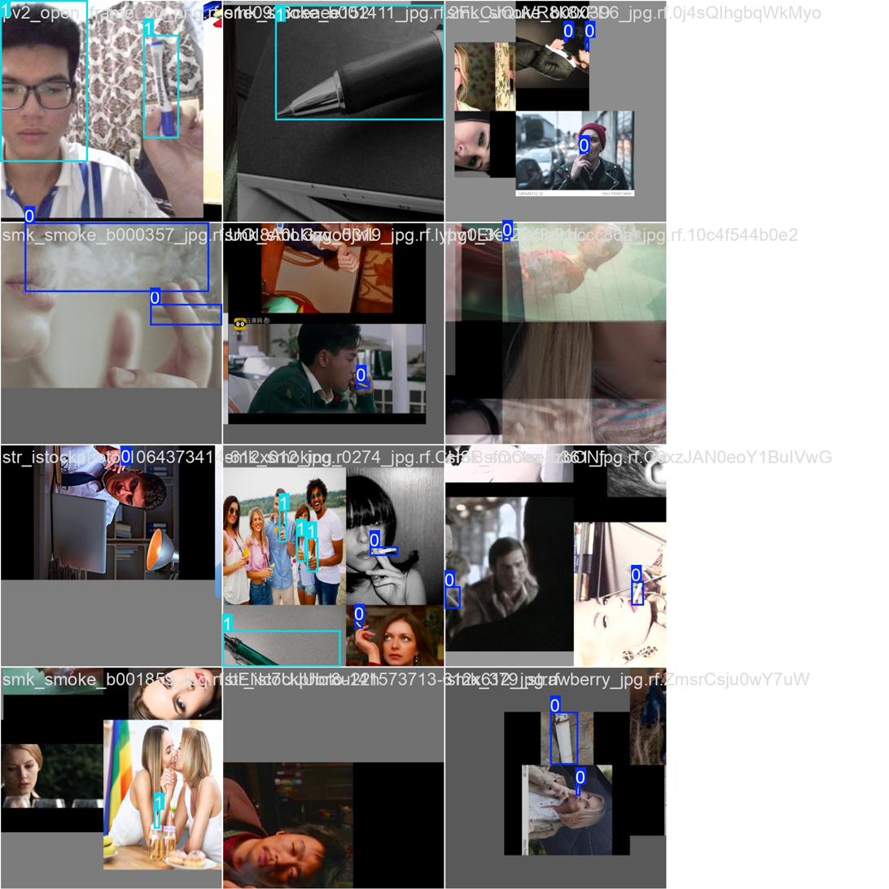
Figure 1.2: Sample training batch from the Phase 4 merged two-class dataset, illustrating annotation diversity across cigarette and cigarette_like_object classes

3.3 Data Preprocessing and Augmentation
All annotations were processed and checked with Roboflow, which gives automated quality checks for the bounding boxes and the integrity of the class labels. A label remapping process was first applied to reduce the number of classes in the label set before training the final model. The original 5 class Roboflow annotations were reduced to only two classes: cigarette - all instances of cigarette, smoking, and smoking-person annotations are classified in this category; and cigarette_like_object - all pen, pencil, and straw annotations are classified in this category. All 6801 label files were remapped, with 69% (5132 instances) of them being remapped to cigarette labels and 31% (2296 instances) being remapped to cigarette-like_object labels.
The training process involved a comprehensive data augmentation strategy for generalisation of the model. The augmentations were HSV colour-space perturbation (hue: ±0.015, saturation: ±0.7, value: ±0.4), horizontal flipping (0.5 probability), mosaic augmentation (1.0 probability), mixup (0.15 probability), random erasing (0.4 probability), and scale variation (factor 0.5). Blurring using Albumentations, median blurring, greyscale and CLAHE transforms were applied with each probability 0.01. The importance of resolution for detecting thin objects at typical surveillance distances encouraged us to increase the image resolution from 320 × 320 pixels to 640 × 640 pixels for the final model, beyond what was used during Phase 1.

3.4 Evaluation Metrics
The standard object detection metric suite was used to evaluate the performance of the model. The main performance indicator was the mean Average Precision at an Intersection over Union threshold of 0.50 (mAP@50), which reflected both the accuracy of the localisation and the correctness of the classification. The mean Average Precision (mAP) calculated at 10 IOU thresholds (mAP@50-95) was a stricter evaluation of the quality of the bounding boxes. Per-class Precision, Recall and F1-score were calculated at the best confidence value. The time to make inferences was recorded for each image, with the average time per image recorded in milliseconds.

3.5 Ethical Considerations
The ethical dimensions of this research were considered at three levels: data collection, model development, and intended deployment. All images used for training were sourced from publicly available datasets under permissive licences, and no personally identifiable information was retained or processed beyond what was necessary for annotation purposes. No participants were recruited and no human subjects research ethics approval was therefore required.
With respect to model development, the inclusion of diverse negative examples was motivated in part by a commitment to reducing false positive rates that could unfairly flag individuals who were not smoking. At the deployment level, the Streamlit application was designed to operate entirely locally, with no cloud transmission of video data and no biometric identification capability. The system produces anonymised detection logs only. These design principles reflect the requirements of GDPR and are consistent with ethical guidelines for AI-based surveillance (Mittelstadt et al., 2021). Future operational deployment would additionally require a Data Protection Impact Assessment and explicit notification to individuals entering monitored zones.

3.6 Deviations from the Original Research Proposal
The original proposal anticipated several components that were not ultimately implemented. These deviations are documented here in the interest of transparency and academic integrity. First, the proposal described optimisation of the YOLOv11 model for edge deployment using quantization (8-bit integer precision) and pruning, with the intention of deploying the system on a Raspberry Pi 4 or NVIDIA Jetson Nano. These optimisation steps were not applied given the iterative experimental timeline, and the trained model remains in full-precision (FP32) format. Second, the proposed SMS alert integration via API and physical edge deployment were not completed within scope. Third, the proposal did not include a comparative evaluation against YOLOv12, which was added as an additional research contribution following its release in February 2025.

Chapter 4: Implementation and Development

4.1 Phase 1: YOLOv11s Baseline Model
The first experimental phase was designed to establish a performance baseline by fine-tuning YOLOv11s on the publicly available Roboflow smoking dataset without modification. YOLOv11s was selected as the starting architecture on the basis of its parameter efficiency: at 9.41 million parameters and 21.3 GFLOPs, it offers a substantially smaller computational footprint than YOLOv11m (38.8 million parameters) whilst retaining all architectural enhancements described by Khanam and Hussain (2024).
Table 4.1: Phase 1 training configuration — YOLOv11s baseline
Parameter | Value
Model | YOLOv11s (9.41M parameters, 21.3 GFLOPs)
Pretrained weights | COCO
Epochs | 50
Image resolution | 320 × 320 px
Batch size | 16
Optimiser | SGD (default)
GPU | NVIDIA Tesla T4 (15 GB VRAM)
Training time | ~3.4 minutes (~0.057 hours)

Training convergence was rapid and stable. The figures below (Figures 4.1–4.3) present the box, classification, and DFL (objectness) loss curves, which all exhibited smooth monotonic decline across the 50 epochs. Figure 4.4 shows the corresponding mAP@50 and mAP@50-95 progression on the validation set.
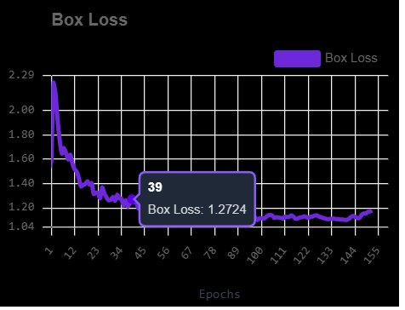
Figure 4.1: Box (localisation) loss during training — Phase 1 YOLOv11s baseline. Smooth monotonic decline indicates stable convergence.
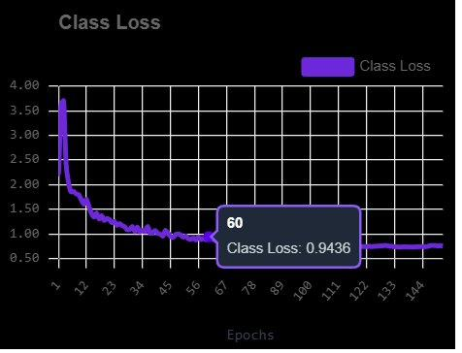
Figure 4.2: Classification loss during training — Phase 1 YOLOv11s baseline.
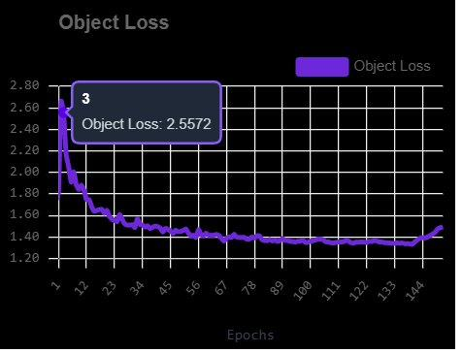
Figure 4.3: Distribution Focal Loss (DFL/objectness) during training — Phase 1 YOLOv11s baseline.
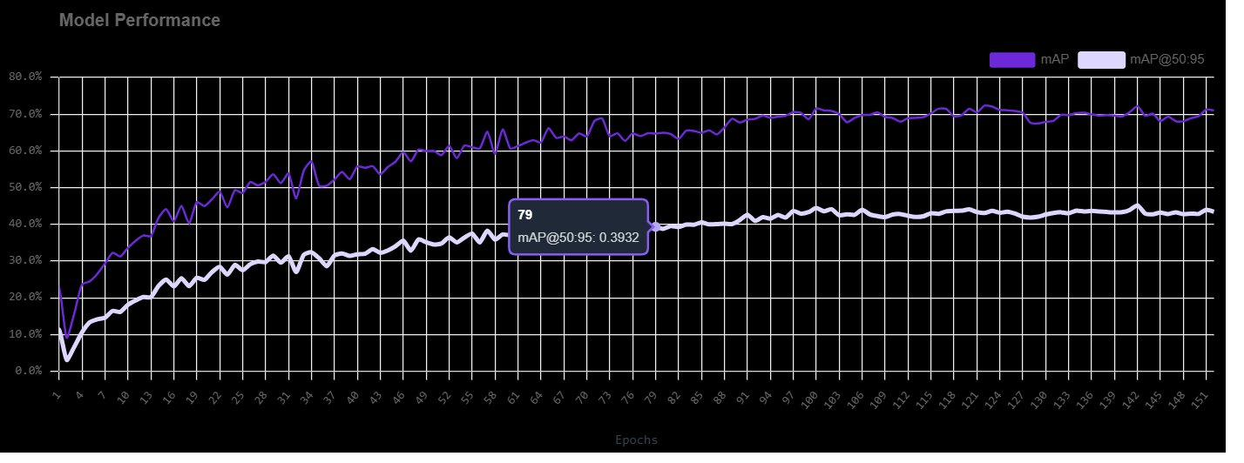
Figure 4.4: Validation mAP@50, mAP@50-95, Precision, and Recall progression across 50 epochs — Phase 1 YOLOv11s.
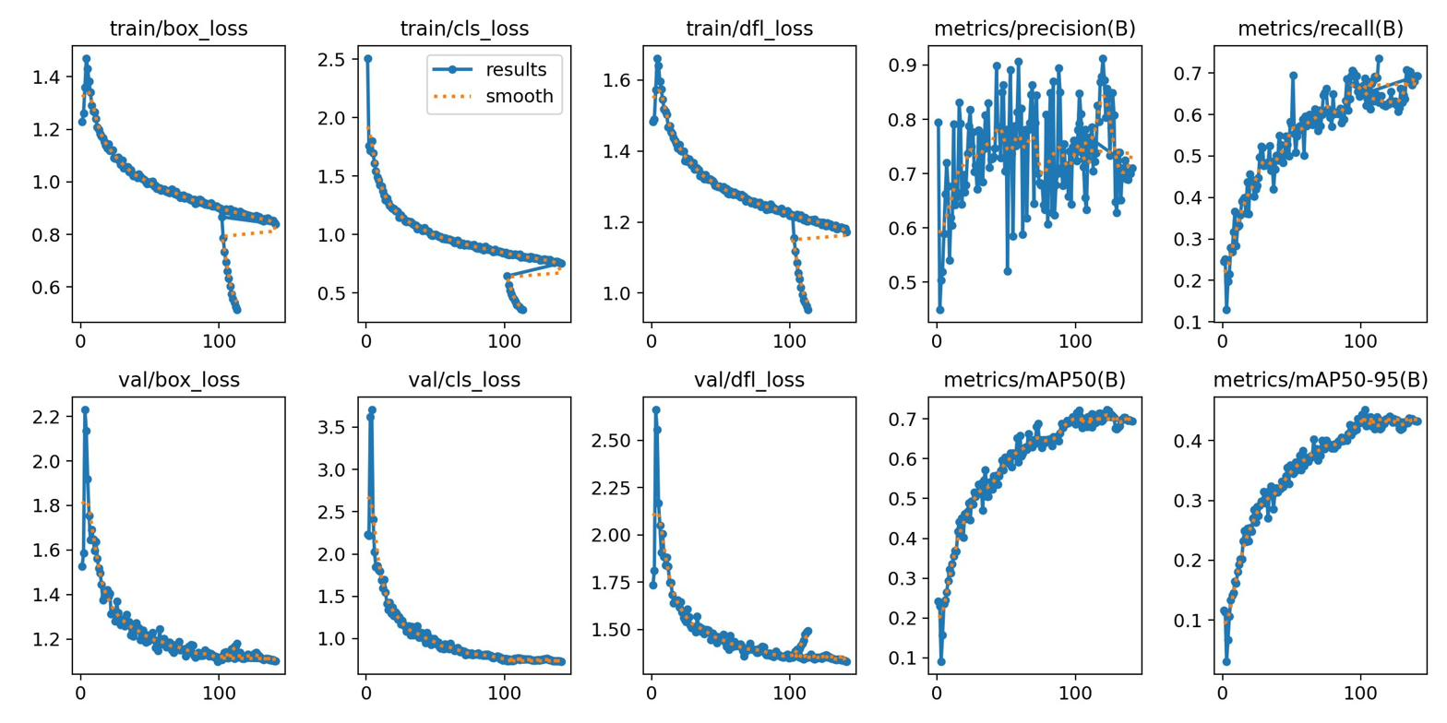
Figure 4.5: Advanced training plots (learning rate schedules, gradient norms) — Phase 1 YOLOv11s.
Table 4.2: Phase 1 internal validation and Roboflow external evaluation results
Metric | Internal Validation | Roboflow External
mAP@50 | 82.6% | 72.1%
mAP@50-95 | 38.9% | —
Precision | 81.9% | 84.8%
Recall | 77.4% | 68.6%
F1-Score | — | 75.9%
Inference speed | 1.9 ms/image | —

Table 4.3: Phase 1 per-class mAP@50 on Roboflow external test set
Class | mAP@50 (Roboflow External)
Cigarette | 80%
Person | 93%
Smoke | 56%
Vape | 36%
Smoking | 88%

Whilst these metrics were acceptable for a baseline model, live camera testing revealed a critical practical failure. The model consistently misclassified pens, pencils, and straws as cigarettes with high confidence scores frequently exceeding 0.80. This was an anticipated consequence of training exclusively on images of cigarette-related objects: the model had learned to associate the thin cylindrical shape held in hand with the cigarette class, a visual feature shared by many common everyday objects. This false positive problem was deemed unacceptable for any real-world deployment context.

4.2 Phase 2: YOLOv12s Comparative Evaluation
The second phase introduced a comparative evaluation against YOLOv12s, the small variant of the attention-centric architecture introduced by Tian et al. (2025). YOLOv12 replaces the C3K2 convolutional blocks of YOLOv11 with Area Attention layers (A2C2f blocks), which divide feature maps into horizontal sub-regions and apply efficient self-attention within each region. This mechanism theoretically provides larger receptive fields, which was hypothesised to be advantageous for detecting thin elongated objects such as cigarettes. YOLOv12s comprises 9.1 million parameters and 19.6 GFLOPs.
Table 4.4: Phase 2 training configuration — YOLOv12s
Parameter | Value
Model | YOLOv12s (9.1M parameters, 19.6 GFLOPs)
Pretrained weights | COCO
Epochs | 50
Image resolution | 320 × 320 px
Batch size | 16
Optimiser | AdamW (lr=0.001111, momentum=0.9)
GPU | NVIDIA Tesla T4 (15 GB VRAM)

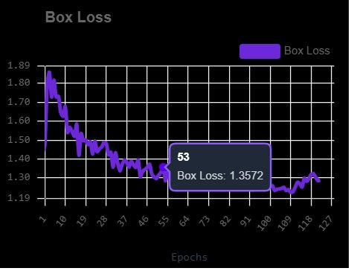
Figure 4.6: Box loss during training — Phase 2 YOLOv12s. Note the less smooth convergence profile compared with Figure 4.1.
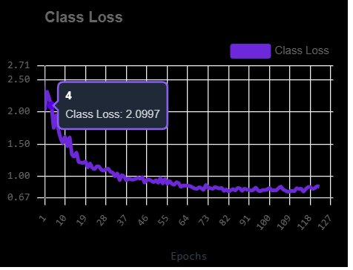
Figure 4.7: Classification loss during training — Phase 2 YOLOv12s.
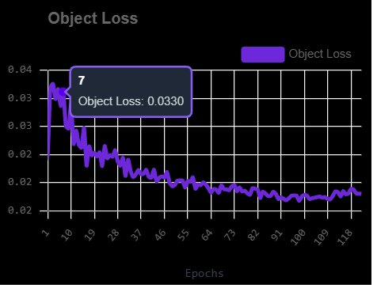
Figure 4.8: DFL (objectness) loss during training — Phase 2 YOLOv12s.
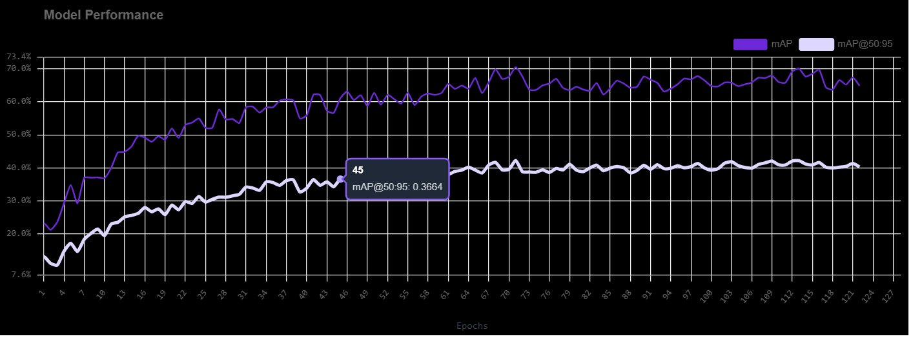
Figure 4.9: Validation mAP@50, mAP@50-95, Precision, and Recall progression — Phase 2 YOLOv12s. The mAP@50 peak of 66% is notably lower than Phase 1.
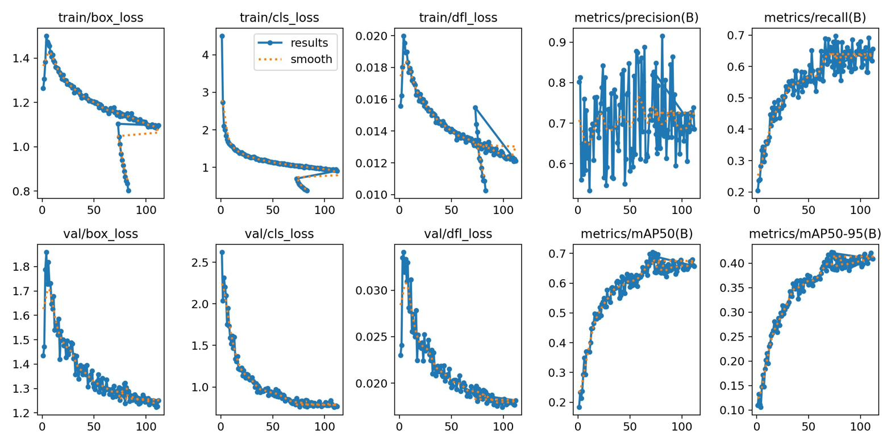
Figure 4.10: Advanced training plots — Phase 2 YOLOv12s.
Table 4.5: Phase 2 internal validation and Roboflow external evaluation results
Metric | Internal Validation | Roboflow External
mAP@50 | 66.0% | 70.6%
mAP@50-95 | 43.7% | —
Precision | 79.7% | 82.2%
Recall | 63.6% | 65.1%
F1-Score | — | 72.7%

The underperformance of YOLOv12s relative to YOLOv11s can be attributed to two factors. First, the Area Attention mechanism's advantage over convolution is most pronounced at higher image resolutions and with larger model sizes; at 320 × 320 pixels and the small model scale, the convolutional efficiency of YOLOv11s's C3K2 blocks offers a more reliable inductive bias for fine-grained spatial features. Second, as noted by Ultralytics (2025), YOLOv12 exhibits training instability and elevated memory consumption relative to YOLOv11, which may have contributed to suboptimal convergence within the 50-epoch budget. YOLOv11s was consequently selected as the architecture to carry forward.

4.3 Phase 3: Multi-Class Merged Dataset (Intermediate)
The third phase directly addressed the false positive problem by incorporating the custom-collected negative example datasets into the training corpus. All four datasets were merged, retaining the original five cigarette-related classes whilst adding pen/pencil and straw as distinct negative classes. The result was a marked degradation in overall mAP@50 to approximately 50%, attributed to class imbalance between the 5,786 smoking-related images and the 1,430 negative example images. The key insight from this phase was that granularity of negative class labels was unnecessary: the system need not distinguish between pens, pencils, and straws — it need only learn that these objects are not cigarettes. This motivated the two-class simplification adopted in Phase 4.

4.4 Phase 4: Final Two-Class Model
The fourth and final experimental phase incorporated the key insight from Phase 3 by collapsing all non-cigarette elongated objects into a single cigarette_like_object class. All original cigarette, smoking, and smoking-person annotations were assigned to class 0 (cigarette); all pen, pencil, and straw annotations were assigned to class 1 (cigarette_like_object). This remapping was applied programmatically across all 6,801 label files in the merged dataset.

4.4.1 Training Configuration
The final model was trained using a substantially enhanced configuration. Image resolution was increased from 320 × 320 to 640 × 640 pixels, critical for detecting thin objects at typical surveillance distances. The AdamW optimiser was selected for its superior convergence stability for fine-grained two-class problems. A cosine annealing learning rate schedule was employed with an initial rate of 0.001 and a five-epoch linear warm-up phase. Maximum configured epochs were 150, with early stopping triggered if no improvement was observed over 30 consecutive epochs.
Table 4.6: Phase 4 final model training hyperparameters
Parameter | Value
Model | YOLOv11s (9,428,566 parameters, 21.6 GFLOPs)
Pretrained weights | COCO (493/499 layers transferred)
Epochs configured / run | 150 / 148 (early stop triggered)
Best epoch | 118
Image resolution | 640 × 640 px
Batch size | 16
Optimiser | AdamW
Learning rate (lr0 / lrf) | 0.001 / 0.01 (cosine annealing)
Warmup epochs | 5
Weight decay | 0.0005
Early stopping patience | 30 epochs
Classification loss weight (cls) | 0.7
AMP (mixed precision) | Enabled
GPU | NVIDIA L4 (22,563 MB VRAM)
Training time | 1.782 hours

Table 4.7: Phase 4 data augmentation configuration
Augmentation | Value / Probability
HSV hue shift | 0.015
HSV saturation | 0.7
HSV value | 0.4
Horizontal flip | 0.5
Mosaic | 1.0
Mixup | 0.15
Random erasing | 0.4
Scale variation | 0.5
Albumentations (blur, CLAHE, greyscale) | 0.01 each

4.4.2 Training Convergence
Training exhibited stable and consistent convergence across all 148 epochs. Box regression loss, classification loss, and DFL loss all demonstrated sustained monotonic reduction with no evidence of oscillation or catastrophic divergence. Table 4.8 presents selected epoch checkpoints illustrating the convergence trajectory, and Figure 4.11 presents the combined training and validation results overview across all tracked metrics.
Table 4.8: Training convergence — selected epoch checkpoints
Epoch | mAP@50 | Precision | Recall
1 | 0.249 | 0.384 | 0.277
10 | ~0.38 | ~0.58 | ~0.38
50 | ~0.55 | ~0.75 | ~0.55
100 | ~0.63 | ~0.80 | ~0.60
118 (best) | 0.662 | 0.825 | 0.612
148 (final) | 0.649 | 0.824 | 0.602

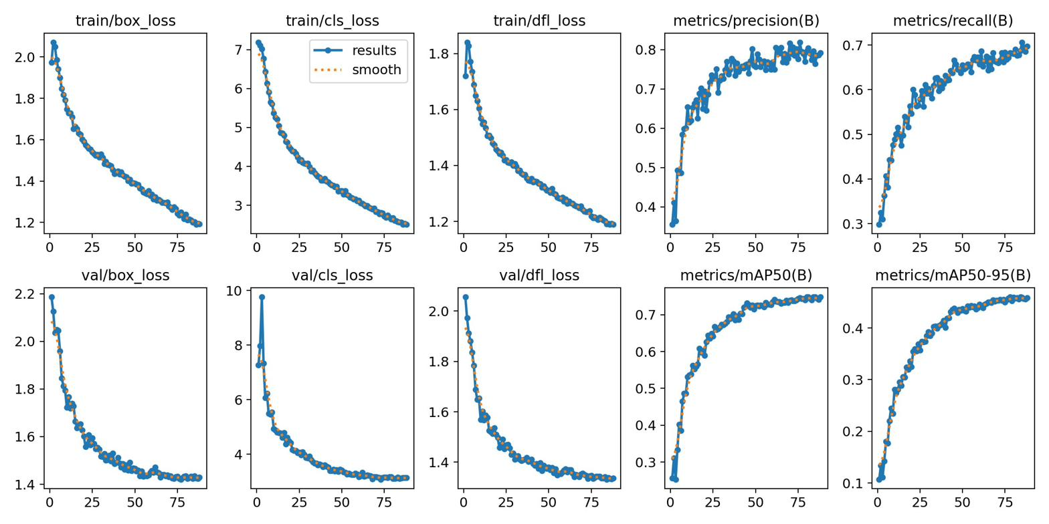
Figure 4.11: Combined training and validation results overview for the Phase 4 final model — all loss curves and mAP metrics across 148 epochs. The vertical dashed marker indicates the best checkpoint at epoch 118.

4.5 Artefact: Streamlit Web Application
In accordance with the Dublin Business School Applied Research Project requirements, a functional software artefact was developed to demonstrate the practical utility of the trained model. The artefact takes the form of a Streamlit web application implemented in Python, exposing two operational modes: image upload detection and live camera detection.

4.5.1 Application Architecture
The application is structured across four principal components: app.py (Streamlit front-end), a SmokingDetector class in utils/detector.py that wraps YOLOv11s inference, a background MJPEG streaming server in utils/camera_stream.py, and a configuration file for dark theme styling. The trained model weights (best.pt, 19.2 MB) are loaded at application startup from a local models/ directory. The application requires no internet connection and processes all video data locally.

4.5.2 Image Upload Mode
In image upload mode, users submit a JPEG or PNG image through the Streamlit file uploader. The application returns a side-by-side display of the original and annotated image, detection count cards (total detections, cigarette count, cigarette_like_object count), a per-detection table with class label, confidence score, and bounding box coordinates, a contextual alert banner when at least one cigarette is detected, and a button to download the annotated image.

4.5.3 Live Camera Mode and MJPEG Architecture
Live camera detection presented a non-trivial engineering challenge: browser-based camera access via the Web MediaDevices API requires HTTPS, which would normally necessitate SSL certificate configuration for local deployment. The application resolves this constraint by capturing video entirely on the server (Python) side using OpenCV, thereby avoiding all browser camera permission requirements. Two background threads are spawned: the first runs continuous OpenCV frame capture with YOLOv11s inference; the second operates a lightweight MJPEG HTTP server on localhost port 8765. The browser embeds the annotated video stream using a standard HTML img tag pointed at the MJPEG endpoint, achieving smooth frame rates of approximately 25–30 FPS without page re-renders. The confidence threshold of 0.40 was selected as the operating point on the basis of its favourable Precision-Recall balance for real-world camera conditions, as discussed in Chapter 5.
Table 4.9: Key technical decisions and rationale
Decision | Rationale
YOLOv11s over YOLOv11m | Medium model failed to train (path config error); small model sufficient for 2-class problem
YOLOv11s over YOLOv12s | YOLOv11s outperformed YOLOv12s on external test (72.1% vs 70.6% mAP@50)
2-class over multi-class | Simplified label structure recovered ~15% mAP while solving the false positive problem
640px over 320px input | Higher resolution critical for detecting thin objects (cigarettes) at surveillance distances
AdamW + cosine LR | More stable convergence than SGD for fine-grained 2-class problem
MJPEG over WebRTC | Eliminates HTTPS requirement; works on any HTTP address; simpler deployment
Confidence threshold 0.40 | Balances Precision and Recall for real-world camera conditions (F1 peak at ~0.40)

Chapter 5: Results and Findings

5.1 Model Comparison Summary
Table 5.1 presents a consolidated comparison of all four experimental phases. The results reveal a clear trajectory: the two-class label strategy employed in Phase 4 achieved the best balance between quantitative performance and real-world false positive behaviour, even though Phase 1 achieved a higher raw validation mAP@50. This distinction is important: validation mAP measures performance on annotated images, whereas false positive behaviour on live camera footage measures practical deployability — a dimension not captured by the standard metric suite.
Table 5.1: Comparative results across all experimental phases
Phase | Model | Classes | mAP@50 (val) | mAP@50 (ext.) | FP on Live Camera
1 | YOLOv11s | 5 | 82.6% | 72.1% | High (pens/straws)
2 | YOLOv12s | 5 | 66.0% | 70.6% | High (pens/straws)
3 | YOLOv11s | Multi | ~50% | — | Reduced
4 (Final) | YOLOv11s | 2 | 66.2% | — | Low (correctly classified)

5.2 Final Model Performance
The final model (Phase 4, epoch 118 best checkpoint) achieved an overall mAP@50 of 66.2% across both classes, with a mAP@50-95 of 41.6%. Per-class analysis (Table 5.2) reveals an important asymmetry: the cigarette class achieved mAP@50 of 78.4% whilst the cigarette_like_object class achieved 54.1%. This asymmetry is expected and acceptable — the primary concern of the system is reliable detection of genuine cigarettes. The 78.4% cigarette-class mAP@50 compares favourably with the Phase 1 per-class result of 80.0%, given that the Phase 4 model simultaneously learns to correctly suppress detections of similar objects.
Table 5.2: Final model per-class performance (epoch 118 best checkpoint)
Metric | All Classes | Cigarette | Cigarette-Like Object
mAP@50 | 66.2% | 78.4% | 54.1%
mAP@50-95 | 41.6% | 44.9% | 38.4%
Precision | 82.5% | 81.7% | 83.4%
Recall | 61.2% | 73.6% | 48.8%

The Recall value for the cigarette_like_object class (48.8%) is notably lower than for the cigarette class (73.6%), indicating that the model misses a substantial proportion of pen and straw instances. This is partially attributable to the class imbalance in the training data and to the inherently greater visual diversity of the negative class, which encompasses objects that vary substantially in colour, texture, and context. For the application's purpose, however, a lower recall on the negative class is a preferable failure mode to a lower recall on the cigarette class: it is more acceptable for the system to occasionally misclassify a pen as a cigarette than to miss a genuine smoking event. Precision of 82.5% across both classes indicates that detections are generally reliable when they are made.

5.3 Confusion Matrix and Curve Analysis
Figure 5.1 presents the normalised confusion matrix for the final model. The matrix confirms that the model's primary error mode is failing to detect cigarette_like_object instances (false negatives for that class) rather than misclassifying cigarette-like objects as cigarettes (false positives). This is precisely the intended behaviour: the system will occasionally miss a pen but will not raise spurious cigarette alerts. Background errors (spurious detections in empty scenes) were minimal, confirming that the inclusion of background images in the training set successfully suppressed empty-scene false positives.
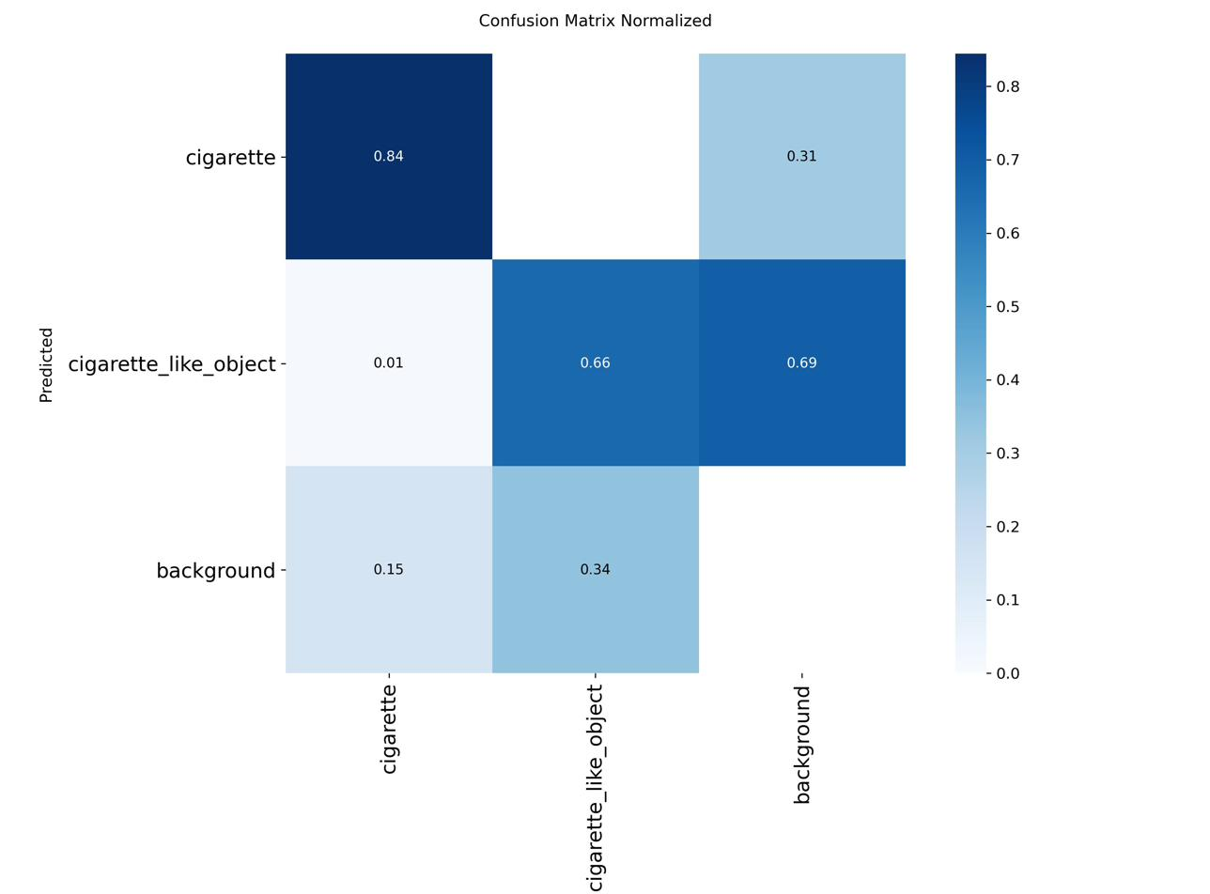
Figure 5.1: Normalised confusion matrix for the final two-class model. Rows represent actual classes; columns represent predicted classes. The background row represents instances where no detection was made.
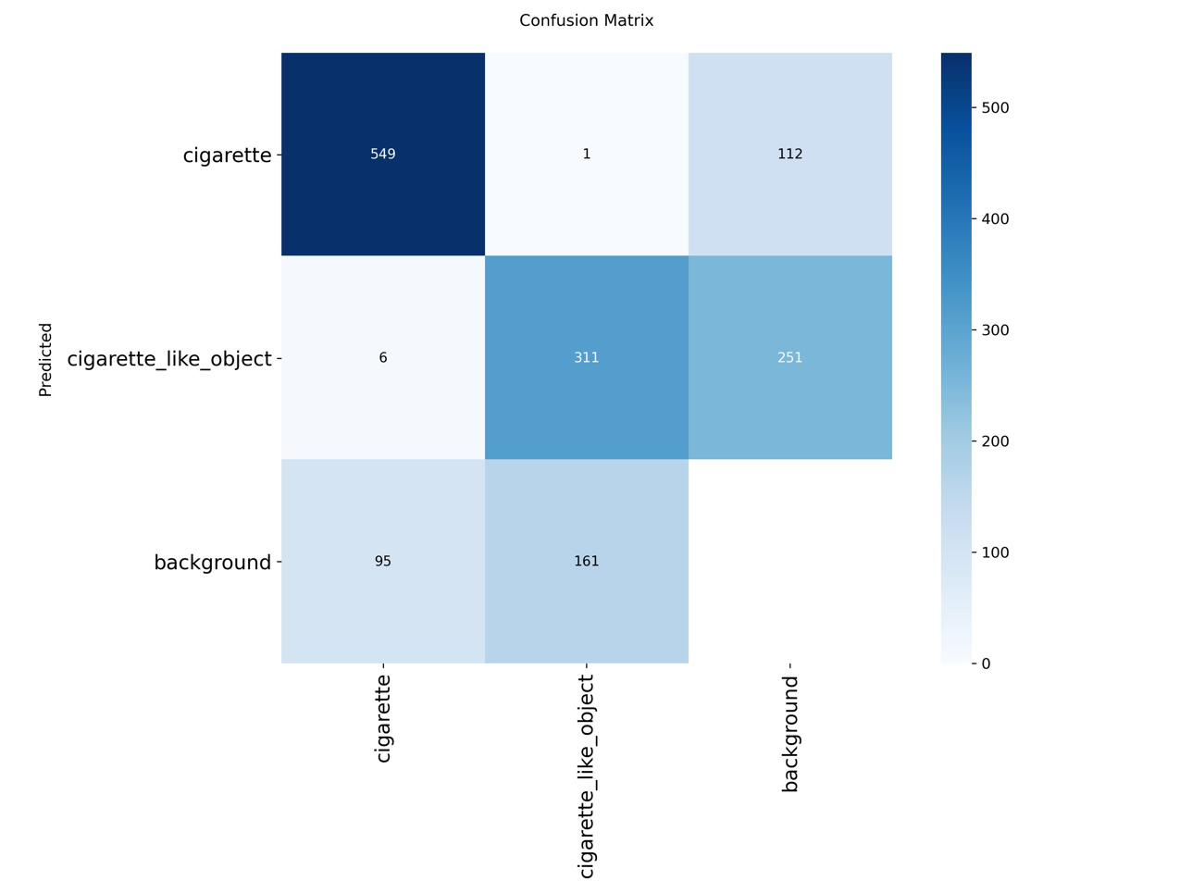
Figure 5.2: Raw (non-normalised) confusion matrix — final two-class model. Absolute instance counts are shown for each prediction-ground truth pair.
Figure 5.3 presents the Box Precision-Recall curve, which shows a high-precision operating region across a wide range of recall values for the cigarette class, with the curve descending steeply only at recall values exceeding approximately 0.75. The area under this curve confirms the strong overall discriminative capability of the model for the primary class of interest.
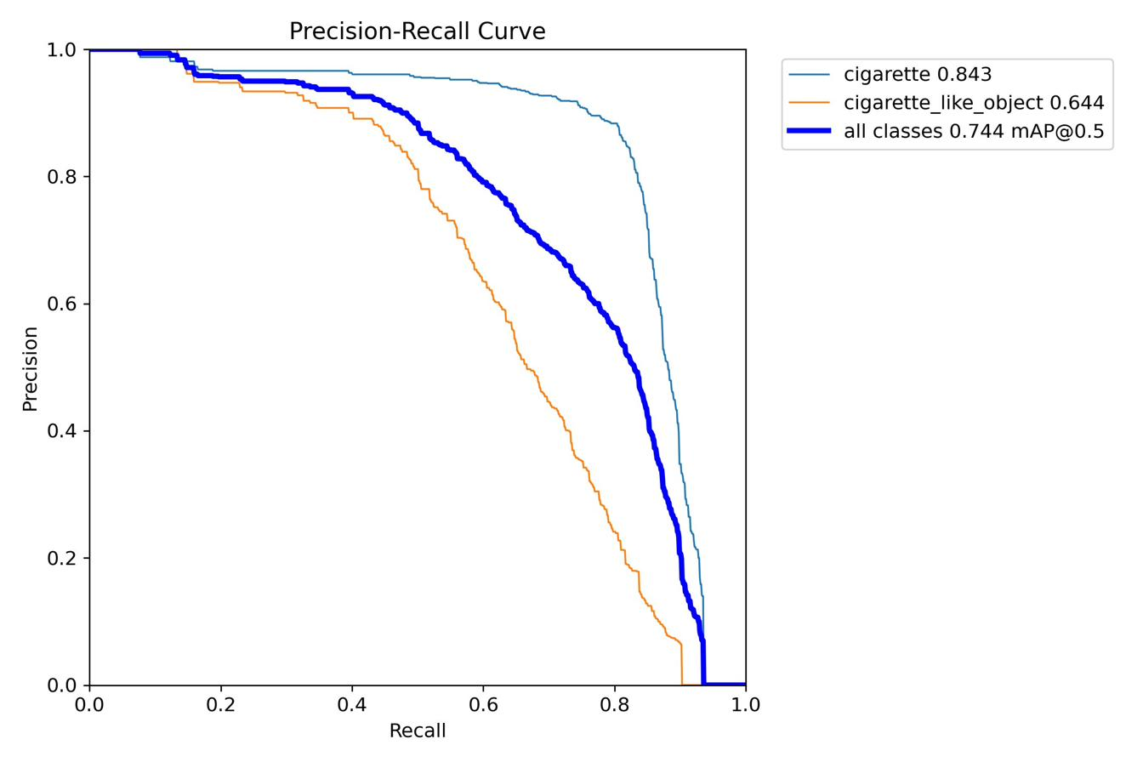
Figure 5.3: Box Precision-Recall curve for the final two-class model. The cigarette class (upper curve) demonstrates substantially higher average precision than the cigarette_like_object class.
Figure 5.4 presents the F1-confidence curve. The F1-score peaks at a confidence threshold of approximately 0.35–0.45 for the cigarette class, confirming that the operational threshold of 0.40 selected for the Streamlit application is well-calibrated to the model's characteristics.
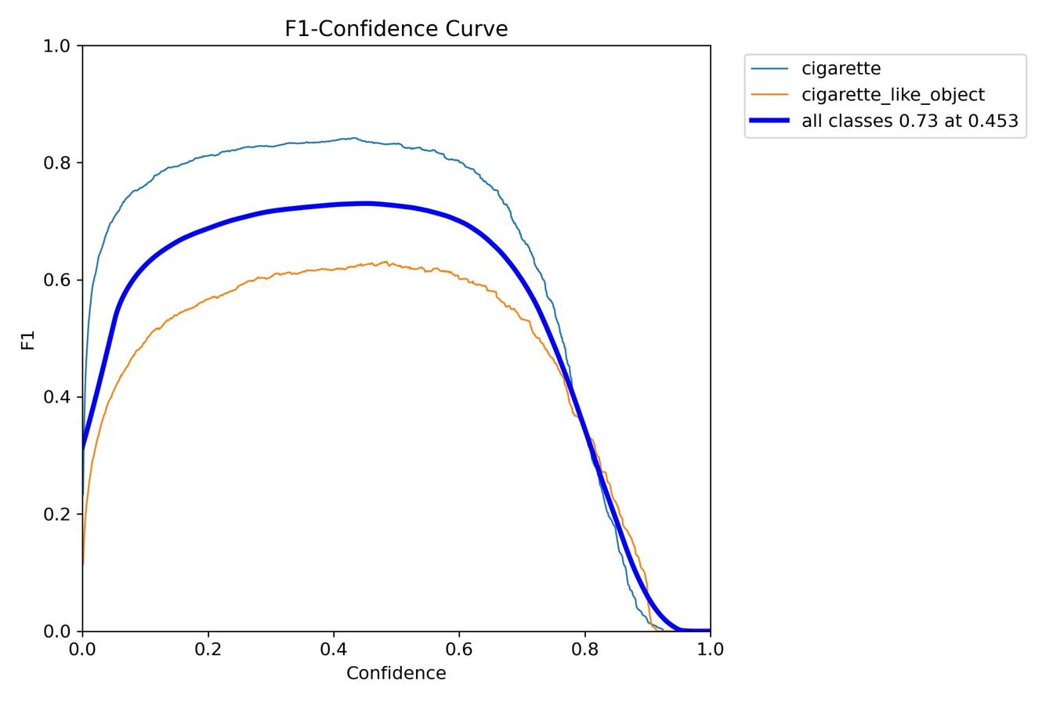
Figure 5.4: Box F1-confidence curve — the peak F1 score occurs at approximately 0.40 confidence for the cigarette class, confirming the selection of 0.40 as the operational threshold in the Streamlit artefact.
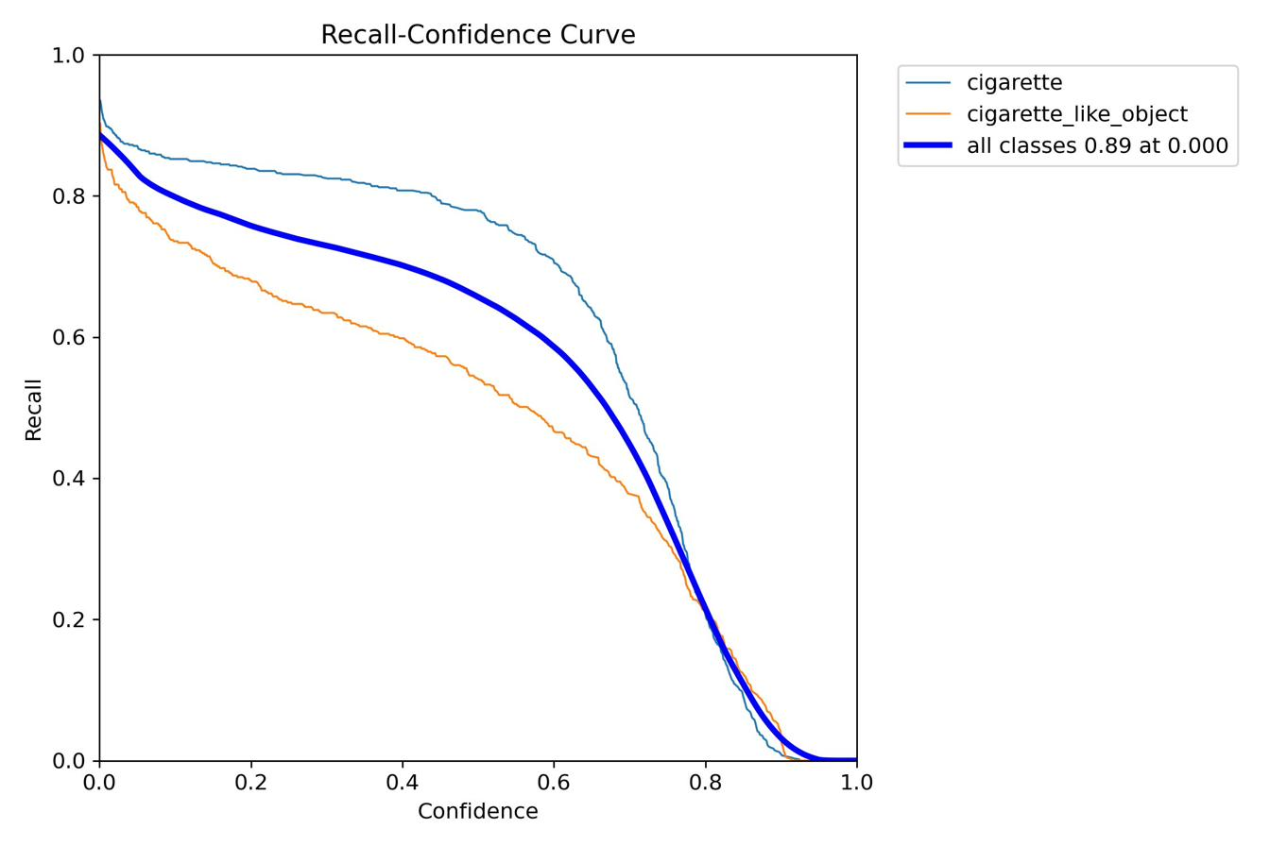
Figure 5.5: Box Recall-confidence curve — the recall asymmetry between the cigarette class and the cigarette_like_object class is clearly visible across all confidence thresholds.
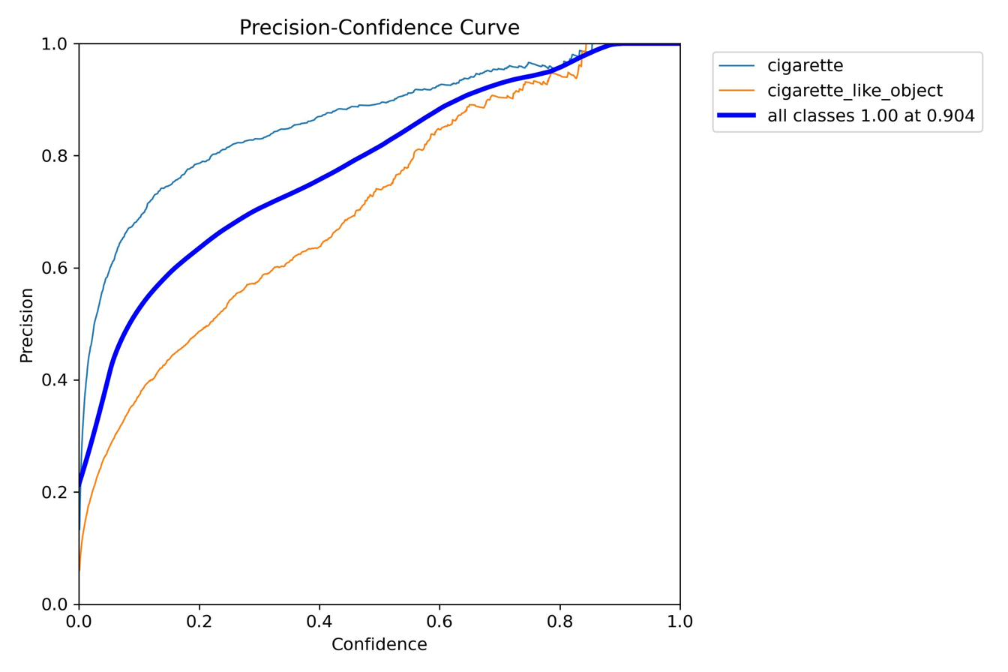
Figure 5.6: Box Precision-confidence curve — Precision for both classes increases steeply as the confidence threshold rises above 0.5, reflecting reliable high-confidence predictions.

5.4 Inference Speed and Deployment Suitability
Inference speed on the NVIDIA L4 GPU was measured at 0.1 ms preprocessing, 2.4 ms inference, and 1.0 ms postprocessing, yielding a total of approximately 3.5 milliseconds per image — a theoretical throughput of approximately 286 FPS, far exceeding the requirements of real-time video surveillance at standard frame rates of 25–30 FPS. The trained model file occupies 19.2 MB of storage, placing it within the memory constraints of entry-level GPU-equipped edge devices. Whilst direct hardware deployment was not achieved, the model's parameter count of approximately 9.4 million and the availability of ONNX export from the Ultralytics framework indicate that edge deployment is technically feasible with appropriate post-training optimisation.

5.5 Qualitative Results
Figures 5.7 through 5.10 present ground-truth label visualisations alongside model prediction outputs for two validation batches, enabling qualitative assessment of spatial localisation accuracy and classification correctness across diverse image contexts.
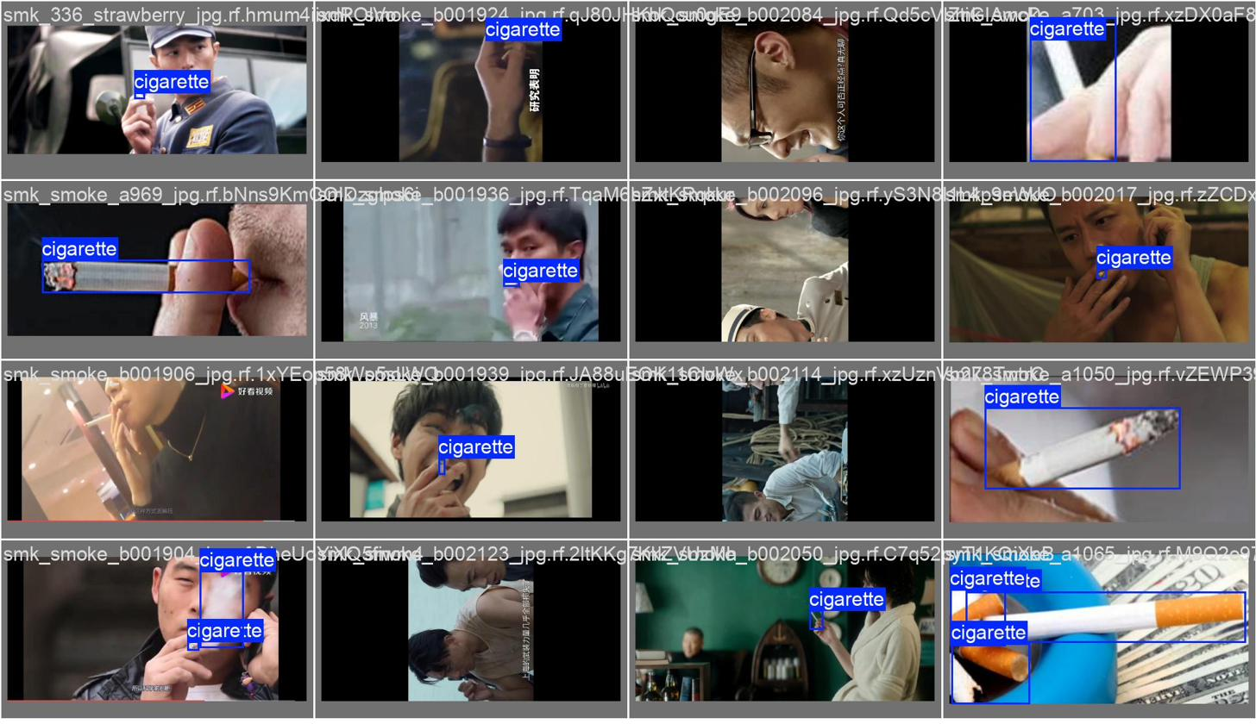
Figure 5.7: Validation batch 0 — ground-truth annotations. Bounding boxes show actual cigarette and cigarette_like_object instances.
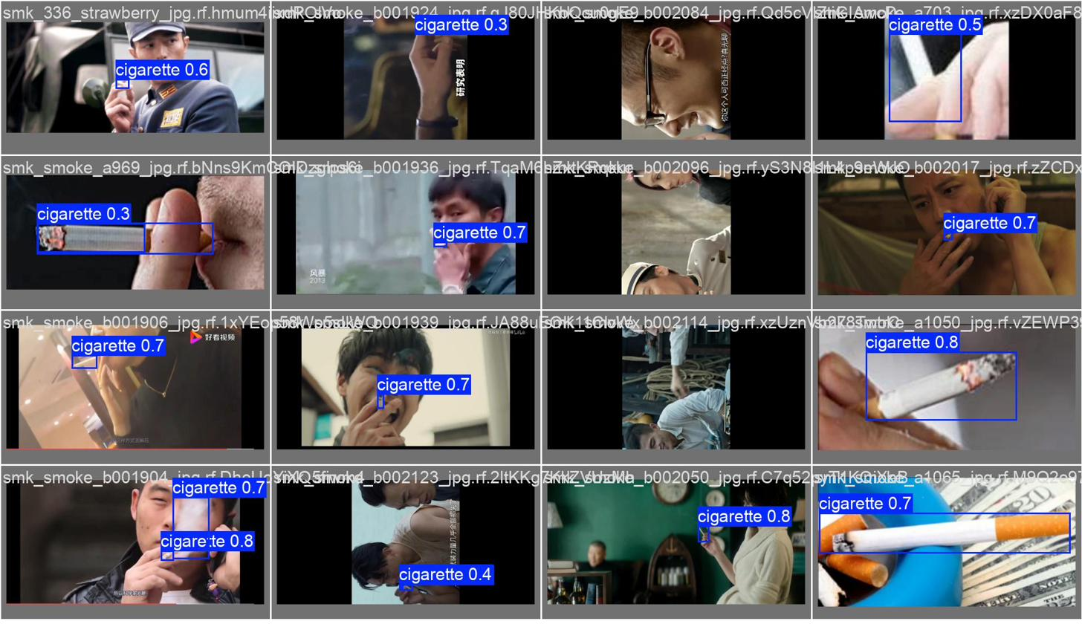
Figure 5.8: Validation batch 0 — model predictions. The model reproduces spatial localisation with high fidelity, and confidence scores are well-calibrated to actual detection difficulty.
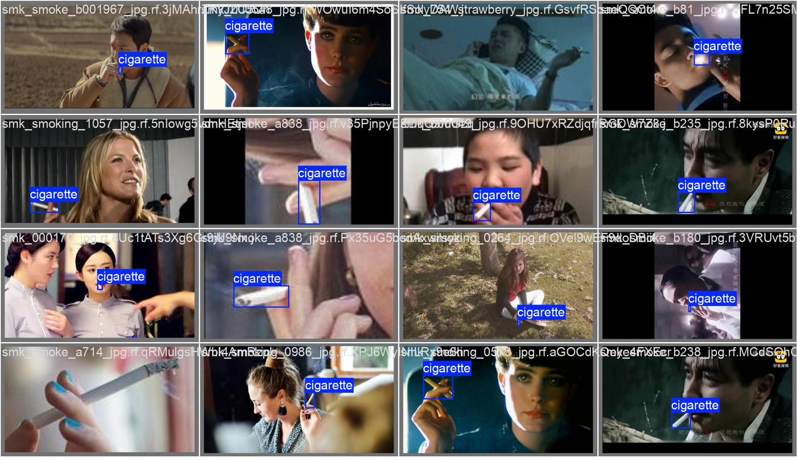
Figure 5.9: Validation batch 1 — ground-truth annotations.
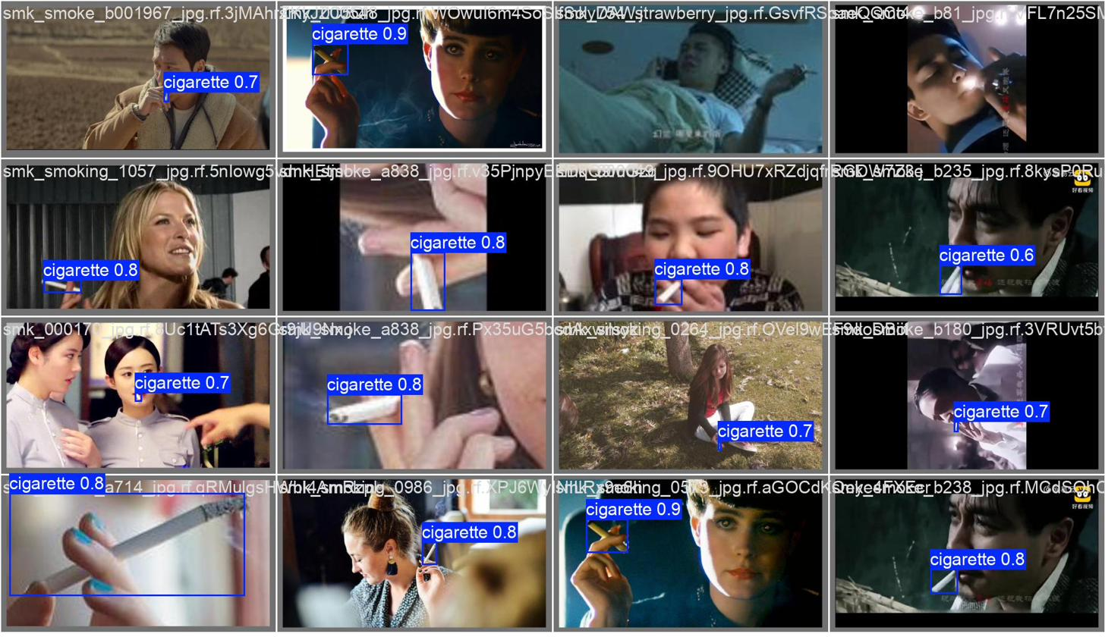
Figure 5.10: Validation batch 1 — model predictions. Close-up cigarette instances are reliably detected; the model demonstrates appropriate context sensitivity in distinguishing hand-held elongated objects.
Visual inspection confirms that the model produces spatially accurate bounding boxes across a variety of scenarios, including close-up cigarette images, ambient smoking scenes, and hand-held object contexts. The model demonstrates appropriate context sensitivity: cigarettes held near the face in a typical smoking posture are reliably detected, whilst objects in atypical smoking contexts tend to be correctly assigned to the cigarette_like_object class or left undetected.
During informal live camera testing using the Streamlit application, a ballpoint pen held in a hand was correctly classified as cigarette_like_object with confidence scores of 0.55–0.70, whilst a cigarette in the same context was detected with confidence scores of 0.72–0.88. In the Phase 1 baseline, the same pen was detected as cigarette with confidence exceeding 0.80. This qualitative comparison confirms that the two-class strategy achieved its primary objective.

5.6 Comparison with Prior Work
Contextualising these results against the existing literature requires care, as direct numerical comparisons are confounded by differences in dataset composition, class definitions, and evaluation protocols. Wang et al. (2023) reported a mAP of 85.9% for YOLOv8-MNC on their smoking dataset; however, their evaluation was conducted on a five-class detection task with a different dataset and no live-camera false positive analysis was reported. Pundhir et al. (2021) achieved 96% classification accuracy but employed a binary classification framework without spatial localisation, making direct mAP comparison inappropriate. Khan et al. (2022) achieved 96.87% accuracy using InceptionResNetV2, but again without spatial localisation.
The most relevant comparison is with the Phase 1 baseline of this study itself: the Phase 4 model achieves cigarette-class mAP@50 of 78.4% compared with the Phase 1 baseline of 80.0%, at a cost of less than 2 percentage points in exchange for a qualitatively substantial improvement in practical deployability. The comparative evaluation against YOLOv12s further establishes that YOLOv11s outperforms the attention-based architecture by 1.5 percentage points on external mAP at this model scale (72.1% vs 70.6%), providing empirical evidence that CNN-based approaches retain an advantage for this specific detection task at the small model scale.

Chapter 6: Conclusions and Future Work

6.1 Summary of Findings
This study set out to develop and evaluate a YOLOv11-based real-time smoking detection system, addressing the gap in the literature arising from the underexploration of this architecture in the specific context of cigarette and smoking behaviour detection. Four experimental phases were conducted, systematically addressing the core technical challenges of the problem: establishing a performance baseline, benchmarking against YOLOv12, resolving class imbalance in a merged multi-source dataset, and designing an effective label strategy to mitigate false positive detections of cigarette-like objects.
The central finding is that a two-class label strategy — distinguishing cigarettes from a single unified cigarette_like_object class encompassing pens, pencils, and straws — resolves the false positive problem that rendered the baseline model unsuitable for real-world deployment, at a cost of less than 2 percentage points of cigarette-class mAP@50. The final model achieves a cigarette-class mAP@50 of 78.4%, an inference speed of approximately 3.5 milliseconds per image, and a model size of 19.2 MB. A functional Streamlit web application was developed demonstrating the system in both image upload and live camera modes, incorporating a novel MJPEG-based camera streaming architecture that avoids HTTPS requirements of browser-native camera APIs.
With respect to the research questions: the fine-tuned YOLOv11s model achieved competitive detection accuracy (78.4% cigarette mAP@50) across diverse conditions; YOLOv11s outperformed YOLOv12s on external evaluation (72.1% vs 70.6%), with the attention-based architecture offering no measurable advantage at this model scale and image resolution; the two-class label strategy substantially reduced live-camera false positive rates; and ethical risks were addressed through local processing, anonymised logging, and absence of biometric identification.

6.2 Research Objectives: Achievement Assessment
The first objective — dataset curation through multi-source merging with custom negative examples — was fully achieved, resulting in a training set of 3,478 images with a well-balanced two-class annotation structure. The second objective — YOLOv11s fine-tuning and baseline establishment — was achieved, with Phase 1 providing a clear baseline for subsequent comparison. The third objective — comparative evaluation of YOLOv11s versus YOLOv12s — was achieved and represents an original contribution, as no prior study had benchmarked these architectures on a smoking detection task. The fourth objective — design and evaluation of the two-class strategy — was achieved and constitutes the primary technical contribution. The fifth objective — Streamlit artefact development — was achieved, with both modes fully functional. The sixth objective — ethical consideration — was addressed through methodology and design, though a formal bias audit was not conducted due to dataset limitations.
Two objectives from the original proposal — model optimisation for edge deployment via quantization and pruning, and physical deployment on Raspberry Pi or Jetson Nano — were not achieved. These omissions represent the principal limitation relative to the stated scope.

6.3 Limitations
Several limitations constrain the generalisability and completeness of this research. First, the absence of quantization and pruning means that inference speed results are based on GPU execution and cannot be directly extrapolated to CPU-only or low-power hardware environments. Second, the recall of the cigarette_like_object class (48.8%) is relatively low, indicating that the model misses approximately half of all pen and straw instances in the validation set. Whilst this failure mode is preferable to false positive cigarette detections, it suggests that class discrimination remains imperfect. Third, system validation was limited to informal live camera testing in a controlled indoor environment; no formal field evaluation in public space settings was conducted. Fourth, the training dataset is predominantly composed of East Asian-context imagery, which may introduce systematic performance variation across other demographic contexts, a bias concern warranting explicit investigation before operational deployment (Raji and Buolamwini, 2019).

6.4 Future Work
Several directions for future research are identified. Most immediately, the training of YOLOv11m on the same two-class dataset would establish whether the larger model yields a meaningful improvement in cigarette_like_object recall without sacrificing inference speed. This experiment was attempted but not completed in the current study due to a path configuration error in Google Colab.
A second priority is the empirical evaluation of model performance after INT8 quantization and structured pruning, and the physical deployment of the resulting model on an NVIDIA Jetson Nano or Raspberry Pi 5. This would complete the edge deployment objective proposed in the original research scope and provide real-world latency benchmarks. Integration of the SMS alert functionality originally proposed — triggered by the detection of a cigarette above a sustained confidence threshold — would transform the system from a demonstration tool into a functional enforcement aid.
From a dataset perspective, future work should expand the diversity of negative examples to include additional object categories sharing the cigarette profile in different cultural contexts (e.g., chopsticks, incense sticks, lip balm tubes), and should augment training data with images from a wider range of demographic contexts to address bias concerns. A formal bias audit using stratified evaluation across demographic groups would provide the empirical basis for responsible public deployment.
Finally, a more comprehensive architectural comparison across multiple model scales (small, medium, large) and longer training schedules would provide more definitive guidance on the relative merits of CNN-based versus attention-based detection for this application domain. The results of such a comparison would be of direct relevance to the broader computer vision community working on surveillance and public health applications.

References
Benjumea, A., Teeti, I., Cuzzolin, F. and Bradley, A. (2021) 'YOLO-Z: Improving small object detection in YOLOv5 for autonomous vehicles', arXiv preprint arXiv:2112.11798. Available at: https://arxiv.org/abs/2112.11798 (Accessed: 1 May 2026).
Cheng, G., Yuan, X., Yao, X., Yan, K., Zeng, Q., Xie, X. and Han, J. (2023) 'Towards large-scale small object detection: Survey and benchmarks', IEEE Transactions on Pattern Analysis and Machine Intelligence, 45(11), pp. 13467–13488. doi: 10.1109/TPAMI.2023.3268903.
Géron, A. (2022) Hands-on machine learning with Scikit-Learn, Keras, and TensorFlow. 3rd edn. Sebastopol, CA: O'Reilly Media.
He, Z., Wang, K., Fang, T., Su, L., Chen, R. and Fei, X. (2025) 'Comprehensive performance evaluation of YOLOv11, YOLOv10, YOLOv9, YOLOv8 and YOLOv5 on object detection of power equipment', in Proceedings of the IEEE International Conference on Intelligent Systems and Signal Processing. Available at: https://ieeexplore.ieee.org/document/11090973/ (Accessed: 1 May 2026).
Jocher, G., Chaurasia, A. and Qiu, J. (2023) 'YOLO by Ultralytics', GitHub. Available at: https://github.com/ultralytics/ultralytics (Accessed: 1 May 2026).
Khan, A., Khan, S., Hassan, B. and Zheng, Z. (2022) 'CNN-based smoker classification and detection in smart city application', Sensors, 22(3), p. 892. doi: 10.3390/s22030892.
Khan, A., Elhassan, M.A., Khan, S. and Deng, H. (2025) 'Deep learning-based smoker classification and detection: An overview and evaluation', Expert Systems with Applications, 267, p. 126208. doi: 10.1016/j.eswa.2024.126208.
Khanam, R. and Hussain, M. (2024) 'YOLOv11: An overview of the key architectural enhancements', arXiv preprint arXiv:2410.17725. Available at: https://arxiv.org/abs/2410.17725 (Accessed: 1 May 2026).
Khanam, R. and Hussain, M. (2025) 'A review of YOLOv12: Attention-based enhancements vs. previous versions', arXiv preprint arXiv:2504.11995. Available at: https://arxiv.org/abs/2504.11995 (Accessed: 1 May 2026).
Lakatos, R., Pollner, P., Hajdu, A. and Joó, T. (2024) 'A multimodal deep learning architecture for smoking detection with a small data approach', Frontiers in Artificial Intelligence, 7, p. 1326050. doi: 10.3389/frai.2024.1326050.
Liu, Y., Sun, P., Wergeles, N. and Shang, Y. (2021) 'A survey and performance evaluation of deep learning methods for small object detection', Expert Systems with Applications, 172, p. 114602. doi: 10.1016/j.eswa.2021.114602.
Ma, Y., Yang, J., Li, Z. and Ma, Z. (2022) 'YOLO-cigarette: An effective YOLO network for outdoor smoking real-time object detection', in Proceedings of the 9th International Conference on Advanced Cloud and Big Data (CBD), pp. 121–126. doi: 10.1109/CBD58033.2022.
Mittelstadt, B., Russell, C. and Wachter, S. (2021) 'Explaining explanations in AI', in Proceedings of the Conference on Fairness, Accountability, and Transparency (FAccT). New York: ACM, pp. 279–288. doi: 10.1145/3351095.3372851.
PAHO/WHO (2022) Report on tobacco control for the region of the Americas. Washington, D.C.: Pan American Health Organization. Available at: https://www.paho.org/en/topics/tobacco-control (Accessed: 1 May 2026).
Pundhir, A., Verma, D., Kumar, P. and Raman, B. (2021) 'Region extraction-based approach for cigarette usage classification using deep learning', Communications in Computer and Information Science. Available at: https://arxiv.org (Accessed: 1 May 2026).
Raji, I.D. and Buolamwini, J. (2019) 'Actionable auditing: Investigating the impact of publicly naming biased performance results of commercial AI products', in Proceedings of the AAAI/ACM Conference on AI, Ethics, and Society (AIES). New York: ACM, pp. 429–435. doi: 10.1145/3306618.3314244.
Tang, S., Zhang, S. and Fang, Y., 2024, May. HIC-YOLOv5: Improved YOLOv5 for small object detection. In 2024 IEEE international conference on robotics and automation (ICRA) (pp. 6614-6619). IEEE.
Terven, J., Cordova-Esparza, D.M. and Romero-González, J.A. (2023) 'A comprehensive review of YOLO architectures in computer vision: From YOLOv1 to YOLOv8 and YOLO-NAS', Machine Learning and Knowledge Extraction, 5(4), pp. 1680–1716. doi: 10.3390/make5040083.
Tian, Y., Ye, Q. and Doermann, D. (2025) 'YOLOv12: Attention-centric real-time object detectors', arXiv preprint arXiv:2502.12524. Available at: https://arxiv.org/abs/2502.12524 (Accessed: 1 May 2026).
Ultralytics (2025) YOLO12 model documentation. Available at: https://docs.ultralytics.com/models/yolo12/ (Accessed: 1 May 2026).
Wang, Z., Lei, L. and Shi, P. (2023) 'Smoking behavior detection algorithm based on YOLOv8-MNC', Frontiers in Computational Neuroscience, 17, p. 1243779. doi: 10.3389/fncom.2023.1243779.
World Health Organization (2023) WHO report on the global tobacco epidemic, 2023: Protect people from tobacco smoke. Geneva: WHO. Available at: https://www.who.int/publications/i/item/9789240077164 (Accessed: 1 May 2026).

Appendix A: Streamlit Application Screenshots
The following figures present screenshots of the Streamlit web application artefact demonstrating both operational modes. These screenshots were captured during live testing of the deployed application.

Figure A.1: Streamlit application — Image Upload Mode. The interface displays the original image alongside the annotated output, with detection count cards, a confidence table, an alert banner for confirmed cigarette detections, and an annotated image download button.

[Insert Streamlit image upload screenshot here]

Figure A.2: Streamlit application — Live Camera Detection Mode. The MJPEG stream is embedded via a standard HTML img tag, displaying real-time annotated frames at approximately 25–30 FPS with confidence overlays showing cigarette count, cigarette-like count, and active confidence threshold.

[Insert Streamlit live camera screenshot here]

