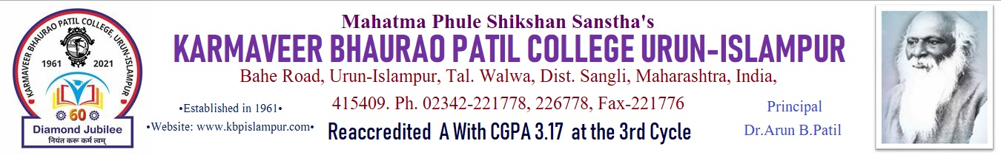



**DEPARTMENT OF INFORMATION TECHNOLOGY**

**CERTIFICATE**

This is Certify that, **Miss. Sanskruti Jalindar Nangre** is submitted the project report entitled **“Online Resume Builder”** for-in partial fulfillment of the award of degree course **“Bachelor of –Information Technology (Entire) (B.Sc. Part III)”** affiliated to Shivaji University, Kolhapur.

This project work is carried out under my guidance to our knowledge and belief, the matter presented in this project report has not been submitted earlier and is our original work. This project work shows her hard working and sincere efforts.

Principal

(Dr. A. B. Patil)

**Place:** Urun-Islampur.

**Date: / / 2023.**





**DEPARTMENT OF INFORMATION TECHNOLOGY**

**CERTIFICATE**

This is Certify that, **Miss. Sanskruti Jalindar Nangre** is submitted the project report entitled **“Online Resume Builder”** for-in partial fulfillment of the award of degree course **“Bachelor of –Information Technology (Entire) (B.Sc. Part III)”** affiliated to Shivaji University, Kolhapur.

This project work is carried out under my guidance to my knowledge and belief, the matter presented in this project report has not been submitted earlier and is my original work. This project work shows her hard working and sincere efforts.

Project Guide Examiner H.O.D.

(Prof. P. A. Kupade) (Prof .P. N. Patil)

**Place:** Urun-Islampur.

**Date: / / 2023.**