PROJECT DOCUMENTATION
A Comprehensive Measure of Well-Being
A Machine-Learning Web App for Estimating the Human Development Index (HDI) Tier
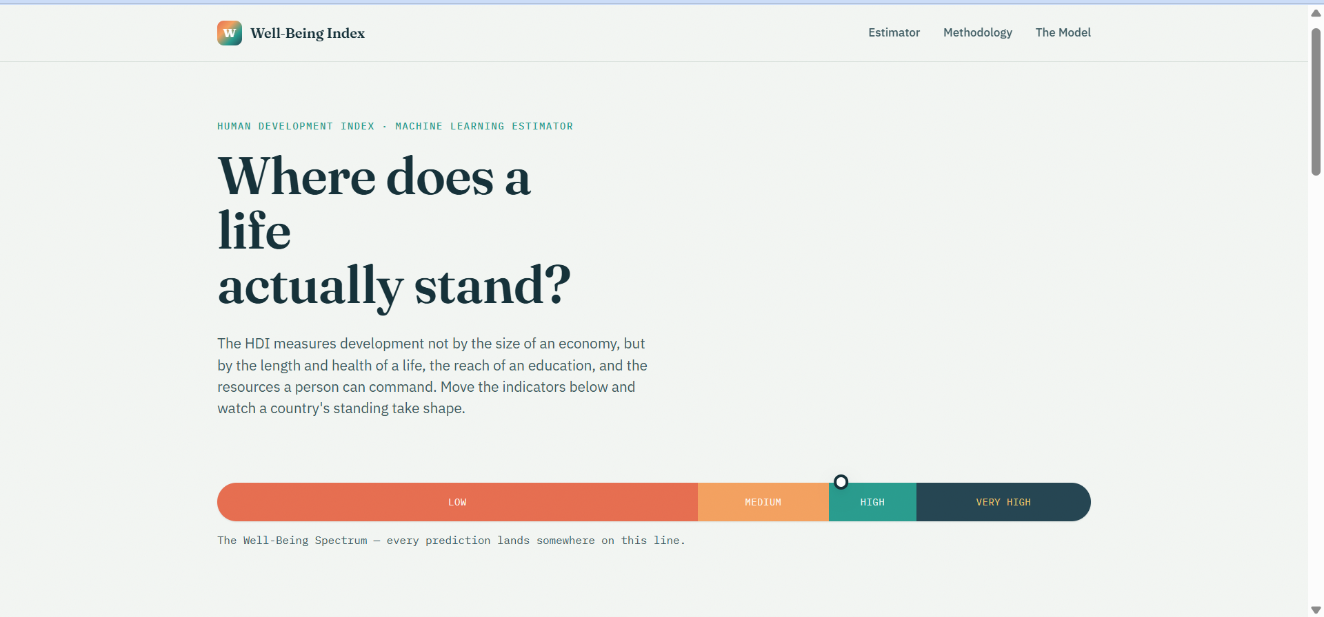
Landing page — "Where does a life actually stand?"

Field | Details
Project Title | A Comprehensive Measure of Well-Being (HDI Well-Being Index)
Team ID
Team Lead | Abdul Jilani
Team Members | Neja Sri Avanthi Gunti, Dasari Roshini, Sai Prattipati, Dodda Yamini Chowdary
Demo Link | https://hdi-wellbeing-project.vercel.app/
GitHub Repository | https://github.com/jilaniabdul880-crypto/hdi_wellbeing_project

Table of Contents
1. Introduction
2. Project Overview
3. Architecture
4. Setup Instructions
5. Folder Structure
6. Running the Application
7. API Documentation
8. Authentication
9. User Interface
10. Testing
11. Screenshots and Demo
12. Known Issues
13. Future Enhancements

1. Introduction

1.1 Project Title
A Comprehensive Measure of Well-Being — an interactive Human Development Index (HDI) estimator.

1.2 Team Members and Roles
Name | Role | Team ID
Abdul Jilani | Team Lead
Neja Sri Avanthi Gunti | Team Member
Dasari Roshini | Team Member
Sai Prattipati | Team Member
Dodda Yamini Chowdary | Team Member

2. Project Overview

2.1 Purpose
The Human Development Index (HDI) is the United Nations Development Programme's summary measure of a nation's average achievement in three basic dimensions of human development: a long and healthy life, access to knowledge, and a decent standard of living. This project builds an interactive web application that lets a user enter a country-style profile — life expectancy, mean years of schooling, expected years of schooling, and GNI per capita — and instantly see where that profile falls on the Well-Being Spectrum (Low, Medium, High, or Very High).
Rather than simply looking up a fixed formula, a machine learning classifier was trained on thousands of simulated country profiles to learn the same non-linear, compensating relationships that the official HDI formula encodes. The app returns both the model's predicted tier (with class probabilities) and the exact formula-based HDI score side by side, so the ML prediction can always be checked for transparency against the official UNDP methodology.

2.2 Key Features
- Interactive estimator with four live sliders (life expectancy, mean years of schooling, expected years of schooling, GNI per capita) built to official UNDP indicator ranges.
- A "Well-Being Spectrum" gauge — a horizontal gradient bar proportioned to the real UNDP thresholds — with a marker that animates to the predicted tier.
- Machine learning tier prediction (Logistic Regression) returned with per-tier class probabilities.
- Parallel formula-based HDI score, computed with the official UNDP geometric-mean formula, for direct comparison against the model's prediction.
- One-click preset scenarios — "Very High", "Emerging", and "Low" — to quickly explore the spectrum.
- A dedicated Methodology page explaining the three HDI dimensions and the geometric-mean formula.
- A "The Model" page surfacing model transparency metrics: algorithm used, held-out accuracy, number of input indicators, and number of development tiers.
- Exploratory data analysis and evaluation visualizations: class distribution, correlation heatmap, feature boxplots, pairplot, and confusion matrix.

3. Architecture
The application follows a simple two-tier architecture: a Flask backend that serves both the page and a JSON prediction API, and a vanilla-JavaScript frontend that talks to it. In place of a traditional database, a pre-trained machine learning pipeline (persisted with joblib) acts as the application's data layer.

3.1 Frontend
Built with plain HTML, CSS, and vanilla JavaScript (no frontend framework):
- templates/index.html — page markup for the Estimator, Methodology, and The Model sections.
- static/css/style.css — the design system: colour palette, typography, the gradient Well-Being Spectrum bar, and responsive layout.
- static/js/script.js — wires up the sliders, live-updates their numeric readouts, animates the spectrum marker, handles the preset-scenario buttons, and calls the backend API asynchronously with fetch().

3.2 Backend
Built with Python and Flask (app.py):
- Loads the trained classifier, feature scaler, and tier label encoder once at startup with joblib for fast repeated inference.
- GET / — renders the single-page UI, passing indicator ranges and model metadata into the template.
- POST /api/predict — accepts the four indicators as JSON, validates their bounds, scales them, and returns the predicted tier, class probabilities, the official formula-based score, and a plain-language interpretation.
- GET /api/model-info — returns the model's metadata (algorithm, features, tiers, accuracy, classification report) as JSON.

3.3 Data & Model Layer
There is no relational or document database; a synthetic, fully reproducible dataset and a trained scikit-learn pipeline take its place:
- data/generate_dataset.py — simulates 6,000 country-like profiles across the full range of the four indicators; each profile's true HDI score is computed with the official UNDP formula and bucketed into a tier, with realistic noise added.
- models/train_model.py — runs exploratory data analysis (saved to /plots), then trains and 5-fold cross-validates three candidate models (Logistic Regression, Random Forest, Gradient Boosting) on standardized features, selects the best performer, and evaluates it on a held-out test set.
- models/hdi_model.pkl, scaler.pkl, label_encoder.pkl, metadata.json — the persisted artifacts loaded by the Flask app at runtime.
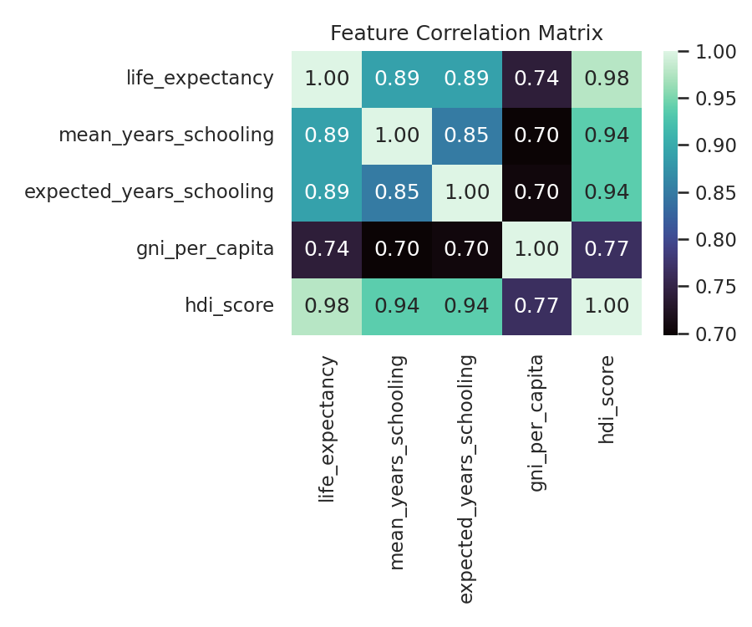
Correlation heatmap of the four UNDP indicators used to train the model.

4. Setup Instructions

4.1 Prerequisites
- Python 3.9 or later
- pip (Python package manager)
- Git (to clone the repository)
Python dependencies (installed automatically via requirements.txt): Flask, NumPy, Pandas, scikit-learn, Matplotlib, Seaborn, joblib.

4.2 Installation
macOS / Linux:
git clone https://github.com/jilaniabdul880-crypto/hdi_wellbeing_project.git
cd hdi_wellbeing_project/hdi_project
python3 -m venv venv
source venv/bin/activate
pip install -r requirements.txt

Windows (PowerShell):
git clone https://github.com/jilaniabdul880-crypto/hdi_wellbeing_project.git
cd hdi_wellbeing_project\hdi_project
python -m venv venv
venv\Scripts\activate
pip install -r requirements.txt

5. Folder Structure
hdi_project/
├── app.py Flask application (routes + API)
├── requirements.txt
├── data/
│ ├── generate_dataset.py Builds the synthetic training dataset
│ └── hdi_dataset.csv 6,000 simulated country profiles
├── models/
│ ├── train_model.py EDA + training + evaluation pipeline
│ ├── hdi_model.pkl Trained classifier (best of 3 models)
│ ├── scaler.pkl Fitted StandardScaler
│ ├── label_encoder.pkl Tier label encoder
│ └── metadata.json Model name, accuracy, classification report
├── plots/ EDA & evaluation charts (PNG)
├── templates/
│ └── index.html UI markup
└── static/
├── css/style.css Design system + layout
└── js/script.js Live sliders, spectrum gauge, API calls

6. Running the Application

6.1 Start the Server
The frontend and backend are served together by the single Flask application — there is no separate frontend build step.
cd hdi_project
python3 app.py (Windows: python app.py)
Then open http://localhost:5000 in a browser.

6.2 Regenerating the Dataset and Model (optional)
Trained artifacts are already included, so the app runs out of the box. To regenerate them from scratch after changing the simulation parameters:
python data/generate_dataset.py
python models/train_model.py

7. API Documentation

7.1 GET /
Renders the interactive single-page UI (Estimator, Methodology, The Model), passing indicator ranges and current model metadata into the template.

7.2 POST /api/predict
Accepts the four UNDP indicators as JSON and returns the predicted well-being tier.

Request body
{
"life_expectancy": 72.0,
"mean_years_schooling": 8.0,
"expected_years_schooling": 12.0,
"gni_per_capita": 15000
}
Parameter | Type | Valid Range
life_expectancy | float | 20 – 85 years
mean_years_schooling | float | 0 – 15 years
expected_years_schooling | float | 0 – 18 years
gni_per_capita | float | $100 – $75,000 (PPP)

Example response
{
"predicted_tier": "High",
"probabilities": {
"Low": 0.0021, "Medium": 0.1104,
"High": 0.7822, "Very High": 0.1053
},
"hdi_score": 0.7415,
"formula_tier": "High",
"tier_info": { "color": "#2A9D8F", "blurb": "..." },
"tier_order": ["Low", "Medium", "High", "Very High"],
"model_name": "LogisticRegression"
}
A request with a value outside the valid range, or a missing/invalid field, returns HTTP 400 with a JSON error message describing the problem.

7.3 GET /api/model-info
Returns the trained model's metadata as JSON: algorithm name, input features, tier order, held-out test accuracy, cross-validation scores for all three candidate models, and the full per-tier classification report (precision, recall, F1-score, support).

8. Authentication
This project does not implement user authentication or authorization. The estimator is a public, stateless tool: there are no user accounts, login flow, sessions, or tokens, and all API endpoints (GET /, POST /api/predict, GET /api/model-info) are open to any client. Input safety is instead enforced at the API layer through strict bounds validation on every request field — the /api/predict endpoint rejects out-of-range or malformed values with an HTTP 400 response before any inference is run.
Should the project be extended to support saved scenarios or per-user history, token-based authentication (e.g. JWT) would be layered onto the existing Flask routes without changing the prediction pipeline itself.

9. User Interface
The interface is a single scrolling page with three anchored sections — Estimator, Methodology, and The Model — reached from a persistent top navigation bar.

9.1 Estimator
Four sliders map directly to the UNDP indicator ranges. Values update live as the user drags, and the Well-Being Spectrum gauge previews roughly where the profile sits before submission. Three preset buttons — Very High, Emerging, Low — pre-fill representative scenarios.
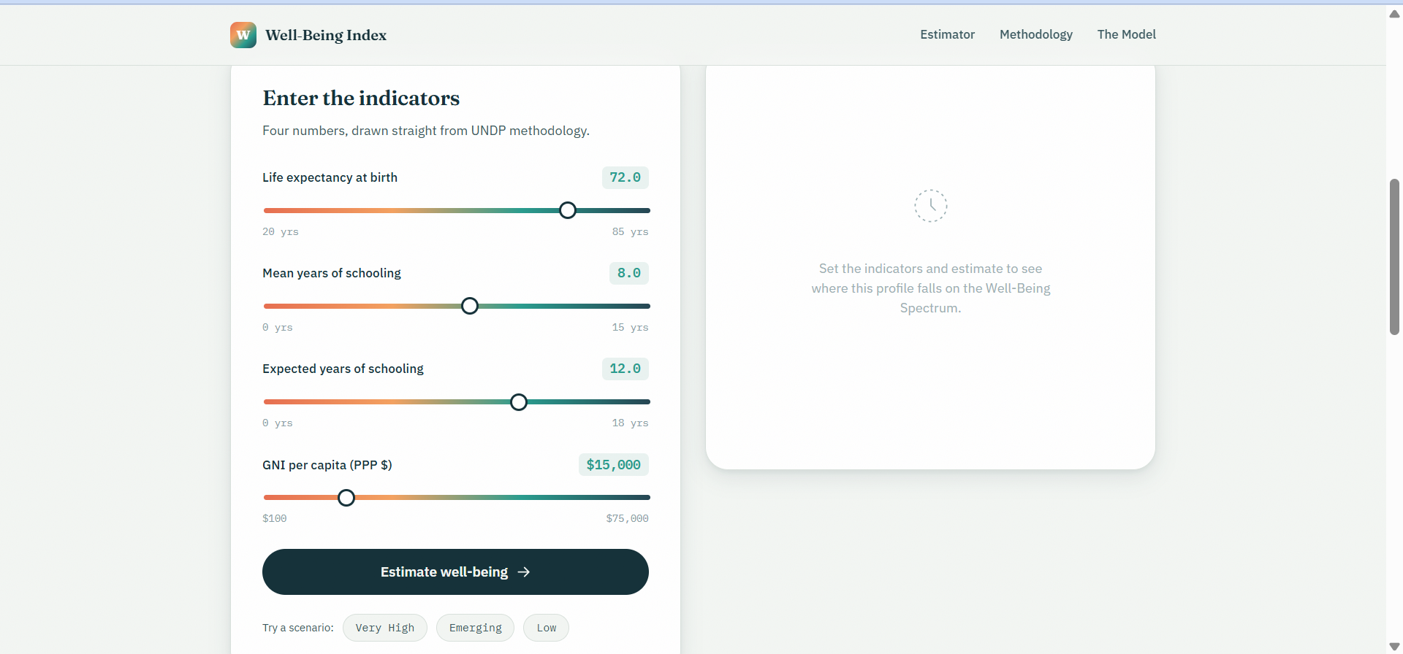
The Estimator — four indicator sliders feeding the Well-Being Spectrum gauge.

9.2 Methodology
Explains the three HDI dimensions (health, education, income) and displays the geometric-mean formula, HDI = ∛(Health × Education × Income), noting that this form penalises a country whenever any single dimension lags behind the others.
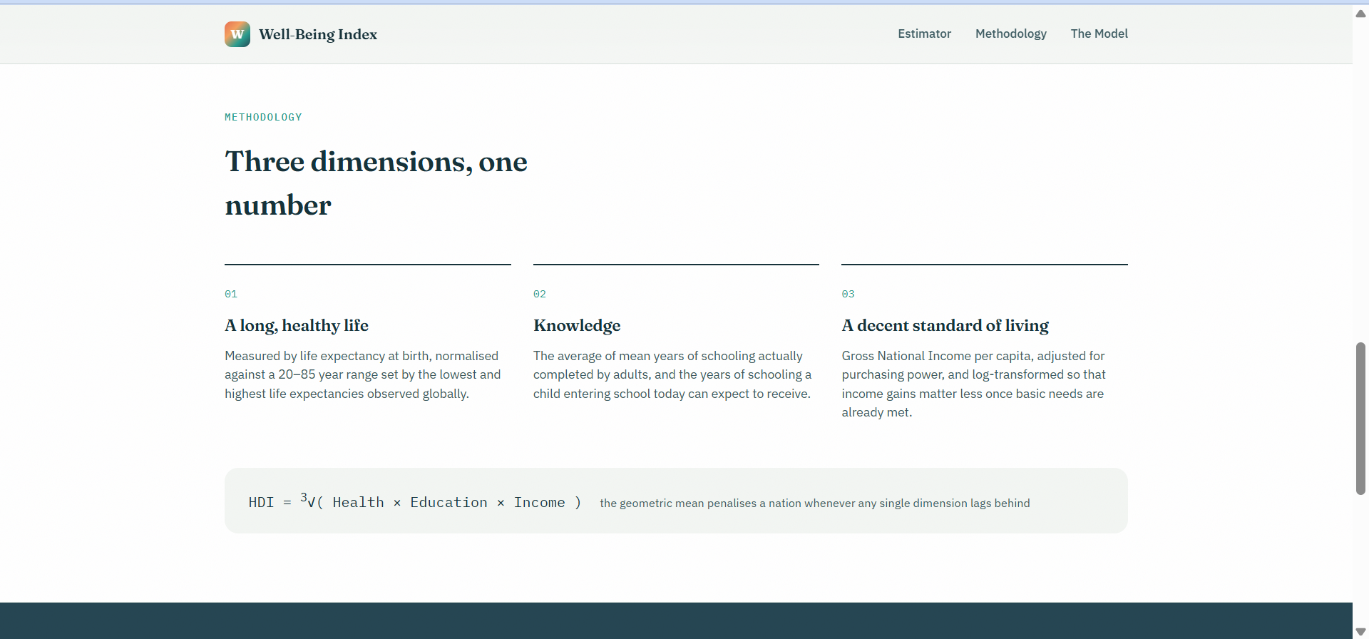
The Methodology page — the three HDI dimensions and the geometric-mean formula.

9.3 The Model
A transparency panel summarising the classifier itself: algorithm (Logistic Regression), held-out accuracy (96.6%), number of input indicators (4), and number of development tiers (4).
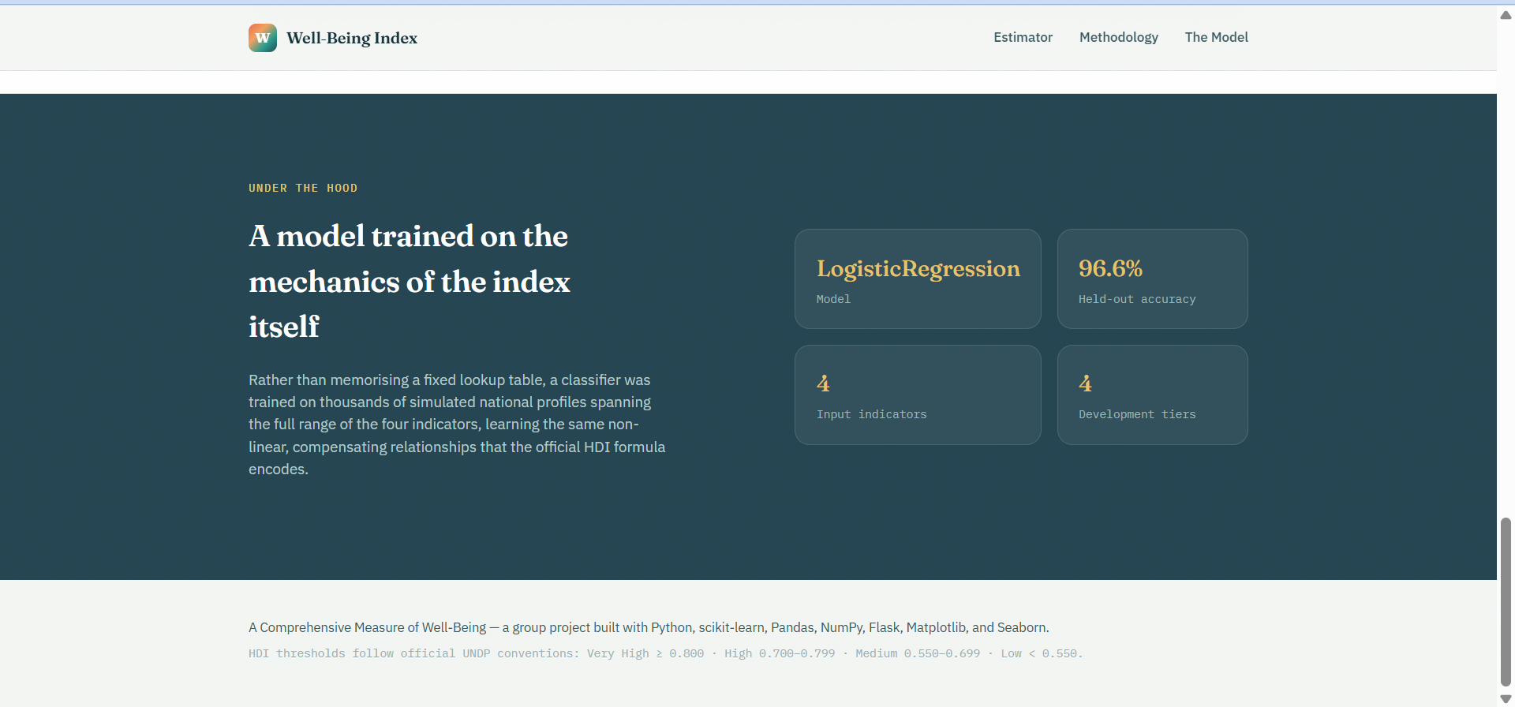
The Model page — under-the-hood statistics for the trained classifier.

10. Testing

10.1 Model Evaluation
Three candidate algorithms — Logistic Regression, Random Forest, and Gradient Boosting — were trained on standardized features and compared using 5-fold cross-validation, then the best performer was evaluated on a held-out test set.
Model | Cross-Validation Accuracy
Logistic Regression (selected) | 96.23%
Random Forest | 95.75%
Gradient Boosting | 95.71%
The selected Logistic Regression model reached 96.58% accuracy on the held-out test set, with weighted-average precision of 0.9657 and weighted-average recall of 0.9658 across all four tiers.
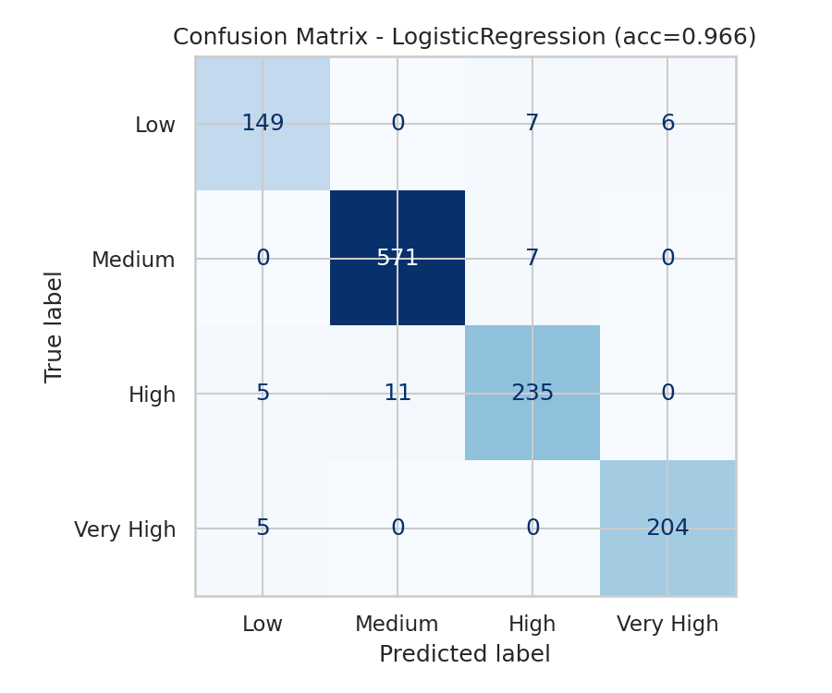
Confusion matrix for the final model on the held-out test set.

10.2 Functional & Manual Testing
- Boundary testing — values at and just outside each indicator's minimum/maximum trigger the expected HTTP 400 validation error.
- Scenario testing — the built-in Very High / Emerging / Low presets were used to confirm the predicted tier and the formula-based tier agree in the vast majority of cases.
- Cross-checking — the ML-predicted tier was manually compared against the official formula-based tier returned in the same response for a range of manually chosen inputs.
- UI testing — slider readouts, the animated spectrum marker, and the preset buttons were manually verified across common screen sizes.

11. Screenshots and Demo
Live Demo: https://hdi-wellbeing-project.vercel.app/
GitHub Repository: https://github.com/jilaniabdul880-crypto/hdi_wellbeing_project

11.1 Landing Page

"Where does a life actually stand?" — the landing hero and spectrum legend.

11.2 Exploratory Data Analysis
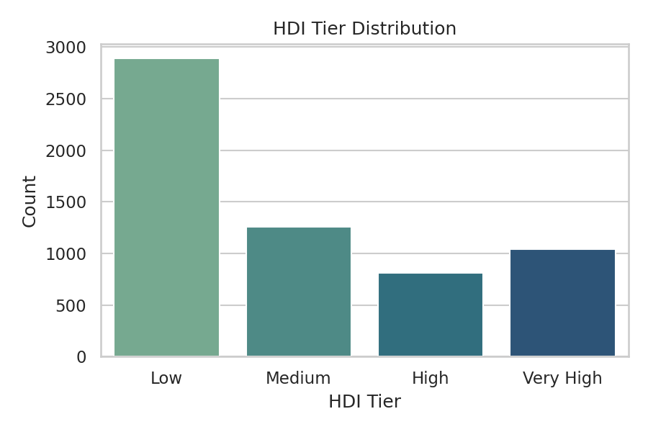
Class distribution across the four development tiers in the training data.
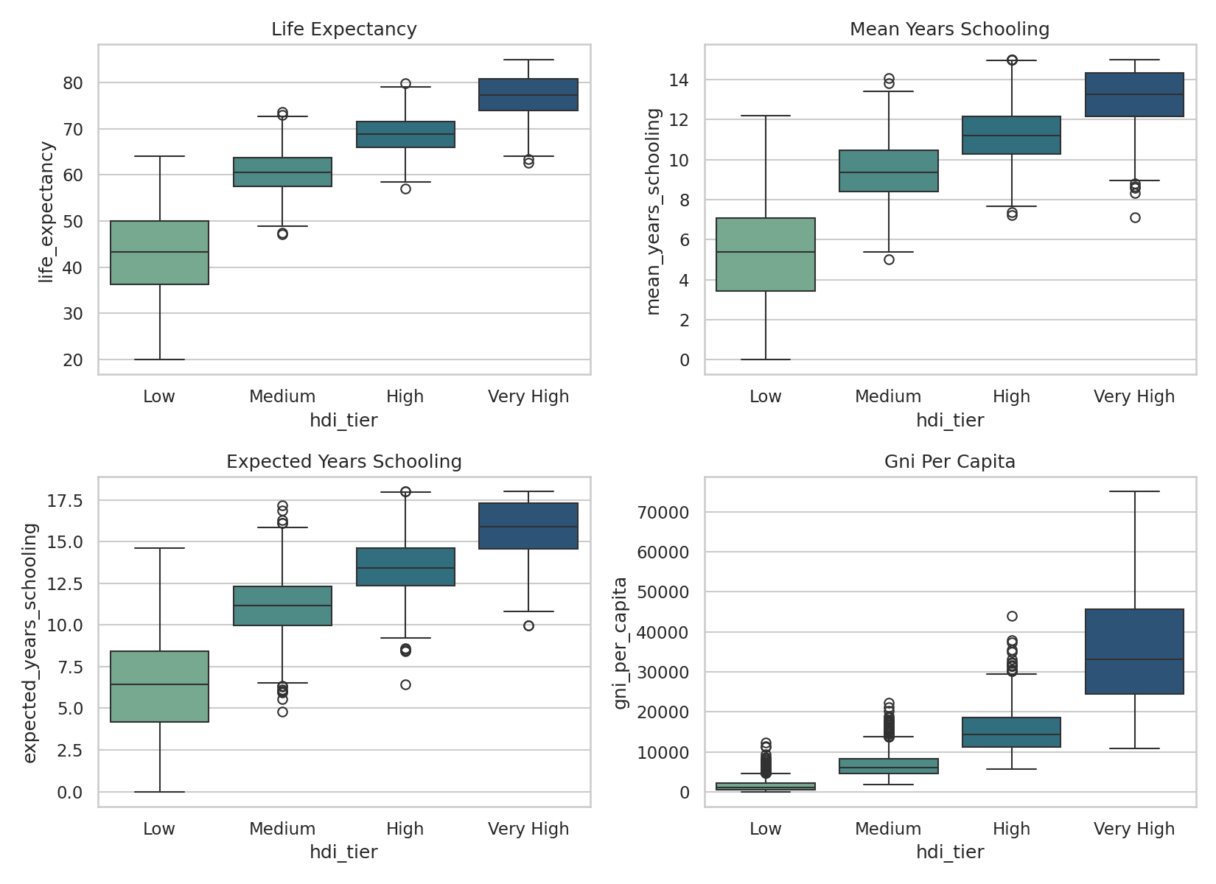
Feature distributions by tier.
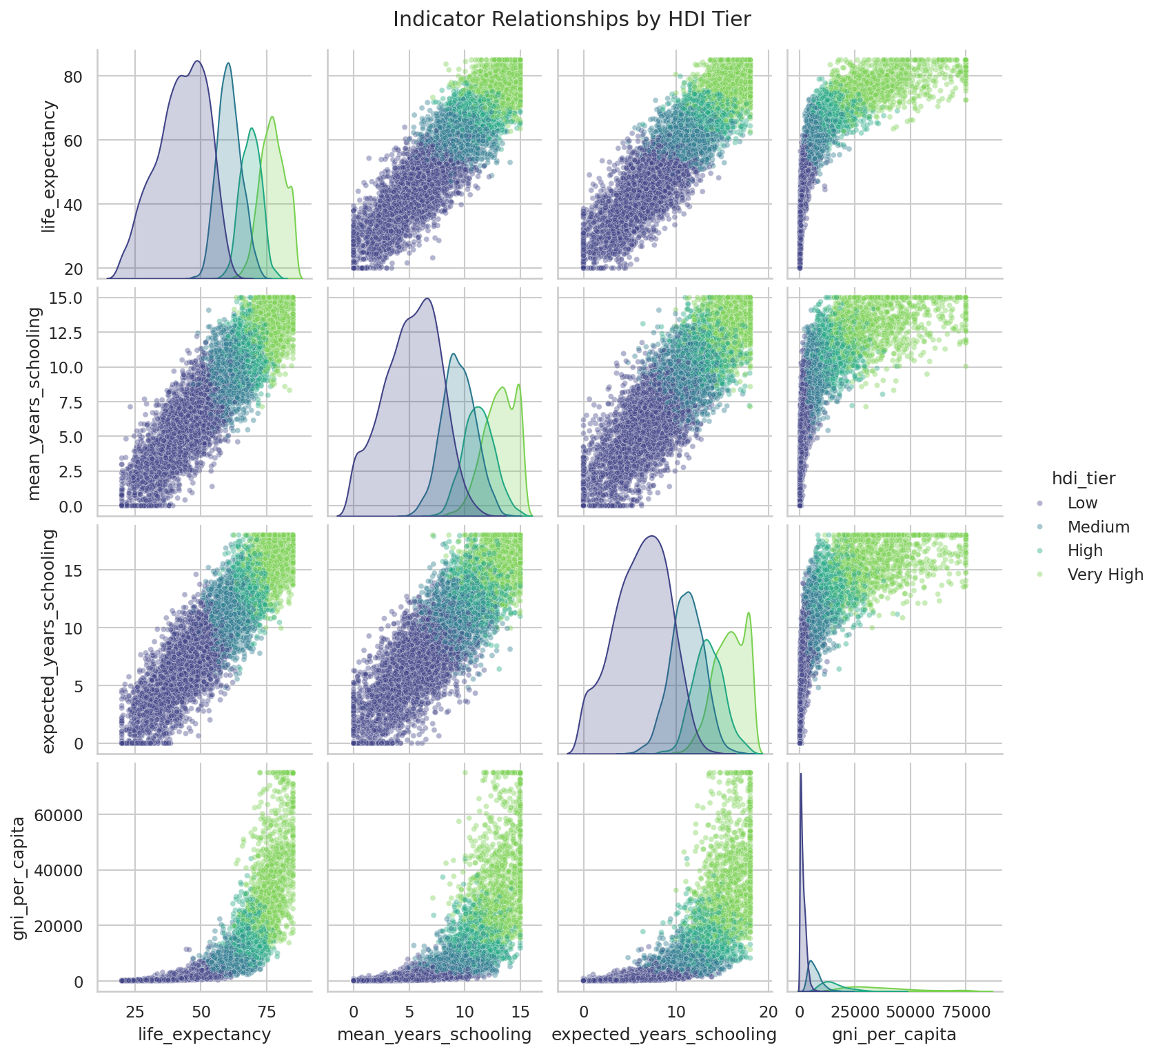
Pairwise relationships between the four UNDP indicators.

12. Known Issues
- The training data is synthetically generated from the official UNDP formula plus noise, not scraped from a live UNDP source — predictions are illustrative of the methodology, not an official HDI lookup for real countries.
- There is no database or persistence layer, so submitted estimates and scenario history are not saved between visits.
- No authentication is implemented; the API endpoints are open to any client with the URL.
- Slider ranges are fixed to the bounds used during training/data simulation (e.g. GNI per capita $100–$75,000); values outside these bounds are rejected rather than extrapolated.
- The app runs as a single Flask process without production-grade process management, rate limiting, or caching.

13. Future Enhancements
- Swap the synthetic dataset for the UNDP's published Human Development Report indicator tables, without changing any code beyond data/generate_dataset.py.
- Add historical trend charts so a user can see how a country's real HDI score has moved over time.
- Introduce user accounts and authentication so scenarios and comparisons can be saved and revisited.
- Expose /api/predict behind rate limiting and API-key access for external integrations.
- Add contextual tooltips and country examples alongside each slider to make the indicator ranges easier to interpret.
- Support multi-language UI and localized number formatting for GNI values.

Built with Python · Flask · scikit-learn · Pandas · NumPy · Matplotlib · Seaborn · HTML/CSS/vanilla JavaScript

