Polarization Correction for Area Detector

z
SD: distance from Sample to Detector
r (OA): distance of lighted spot to the detector center
α: azimuthal angle of the lighted spot
β: polarization angle, measures how much the scattered beam moves along the x axis
r
SD
α
β
sample
x
y
β
E
E’
θ
A
O
B

Diagram: X-ray scattering with linearly polarized incident beam and area detector

Configuration and Argument:

Incident beam comes from right (y direction), with polarization E at x direction, as diagram shows. After it is scattered by the sample, the beam reaches area detector on the lighted spot A. As a result, the beam shifted in the x direction by a distance of OB, or an angle of β. Thus the polarization direction also shifts an angle of β, to E’. Notice here that E and E’ are both in the xy plane. In this circumstance, if the scattered beam intensity is Is, the detector actually measures only Is * cos²β. Hence, to get the correct Is, the measured intensity must be divided by cos²β.

Calculation:

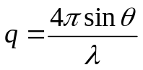 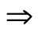 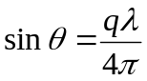 ………………………………………… (1)

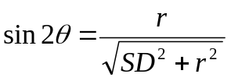 …………………………………………………………. (2)
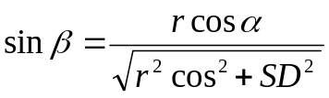 ………………………………………………………….. (3)

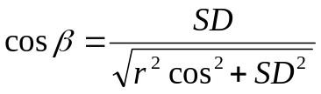 ………………………………………………………….. (4)

From Eq (4), we know that in order to get cosβ, we need to find out r, which is determined by θ and hence q of each point.

From Eq (2), we have 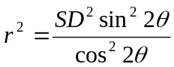, plugging this result back into Eq (4), we have

Or 