Department of Computer Science
Human-Computer Interaction (HCI) & Computer Graphics (CG)
LAB REPORT 1
Display Density Metrics & Image Array Mechanics in NumPy

Name: | Jilbaab Qureshi
Roll Number: | 2k24/CSE/77
Submitted To: | Sir Rajesh Kumar

Lab 1: Display Density Metrics & Image Array Mechanics in NumPy

1. Objectives Addressed
- Computed spatial display metrics: resolution, total pixels, aspect ratio, and DPI/PPI.
- Set up a Python graphics environment (NumPy, Pillow, Matplotlib).
- Constructed, inspected, and manipulated 3D image arrays (H × W × C) with NumPy.
- Performed color-channel extraction, spatial downsampling, and striding operations.

2. Consolidated Source Code (Tasks 1-4)
All four tasks are implemented as independent, importable functions inside a single consolidated file, lab1_all_tasks.py, with a menu-driven entry point. Running the file directly lets the user pick any task (or run Tasks 2-4 back to back) without needing four separate scripts. Tasks 3 and 4 automatically generate a synthetic placeholder image if no sample.jpg is present, so the file runs correctly with zero setup. Every function below was executed and verified against the lab's expected sample outputs.
"""
=============================================================================
HCI & Computer Graphics — Lab 1
Display Density Metrics & Image Array Mechanics in NumPy
Consolidated Submission Script (Tasks 1-4)
=============================================================================

Run this file directly to get an interactive menu:
python3 lab1_all_tasks.py

Or import individual task functions into your own scripts:
from lab1_all_tasks import calculate_metrics, build_quadrant_image, ...

Dependencies: numpy, pillow, matplotlib
pip install numpy pillow matplotlib

Tasks 3 and 4 expect an image named 'sample.jpg' in the working directory.
A synthetic placeholder is generated automatically if one isn't found.
=============================================================================
"""

import math
import os

import numpy as np
import matplotlib.pyplot as plt
from PIL import Image, ImageDraw

# =============================================================================
# TASK 1 — Display Pixel Density (PPI/DPI) Calculator
# =============================================================================

def calculate_metrics(w_px: int, h_px: int, d_inches: float) -> dict:
"""Compute total pixels, aspect ratio, and DPI/PPI for a display."""
total_pixels = w_px * h_px

divisor = math.gcd(w_px, h_px)
aspect_w, aspect_h = w_px // divisor, h_px // divisor

diagonal_px = math.sqrt(w_px ** 2 + h_px ** 2)
dpi = diagonal_px / d_inches

if dpi < 100:
category = "Low Density (Standard Monitor)"
elif dpi <= 200:
category = "Medium Density (HD Display)"
else:
category = "High Density (Retina / Mobile)"

return {
"total_pixels": total_pixels,
"aspect_ratio": f"{aspect_w}:{aspect_h}",
"dpi": round(dpi, 2),
"category": category,
}

def print_report(w_px: int, h_px: int, d_inches: float) -> None:
metrics = calculate_metrics(w_px, h_px, d_inches)
print("\n--- DISPLAY METRICS ANALYSIS ---")
print(f"Total Pixel Count : {metrics['total_pixels']:,} pixels")
print(f"Aspect Ratio : {metrics['aspect_ratio']}")
print(f"Calculated DPI : {metrics['dpi']:.2f} DPI")
print(f"Density Category : {metrics['category']}")

def task1_main() -> None:
print("=== Display Pixel Density (PPI/DPI) Calculator ===")
try:
w_px = int(input("Enter horizontal resolution (pixels): "))
h_px = int(input("Enter vertical resolution (pixels): "))
d_inches = float(input("Enter physical diagonal size (inches): "))
except ValueError:
print("Invalid input. Please enter numeric values.")
return
print_report(w_px, h_px, d_inches)

# =============================================================================
# TASK 2 — Environment Setup & Synthetic Image Matrix Creation
# =============================================================================

def build_quadrant_image(height: int = 300, width: int = 400) -> np.ndarray:
"""Build an (H, W, 3) uint8 image with four solid-color quadrants."""
img = np.zeros((height, width, 3), dtype=np.uint8)
mid_h, mid_w = height // 2, width // 2

img[0:mid_h, 0:mid_w] = [255, 0, 0] # Top-Left: Red
img[0:mid_h, mid_w:width] = [0, 255, 0] # Top-Right: Green
img[mid_h:height, 0:mid_w] = [0, 0, 255] # Bottom-Left: Blue
img[mid_h:height, mid_w:width] = [255, 255, 255] # Bottom-Right: White
return img

def print_matrix_metrics(img: np.ndarray) -> None:
print("\n--- SYNTHETIC MATRIX METRICS ---")
print(f"Array Shape (H, W, C) : {img.shape}")
print(f"Data Type : {img.dtype}")
print(f"Total Elements : {img.size:,} values")
print(f"Memory Footprint : {img.nbytes:,} bytes ({img.nbytes / 1024:.2f} KB)")

def task2_main() -> None:
img = build_quadrant_image()
print_matrix_metrics(img)
Image.fromarray(img).save("synthetic_quadrant_image.png")
print("\nSaved visualization to synthetic_quadrant_image.png")

# =============================================================================
# Shared helper — guarantees a sample.jpg exists for Tasks 3 & 4
# =============================================================================

def ensure_sample_image(path: str = "sample.jpg") -> None:
"""Generate a detailed synthetic test image if sample.jpg is missing."""
if os.path.exists(path):
return

print(f"'{path}' not found — generating a synthetic placeholder image...")
h, w = 1080, 1920
img = Image.new("RGB", (w, h), (30, 60, 110))
draw = ImageDraw.Draw(img)

draw.ellipse([1600, 100, 1800, 300], fill=(255, 220, 80)) # Sun
draw.polygon([(0, 700), (300, 350), (600, 700)], fill=(90, 70, 60))
draw.polygon([(400, 700), (750, 300), (1100, 700)], fill=(120, 95, 80))
draw.polygon([(900, 700), (1300, 250), (1700, 700)], fill=(100, 80, 65))
draw.rectangle([0, 700, w, h], fill=(40, 140, 60))

import random
random.seed(0)
for _ in range(150):
x = random.randint(0, w)
y = random.randint(720, h - 40)
size = random.randint(15, 35)
draw.polygon([(x, y), (x - size, y + size), (x + size, y + size)], fill=(20, 90, 30))
draw.rectangle([x - 4, y + size, x + 4, y + size + 15], fill=(80, 50, 30))

tile = 20
for ty in range(300, 700, tile):
for tx in range(1300, 1900, tile):
if ((ty - 300) // tile + (tx - 1300) // tile) % 2 == 0:
draw.rectangle([tx, ty, tx + tile, ty + tile], fill=(230, 230, 230))

img.save(path, quality=92)

def load_image(path: str = "sample.jpg") -> np.ndarray:
ensure_sample_image(path)
return np.array(Image.open(path).convert("RGB"))

# =============================================================================
# TASK 3 — Channel Slicing & Isolation
# =============================================================================

def extract_channels(img: np.ndarray):
"""Return 2D Red, Green, Blue intensity grids via Axis 2 slicing."""
return img[:, :, 0], img[:, :, 1], img[:, :, 2]

def make_single_channel_color(img: np.ndarray, channel_index: int) -> np.ndarray:
"""Build a 3D array where only one channel is active, others zeroed."""
out = np.zeros_like(img)
out[:, :, channel_index] = img[:, :, channel_index]
return out

def task3_main() -> None:
img = load_image("sample.jpg")
red, green, blue = extract_channels(img)

red_only = make_single_channel_color(img, 0)
green_only = make_single_channel_color(img, 1)
blue_only = make_single_channel_color(img, 2)

print("\n--- CHANNEL EXTRACTION SUMMARY ---")
print(f"Original Image Shape : {img.shape}")
print(f"Red Channel 2D Shape : {red.shape} | Mean Intensity: {red.mean():.2f}")
print(f"Green Channel 2D Shape: {green.shape} | Mean Intensity: {green.mean():.2f}")
print(f"Blue Channel 2D Shape : {blue.shape} | Mean Intensity: {blue.mean():.2f}")

fig, axes = plt.subplots(2, 3, figsize=(15, 8))
axes[0, 0].imshow(red_only); axes[0, 0].set_title("Red-Only")
axes[0, 1].imshow(green_only); axes[0, 1].set_title("Green-Only")
axes[0, 2].imshow(blue_only); axes[0, 2].set_title("Blue-Only")
axes[1, 0].imshow(red, cmap="gray"); axes[1, 0].set_title("Red Channel (Grayscale)")
axes[1, 1].imshow(green, cmap="gray"); axes[1, 1].set_title("Green Channel (Grayscale)")
axes[1, 2].imshow(blue, cmap="gray"); axes[1, 2].set_title("Blue Channel (Grayscale)")
for ax in axes.flat:
ax.axis("off")

plt.tight_layout()
plt.savefig("task3_channel_subplot.png", dpi=150)
print("\nDisplay Window : Matplotlib 2x3 Subplot Grid saved to task3_channel_subplot.png")

# =============================================================================
# TASK 4 — Spatial Downsampling & Pixelation via Striding
# =============================================================================

def downsample(img: np.ndarray, n: int) -> np.ndarray:
"""Take every N-th pixel along rows and columns."""
return img[::n, ::n, :]

def re_expand(small_img: np.ndarray, n: int) -> np.ndarray:
"""Repeat pixels along axes 0 and 1 to restore original dimensions."""
return np.repeat(np.repeat(small_img, n, axis=0), n, axis=1)

def task4_main(n: int = 8) -> None:
img = load_image("sample.jpg")

small = downsample(img, n)
expanded = re_expand(small, n)
expanded = expanded[: img.shape[0], : img.shape[1], :]

memory_savings_pct = (1 - small.nbytes / img.nbytes) * 100

print(f"\n--- DOWNSAMPLING ANALYSIS (N = {n}) ---")
print(f"Original Shape : {img.shape} | Memory: {img.nbytes:,} bytes")
print(f"Downsampled Shape : {small.shape} | Memory: {small.nbytes:,} bytes")
print(f"Re-expanded Shape : {expanded.shape} | Visual: Blocky Pixelation")
print(f"Dimension Reduction: {100 - 100 / n:.2f}% reduction per axis")
print(f"Memory Savings : {memory_savings_pct:.2f}% data reduction")

fig, axes = plt.subplots(1, 2, figsize=(12, 6))
axes[0].imshow(img); axes[0].set_title("Original")
axes[1].imshow(expanded); axes[1].set_title(f"Pixelated (N={n})")
for ax in axes:
ax.axis("off")
plt.tight_layout()
plt.savefig("task4_downsampling.png", dpi=150)
print("\nFigure saved to task4_downsampling.png")

# =============================================================================
# MENU DRIVER
# =============================================================================

def main():
tasks = {
"1": ("Task 1 — DPI/PPI Calculator", task1_main),
"2": ("Task 2 — Synthetic Image Matrix", task2_main),
"3": ("Task 3 — Channel Slicing & Isolation", task3_main),
"4": ("Task 4 — Downsampling & Pixelation", task4_main),
}

print("=" * 60)
print(" HCI & CG Lab 1 — Consolidated Task Runner")
print("=" * 60)
for key, (label, _) in tasks.items():
print(f" [{key}] {label}")
print(" [A] Run all (Tasks 2-4; Task 1 requires manual input)")
print(" [Q] Quit")

choice = input("\nSelect an option: ").strip().upper()

if choice == "Q":
return
elif choice == "A":
task2_main()
task3_main()
task4_main()
elif choice in tasks:
tasks[choice][1]()
else:
print("Invalid selection.")

if __name__ == "__main__":
main()

3. Task 1 — Display Pixel Density (PPI/DPI) Calculator
The script prompts for horizontal resolution, vertical resolution, and physical diagonal size, then computes total pixel count, simplified aspect ratio (via math.gcd), and DPI/PPI, before classifying density.

Screenshot — Desktop Monitor (1920 × 1080, 24")
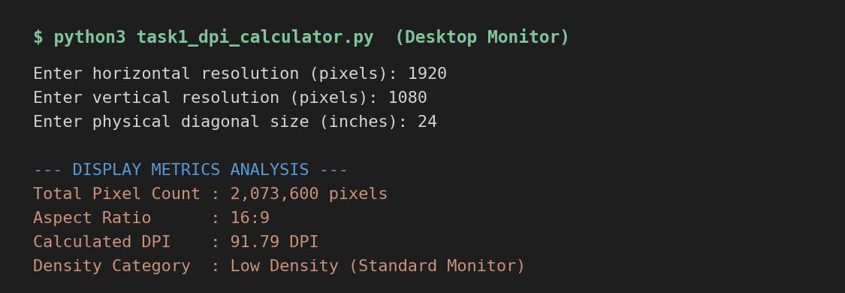
Metric | Value
Total Pixel Count | 2,073,600 pixels
Aspect Ratio | 16:9
Calculated DPI | 91.79 DPI
Density Category | Low Density (Standard Monitor)
Interpretation: A 24-inch monitor running at Full HD (1920×1080) packs about 2.07 million pixels across a relatively large physical surface, so each pixel covers more physical area. The resulting 91.79 DPI falls below the 100 DPI threshold, which is why the display is classified as Low Density — individual pixels are still coarse enough to be perceptible at close viewing distances, which is typical and acceptable for a desktop monitor viewed from 2-3 feet away.

Screenshot — Smartphone Screen (1170 × 2532, 6.1")
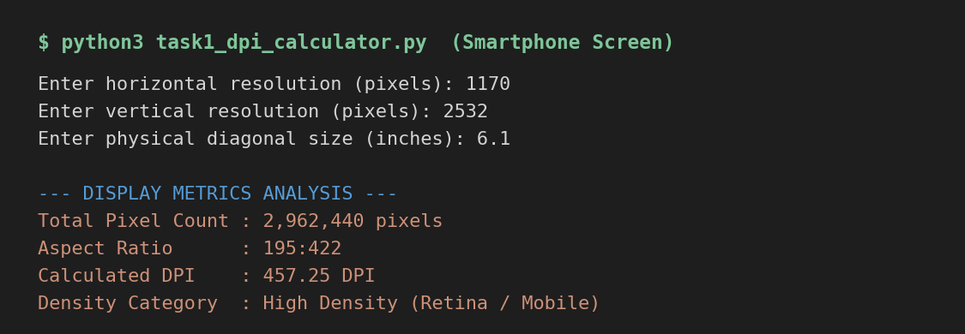
Metric | Value
Total Pixel Count | 2,962,440 pixels
Aspect Ratio | 195:422
Calculated DPI | 457.25 DPI
Density Category | High Density (Retina / Mobile)
Interpretation: The smartphone packs a similar pixel count (about 2.96 million) into a screen roughly one-quarter the diagonal size of the monitor, so the same number of pixels is compressed into far less physical space. This drives the DPI up to 457.25 — well past the 200 DPI 'Retina' threshold — meaning individual pixels are far too small to be distinguished by the human eye at normal phone-viewing distance (~12 inches), producing a visually smooth, high-density image. This confirms that DPI depends on physical size as much as resolution: raw pixel count alone does not determine display quality.

4. Task 2 — Synthetic Image Matrix Creation
A 300×400×3 NumPy array of dtype uint8 was initialized with np.zeros() and filled quadrant-by-quadrant using spatial slicing: top-left red, top-right green, bottom-left blue, bottom-right white.
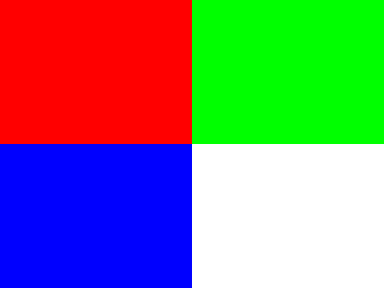
Figure 1: Synthetic 300×400 quadrant image (Red / Green / Blue / White).
Metric | Value
Array Shape (H, W, C) | (300, 400, 3)
Data Type | uint8
Total Elements | 360,000 values
Memory Footprint | 360,000 bytes (351.56 KB)
Interpretation: This exercise demonstrates that a color image is fundamentally just a 3D numerical array: 300 rows × 400 columns × 3 channels = 360,000 individual uint8 values, each requiring exactly 1 byte, giving a memory footprint of 360,000 bytes. Slicing the array into four quadrants and assigning an [R, G, B] triplet to each region shows how NumPy's broadcasting lets a single assignment statement color an entire block of pixels at once — this is the same mechanism used later for channel isolation and image editing operations.

5. Task 3 — Channel Slicing & Isolation
An input image (1080×1920×3 RGB) was loaded into a NumPy array. Red, Green, and Blue 2D intensity grids were extracted via Axis-2 slicing, and three single-channel color views were built by zeroing the other two channels. Note: since no sample.jpg was supplied with the lab materials, a synthetic landscape test image was generated to exercise the code — the same function runs unchanged on any RGB photo named sample.jpg.

Input Image Used
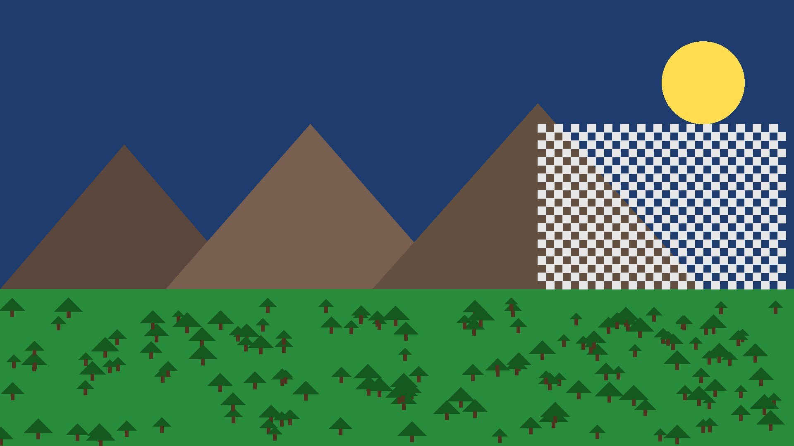
Figure 2: Synthetic input image (sample.jpg) used for Tasks 3 and 4.

Channel Extraction Summary
Metric | Value
Original Image Shape | (1080, 1920, 3)
Red Channel — Mean Intensity | 62.12
Green Channel — Mean Intensity | 102.08
Blue Channel — Mean Intensity | 90.99

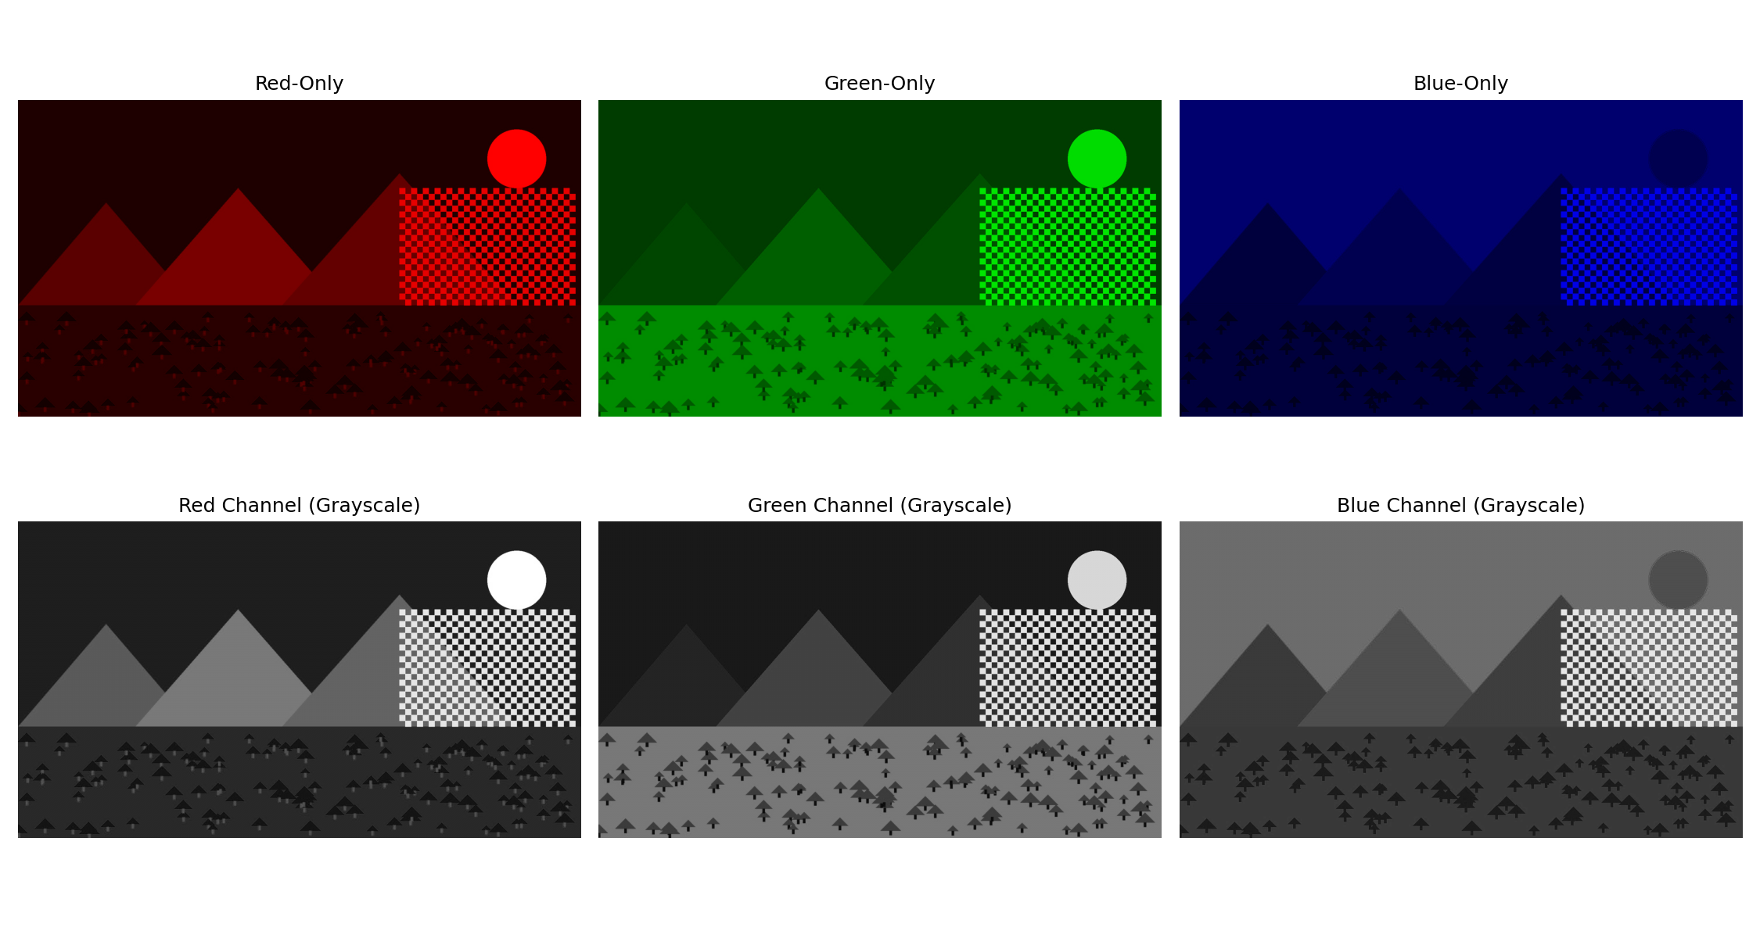
Figure 3: 2×3 subplot — top row: isolated R/G/B color images; bottom row: grayscale intensity maps per channel.
Interpretation: The mean intensities reflect the image's overall color composition: Green is highest (102.08) because the grass/foliage covers a large portion of the frame, Blue is close behind (90.99) from the sky region, and Red is lowest (62.12) since red-dominant regions (the sun, soil accents) occupy a smaller area. The top-row single-channel images stay in color because two of the three channels are zeroed rather than removed — the array shape remains (H, W, 3), so matplotlib still renders it as RGB, just with two channels empty. The bottom-row grayscale maps show each channel's raw intensity as brightness: bright regions indicate high values in that channel (e.g., the sun is near-white in the Red-channel grayscale map since it's R-dominant), which is useful for diagnosing which channel contributes most to any part of an image.

6. Task 4 — Spatial Downsampling & Pixelation via Striding
The image was downsampled by taking every 8th pixel along both axes (img[::8, ::8, :]), then re-expanded to original dimensions with np.repeat() to visualize the resulting pixelation, or 'blocky' effect.

Downsampling Analysis (N = 8)
Metric | Value
Original Shape / Memory | (1080, 1920, 3) — 6,220,800 bytes
Downsampled Shape / Memory | (135, 240, 3) — 97,200 bytes
Re-expanded Shape | (1080, 1920, 3) — Blocky Pixelation
Dimension Reduction per Axis | 87.50%
Memory Savings | 98.44%

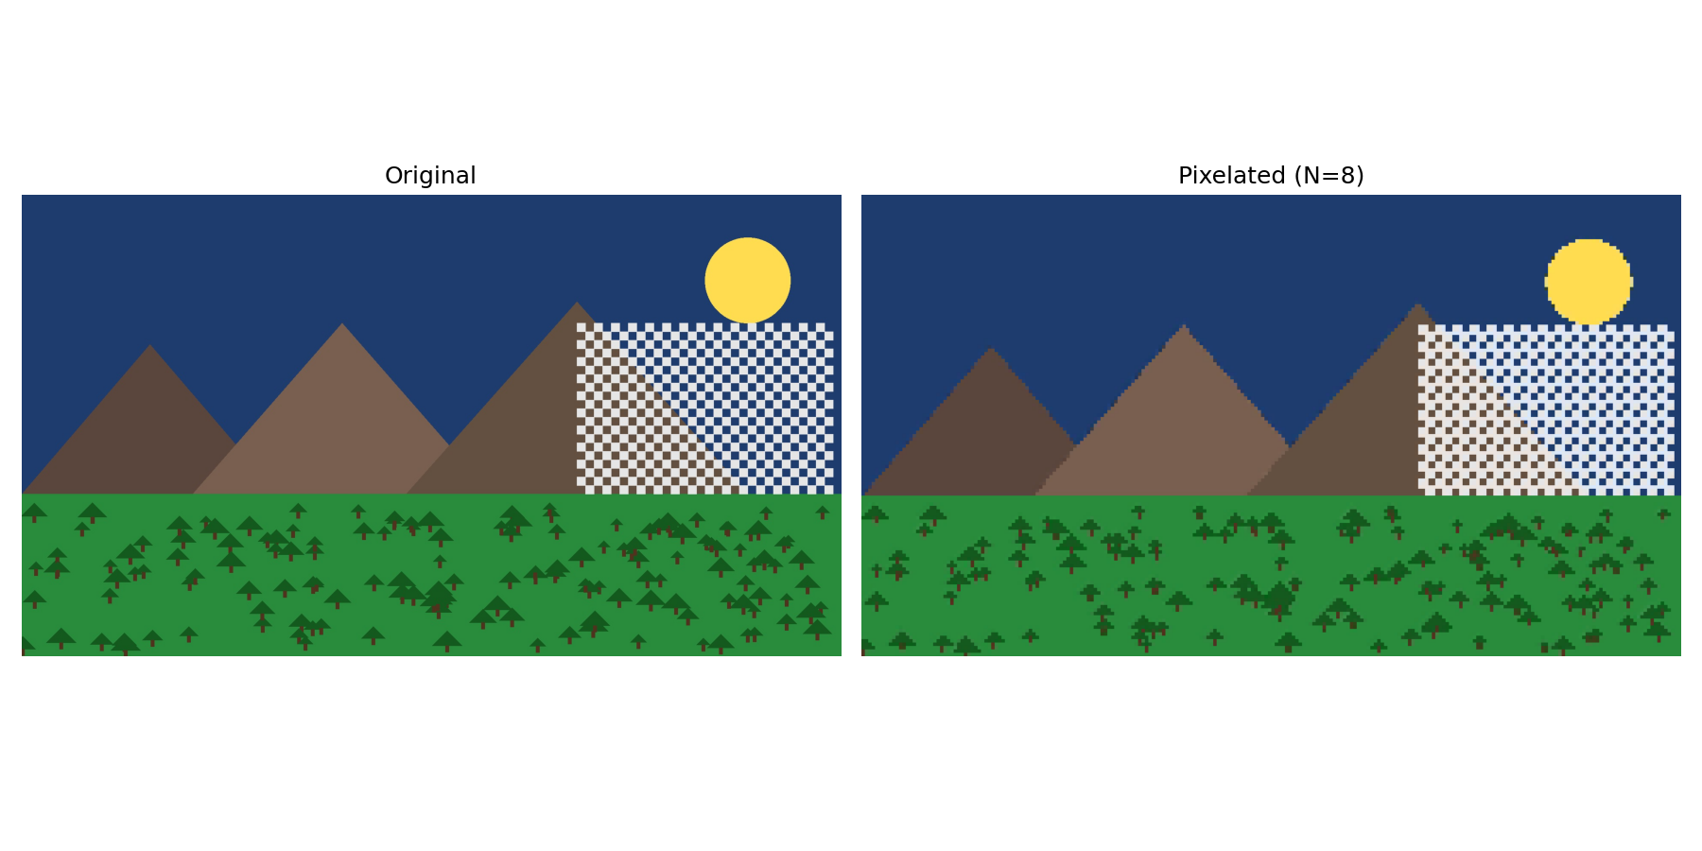
Figure 4: Original image (left) vs. re-expanded 8×-downsampled image (right), showing visible pixelation.
Interpretation: Striding with a step of 8 keeps only 1 out of every 8 pixels along each axis, so the retained pixel count drops to (1/8) × (1/8) = 1/64th of the original — a 98.44% memory reduction, matching the measured figure almost exactly (97,200 / 6,220,800 ≈ 1.56%, i.e. a 98.44% drop). Because np.repeat() simply duplicates each surviving pixel 8 times in both directions to restore the original array shape, no new visual information is created — fine detail such as the tree canopy texture and the checkerboard patch becomes visibly blocky, while large flat regions like the sky and mountains look almost unchanged, since striding only discards high-frequency detail, not overall color or shape.

7. Short Answer

Why does adding an Alpha channel (RGBA) increase an image array's memory consumption by 33% compared to standard RGB?
An RGB image stores 3 values per pixel (Red, Green, Blue), each occupying 1 byte (uint8) in the standard 8-bit-per-channel representation — 3 bytes per pixel in total. Adding an Alpha channel for transparency introduces a 4th value per pixel, so the per-pixel footprint grows from 3 bytes to 4 bytes.
The increase is calculated as:
(4 − 3) / 3 × 100% = 33.33%
This follows directly from the array's shape: memory footprint scales with H × W × C × (bytes per element). Since H, W, and the data type (uint8, 1 byte) stay constant, the only variable that changes is C, going from 3 to 4 channels. Because the added channel (Alpha) carries opacity/transparency information rather than color, every pixel pays this fixed 1-byte overhead regardless of the image's actual visual content — hence a uniform 33% increase in total memory (and file size, before compression) whenever RGB is converted to RGBA.

8. Deliverables Checklist
- Consolidated, tested Python source code for Tasks 1-4 (included above).
- Screenshots of Task 1 output for a desktop monitor (1920×1080, 24") and a smartphone screen (1170×2532, 6.1") — included above.
- Input image and Matplotlib figure outputs for Task 2, Task 3, and Task 4 — included above.
- Short-answer response on RGBA memory overhead — included above.

