SIIM-CAIMI26 · AI Builder Showcase submission (draft for review)

ITK-SNAP as an Agent-Callable Tool: Expert Human Correction as a Resumable, Audited Pipeline Step
Presenting author: Jilei Hao · Co-authors / affiliation: TO CONFIRM
Body word count: 497 / 500 (title, section headings and keywords are excluded per submission rules §4)
Deadline: July 24, 2026, 11:59 PM PST · Portal EventKey: QRFBVSUS · Not blind: institution / tool names allowed.

Keywords
human-in-the-loop; interactive segmentation; agentic AI; Model Context Protocol; provenance; foundation models; TotalSegmentator; open-source toolkits

Problem Statement 87 words
Automatic segmentation models are increasingly capable but still imperfect, so clinical and research pipelines depend on expert verification and correction. Yet that expert judgment is trapped inside interactive GUIs: a person opens an image, paints a fix, and saves a file — the reasoning and the exact change evaporate. An automated pipeline or AI agent has no clean way to call a human expert as a first-class pipeline step and receive a machine-consumable answer back. The human-in-the-loop is real in practice but missing from our software interfaces.

Approach / What You Built 180 words
We exposed ITK-SNAP — a 20-year, open-source segmentation application (>1M downloads) — as an agent-callable tool via the Model Context Protocol (MCP). An external agent runs automatic segmentation (TotalSegmentator, served by our open itksnap-dls model server) and applies the proposal into a durable ITK-SNAP workspace — headlessly, with no GUI running. When a case needs review, the agent opens that same workspace in a live ITK-SNAP where the expert corrects it. Every edit — agent or human — returns not an opaque file but a structured audit record (Table 1). Two design choices make this practical. First, provenance is captured at a single commit point as one schema — whether computed headlessly from the before/after label volumes or reconstructed in the live GUI from ITK-SNAP’s undo delta (old = new − delta) — so none of the eleven editing tools changed. Second, because the workspace is the source of truth, the step is resumable: an automated pipeline can prepare a case before any human is involved, and the audit trail persists across sessions.

Demo or Evidence of Function 104 words
GitHub: github.com/jilei-hao/itksnap-mcp (the Python agent glue and a one-command driver) and github.com/jilei-hao/itksnap (the C++ audit engine and command channel); a short video walkthrough. Verified live end-to-end on a GPU: the agent ran TotalSegmentator on a body CT (48 anatomically correct thoracic structures), applied a chosen structure into an ITK-SNAP workspace, and read back the audit record (Table 1). A human then opened that workspace in ITK-SNAP and corrected the proposal with the paintbrush, and the agent received the identical record auto-tagged actor: human — the agent’s commit consumes the tag, so any edit it did not make is attributed to the person (Figure 1).

Clinical or Operational Impact 50 words
This turns expert review into an orchestrable, resumable pipeline step. Inside a large automated cohort, a human becomes a callable checkpoint invoked only for uncertain cases, and every correction is captured as reusable, attributable provenance — labeled by who made it — that can feed model fine-tuning and quality auditing.

Current Stage 46 words
Prototype, open-source, not a product. The propose → apply → audit backbone works end-to-end; the correction in the walkthrough was made by a developer, not a clinician, so it exercises the mechanism rather than clinical judgment. Confidence-gated routing and a packaged MCP distribution are in progress.

What Feedback You're Seeking 37 words
Which audit-record fields matter most for downstream model fine-tuning and provenance? What confidence signals do you trust to decide auto-accept versus route-to-human? And where would a callable expert-correction step plug into your existing annotation and quality-assurance workflows?

Figures
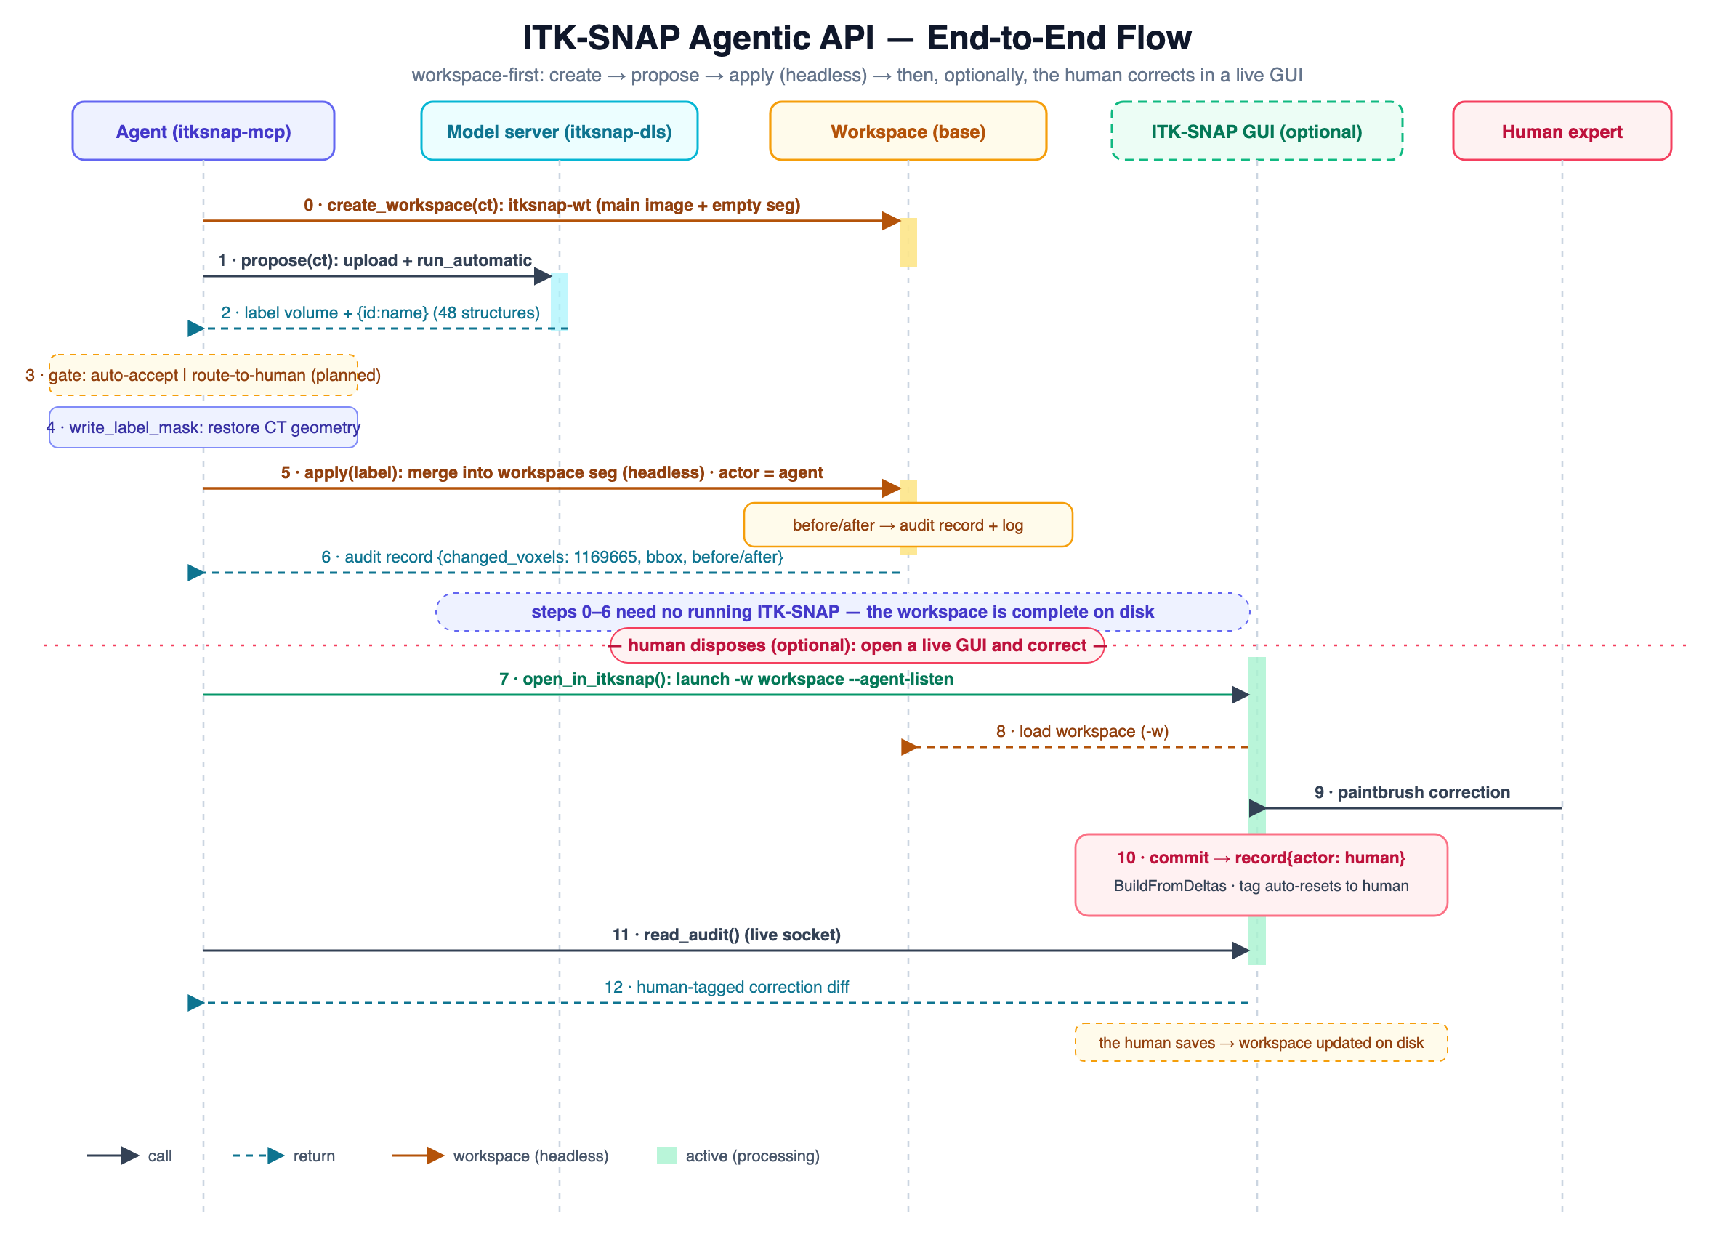
Figure 1. One end-to-end run, workspace-first. The agent creates a durable ITK-SNAP workspace, gets an automatic proposal from the model server, and applies it into the workspace segmentation headlessly — no running ITK-SNAP (steps 0–6). When a case needs review it opens the workspace in a live ITK-SNAP for the expert’s paintbrush correction; every committed edit returns the same structured audit record, tagged agent or human.
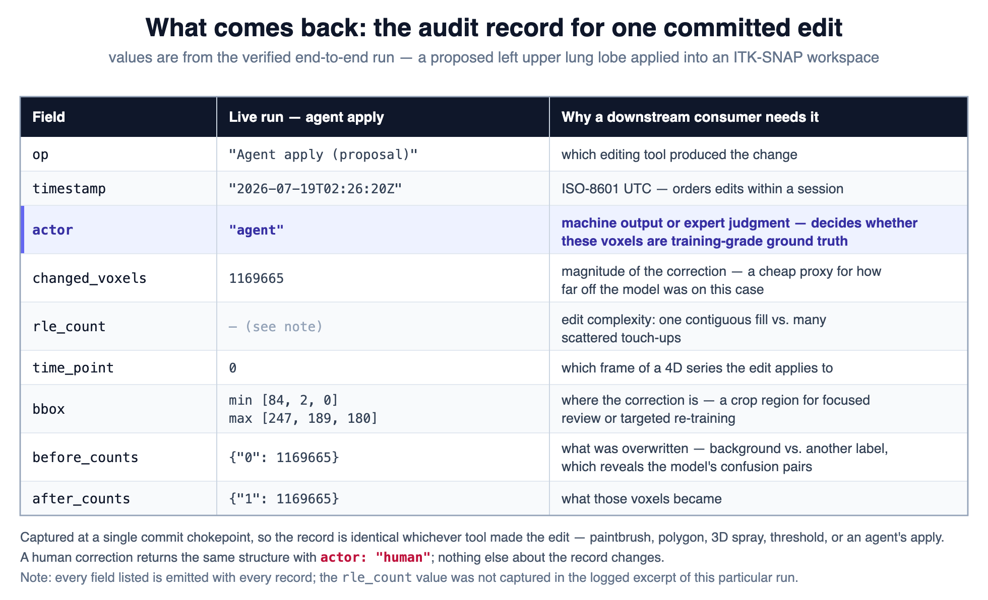
Table 1. What comes back: the audit record for one committed edit. Values from the verified end-to-end run (a proposed left upper lung lobe). The same schema is emitted whether the edit is applied headlessly (computed from the before/after label volumes) or corrected in the live GUI (reconstructed from the undo delta); a human correction returns the identical structure tagged actor: human.

