Supporting Document — ITK-SNAP: Human-in-the-Loop AI Image Segmentation
What this is. Draft content for the optional Section-4 upload (1 PDF, ≤ 4 pages: PI/co-PI bios, references, figures, and other supporting documentation). This is not the Section-4 narrative (Section 4 is the character-limited fields in section4_fields.md + the work-plan-template PDF). Content reframed from the earlier draft. Check that this renders to ≤ 4 pages before exporting; trim figures or bios to fit. [bracketed italics] = the team must complete/verify.
1. PI and Co-PI biographies
(The optional upload asks for PI/co-PI bios only. Other key personnel — e.g. lead developer Jilei Hao — are captured in Section 1 of the application form, not here.)
Paul A. Yushkevich, PhD — Principal Investigator. Professor of Radiology at the University of Pennsylvania (Perelman School of Medicine), in the Penn Image Computing and Science Laboratory (PICSL), with a graduate-group appointment in Bioengineering; PhD in Computer Science, University of North Carolina at Chapel Hill (2003). He is the creator and long-standing lead maintainer of ITK-SNAP across its ~20-year history. His NIH-funded research develops statistical-shape and biomedical image-analysis methods — including automatic segmentation and morphometry of the hippocampal formation for Alzheimer's-disease imaging biomarkers, and machine-learning methods that improve general-purpose segmentation — with a sustained record of building open-source imaging software (NIH; CZI EOSS). [Add "Director of PICSL" if accurate; the source page lists PICSL as affiliation but not a directorship.]
Alison M. Pouch, PhD — Co-Principal Investigator. Assistant Professor of Radiology at the University of Pennsylvania (Perelman School of Medicine), with core-faculty appointments in the Penn Center for Biomedical Image Computing and Analysis (CBICA), the Penn Cardiovascular Institute, and the Penn Institute for Computational Sciences (PICS), and a graduate-group appointment in Bioengineering; PhD in Bioengineering, University of Pennsylvania (2013). Her research centers on cardiac image analysis — 3D/4D echocardiography, heart-valve modeling, and 3D-ultrasound and foundation-model segmentation — and she is a senior author on the ITK-SNAP 4 / 4D cardiac tools paper (Hao et al., FIMH 2025 — ref 2), collaborating directly with the project's lead developer. In this project she leads the cardiac use cases and the Year-2 evaluation of expert-in-the-loop model improvement.
[Add any additional co-PIs with a 2–3 sentence bio each; do not exceed the ≤4-page budget.]
2. Project maturity, adoption, and ecosystem role
ITK-SNAP is among the most established and most-cited tools for 3D/4D biomedical image segmentation:
- Scientific impact & adoption: ~20 years of continuous development; 11,082 citations of the methods paper (incl. Science and Nature venues); 1.16M+ downloads (SourceForge); a large international user base across neuroimaging, radiology, and cardiology. [Add a recent 12–24-month download/citation-growth figure — reviewers weigh recent growth explicitly. See Fig. 2.]
- Sustained, open development: 2,284 non-merge commits and contributions from ~24 individual developers over the project's lifetime, with active development continuing through the current 4.6.0-alpha series and the 4.8 / 4.10 release train tracked as public GitHub Milestones.
- Ecosystem role: built on the ITK/VTK/Qt stack; nnInteractive (CVPR 2025 interactive-segmentation challenge winner) is now integrated across napari, MITK, 3D Slicer, and ITK-SNAP, and our itksnap-dls server is ITK-SNAP's path into that shared model ecosystem. Cross-ecosystem engagement is concrete: past contributors include developers from Kitware/ITK (Dženan Zukić, Matt McCormick, Jared Vicory) and ANTs (Nicholas Tustison) — evidence of real ties across the open-source imaging ecosystem.
3. Technical approach and feasibility
The effort is integration-heavy, not greenfield: it composes mature, working components (ITK-SNAP, itksnap-dls, greedy/Convert3D, SegFlow4D) behind small, well-scoped new interfaces, validated at each step by ITK-SNAP's existing automated test harness. A key feasibility fact is that both technical substrates already exist:
- A toolkit-independent, GUI-free logic tier. ITK-SNAP's core logic already builds free of GUI dependencies — proven today by the shipped headless itksnap-wt binary — so the Python/agent-callable surface (Aim 1) is a binding-and-interface exercise, not a rewrite.
- A working remote-data transport layer. ITK-SNAP already loads images and workspaces over Flywheel, SSH, and HTTP, with caching; Aim 2 adds a browsable explorer UI and agent API over that transport, plus DICOM/BIDS-aware organization.
The genuinely new work is therefore concentrated and independently testable — the Python binding, the agent-callable review/command surface, the provenance/audit record, the MCP server, and the explorer UI — with a single larger new subsystem (DICOM-SEG interchange) isolated as a discrete Year-2 deliverable and validated by round-trip against an external tool (e.g. 3D Slicer). The model-improvement loop (milestone 1.3) relies only on mature techniques — supervised fine-tuning on expert-corrected labels and uncertainty-based case routing (active learning) — so it depends on no unproven advance; the novel element is the capture plumbing, which is squarely in the team's competency. This shape — small interfaces over shipped code, continuously validated — is well matched to AI-assisted development within a focused two-year effort.
[Optional: insert the layered-architecture figure here — see Fig. 1.]
4. Team, governance, and sustainability
Governance. [Articulate the project’s governance and maintainer model: how releases are approved, how external contributions are reviewed and merged, and how maintainership is shared. If no formal document exists, a short public GOVERNANCE/MAINTAINERS statement created before submission would directly address the "open-source quality" review criterion.]
Contributor base and growth. Development is currently concentrated in a small core team (the PI and lead developer account for the large majority of commits), within a real ~24-developer lifetime base that includes ITK/ANTs-ecosystem collaborators. Broadening the active contributor and maintainer base is an explicit objective (Goal 3): the contributor hackathon and developer documentation for the new interfaces are designed to lower the barrier to entry, with a concrete target of [N] new external contributors / merged community pull requests.
Sustainability beyond the grant. The pip-installable API and MCP server are lightweight, auto-updatable artifacts published to PyPI, with pip-based download metrics for transparent ongoing adoption tracking; the GUI continues on ITK-SNAP's established release and installer channels; and institutional cost-share contributes a portion of the lead maintainer's time, existing CI/test infrastructure, and the mature codebases the work builds on. Together with the contributor-growth activities, this maintains the project's trajectory after the funding period.
5. Figures and tables
Table 1 — The landscape gap. Legend: ✓ available today · ◐ partial · ★ delivered by this proposal · ✗ not available.
Capability | ITK-SNAP | 3D Slicer | MITK | napari | MONAI Label
Established, widely adopted for its audience | ✓ | ✓ | ✓ | ✓ (microscopy) | ✓ (framework)
Interactive foundation-model segmentation | ✓ | ✓ | ✓ | ✓ | ✓
Remote / cloud data access | ✓ | ✓ | ◐ | ◐ | ✓
Lossless open-format interchange (DICOM-SEG) | ★ | ✓ | ✓ | ◐ | ✓
Agent-callable API for external pipelines | ★ | ◐ | ✗ | ◐ | ◐
Expert review/correction as a callable, resumable, audited pipeline step | ★ | ✗ | ✗ | ✗ | ✗
No existing tool exposes the bottom-row primitive — competitors keep the human inside their own UI or labeling loop rather than offering expert review as a step an external agent invokes. That gap is this proposal’s core contribution. (Mirrors the LOI Landscape Analysis.)
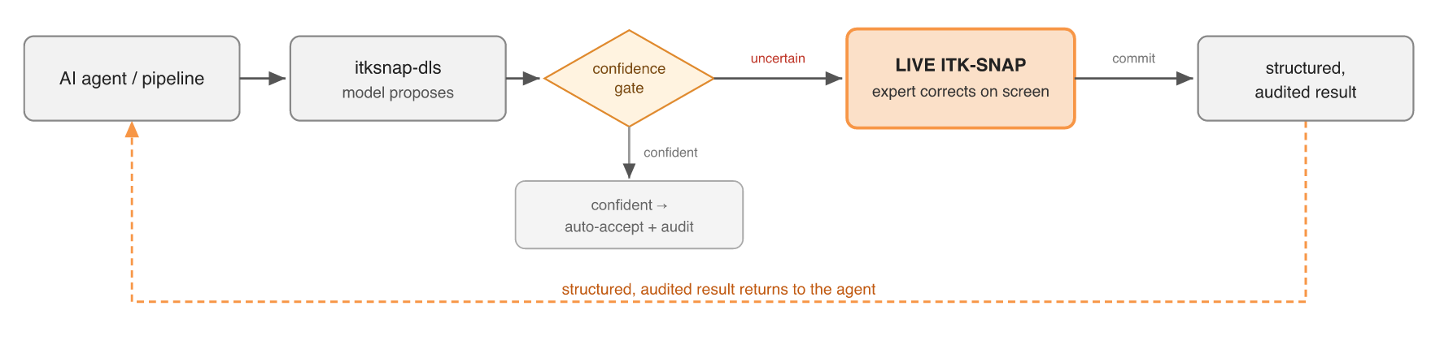
Fig. 1 — Human-in-the-loop workflow (created). Model proposes (itksnap-dls) → the agent's confidence gate flags an uncertain case → control hands to a live ITK-SNAP session where the expert corrects on screen → a structured, audited result returns to the agent.
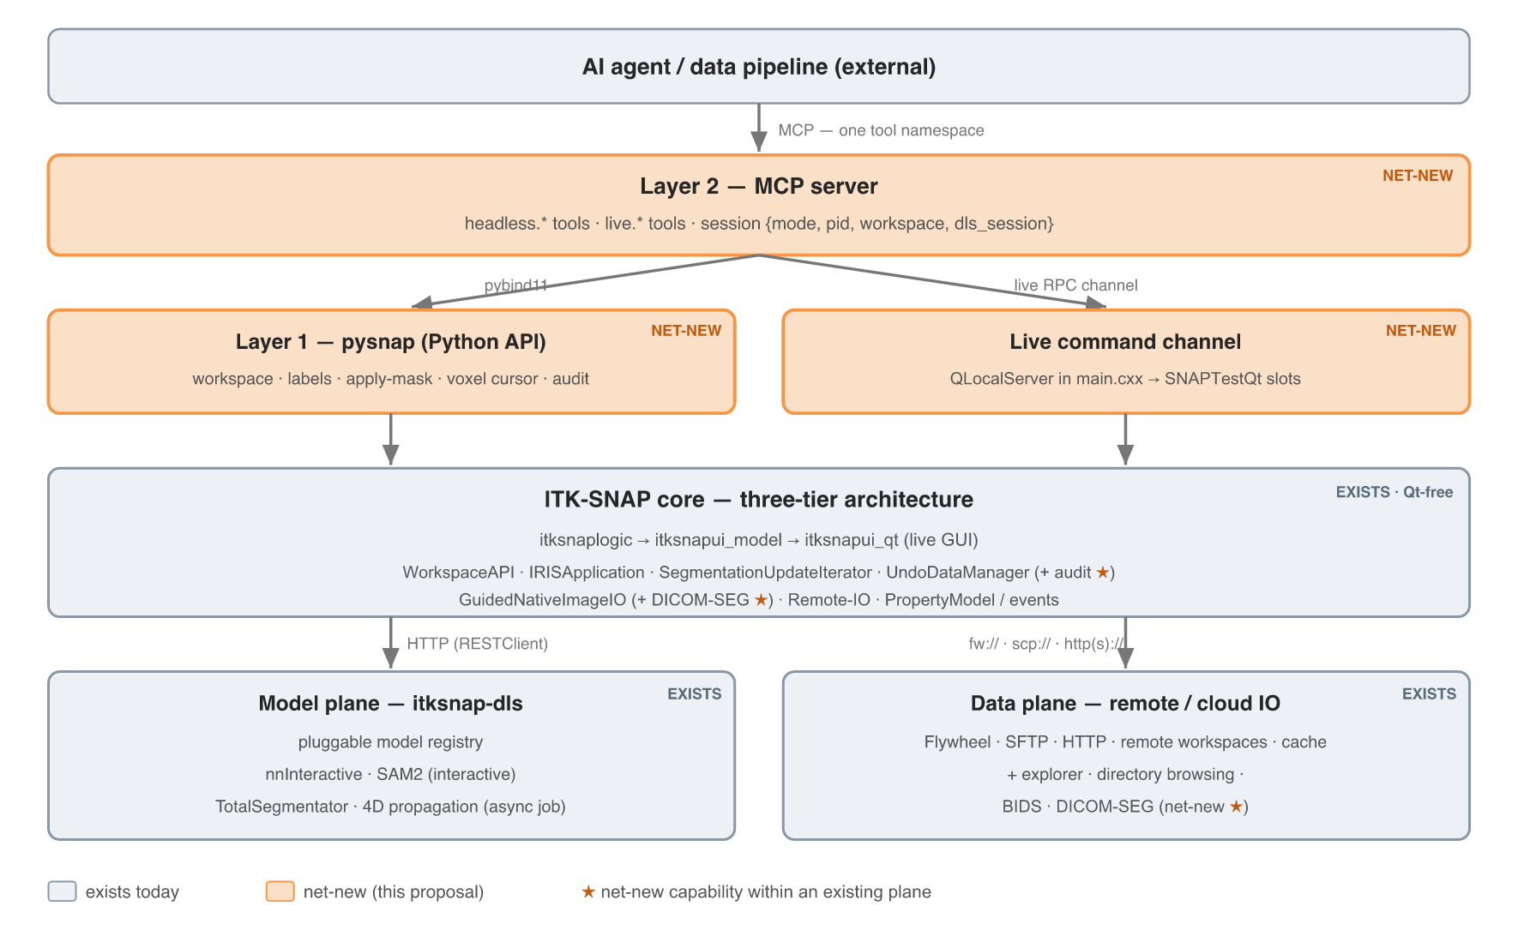
Fig. 2 — System architecture (created). The net-new agent/MCP surface over ITK-SNAP's existing Qt-free core, the itksnap-dls model plane, and the remote/cloud data plane; ★ marks net-new capabilities added within existing components (audit record, DICOM-SEG, explorer).
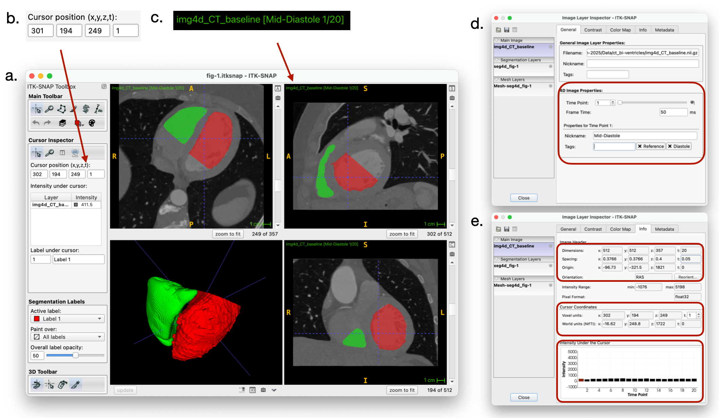
Fig. 3 — ITK-SNAP 4 on a 4D cardiac study (reuse, with attribution). Reproduced from Fig. 1 of Hao et al., FIMH 2025 [ref 2]: 20 time points, with ventricle segmentations across tri-planar and 3D views; grounds ITK-SNAP as a mature, actively developed, natively-4D tool.
All three figures plus the table exceed the 4-page limit — trim before submission (drop or shrink a figure, or lay figures out more compactly).
Export figures at ≥300 dpi; reused paper figures carry a citation to ref 2; keep the whole supporting document to ≤4 pages.
6. References
[Verify exact citation details before submission.]
1. Yushkevich PA, Piven J, Hazlett HC, Smith RG, Ho S, Gee JC, Gerig G. User-guided 3D active contour segmentation of anatomical structures: significantly improved efficiency and reliability. NeuroImage. 2006;31(3):1116–1128. — ITK-SNAP methods paper (canonical).
2. Hao J, Yushkevich PA, Dong NJ, Amin S, Guo Z, Yushkevich N, Aggarwal A, Pouch AM. Streamlining 4D Cardiac Image Workflows: Open-Source Tools for Segmentation, Registration, and Visualization. Functional Imaging and Modeling of the Heart (FIMH) 2025. [verify volume/pages/DOI] — recent ITK-SNAP 4 paper; source of Fig. 3.
3. Isensee F, Rokuss M, Krämer L, Dinkelacker S, Ravindran A, Stritzke F, et al. nnInteractive: Redefining 3D Promptable Segmentation. arXiv:2503.08373. 2025. — interactive-segmentation foundation model integrated in ITK-SNAP via itksnap-dls.
4. Diaz-Pinto A, Alle S, Ihsani A, Asad M, Nath V, Pérez-García F, et al. MONAI Label: A framework for AI-assisted interactive labeling of 3D medical images. Medical Image Analysis. 2024;95:103207. doi:10.1016/j.media.2024.103207.
5. Wasserthal J, et al. TotalSegmentator: robust segmentation of anatomical structures in CT images. Radiology: Artificial Intelligence. 2023. — [verify.]
6. Antonelli M, et al. The Medical Segmentation Decathlon. Nature Communications. 2022. — [verify; hippocampus benchmark, Task 04.]
7. Zhuang X, et al. Evaluation of algorithms for Multi-Modality Whole Heart Segmentation: an open-access grand challenge (MM-WHS). Medical Image Analysis. 2019. — [verify; cardiac CT benchmark.]

