Homework Question1:

In such a game, whenever user makes a move, all players of the game must be notified about it. Thus, an observer pattern is used

In the main function, the turn alternates between the two users. At every turn the function checks if a winner can be decided. If so, all users are notified of the winner. Else, the turn goes to the next player. And all users’ are updated and notified after the other player makes their move.

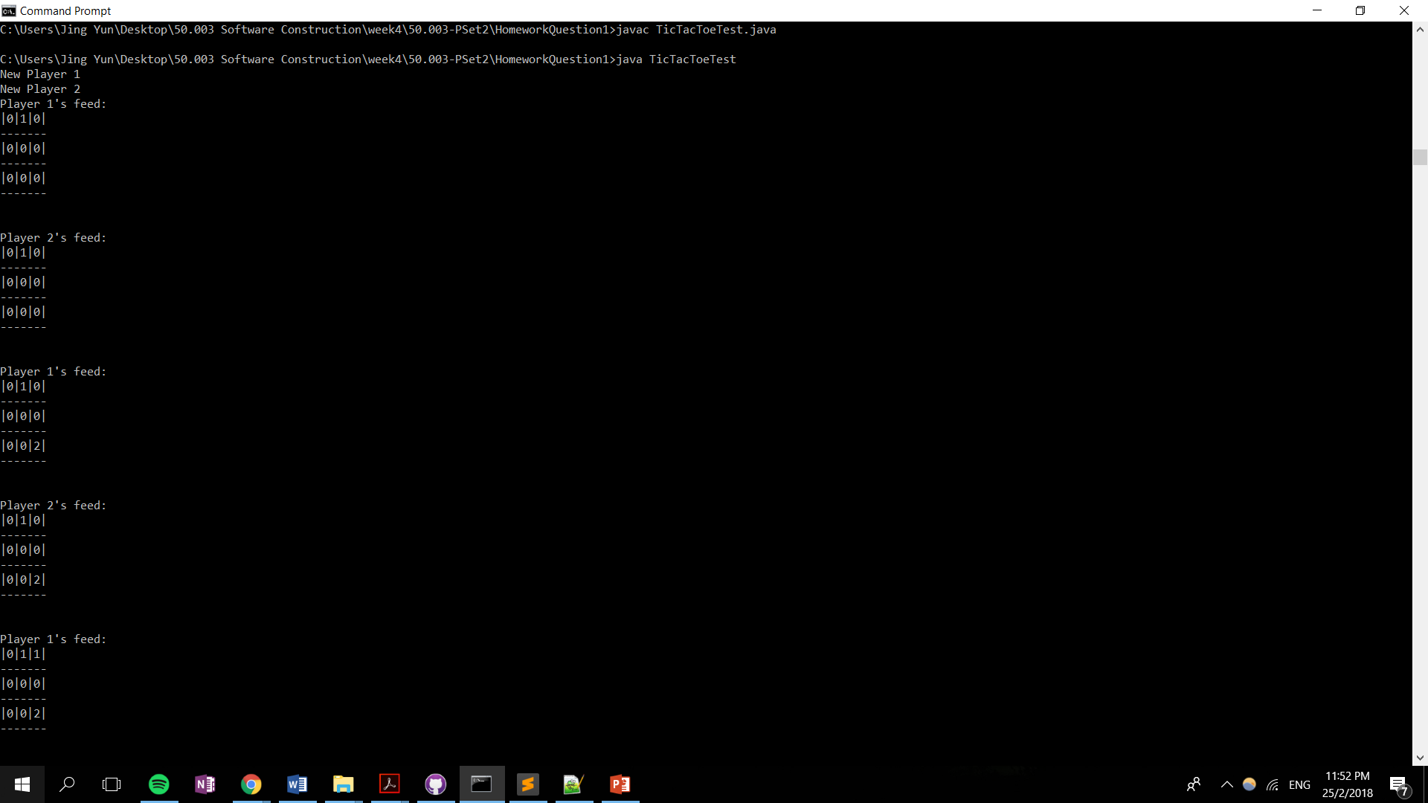

Homework Question2:

Visitor Pattern is used

Votes of each voter should be private—Observer pattern cannot be used

Each voter can only vote for one candidate—Decorator pattern cannot be used

VoteVisitor in visitor pattern visits each voter sequentially, this fulfils the criteria for each voter voting one after and another. VoteVisitor visits each voter only once, allowing the voters to vote only once. Voting for only one person is handled in VoteVisitor.

Output:

