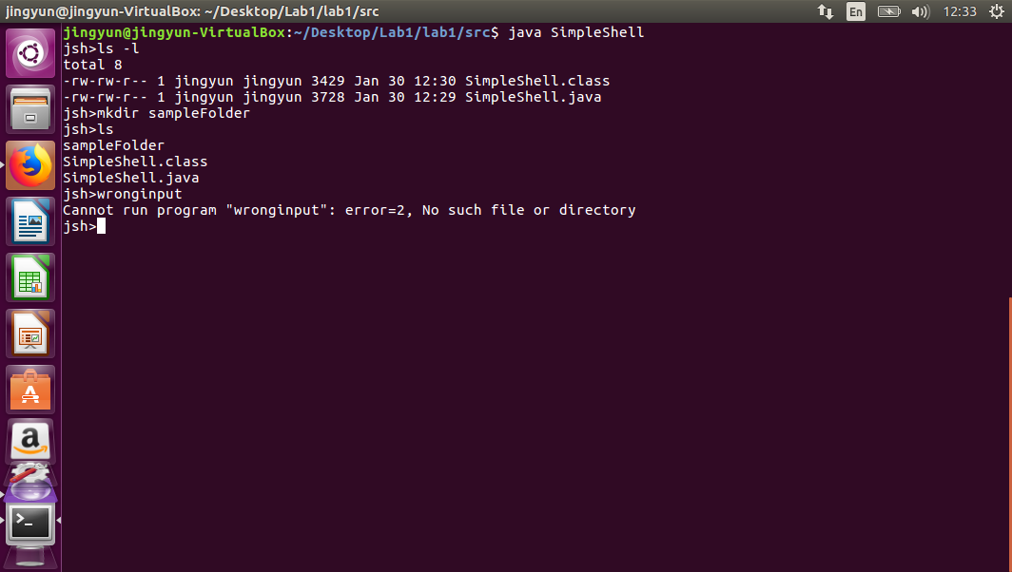(1) external process created by using Java 8 ProcessBuilder

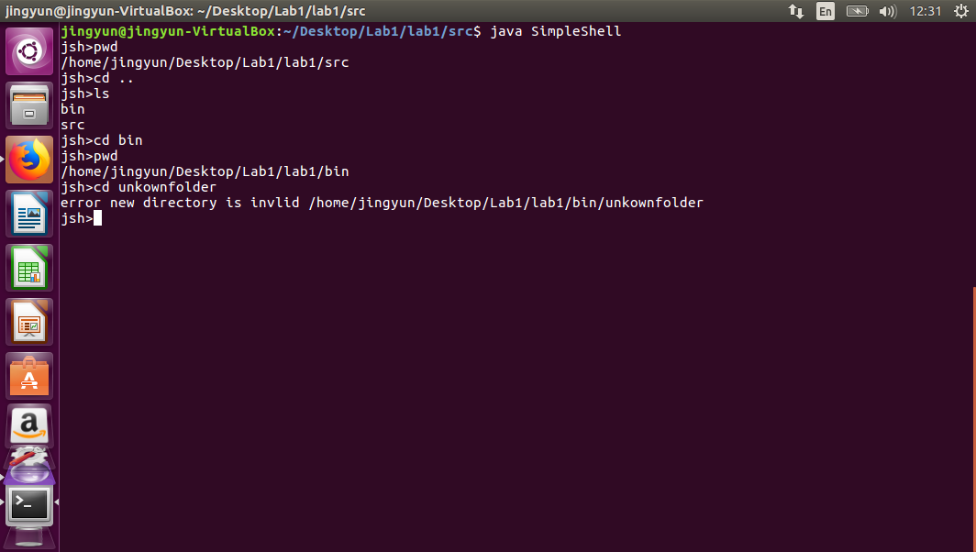(2) Changing directory. Changing directory was acheived by using Java ProcessBuilder.diretory function

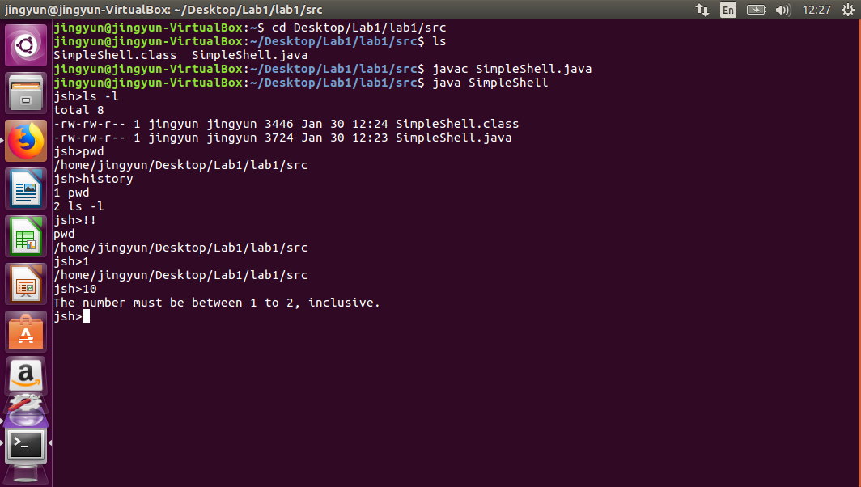(3) History. For the history function, LinkedList was used. LinkedList.addFirst function was used to ensure the latest functions were at the front of the LinkedList.

Only relevant commands were stored in history. Command received is checked, if it is ‘history’, ‘!!’ “” or a number, it is not recorded in history

When an integer is entered, it is checked. If the integer is >0 and if it is smaller or equal to the size of the history linked list, the relevant command is then executed.

If the integer is not valid, the error message is generated, it tells the user the appropriate numbers that can be accepted. Relevant integers accept are 1 till the size of the history linked list, inclusive.