Module Design Document
For
Diagnostic Manager Proxy

VERSION: 5.0
DATE: 29-JUN-2017

Prepared By:
Shruthi Raghavan
Location: The official version of this document is stored in the Nexteer Configuration Management System.

Revision History

Sl. No. | Description | Author | Version | Date
1 | ES101A_DiagcMgr_Design version 2 implementation | SB | 1.0 | 11-Mar-2016
2 | ES101A_DiagcMgr_Design version 4 implementation | SB | 2.0 | 22-Jun-2016
3 | Added new DET in Init1 | SB | 3.0 | 02-Dec-2016
4 | Added new runnable SetNtcStsAndSnpshtData. | SR | 4.0 | 21-Apr-2017
5 | Added unit test considerations per EA4#9649 | SR | 5.0 | 29-Jun-2017

Table of Contents
1 Abbrevations And Acronyms 5
2 References 6
3 DiagcMgrPROXYAPPLX & High-Level Description 7
4 Design details of software module 8
4.1 Graphical representation of DiagcmgrPRoxyApplX 8
4.2 Data Flow Diagram 8
4.2.1 Module level DFD 8
4.2.2 Sub-Module level DFD 8
4.3 COMPONENT FLOW DIAGRAM 8
5 Variable Data Dictionary 9
5.1 User defined typedef definition/declaration 9
5.2 Variable definition for enumerated types 9
6 Constant Data Dictionary 10
6.1 Program(fixed) Constants 10
6.1.1 Embedded Constants 10
6.1.1.1 Local 10
6.1.1.2 Global 10
6.1.2 Module specific Lookup Tables Constants 10
7 Software Module Implementation 11
7.1 Sub-Module Functions 11
7.1.1 Initialization Functions 11
7.1.1.1 INIT: DiagcMgrPROXYAPPLXInit1 11
7.1.1.2 Design Rationale 11
7.1.1.3 Store Module Inputs to Local copies 11
7.1.1.4 (Processing of function)……… 11
7.1.1.5 Store Local copy of outputs into Module Outputs 11
7.1.2 PERIODIC FUNCTIONS 11
7.1.2.1 Per: diagcmgrPROXYAPPLXPer1 11
7.1.2.2 Design Rationale 11
7.1.2.3 Store Module Inputs to Local copies 11
7.1.2.4 (Processing of function)……… 11
7.1.2.5 Store Local copy of outputs into Module Outputs 11
7.1.3 Interrupt Functions 11
7.1.4 Server Runnable Functions 12
7.1.4.1 GetDiagcDataApplX_Oper 12
7.1.4.2 GetNtcActvX_Oper 12
7.1.4.3 GetNtcDebCntrAppl0_Oper 12
7.1.4.4 GetNtcInfoApplX_Oper 12
7.1.4.5 GetNtcQlfrStsX_Oper 12
7.1.4.6 GetNtcStsX_Oper 13
7.1.4.7 SetNtcStsX_Oper 14
7.1.5 Local Function/Macro Definitions 14
7.1.5.1 Description 14
7.1.6 TRANSIENT FUNCTIONS 14
8 Known Limitations With Design 15
9 UNIT TEST CONSIDERATION 16
10 Appendix 17

Abbrevations And Acronyms
Abbreviation | Description
DFD | Design functional diagram
MDD | Module design Document

References
This section lists the title & version of all the documents that are referred for development of this document
Sr. No. | Title | Version
1 | MDD Guidelines | See process v04.04.02 document from eRoom here
2 | EA4 Software Naming Conventions | See process v04.04.02 document from eRoom here
3 | Coding standards | See process v04.04.02 document from eRoom here
4 | ES101A_DiagcMgr_Design | See Synergy Design Subproject Version

DiagcMgrPROXYAPPLX & High-Level Description
There are 11 proxy components whose design is same but the name of the components is based on the application number. ApplX is used through out the document in place of application number.

Design details of software module

Graphical representation of DiagcmgrPRoxyApplX
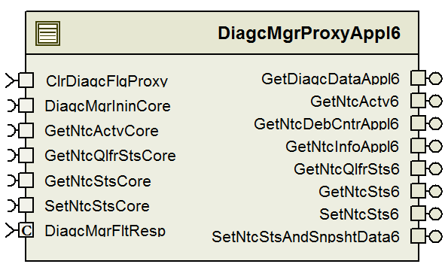

Data Flow Diagram

Module level DFD
N/A

Sub-Module level DFD
N/A

COMPONENT FLOW DIAGRAM
N/A

Variable Data Dictionary

User defined typedef definition/declaration
<This section documents any user types uniquely used for the module.>

Typedef Name | Element Name | User Defined Type | Legal Range  (min) | Legal Range  (max)
Refer DiagcMgr_MDD

Variable definition for enumerated types
Enum Name | Element Name | Value
N/A

Constant Data Dictionary

Program(fixed) Constants

Embedded Constants
< All program specific constants will be defined in detail >

Local
Constant Name | Resolution | Units | Value
See DataDict.m file
Refer DiagcMgr_MDD

Global
<This section lists the global constants used by the module. For details on global constants, refer to the Data Dictionary for the application>
Constant Name
See DataDict.m file

Module specific Lookup Tables Constants
<(This is for lookup tables (arrays) with fixed values, same name as other tables)>
Constant Name | Resolution | Value | Software Segment
Refer DiagcMgr_MDD

Software Module Implementation

Sub-Module Functions
None

Initialization Functions

INIT: DiagcMgrPROXYAPPLXInit1
X in the flowchart will change based on the proxy application number.
ErrorID ‘0’ is ensuring if DTCIDX value in fault response table is set to have value larger than the total number of DTCs in the code configuration.
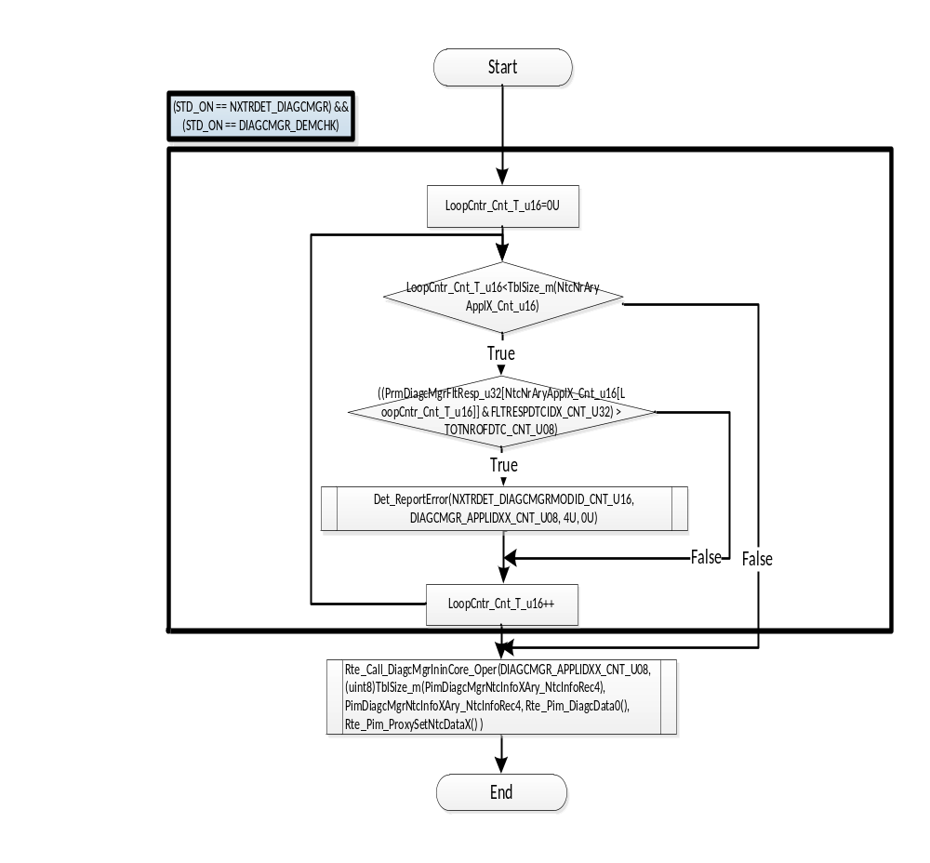

Design Rationale

PERIODIC FUNCTIONS

Per: diagcmgrPROXYAPPLXPer1

Design Rationale
Design rationale for the subblock:
DiagcMgrProxyApplXPer1/Clear All NTCs/For Number of NTCs in NtcInfoAryX/Clear the NTCs that are active
This block clears the NTCs that are active and Not Status Locked This Ignition Cycle.
It also clears the NTCs that are NOT active from history even if they are Status Locked This Igniton Cycle
In the case of an invalid aging counter, the status of the NTC must be set to TestNotCompleteThisIgnitionCycle.

MC/DC Coverage Can be Achieved:
The above is verified to not be a MC/DC coverage issue
The second condition when reached by an invalid aging counter can still check whether the status locked and test complete conditions individually affect it.

Interrupt Functions
None

Server Runnable Functions

GetDiagcDataApplX_Oper
See DataDict.m file and model for detailed description.

GetNtcActvX_Oper
See DataDict.m file and model for detailed description.
X in the flowchart will change based on the proxy application number.
ErrorID ‘0’ is ensuring if NtcNr is within the valid range.
ErrorID ‘1’ is ensuring if ApplIdx is valid.
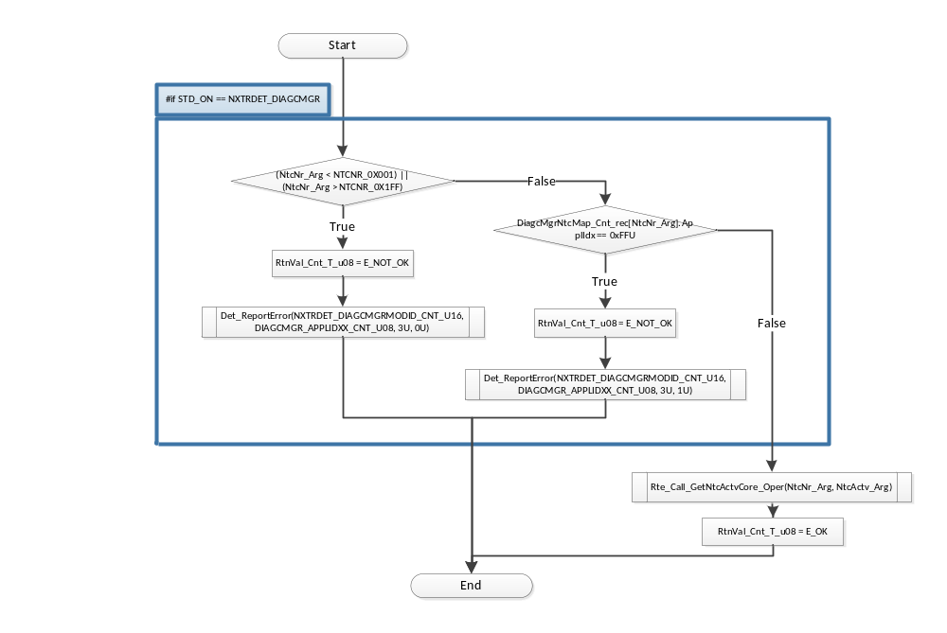

GetNtcDebCntrAppl0_Oper
See DataDict.m file and model for detailed description.

GetNtcInfoApplX_Oper
See DataDict.m file and model for detailed description.

GetNtcQlfrStsX_Oper
See DataDict.m file and model for detailed description.
X in the flowchart will change based on the proxy application number.
ErrorID ‘0’ is ensuring if NtcNr is within the valid range.
ErrorID ‘1’ is ensuring if ApplIdx is valid.
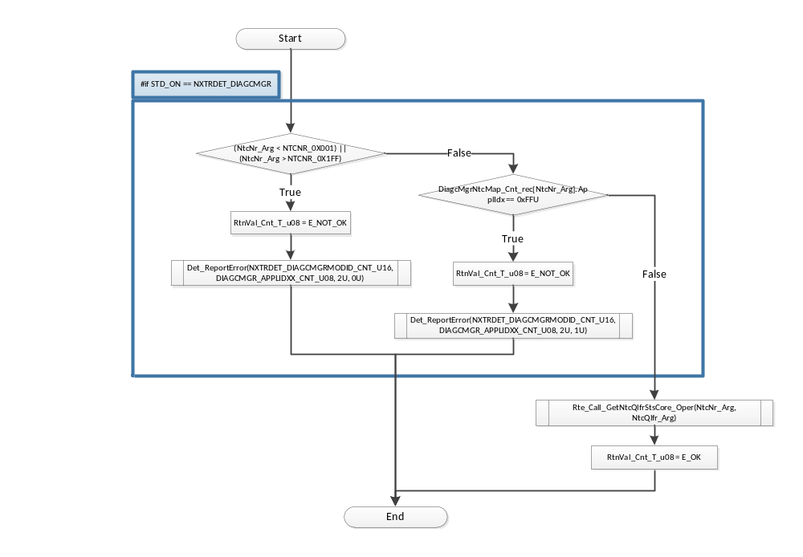

GetNtcStsX_Oper
See DataDict.m file and model for detailed description.
X in the flowchart will change based on the proxy application number.
ErrorID ‘0’ is ensuring if NtcNr is within the valid range.
ErrorID ‘1’ is ensuring if ApplIdx is valid.
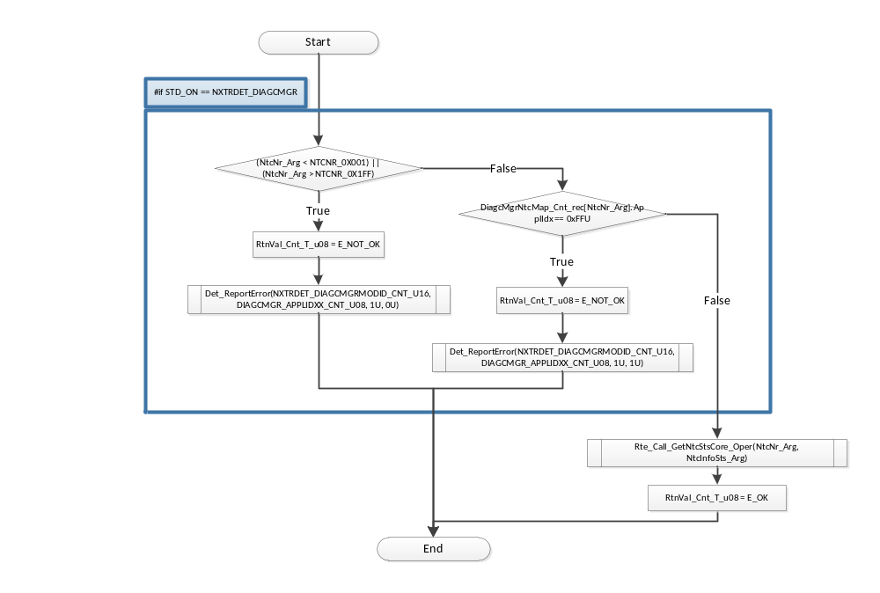

SetNtcStsX_Oper
See DataDict.m file and model for detailed description.
X in the flowchart will change based on the proxy application number.
ErrorID ‘0’ is ensuring if NtcNr is within the valid range.
ErrorID ‘1’ is ensuring if ApplIdx is valid.
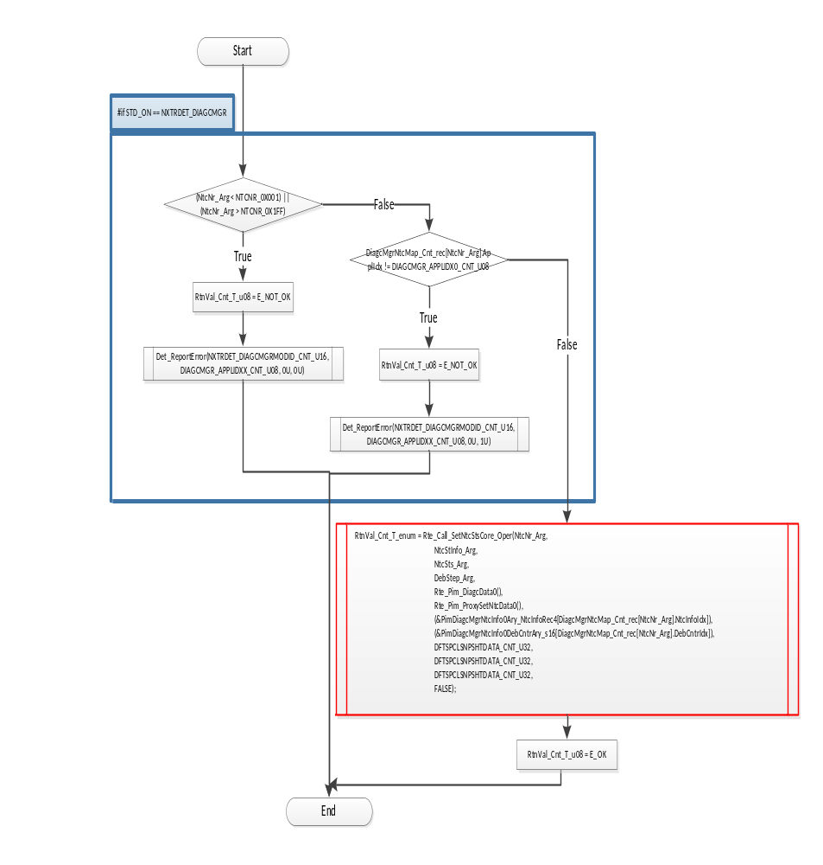

SetNtcStsAndSnpshtDataX_Oper
See DataDict.m file and model for detailed description.
X in the flowchart will change based on the proxy application number.
ErrorID ‘0’ is ensuring if NtcNr is within the valid range.
ErrorID ‘1’ is ensuring if ApplIdx is valid.
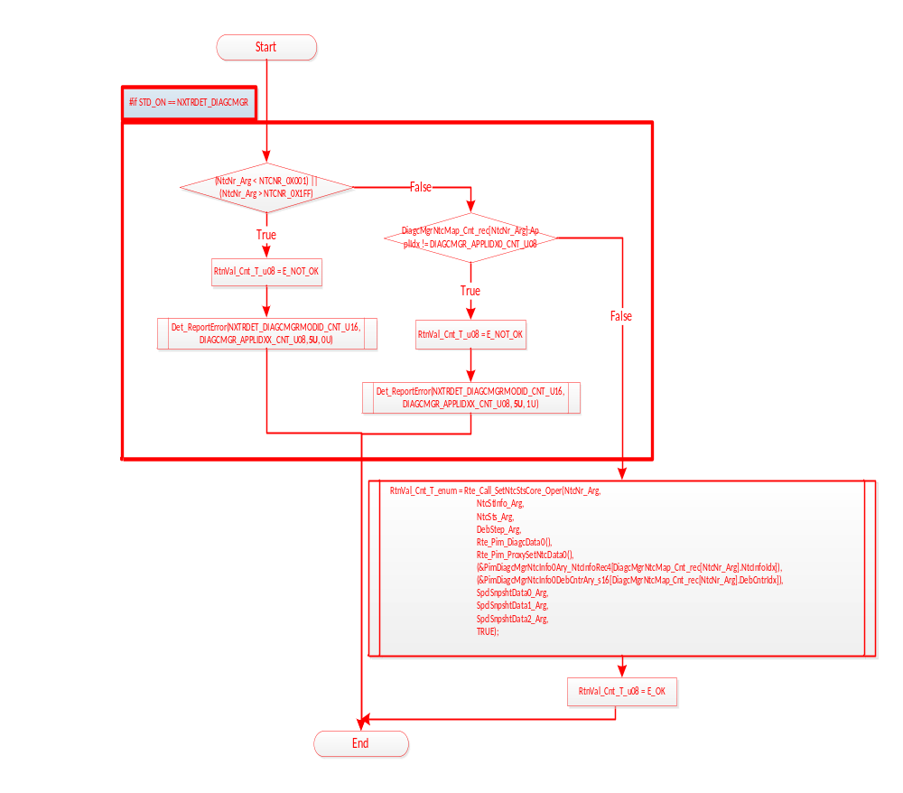

Local Function/Macro Definitions

Description
Proxies use functions from the private.c file, refer DiagcMgr MDD for function descriptions.

TRANSIENT FUNCTIONS
None

Known Limitations With Design
- Per the FDD author, safety critical data is protected in an exclusive area but there is a possibility of corruption of non critical data.
- Refer to Design Rationale section on the top level of DiagcMgrProxy Simulink model.

UNIT TEST CONSIDERATION

- Config files in the contract folder are for a test project with sample configurations using Application 6 and Application 10. Therefore with this configuration, the following files cannot be tested – DiagcMgrProxyAppl0, DiagcMgrProxyAppl1, DiagcMgrProxyAppl2, DiagcMgrProxyAppl3, DiagcMgrProxyAppl4, DiagcMgrProxyAppl5, DiagcMgrProxyAppl7, DiagcMgrProxyAppl8, DiagcMgrProxyAppl9.
- Low Path Coverage can be justified in the notes for now, if the reason is due to Configurable code in the component.
Note: Continuous improvement CR EA4#9630 has been written to modify the contract folder header files to allow better coverage in unit test.

Appendix
None

