Module Design Document
For
BattVltgCorrln

27-Jun-2017
Prepared For:
Software Engineering
Nexteer Automotive,
Saginaw, MI, USA
Prepared By:
Brionna Spencer,
Nexteer Automotive,
Saginaw, MI, USAChange History
Description | Author | Version | Date
Initial Version | N. Saxton | 1.0 | 7-Jun-2016
Updated the graphical representation, added design rationale for BattVltgCorrlnPer1, and updated the documentation for modified local functions (i.e. DetInstCorrln, DetIdptSig, and DetCorrlnSts). | B. Spencer | 2.0 | 27-Jun-2017

Table of Contents

1 BattVltgCorrln & High-Level Description 4

2 Design details of software module 5

2.1 Graphical representation of BattVltgCorrln 5

2.2 Data Flow Diagram 6

2.2.1 Component level DFD 6

2.2.2 Function level DFD 6

3 Constant Data Dictionary 7

3.1 Program (fixed) Constants 7

3.1.1 Embedded Constants 7

4 Software Component Implementation 8

4.1.1 Sub-Module Functions 8

4.1.2 Interrupt Service Routines 8

4.1.3 Server Runnable Functions 8

4.1.4 Module Internal (Local) Functions 8

4.1.5 Transition Functions 10

5 Known Limitations with Design 11

6 UNIT TEST CONSIDERATION 12

Appendix A Abbreviations and Acronyms 13

Appendix B Glossary 14

Appendix C References 15

BattVltgCorrln & High-Level Description
Refer FDD

Design details of software module

Graphical representation of BattVltgCorrln

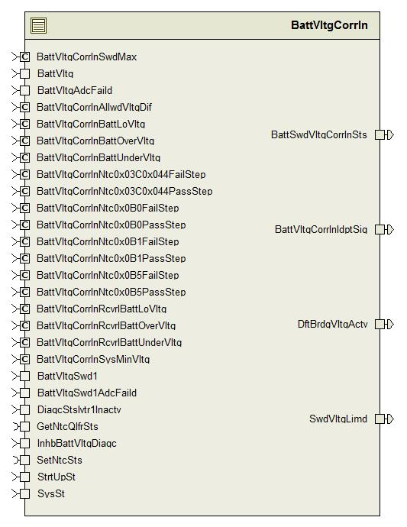

Data Flow Diagram

Component level DFD
N/A

Function level DFD
N/A

Constant Data Dictionary

Program (fixed) Constants

Embedded Constants

Local Constants
Constant Name | Resolution | Units | Value
BATTVLTGIDPTSIGMIN_CNT_U08 | None | Cnt | 0
BATTVLTGIDPTSIGMAX_CNT_U08 | None | Cnt | 2

* Refer FDD for other constant definition

Software Component Implementation

Sub-Module Functions

Initialization sub-module {_Init()}

BattVltgCorrlnInit1

Design Rationale
Refer to FDD

Store module inputs to local copies
Refer to FDD

(Processing of function)……
Refer to FDD

Store local copy of outputs into module outputs
Refer FDD

Periodic sub-module {_Per()}

BattVltgCorrlnPer1

Design Rationale
Refer to FDD
Note the BattAndSwdVltgPassed temporary variable in the FDD was renamed to BattVltgAndSwd1NotFailed because the ‘no result’ case is also considered in the logic.

Store module inputs to local copies
Refer to FDD

(Processing of function)……
Refer to FDD

Store local copy of outputs into module outputs
Refer FDD

Interrupt Service Routines
None

Server Runnable Functions
None

Module Internal (Local) Functions

Local Function #1
Function Name | DetInstCorrln | Type | Min | Max
Arguments Passed | BattVltg_Volt_T_f32 | float32 | 0 | 40
 | BattVltgSwd1_Volt_T_f32 | float32 | 0 | 40
 | DiagcStsIvtr1Inactv_Cnt_T_logl | boolean | FALSE | TRUE
 | *BattVltgAndSwd1Ok_Cnt_T_logl | boolean | FALSE | TRUE
 | *UseSwdVltg_Cnt_T_logl | boolean | FALSE | TRUE
 | *UseBattVltg_Cnt_T_logl | boolean | FALSE | TRUE
 | *Ntc0x03CQlfrSts_Cnt_T_enum | SigQlfr1 | SIGQLFR_NORES | SIGQLFR_FAILD
 | *Ntc0x044QlfrSts_Cnt_T_enum | SigQlfr1 | SIGQLFR_NORES | SIGQLFR_FAILD
Return Value | SwdVltgLimd_Cnt_T_logl | boolean | FALSE | TRUE

Description
Refer “Determine Instantaneous Correlation” subsystem in FDD.

Local Function #2
Function Name | DetIdptSig | Type | Min | Max
Arguments Passed | Ntc0x03CQlfrSts_Cnt_T_enum | SigQlfr1 | SIGQLFR_NORES | SIGQLFR_FAILD
 | Ntc0x044QlfrSts_Cnt_T_enum | SigQlfr1 | SIGQLFR_NORES | SIGQLFR_FAILD
 | *BattVltgAndSwd1NotFailed_Cnt_T_logl | boolean | FALSE | TRUE
Return Value | BattVltgCorrlnIdptSig_Cnt_T_u08 | uint8 | 0 | 2

Description
This function implements the “Determine Independent Signals” subsystem in the model.

Local Function #3
Function Name | DetCorrlnSts | Type | Min | Max
Arguments Passed | BattVltgAndSwd1NotFailed_Cnt_T_logl | boolean | FALSE | TRUE
 | BattVltgAndSwd1Ok_Cnt_T_logl | boolean | FALSE | TRUE
 | UseSwdVltg_Cnt_T_logl | boolean | FALSE | TRUE
 | UseBattVltg_Cnt_T_logl | boolean | FALSE | TRUE
 | *DftBrdgVltgActv_Cnt_T_logl | boolean | FALSE | TRUE
Return Value | BattSwdVltgCorrlnSts_Cnt_T_u08 | uint8 | 0 | 2

        - Description
This function implements the “Determine Correlation Status” subsystem in the model.

Local Function #4
Function Name | BattVltgDiag | Type | Min | Max
Arguments Passed | BattVltg_Volt_T_f32 | float32 | 0 | 40
 | InhbBattVltgDiagc_Cnt_T_logl | boolean | FALSE | TRUE

Description
Implements “Battery Voltage Diagnostics” subsystem.

Local Function #5
Function Name | RngChk | Type | Min | Max
Arguments Passed | BattVltg_Volt_T_f32 | float32 | 0 | 40
 | BattVltgSwdMax_Volt_T_f32 | float32 | 0 | 40
Return Value | TestLgc_Cnt_T_logl | boolean | FALSE | TRUE

Description
Implements “Range Check” block in the model. Created to reduce cyclomatic complexity and static path count.

Transition Functions
None

Known Limitations with Design
None

UNIT TEST CONSIDERATION
None

Abbreviations and Acronyms
None

Glossary
Note: Terms and definitions from the source “Nexteer Automotive” take precedence over all other definitions of the same term. Terms and definitions from the source “Nexteer Automotive” are formulated from multiple sources, including the following:
- ISO 9000
- ISO/IEC 12207
- ISO/IEC 15504
- Automotive SPICE® Process Reference Model (PRM)
- Automotive SPICE® Process Assessment Model (PAM)
- ISO/IEC 15288
- ISO 26262
- IEEE Standards
- SWEBOK
- PMBOK
- Existing Nexteer Automotive documentation
Term | Definition | Source
MDD | Module Design Document
DFD | Data Flow Diagram

References
Ref. # | Title | Version
1 | AUTOSAR Specification of Memory Mapping | v1.3.0 R4.0 Rev 2
2 | MDD Guideline | EA4 01.00.01
3 | EA4 Software Naming Conventions | 01.01.00
4 | Software Design and Coding Standards | 2.1
5 | FDD – ES259B Battery or Switched Voltage Correlation | See Synergy subproject version

