Module Design Document
For
MotCtrlPrmEstimn

VERSION: 4.0
DATE: 25-Sep-2017

Prepared By:

TATA,
Trivandrum, India

Location: The official version of this document is stored in the Nexteer Configuration Management System.

Revision History

Sl. No. | Description | Author | Version | Date
1 | Initial Version | Rijvi | 1.0 | 20-JUN-2015
2 | Updated per design rev. 1.5.0 | Rijvi | 2.0 | 07-APRIL-2016
3 | Updated per design rev. 2.1.0 | ML | 3.0 | 29-NOV-2016
4 | New Input added MotAndThermProtnLoaMod and deleted IvtrLoaMtgtnEna | TATA | 4.0 | 25-SEP-2017
Table of Contents
1 Abbrevations And Acronyms 5
2 References 6
3 MotCtrlPrmEstimn & High-Level Description 7
4 Design details of software module 8
4.1 Graphical representation of MotCtrlPrmEstimn 8
4.2 Data Flow Diagram 9
4.2.1 Module level DFD 9
4.2.2 Sub-Module level DFD 9
4.3 COMPONENT FLOW DIAGRAM 9
5 Variable Data Dictionary 10
5.1 User defined typedef definition/declaration 10
5.2 Variable definition for enumerated types 10
6 Constant Data Dictionary 11
6.1 Program(fixed) Constants 11
6.1.1 Embedded Constants 11
6.1.1.1 Local 11
6.1.1.2 Global 11
6.1.2 Module specific Lookup Tables Constants 11
7 Software Module Implementation 12
7.1 Sub-Module Functions 12
7.2 Initialization Functions 12
7.2.1 Per: MotCtrlPrmEstimnInit1 12
7.2.1.1 Design Rationale 12
7.2.1.2 Store Module Inputs to Local copies 12
7.2.1.3 (Processing of function)……… 12
7.2.1.4 Store Local copy of outputs into Module Outputs 12
7.3 PERIODIC FUNCTIONS 12
7.3.1 Per: MotCtrlPrmEstimnPer1 12
7.3.1.1 Design Rationale 12
7.3.1.2 Store Module Inputs to Local copies 12
7.3.1.3 (Processing of function)……… 12
7.3.1.4 Store Local copy of outputs into Module Outputs 12
7.3.2 Per: MotCtrlPrmEstimnPer2 12
7.3.2.1 Design Rationale 12
7.3.2.2 Store Module Inputs to Local copies 12
7.3.2.3 (Processing of function)……… 12
7.3.2.4 Store Local copy of outputs into Module Outputs 13
7.4 Non PERIODIC FUNCTIONS 13
7.5 Interrupt Functions 13
7.6 Server runnables 13
7.6.1 GetMotPrmNomEol 13
7.6.1.1 Design Rationale 13
7.6.1.2 Store Module Inputs to Local copies 13
7.6.1.3 (Processing of function)……… 13
7.6.1.4 Store Local copy of outputs into Module Outputs 13
7.6.2 SetMotPrmNomEol 13
7.6.2.1 Design Rationale 13
7.6.2.2 Store Module Inputs to Local copies 13
7.6.2.3 (Processing of function)……… 13
7.6.2.4 Store Local copy of outputs into Module Outputs 13
7.7 Serial Communication Functions 14
7.8 Local Function/Macro Definitions 14
7.8.1 Local Function #1 CalcCurrMagSqRef 14
7.9 GLObAL Function/Macro Definitions 14
7.10 TRANSIENT FUNCTIONS 14
8 Unit Test Considerations 15
9 Known Limitations With Design 16
10 Appendix 17

Abbrevations And Acronyms
Abbreviation | Description
DFD | Design functional diagram
MDD | Module design Document
 | <ADD more to the table if applicable>

References
This section lists the title & version of all the documents that are referred for development of this document
Sr. No. | Title | Version
<1> | <MDD Guidelines> | Process 4.02.00
<2> | <Software Naming Conventions> | Process 4.02.00
<3> | <Coding standards> | 2.1
<4> | FDD - SF102A_MotCtrlPrmEstimn_Design | See Synergy Subproject version
 | <Add if more available>

MotCtrlPrmEstimn & High-Level Description
Please refer FDD

Design details of software module

Graphical representation of MotCtrlPrmEstimn

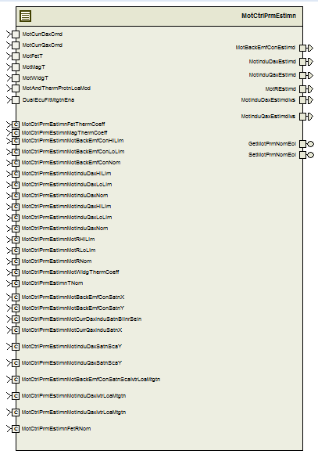

Data Flow Diagram

Module level DFD

Sub-Module level DFD

COMPONENT FLOW DIAGRAM

Variable Data Dictionary

User defined typedef definition/declaration

Typedef Name | Element Name | User Defined Type | Legal Range  (min) | Legal Range  (max)
None

Variable definition for enumerated types
Enum Name | Element Name | Value
N/A | <(Variable name qualified Refer[2])> | <Define the value >

Constant Data Dictionary

Program(fixed) Constants

Embedded Constants
< All program specific constants will be defined in detail >

Local
Constant Name | Resolution | Units | Value
Refer constants from .m file
BITMASK2_CNT_U08 | 1 | Cnt | 2U

Global
<This section lists the global constants used by the module. For details on global constants, refer to the Data Dictionary for the application>
Constant Name
None

Module specific Lookup Tables Constants
<(This is for lookup tables (arrays) with fixed values, same name as other tables)>
Constant Name | Resolution | Value | Software Segment
None

Software Module Implementation

Sub-Module Functions
NONE

Initialization Functions

Per: MotCtrlPrmEstimnInit1

Design Rationale
Refer to FDD

Store Module Inputs to Local copies
Refer to FDD

(Processing of function)………
Refer to FDD

Store Local copy of outputs into Module Outputs
Refer to FDD

PERIODIC FUNCTIONS

Per: MotCtrlPrmEstimnPer1

Design Rationale

Store Module Inputs to Local copies
Refer to FDD

(Processing of function)………
Refer to FDD

Store Local copy of outputs into Module Outputs
Refer to FDD

Per: MotCtrlPrmEstimnPer2

Design Rationale

Store Module Inputs to Local copies
Refer to FDD

(Processing of function)………
Refer to FDD

Store Local copy of outputs into Module Outputs
Refer to FDD

Non PERIODIC FUNCTIONS
None

Interrupt Functions
None

Server runnables

GetMotPrmNomEol

Design Rationale
None

Store Module Inputs to Local copies
None

(Processing of function)………
See GetMotPrmNomEol block in the FDD

Store Local copy of outputs into Module Outputs
None

SetMotPrmNomEol

Design Rationale
None

Store Module Inputs to Local copies
None

(Processing of function)………
See SetMotPrmNomEol block in the FDD

Store Local copy of outputs into Module Outputs
None

Serial Communication Functions
None

Local Function/Macro Definitions

Local Function #1 CalcCurrMagSqRef
None

GLObAL Function/Macro Definitions
None

TRANSIENT FUNCTIONS
None

Unit Test Considerations
None

Known Limitations With Design

CurrMeasLoaMtgtnEna and FetLoaMtgtnEna are terminated. These flags need not be computed at all.

Appendix
None

