Integration Manual
For
Imc Arbitration

VERSION: 1.0
DATE: 02-Feb-2017

Prepared By:
Software Group,
Nexteer Automotive,
Saginaw, MI, USA

Revision History

Sl. No. | Description | Author | Version | Date
1 | Initial version | Akilan Rathakrishnan | 1.0 | 17-Jan-2017
2 | Added note about potential compilation issue in case of no signal group configured | Akilan Rathakrishnan | 2.0 | 02-Feb-2017
Table of Contents
1 Abbrevations And Acronyms 4
2 References 5
3 Dependencies 6
3.1 SWCs 6
3.2 Global Functions(Non RTE) to be provided to Integration Project 6
4 Configuration REQUIREMeNTS 7
4.1 Build Time Config 7
4.2 Configuration Files to be provided by Integration Project 7
4.3 Da Vinci Parameter Configuration Changes 7
4.4 DaVinci Interrupt Configuration Changes 7
4.5 Manual Configuration Changes 8
5 Integration DATAFLOW REQUIREMENTS 9
5.1 Required Global Data Inputs 9
5.2 Required Global Data Outputs 9
5.3 Specific Include Path present 9
6 Runnable Scheduling 10
7 Memory Map REQUIREMENTS 12
7.1 Mapping 12
7.2 Usage 12
7.3 Non RTE NvM Blocks 12
7.4 RTE NvM Blocks 12
8 Compiler Settings 13
8.1 Preprocessor MACRO 13
8.2 Optimization Settings 13
9 Appendix 14

Abbrevations And Acronyms

Abbreviation | Description
DFD | Design functional diagram
MDD | Module design Document
 | <ADD more to the table if applicable>

References
This section lists the title & version of all the documents that are referred for development of this document
Sr. No. | Title | Version
<1> | <FDD - <AR350A_ImcArbn_Design> | Refer Synergy subproject version

Dependencies

SWCs

Module | Required Feature
None | N/A
Note : Referencing the external components should be avoided in most cases. Only in unavoidable circumstance external components should be referred. Developer should track the references.

Global Functions(Non RTE) to be provided to Integration Project
None

Configuration REQUIREMeNTS

Build Time Config
Modules | Notes
None

Configuration Files to be provided by Integration Project
ImcArbn_Private_Cfg.c
ImcArbn_Private_Cfg.h
ImcArbn_ Cfg.h

Note 1: Include “ImcArbn_Private_Cfg.h” in the “Rte_UserTypes.h” file as user defined typedefs are generated in this file.
Note 2: Configuration files “ImcArbn_Private_Cfg.c”, “ImcArbn_Private_Cfg.h” and “ImcArbn_ Cfg.h”
shall be regenerated whenever there is a change in text template files ImcArbn_Private_Cfg.c.tt, ImcArbn_Private_Cfg.h.tt and ImcArbn_Cfg.c.tt.
Note 3: If there is no IMC Signal Group / IMC Signals are configured, configuration scripts of this component will end-up in generating zero-size array typedefs, which will cause compilation issues. It is a design limitation and underlying assumption is that if no Signal Group configured, then the component shall be removed from the project altogether.

Da Vinci DEVELOPER NOTES

Davinci Developer project for this component is just base. Integrator need to import the developer project into the integration project and add all required IMC Signals in order to access the signal using S/R Ports. Also, for every of the signal, based on the Rate Group provided by higher level Architectural and Requirement documents, port access shall be provided to corresponding Transmit periodics (ImcArbnPer1= 2ms, ImcArbnPer2= 10ms and ImcArbnPer3= 100ms). All IMC Signals RTE reads shall be direct reads.

Da Vinci Parameter Configuration Changes
Following configurations shall be made in DaVinci configurator for the component. Configuration data for this component shall be provided by higher level Architectural and Requirement documents.

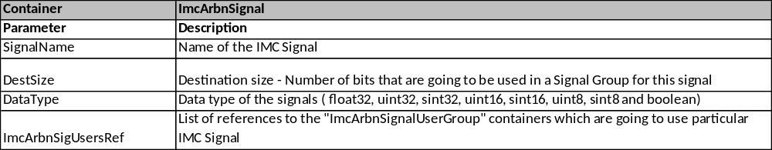

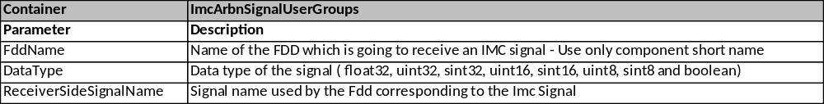

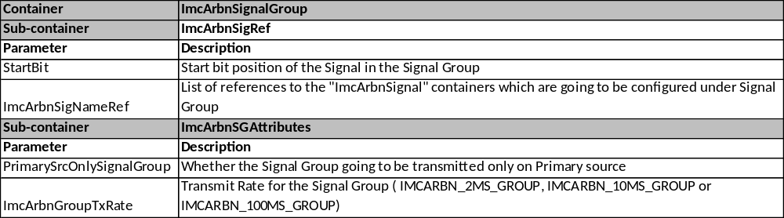

DaVinci Interrupt Configuration Changes
ISR Name | VIM # | Priority Dependency | Notes
N/A

Manual Configuration Changes
Constant | Notes | SWC
N/A

Exclusive Areas
Constant | Notes | SWC
ExclsvAr1DrvrTxRxBuf | Exclusive area needs to protect access to Transmit and Receive buffers from asynchronous updates by server runnables and periodic updates by tasks.  Integrator needs to verify if client calls to server runnables can inteerupt periodics and set up exclusive area to properly protect access. If exclusive area is needed, at minimum it must disable OS Task scheduling (It is assumed that all clients call occurs in OS Tasks).
ExclsvAr2SigDataBuf | Exclusive area needs to protect access to Signal data buffers from asynchronous read by server runnables and periodic updates by tasks.  Integrator needs to verify if client calls to server runnables can inteerupt periodics and set up exclusive area to properly protect access. If exclusive area is needed, at minimum it must disable OS Task scheduling (It is assumed that all clients call occurs in OS Tasks).

Integration DATAFLOW REQUIREMENTS

Required Global Data Inputs
Refer AR350A_ImcArbn_DataDict.m file

Required Global Data Outputs
Refer AR350A_ImcArbn_DataDict.m file

Specific Include Path present
Yes

Runnable Scheduling
This section specifies the required runnable scheduling.

Init | Scheduling Requirements | Trigger
ImcArbnInit1 | Invoked by RTE during Init | RTE

Runnable | Scheduling Requirements | Trigger
ImcArbnPer1 | Refer Notes listed below the table | RTE 2ms Task
ImcArbnPer2 | Refer Notes listed below the table | RTE 10ms Taks
ImcArbnPer3 | Refer Notes listed below the table | RTE 100ms Task
ImcArbnPer4 | Refer Notes listed below the table | RTE 2ms Task
ImcArbnPer5 | Refer Notes listed below the table | RTE 10ms Task
ImcArbnPer6 | Refer Notes listed below the table | RTE 100ms Task
GetSigImcDataExtdSts_f32_Oper | Server Runnable | Client call
GetSigImcDataExtdSts_u32_Oper | Server Runnable | Client call
GetSigImcDataExtdSts_s32_Oper | Server Runnable | Client call
GetSigImcDataExtdSts_u16_Oper | Server Runnable | Client call
GetSigImcDataExtdSts_s16_Oper | Server Runnable | Client call
GetSigImcDataExtdSts_u08_Oper | Server Runnable | Client call
GetSigImcDataExtdSts_s08_Oper | Server Runnable | Client call
GetSigImcDataExtdSts_logl_Oper | Server Runnable | Client call
GetSigImcData_f32_Oper | Server Runnable | Client call
GetSigImcData_u32_Oper | Server Runnable | Client call
GetSigImcData_s32_Oper | Server Runnable | Client call
GetSigImcData_u16_Oper | Server Runnable | Client call
GetSigImcData_s16_Oper | Server Runnable | Client call
GetSigImcData_u08_Oper | Server Runnable | Client call
GetSigImcData_s08_Oper | Server Runnable | Client call
GetSigImcData_logl_Oper | Server Runnable | Client call
GetTxRateGroup_Oper | Server Runnable | Client call
GetTxSigGroup_Oper | Server Runnable | Client call
SetRxSigGroup_Oper | Server Runnable | Client call

Notes:

- ImcArbnPer1, ImcArbnPer2 and ImcArbnPer3 periodic functions shall be called prior to calling respective primary and secondary signal source transmit layer functions.
- ImcArbnPer4, ImcArbnPer5 and ImcArbnPer6 periodic functions shall be called after calling respective primary and secondary signal source receive layer functions.
- ImcArbn Receive periodic functions (ImcArbnPer4, ImcArbnPer5 and ImcArbnPer6) shall run prior to the ImcArbn Transmit periodics (ImcArbnPer1, ImcArbnPer2 and ImcArbnPer3) functions.

Memory Map REQUIREMENTS

Mapping
Memory Section | Contents | Notes
None
* Each …START_SEC… constant is terminated by a …STOP_SEC… constant as specified in the AUTOSAR Memory Mapping requirements.

Usage
Feature | RAM | ROM
None
Table 1: ARM Cortex R4 Memory Usage

Non RTE NvM Blocks
Block Name
None
Note : Size of the NVM block if configured in developer

RTE NvM Blocks
Block Name
None

Note : Size of the NVM block if configured in developer

Compiler Settings

Preprocessor MACRO
None

Optimization Settings
None

Appendix
<This section is for appendix>

