Module Design Document
For
Imc Arbitration

Jan 17, 2017
Prepared For:
Software Engineering
Nexteer Automotive,
Saginaw, MI, USA
Prepared By:
Software Group,
Nexteer Automotive,
Saginaw, MI, USAChange History
Sl. No. | Description | Author | Version | Date
1 | Initial Version | Akilan Rathakrishnan | 1.0 | 17-Jan-2017

Table of Contents

1 ImcArbn High-Level Description 7

2 Design details of software module 8

Graphical representation of ImcArbn 8

2.1.1 Data Flow Diagram 8

2.1.2 Component level DFD 9

2.1.3 Function level DFD 9

3 Variable Data Dictionary 10

3.1 User defined typedef definition/declaration 10

3.2 Variable definition for enumerated types 12

4 Constant Data Dictionary 13

Program (fixed) Constants 13

4.1.1 Embedded Constants 13

4.1.1.2 Global 13

4.1.2 Module specific Lookup Tables Constants 13

5 Software Module Implementation 14

5.1 Sub-Module Functions 14

5.1.1 Init: ImcArbnInit1 14

5.1.1.1 Design Rationale 14

5.1.1.2 Design Rationale 14

5.1.2 PERIODIC FUNCTIONS 14

5.1.3 Per: ImcArbnPer1 14

5.1.3.1 Design Rationale 14

5.1.4 Per: ImcArbnPer2 14

5.1.4.1 Design Rationale 14

5.1.5 Per: ImcArbnPer3 14

5.1.5.1 Design Rationale 14

5.1.6 Per: ImcArbnPer4 14

5.1.6.1 Design Rationale 14

5.1.7 Per: ImcArbnPer5 14

5.1.7.1 Design Rationale 14

5.1.8 Per: ImcArbnPer6 14

5.1.8.1 Design Rationale 14

5.1.9 Interrupt Functions 14

5.2 Server Runnable Functions 15

5.2.1 GetSigImcDataExtdSts_f32 15

5.2.1.1 Design Rationale 15

5.2.2 GetSigImcDataExtdSts_u32 15

5.2.2.1 Design Rationale 15

5.2.3 GetSigImcDataExtdSts_u16 15

5.2.3.1 Design Rationale 15

5.2.4 GetSigImcDataExtdSts_s16 15

5.2.4.1 Design Rationale 15

5.2.5 GetSigImcDataExtdSts_u08 15

5.2.5.1 Design Rationale 15

5.2.6 GetSigImcDataExtdSts_s08 15

5.2.6.1 Design Rationale 15

5.2.7 GetSigImcDataExtdSts_logl 15

5.2.7.1 Design Rationale 15

5.2.8 GetSigImcData_f32 15

5.2.8.1 Design Rationale 15

5.2.9 GetSigImcData_u32 15

5.2.9.1 Design Rationale 15

5.2.10 GetSigImcData_s32 15

5.2.10.1 Design Rationale 15

5.2.11 GetSigImcData_u16 16

5.2.11.1 Design Rationale 16

5.2.12 GetSigImcData_s16 16

5.2.12.1 Design Rationale 16

5.2.13 GetSigImcData_u08 16

5.2.13.1 Design Rationale 16

5.2.14 GetSigImcData_s08 16

5.2.14.1 Design Rationale 16

5.2.15 GetSigImcData_logl 16

5.2.15.1 Design Rationale 16

5.2.16 GetTxRateGroup 16

5.2.16.1 Design Rationale 16

5.2.17 GetTxSigGroup 16

5.2.17.1 Design Rationale 16

5.2.18 SetRxSigGroup 16

5.2.18.1 Design Rationale 16

5.3 Module Internal (Local) Functions 16

5.3.1 Local Function #1 16

5.3.1.1 Description 17

5.3.2 Local Function #2 17

5.3.2.1 Description 17

5.3.3 Local Function #3 17

5.3.3.1 Description 17

5.3.4 Local Function #4 17

5.3.4.1 Description 17

5.3.5 Local Function #5 17

5.3.5.1 Description 18

5.3.6 Local Function #6 18

5.3.6.1 Description 18

5.3.7 Local Function #7 18

5.3.7.1 Description 18

5.3.8 Local Function #8 18

5.3.8.1 Description 18

5.3.9 Local Function #9 19

5.3.9.1 Description 19

5.3.10 Local Function #10 19

5.3.10.1 Description 19

5.3.11 Local Function #11 19

5.3.11.1 Description 19

5.3.12 Local Function #12 19

5.3.12.1 Description 20

5.3.13 Local Function #13 20

5.3.13.1 Description 20

5.3.14 Local Function #14 20

5.3.14.1 Description 20

5.3.15 Local Function #15 20

5.3.15.1 Description 20

5.3.16 Local Function #16 20

5.3.16.1 Description 20

5.3.17 Transition Functions 20

5.3.18 Global Function/Macro Definitions 21

6 Known Limitations with Design 22

7 UNIT TEST CONSIDERATION 23

Appendix A Abbreviations and Acronyms 24

Appendix B Glossary 25

Appendix C References 26

ImcArbn High-Level Description
The Inter-Micro Communication (IMC) Arbitration prepares data for transmission to a complimentary ECU through two redundant communication paths. On the receive side, the Arbitration reads data from the primary source and determines the data validity. A validity fault on primary source prompts the IMC Arbitration component to evaluate the same signal from the secondary source. Faulty signals from the primary source will be replaced with signals from the secondary source, as long as they are valid. If both data sources are invalid the IMC Arbitration outputs the signal status based on never received, missing and invalid conditions.

Design details of software module
See FDD.

Graphical representation of ImcArbn
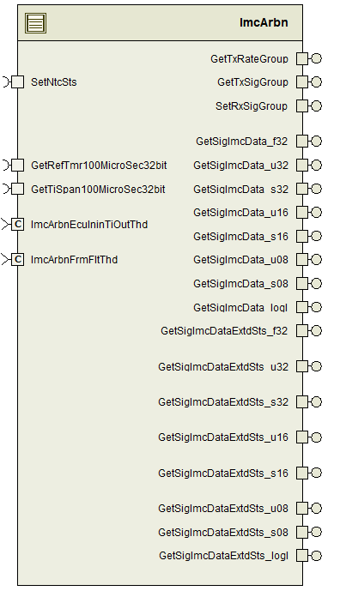

Data Flow Diagram
See FDD.

Component level DFD
See FDD.

Function level DFD
See FDD.

Variable Data Dictionary

User defined typedef definition/declaration
<This section documents any user types uniquely used for the module.>
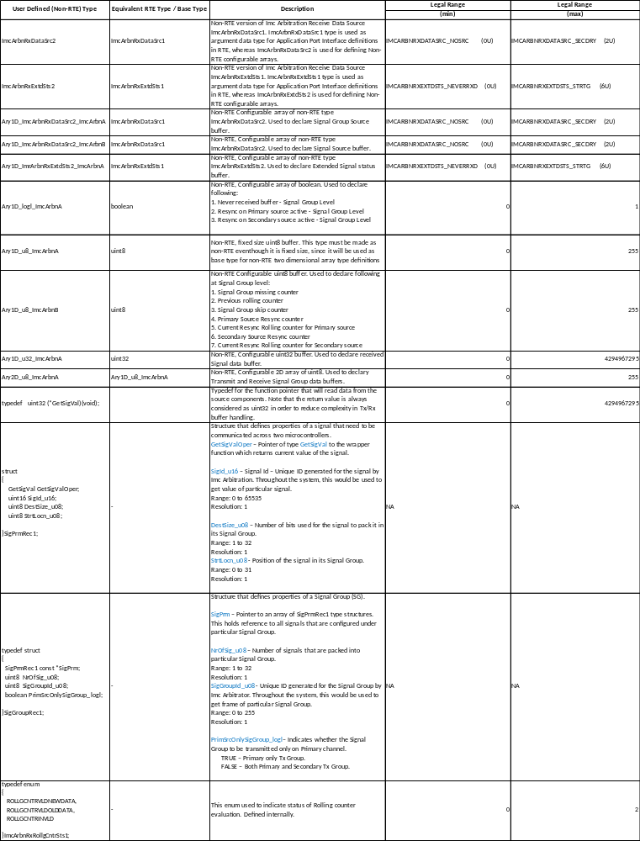

Variable definition for enumerated types
Enum Name | Element Name | Value
See AR350A_ImcArbn_DataDict.m file

Constant Data Dictionary

Program (fixed) Constants

Embedded Constants

Local Constants
Constant Name | Resolution | Units | Value
See AR350A_ImcArbn_DataDict.m file

Global
<This section lists the global constants used by the module. For details on global constants, refer to the Data Dictionary for the application>
Constant Name
See AR350A_ImcArbn_DataDict.m file

Module specific Lookup Tables Constants
<(This is for lookup tables (arrays) with fixed values, same name as other tables)>
Constant Name | type | Value | Software Segment
SIGGROUPCONFIG_REC | SigGroupRec1 | Configurable | ImcArbn_CONST
<SIGGROUPNAME>_REC | SigPrmRec1 | Configurable | ImcArbn_CONST
RATEGROUPOFFS_CNT_U08 | Uint8 | Configurable | ImcArbn_CONST
NRSIGGROUPINRATEGROUP_CNT_U08 | Uint8 | Configurable | ImcArbn_CONST
MISSSIGGROUPTIOUT_CNT_U08 | Uint8 | Configurable | ImcArbn_CONST

Note: <SIGGROUPNAME>_REC – Placeholder <SIGGROUPNAME> will be replaced based on respective Signal Group names from the configuration. Also note, this component will have as many number of <SIGGROUPNAME>_REC constants as number of Signal Groups.

Software Module Implementation

Sub-Module Functions
None

Init: ImcArbnInit1

Design Rationale
Design follows implementation in FDD.

Design Rationale
Refer FDD

PERIODIC FUNCTIONS

Per: ImcArbnPer1

Design Rationale
Refer FDD

Per: ImcArbnPer2

Design Rationale
Refer FDD

Per: ImcArbnPer3

Design Rationale
Refer FDD

Per: ImcArbnPer4

Design Rationale
Refer FDD

Per: ImcArbnPer5

Design Rationale
Refer FDD

Per: ImcArbnPer6

Design Rationale
Refer FDD

Interrupt Functions
None

Server Runnable Functions

GetSigImcDataExtdSts_f32

Design Rationale
Refer FDD

GetSigImcDataExtdSts_u32

Design Rationale
Refer FDD

GetSigImcDataExtdSts_u16

Design Rationale
Refer FDD

GetSigImcDataExtdSts_s16

Design Rationale
Refer FDD

GetSigImcDataExtdSts_u08

Design Rationale
Refer FDD

GetSigImcDataExtdSts_s08

Design Rationale
Refer FDD

GetSigImcDataExtdSts_logl

Design Rationale
Refer FDD

GetSigImcData_f32

Design Rationale
Refer FDD

GetSigImcData_u32

Design Rationale
Refer FDD

GetSigImcData_s32

Design Rationale
Refer FDD

GetSigImcData_u16

Design Rationale
Refer FDD

GetSigImcData_s16

Design Rationale
Refer FDD

GetSigImcData_u08

Design Rationale
Refer FDD

GetSigImcData_s08

Design Rationale
Refer FDD

GetSigImcData_logl

Design Rationale
Refer FDD

GetTxRateGroup

Design Rationale
Refer FDD

GetTxSigGroup

Design Rationale
Refer FDD

SetRxSigGroup

Design Rationale
Refer FDD

Module Internal (Local) Functions

Local Function #1

Function Name | ImcArbnTx | Type | Min | Max
Arguments Passed | RateGroup_Cnt_T_u08 | Uint8 | 0 | 2
Return Value | void | N/A | N/A | N/A

Description
This function implements “ImcArbnTx” function in the FDD.

Local Function #2

Function Name | ImcArbnRx | Type | Min | Max
Arguments Passed | FrmFltCntr_Ary2D_u8 | Ary2D_u8_2_2* | 0x00000001 | 0xFFFFFFFF
 | RateGroup_Cnt_T_u08 | uint8 | 0 | 2
 | IniTiOutChkCmpl_Cnt_T_logl | Boolean | 0 | 1
Return Value | None | N/A | N/A | N/A

Description
This function implements “ImcArbnRx” function in the FDD.

Local Function #3
Function Name | NoDataHndlg | Type | Min | Max
Arguments Passed | RxSigExtdSts1_Cnt_T_enum | ImcArbnRxExtdSts1 | 0 | 6
 | RxDataSrc_Cnt_T_enum | ImcArbnRxDataSrc1 | 0 | 2
 | RateGroup_Cnt_T_u08 | uint8 | 0 | 2
 | SigGroup_Cnt_T_u08 | uint8 | 0 | 255
 | PrimSrcNoDataRxd_Cnt_T_logl | boolean | 0 | 1
 | SecdrySrcNoDataRxd_Cnt_T_logl | boolean | 0 | 1
Return Value | None | N/A | N/A | N/A

Description
This function implements “NoDataHndlg” function in the FDD.

Local Function #4
Function Name | OvrdSigStsDurgStrtUp | Type | Min | Max
Arguments Passed | SigGroup_Cnt_T_u08 | uint8 | 0 | 255
 | IniTiOutChkCmpl_Cnt_T_logl | Boolean | 0 | 1
Return Value | None | N/A | N/A | N/A

Description
This function implements “OvrdSigStsDurgStrtUp” function in the FDD.

Local Function #5
Function Name | EvlSigGroupNeverRxdMissSts | Type | Min | Max
Arguments Passed | RateGroup_Cnt_T_u08 | uint8 | 0 | 2
 | SigGroup_Cnt_T_u08 | uint8 | 0 | 255
Return Value | RxSigExtdSts1_Cnt_T_enum | ImcArbnRxExtdSts1 | 0 | 6

Description
This function implements “OvrdSigStsDurgStrtUp” function in the FDD.

Local Function #6
Function Name | RxFrmVldChk | Type | Min | Max
Arguments Passed | DataBuf_Cnt_T_u08 | uint8* | 0x00000001 | 0xFFFFFFFF
 | FrmFltCntr_Cnt_T_u08 | Ary1D_u8_2* | 0x00000001 | 0xFFFFFFFF
 | SigGroupDataSrc_Cnt_T_enum | ImcArbnRxDataSrc1 | 0 | 2
 | RateGroup_Cnt_T_u08 | uint8 | 0 | 2
 | SigGroup_Cnt_T_u08 | Uint8 | 0 | 255
 | PrimSrcOnlySigGroup_Cnt_T_logl | Boolean | 0 | 1
 | IniTiOutChkCmpl_Cnt_T_logl | Boolean | 0 | 1
Return Value | FrmSts_Cnt_T_enum | ImcArbnRxRollgCntrSts1 | 0 | 2

Description
This function implements “RxFrmVldChk” function in the FDD.

Local Function #7
Function Name | ImcChResyncHndlg | Type | Min | Max
Arguments Passed | SigGroupDataSrc_Cnt_T_enum | ImcArbnRxDataSrc1 | 0 | 2
 | SigGroup_Cnt_T_u08 | Uint8 | 0 | 255
 | PrsntRollgCntr_Cnt_T_u08 | Uint8 | 0 | 31
Return Value | Void | NA | NA | NA

Description
This function implements “ImcChResyncHndlg” function in the FDD.

Local Function #8
Function Name | VldtRollgCntr | Type | Min | Max
Arguments Passed | SigGroupDataSrc_Cnt_T_enum | ImcArbnRxDataSrc1 | 0 | 2
 | RateGroup_Cnt_T_u08 | Uint8 | 0 | 2
 | SigGroup_Cnt_T_u08 | Uint8 | 0 | 255
 | PrsntRollgCntr_Cnt_T_u08 | Uint8 | 0 | 31
Return Value | RollgCntrSts_Cnt_T_enum | ImcArbnRxRollgCntrSts1 | 0 | 2

Description
This function implements “VldtRollgCntr” function in the FDD.

Local Function #9
Function Name | VldtRollgCntrAlg | Type | Min | Max
Arguments Passed | SigGroupDataSrc_Cnt_T_enum | ImcArbnRxDataSrc1 | 0 | 2
 | RateGroup_Cnt_T_u08 | Uint8 | 0 | 2
 | SigGroup_Cnt_T_u08 | Uint8 | 0 | 255
 | PrsntRollgCntr_Cnt_T_u08 | Uint8 | 0 | 31
Return Value | RollgCntrSts_Cnt_T_enum | ImcArbnRxRollgCntrSts1 | 0 | 2

Description
This function implements “VldtRollgCntrAlg” function in the FDD.

Local Function #10
Function Name | RollgCntrSeqChk | Type | Min | Max
Arguments Passed | PrsntRollgCntr_Cnt_T_u08 | Uint8 | 0 | 31
 | AntcptdRollCntr_Cnt_T_u08 | Uint8 | 0 | 31
 | UpprDriftLim_Cnt_T_u08 | Uint8 | 0 | 255
 | LwrDriftLim_Cnt_T_u08 | Uint8 | 0 | 255
Return Value | RollgCntrVld_Cnt_T_logl | boolean | 0 | 1

Description
This function implements “RollgCntrSeqChk” function in the FDD.

Local Function #11
Function Name | CreatSigGroupData | Type | Min | Max
Arguments Passed | SigGroup_T_rec | SigGroupRec1 const* | 0x00000001 | 0xFFFFFFFF
Return Value | RetData_Uls_T_u32 | uint32 | 0 | 4294967295

Description
This function implements “CreatSigGroupData” function in the FDD.

Local Function #12
Function Name | DecodSigGroupData | Type | Min | Max
Arguments Passed | SigGroup_T_rec | SigGroupRec1 const* | 0x00000001 | 0xFFFFFFFF
 | SigGroupRxData_Uls_T_u32 | uint32 | 0 | 4294967295
 | RxSigExtdSts1_Cnt_T_enum | ImcArbnRxExtdSts1 | 0 | 6
 | RxDataSrc_Cnt_T_enum | ImcArbnRxDataSrc1 | 0 | 2
Return Value | void

Description
This function implements “DecodSigGroupData” function in the FDD.

Local Function #13
Function Name | GetBitMask | Type | Min | Max
Arguments Passed | NrOfBits_Cnt_T_u08 | Uint8 | 0 | 31
Return Value | BitMask_Cnt_T_u32 | uint32 | 0 | 4294967295

Description
This function implements “GetBitMask” function in the FDD.

Local Function #14
Function Name | GetImcSigSts | Type | Min | Max
Arguments Passed | RxSigExtdSts1_Cnt_T_enum | ImcArbnRxExtdSts1 | 0 | 6
Return Value | RetSts_Cnt_T_enum | ImcArbnRxSts1 | 0 | 2

Description
This function implements “GetImcSigSts” function in the FDD.

Local Function #15
Function Name | GetImcFltParamByte | Type | Min | Max
Arguments Passed | void
Return Value | FltBitMask_Cnt_T_u08 | Uint8 | 0 | 15

Description
This function implements “GetImcFltParamByte” function in the FDD.

Local Function #16
Function Name | NoDataRxd | Type | Min | Max
Arguments Passed | StrtByte_Cnt_T_u08 | Uint8 | 0 | 255
 | EndByte_Cnt_T_u08 | Uint8 | 0 | 255
Return Value | RetVal_Cnt_T_logl | boolean | 0 | 1

Description
This function implements “NoDataRxd” function in the FDD.

Transition Functions
None.

Global Function/Macro Definitions
Refer FDD

Known Limitations with Design
None

UNIT TEST CONSIDERATION
- Number of Signals / Signal Groups / Rate Groups that can be supported by Imc Tx/Rx is configurable. Even though underlying data type of configuration information might have wider range, only values that are generated out of configuration will be supported by the component. If complete range need to be supported, then make configuration, and generate the cfg files accordingly. Also, none of the configuration values shall be hand-modified to cover legal range of underlying parameter.

Abbreviations and Acronyms
Abbreviation or Acronym | Description
DFD | Design functional diagram
MDD | Module design Document
FDD | Functional Design Document

Glossary
Note: Terms and definitions from the source “Nexteer Automotive” take precedence over all other definitions of the same term. Terms and definitions from the source “Nexteer Automotive” are formulated from multiple sources, including the following:
- ISO 9000
- ISO/IEC 12207
- ISO/IEC 15504
- Automotive SPICE® Process Reference Model (PRM)
- Automotive SPICE® Process Assessment Model (PAM)
- ISO/IEC 15288
- ISO 26262
- IEEE Standards
- SWEBOK
- PMBOK
- Existing Nexteer Automotive documentation
Term | Definition | Source
MDD | Module Design Document
DFD | Data Flow Diagram

References
Ref. # | Title | Version
1 | AUTOSAR Specification of Memory Mapping (Link:AUTOSAR_SWS_MemoryMapping.pdf) | v1.3.0 R4.0 Rev 2
2 | MDD Guideline | EA4 01.00.00
3 | Software Naming Conventions.doc | 1.0
4 | Software Design and Coding Standards.doc | 2.1
5 | FDD: AR350A_ImcArbn_Design | See Synergy subproject version

