Exception Handling
(ExcpnHndlg)

FDD CM101A

1. High Level Description 5
2. Sub-Functions In This Document 7
3. Critical Register Verification References 7
4. Sub-functions 8
4.1. Sub-Function: Exception Handling Configuration 8
4.1.1. NTCs 8
4.1.2. SAN Linkage 8
4.1.3. Description 8
4.1.4. Rationale 8
4.1.5. Implementation 8
4.1.6. Reference 10
4.1.7. Diagnostic Verification Method 11
4.2. Sub-Function: Exception Handling Routine SYSERR 12
4.2.1. NTCs 12
4.2.2. SAN Linkage 12
4.2.3. Description 12
4.2.4. Rationale 12
4.2.5. Implementation 12
4.2.6. Reference 15
4.2.7. Verification Method 18
4.3. Sub-Function: Exception Handling Routine Floating Point 18
4.3.1. NTCs 18
4.3.2. SAN Linkage 18
4.3.3. Description 18
4.3.4. Rationale 18
4.3.5. Implementation 18
4.3.6. Reference 20
4.3.7. Verification Method 22
4.4. Sub-Function: Exception Handling Routine Misalignment 23
4.4.1. NTCs 23
4.4.2. SAN Linkage 23
4.4.3. Description 23
4.4.4. Rationale 23
4.4.5. Implementation 23
4.4.6. Reference 24
4.4.7. Verification Method 25
4.5. Sub-Function: Exception Handling Routine Reserved Instruction 26
4.5.1. NTCs 26
4.5.2. SAN Linkage 26
4.5.3. Description 26
4.5.4. Rationale 26
4.5.5. Implementation 26
4.5.6. Verification Method 26
4.6. Sub-Function: Server Routine FENMI PEG 27
4.6.1. NTCs 27
4.6.2. SAN Linkage 27
4.6.3. Description 27
4.6.4. Rationale 27
4.6.5. Implementation 27
4.6.6. Verification Method 27
4.7. Sub-Function: Server Routine FENMI SPI 2 Bit ECC Error 28
4.7.1. NTCs 28
4.7.2. SAN Linkage 28
4.7.3. Description 28
4.7.4. Rationale 28
4.7.5. Implementation 28
4.7.6. Reference 30
4.7.7. Verification Method 32
4.8. Sub-Function: Server Routine FENMI DMA Transfer Error 33
4.8.1. NTCs 33
4.8.2. SAN Linkage 33
4.8.3. Description 33
4.8.4. Rationale 33
4.8.5. Implementation 33
4.8.6. Reference 34
4.8.7. Verification Method 34
4.9. Sub-Function: Server Routine FENMI DMA Access Violation Error 35
4.9.1. NTCs 35
4.9.2. SAN Linkage 35
4.9.3. Description 35
4.9.4. Rationale 35
4.9.5. Implementation 35
4.9.6. Reference 36
4.9.7. Verification Method 36
4.10. Sub-Function: Server Routine FENMI ECM Master/Checker Compare 37
4.10.1. NTCs 37
4.10.2. SAN Linkage 37
4.10.3. Description 37
4.10.4. Rationale 37
4.10.5. Implementation 37
4.10.6. Verification Method 37
4.11. Sub-Function: Server Routine FENMI Watchdog 37
4.11.1. NTCs 37
4.11.2. SAN Linkage 37
4.11.3. Description 38
4.11.4. Rationale 38
4.11.5. Implementation 38
4.11.6. Verification Method 39
4.12. Sub-Function: Server Routine FENMI DTS Double Bit ECC 40
4.12.1. NTCs 40
4.12.2. SAN Linkage 40
4.12.3. Description 40
4.12.4. Rationale 40
4.12.5. Implementation 40
4.12.6. Verification Method 40
4.13. Sub Function: Server Routine Process Unknown Exception Error 41
4.13.1. NTCs 41
4.13.2. SAN Linkage 41
4.13.3. Description 41
4.13.4. Rationale 41
4.13.5. Implementation 41
4.13.6. Verification Method 41
4.14. Sub-Function: Server Routine Process Memory Protection Unit Exception Error 42
4.14.1. NTCs 42
4.14.2. SAN Linkage 42
4.14.3. Description 42
4.14.4. Rationale 42
4.14.5. Implementation 42
4.14.1. Verification Method 42
4.15. Sub-Function: Server Routine Process Privileged Instruction Exception Error 42
4.15.1. NTCs 42
4.15.2. SAN Linkage 42
4.15.3. Description 42
4.15.4. Rationale 43
4.15.5. Implementation 43
4.15.6. Verification Method 43
4.16. Sub-Function: Server Routine Process Permanent Os Error 43
4.16.1. NTCs 43
4.16.2. SAN Linkage 43
4.16.3. Description 43
4.16.4. Rationale 43
4.16.5. Implementation 43
4.16.6. Verification Method 43
4.17. Sub-Function: Server Routine Process Non Critical Os Error 43
4.17.1. NTCs 43
4.17.2. SAN Linkage 43
4.17.3. Description 44
4.17.4. Rationale 44
4.17.5. Implementation 44
4.17.6. Verification Method 44
4.18. Periodic (ExcpnHndlgPer1) 44
4.18.1. Verification Method 44
4.19. Sub-Function: Server Routine Shutdown Hook 45
4.20. Sub-Function: Exception Handling Routine EIINT 45
4.21. Sub-Function: Reset Source Determination 46
4.21.1. NTCs 46
4.21.2. SAN Linkage 47
4.21.3. Description 47
4.21.4. Rationale 47
4.21.5. Implementation 47
4.21.6. Verification Method 53
5. Special Functions 53
6. Revision Record & Change Approval 54

High Level Description
This document describes the exception handling / reset cause determination for microcontroller diagnostics. Note that the MCU handler is in place to parse / identify FE and EI exception sources (of the 43 shown). The MCU will call server functions in this FDD for FE type interrupts. EI based interrupts will call server functions directly to the FDD.

Additionally, any pre-OS type failures that are detected are “saved” using backup RAM until the reset cause functionality is performed. The reset cause algorithm uses the backup RAM (modified by both Exceptions and pre-OS start up tests) to set appropriate fault codes. For this FDD, NTCs are only set in the reset cause function.

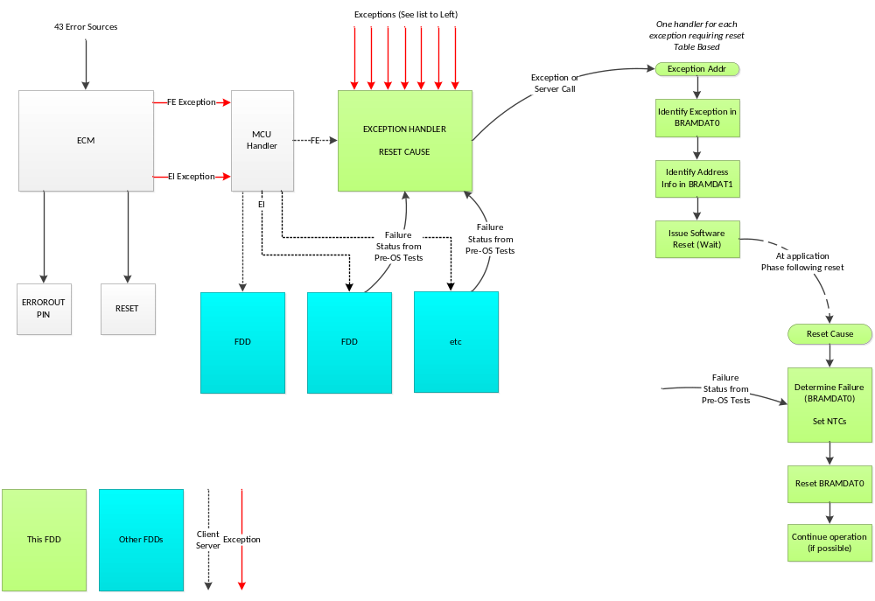

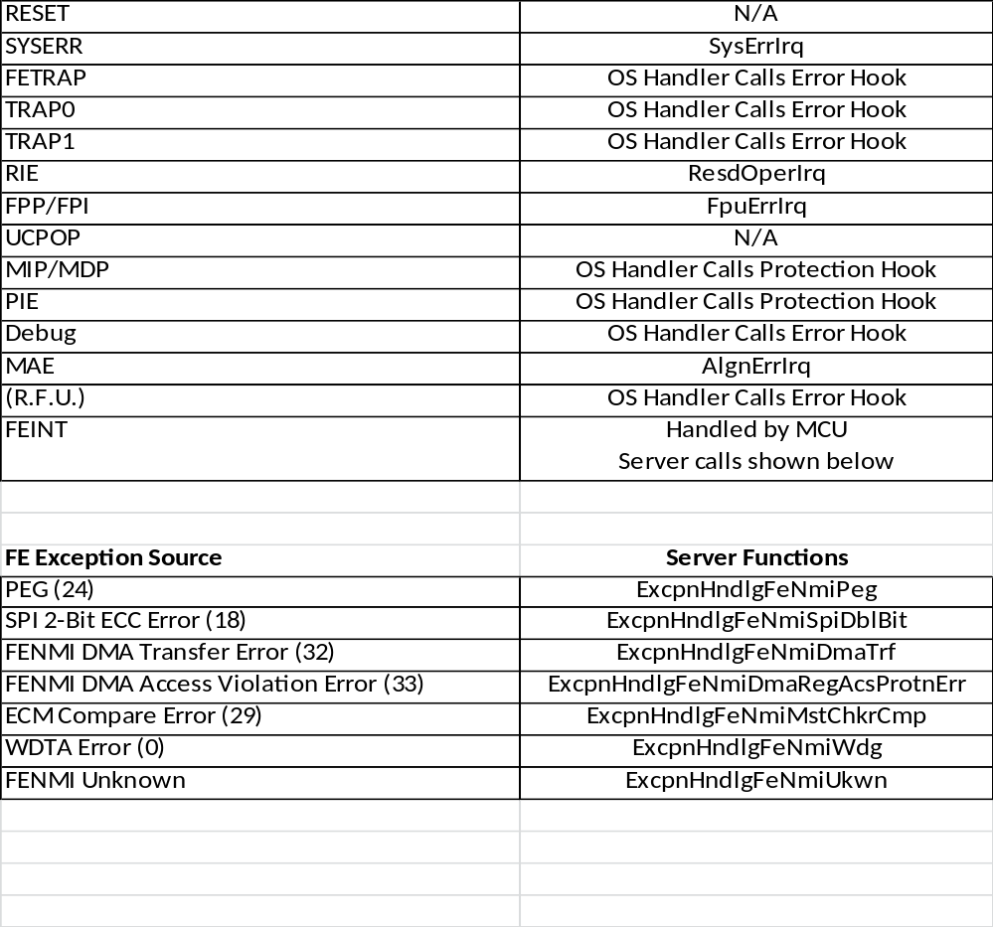

Sub-Functions In This Document
Below is a linked list of all sub-functions owned by this document.

Sub-Function Name | Link
Exception Handling Configuration | 4.1
Exception Handling Routine SYSERR | 4.2
Exception Handling Routine Floating Point | 4.3
Exception Handling Routine Misalignment | 4.4
Exception Handling Routine Reserved Instruction | 4.5
Server Routine FENMI PEG | 4.6
Server Routine FENMI SPI 2 Bit ECC | 4.7
Server Routine FENMI DMA Transfer Error | 4.8
Server Routine FENMI DMA Access Violation Error | 4.9
Server Routine FENMI Master Checker Compare | 4.10
Server Routine FENMI Watchdog | 4.11
Server Routine FENMI DTS Double Bit ECC | 4.12
Server Routine FENMI Unknown | Error: Reference source not found
Server Routine Protection Hook | Error: Reference source not found
Server Routine Error Hook | 4.14
Server Routine Shutdown Hook | 4.19
Exception Handling Routine EIINT | Error: Reference source not found
Reset Source Determination | 4.21

Critical Register Verification References
This table contains the information needed for critical register verification as configured or used in this document.

Register | Register No.  (regID, selID) | Access Permission | Init / Periodic  Verification | Masking | Expected Value | Protn Score From Eval Sheet
FPCFG | SR10, 0 | CU0 | Init | None | 0x0000 001C | 0

Sub-functions

Sub-Function: Exception Handling Configuration
Return to sub-function list link: Sub-Functions In This Document

NTCs
NA

SAN Linkage
SAN-49: After reset the generation of SYSERR exception request due to the errors shown in the Error notification Control Register (SEGCONT) is disabled. This notification can be enabled by setting the related bits accordingly.
SAN-263: Generation of SYSERR exception in case of uncorrectable error (e.g. DED, Address parity) during instruction fetch cannot be masked for instruction fetch unit in SEGCONT. However, such errors shall be always handled by ECM within DTI.
SAN-278: Transition to the safe state shall take place when an ECC 2-bit error, or an overflow error has occurred. For this purpose, the ECM shall be configured accordingly.
SAN-342: Transition the MCU and the system to the safe state shall take place when an address parity error has occurred. For this purpose, the ECM shall be configured accordingly.
SAN-401: Transition to the safe state shall take place when 2-bits error, an error count overflow or an address error has been detected. For this purpose, configure the appropriate response in the ECM accordingly.
SAN-413: Upon detection of non-correctable bit error in the local RAM, a system error exception request will be sent to SEG to generate a SYSERR (FE-level) exception (if it is enabled).

Description
This sub-function configures or identifies the exception handling characteristics for the RH850 related to microcontroller diagnostics.

Rationale
The Nexteer approach planned for exception handling involves two types – those serious errors that will be handled by forcing a software reset of the microcontroller and those that do not. This sub-function is intended to show the list of exceptions and highlight those that will be configured to be a system error (SYSERR) via the use of the SEGCONT register. Floating point exceptions must also be configured.

Exception Handler assumes that the MCAL will configure the CVMREN register to cause a reset when the CVM Fails.

Implementation

Initialization (ExcpnHndlgInit1)

Register Configuration Summary
Register | Value | Comments | Access
Register | Value | Comments | SV | UM
FPCFG (Floating-point operation configuration) | FPCFG.XE.V = 1 (Validity)  FPCFG.XE.Z = 1 (Divide by Zero)  FPCFG.XE.O = 1 (Overflow)  FPCFG.XE.U = 0 (Underflow)  FPCFG.XE.I = 0 (Imprecise) | Only addresses configuring the exception bits | R/W | R/W
* SYSCVMDEW (CVM Detection Enable Register) | SYSCVMDEW. CVMDIAGMEW = 0 | Enable CVM Diagnosis  NOTE: This is a protected register. Can only be written to once. | R/W | R/W
*Denotes that no direct write is required as the default value meets the requirement.
NOTE: MCU configuration has a checkbox selection for the self-test – consider this in the future design.

// Configure floating point exceptions – note that other FPU configuration is done in the FBL
FPCFG = 0x0000 001C

Reference

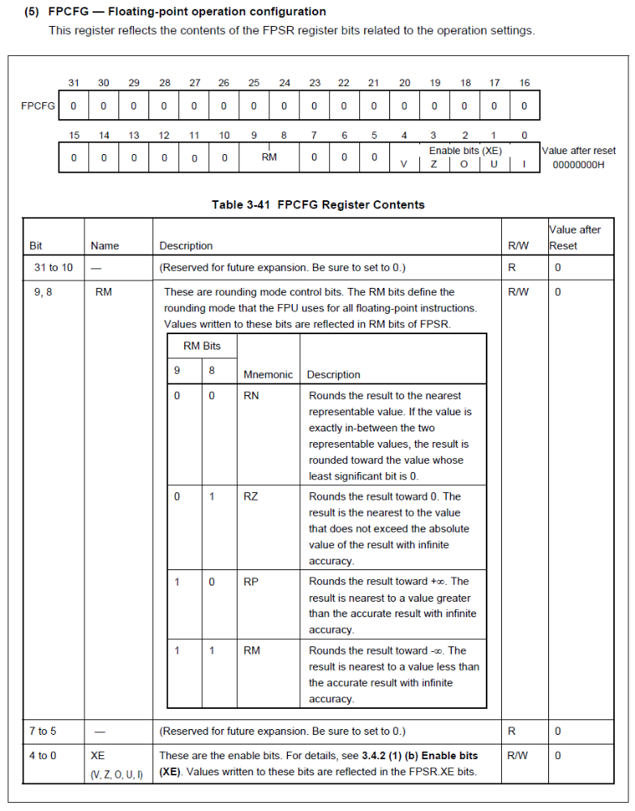

FPSR (See boot loader CM110A for configuration function):
Bits 31 to 24: Status bits – NA for configuration – initialize to zero

Bit 23: FN Flush to Nearest: recommend setting this bit to 1 – along with the FS (Flush Subnormal) bit set to 1 and the RM bits set to RN (round to nearest) , this setting will cause subnormal numbers to be flushed to either zero or +/- the smallest magnitude normal number, whichever is closer to the subnormal result – essentially rounds the subnormal result rather than flushing to zero always. (See FS setting for EA3 comparison)

Bit 22: IF: status bit – NA for configuration – initialize to zero

Bit 21: PEM: recommend setting to 0 – for imprecise floating point exceptions. This does not allow resuming execution after the exception handler, which is ok since the expected design is to cause a reset. Precise exceptions would allow resuming execution but causes slower operation (different pipelining to allow for precise exceptions).

Bit 20: Reserved: must write a 0

Bits 19 and 18: RM, rounding mode, recommend setting is 00 for RN round to nearest. This matches the setting used in EA3.

Bit 17: FS flush subnormal – recommend setting this bit to 1 to enable flush subnormal. This is the default setting of this bit. The floating point coprocessor does not have hardware processing of subnormal numbers; therefore if FS is disabled, any subnormal operand or result causes an exception so that software processing can occur; recommend flush subnormal for throughput optimization. NOTE that this differs from the EA3 setting. The EA3 processor has hardware support for subnormal number processing and we do not flush subnormal numbers; not flushing is the default setting for the EA3 processor.

Bit 16: reserved: must write a 0

Bits 15 to 10: Status bits – NA for configuration – initialize to zero

Bits 9 to 5: Exception enable bits: recommend setting as in EA3 FDD (although no EA3 program has turned these settings on yet)
Bit 9 – V – invalid operation – set to 1 to enable exception
Bit 8 – Z – divide by zero – set to 1 to enable exception
Bit 7 – O – overflow – set to 1 to enable exception
Bit 6 – U – underflow – set to 0 to disable exception
Bit 5 – I – inexact – set to 0 to disable exception

Bits 4 to 0: Status bits – NA for configuration – initialize to zero

Diagnostic Verification Method
NA as this is a configuration sub-function

Sub-Function: Exception Handling Routine SYSERR
Return to sub-function list link: Sub-Functions In This Document

NTCs
None – NTCs are addressed in section 4.21 (Reset Source)

SAN Linkage
SAN-166: If SYSERR exception is generated, a reset of the device shall be issued.
SAN-263: Generation of SYSERR exception in case of uncorrectable error (e.g. DED, Address parity) during instruction fetch cannot be masked for instruction fetch unit in SEGCONT. However, such errors shall be always handled by ECM within DTI.
SAN-278: Transition to the safe state shall take place when an ECC 2-bit error, or an overflow error has occurred. For this purpose, the ECM shall be configured accordingly.
SAN-342: Transition the MCU and the system to the safe state shall take place when an address parity error has occurred. For this purpose, the ECM shall be configured accordingly.
SAN-343: In case an address parity error has occurred, a system error (SYSERR) exception will be generated. This exception is terminating and a reset from the ECM or from the pin becomes necessary.
SAN-401: Transition to the safe state shall take place when 2-bits error, an error count overflow or an address error has been detected. For this purpose, configure the appropriate response in the ECM accordingly.
SAN-413: Upon detection of non-correctable bit error in the local RAM, a system error exception request will be sent to SEG to generate a SYSERR (FE-level) exception (if it is enabled).

Description
This sub-function handles the SYSERR exceptions (after the RBASE / EBASE Switch - refer to start up sequence).
Note that some errors are configured to generate a SYSERR based on the contents of the SEGCONT register (see CM110A for details). The design stores information into back up registers, generates a software reset and then the “Reset Source Determination” sub-function identifies the source of the reset and identifies the NTC.
SYSERRs occurring prior to the RTE initialization will result in an interrupt restarting the FBL.

Rationale
SYSERR approach was selected over ECM as it seems to be a more direct response in cases of serious failures. Note that the ECM error out pin is also configured to go the safe state as another redundant disabling mechanism; however, no EI or FE interrupts are configured as enabled.
Design assumes that if none of the SEGFLAG bits are set, then the assumption is an instruction fetch failure.

R7F701311 has 128KB of RAM with a Base address of 0xFEB8 0000 and the Offset starting at 0x0006 0000.

Implementation
The SYSERR exception has an offset of 0x010.

Event Driven (SysErrIrq)

Registers used
Register | Use | Register Access
Register | Use | SV | UM
SEGFLAG (Error Occurrence Retention Register) | Contains bits to indicate the source of the system error. | R/W | Read  Only
SEGADDR (Error Address) | Contains the error address information that caused the system error. | R/W | Read  Only
CF1STEADR0_PE1 (Code Flash 1st Error Address Register) | Register provides information on address of failure – used for debug purposes | R/W | R/W

TmpData = 0

// Determine source of error from the SEGFLAG bits and indicate in BRAMDAT0
If (SEGVPGF = 1) Then
TmpSrc = McuDiagc1.MCUDIAGC_PRPHLBUSGUARD

ElseIf (SEGVCRF = 1) Then
TmpSrc = McuDiagc1.MCUDIAGC_INTPRPHLGUARD

ElseIf (SEGTCMF = 1) Then
// Identify bank that failed to get address information from the correct register
If (ECCCPU1DEDF0 = 1) Then
// TmpData is the Offset Address of Local RAM ‘OR’ed with Base Addr (0xFEB8 0000) and Bank Addr (0x0)
TmpData = ((ECCCPU1LR1STEADR0_PE1 << 4) | 0xFEB8 0000)
Else If (ECCCPU1DEDF1 = 1)
// TmpData is the Offset Address of Local RAM ‘OR’ed with Base Addr (0xFEB8 0000) and Bank Addr (0x4)
TmpData = ((ECCCPU1LR1STEADR1_PE1 << 4) | 0xFEB8 0004)
Else If (ECCCPU1DEDF2 = 1)
// TmpData is the Offset Address of Local RAM ‘OR’ed with Base Addr (0xFEB8 0000) and Bank Addr (0x8)
TmpData = ((ECCCPU1LR1STEADR2_PE1 << 4) | 0xFEB8 0008)
Else
// TmpData is the Offset Address of Local RAM ‘OR’ed with Base Addr (0xFEB8 0000) and Bank Addr (0xC)
TmpData = ((ECCCPU1LR1STEADR3_PE1 << 4) | 0xFEB8 000C)
EndIf

TmpSrc = McuDiagc1.MCUDIAGC_LCLRAMDBLBIT

ElseIf ((SEGROMF = 1) or (SEGVCIF = 1)) Then // Both bits have code flash ECC
If (CF1STERSTR_PE1 & 0x0000 0004 !=0) Then
TmpSrc = McuDiagc1.MCUDIAGC_ADRPAR
TmpData = ECCFLICF1STEADR0_PE1
Else If (CF1STERSTR_PE1 & 0x0000 0002 !=0) Then
TmpSrc = McuDiagc1.MCUDIAGC_CODFLSDBLBIT
TmpData = ECCFLICF1STEADR0_PE1
Else
// Other VCIE cause
TmpSrc = McuDiagc1.MCUDIAGC_VCIE
End If
Else
// Assume instruction fetch error drove SYSERR
TmpSrc = McuDiagc1.MCUDIAGC_INSTRFETCH

End If

NxtrSwRstFromExcpn (TmpSrc, TmpData)

Reference
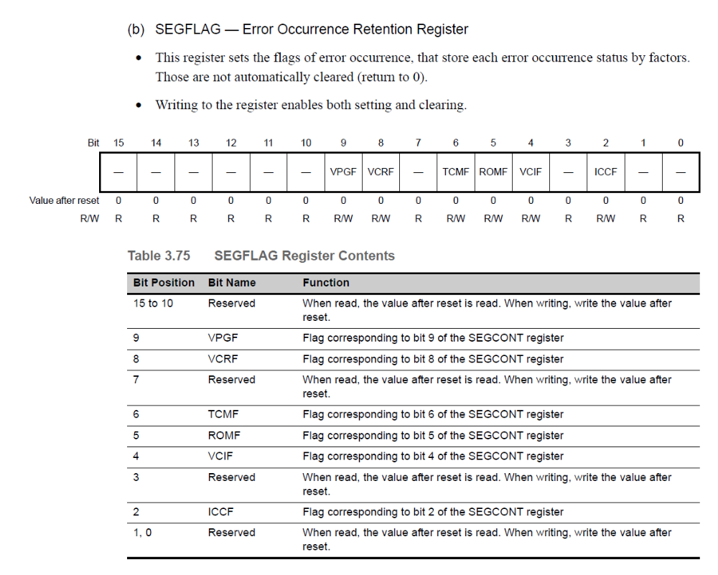

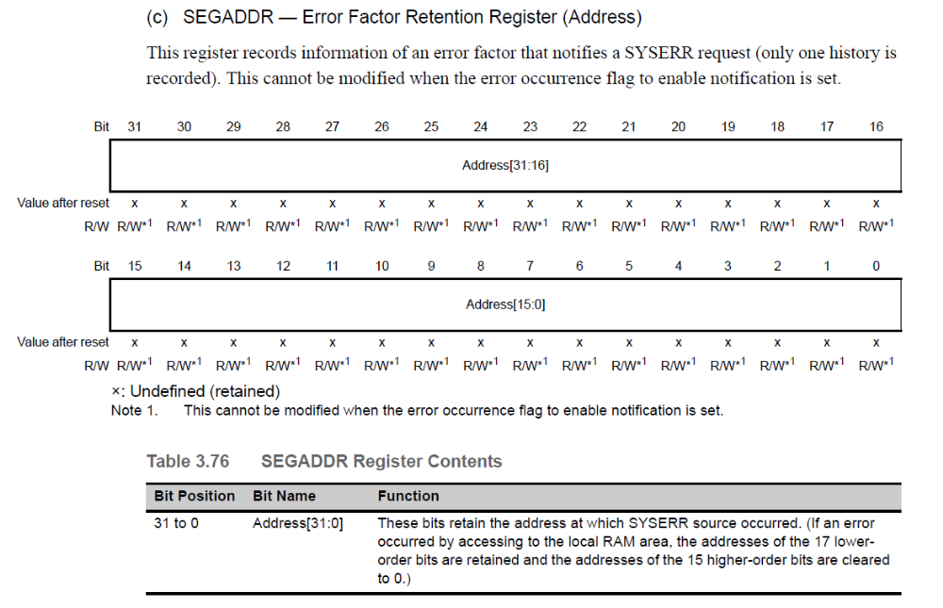

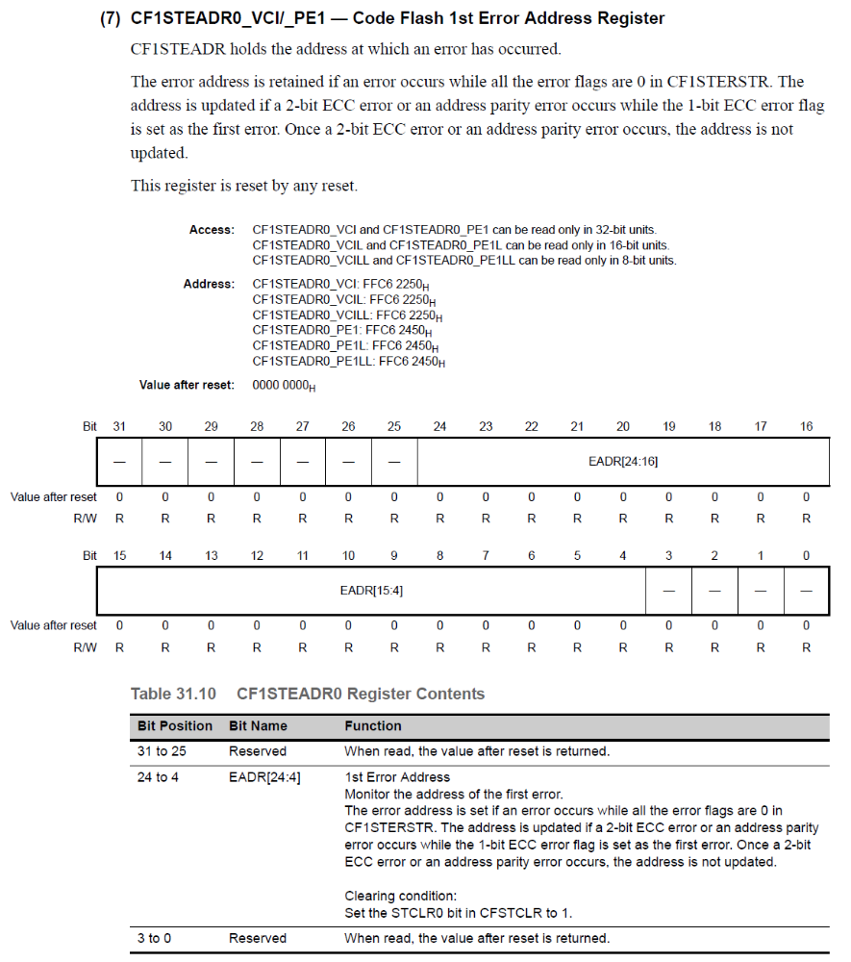

Verification Method

At 2ms rate:

// Invokes a double bit ECC code flash fault
If ((McuDiagcTest = McuDiagcTestTyp.CODFLSDBLBIT)
Temp = Read from Code Flash Test Address 0x0100 A8B0 // invokes a double bit ECC
McuDiagcTest = McuDiagcTestTyp.NoTest
EndIf

// Check on section 8.4.2 in SAN for address parity fault injection options
// Need to find other ways to invoke a SYSERR

Sub-Function: Exception Handling Routine Floating Point
Return to sub-function list link: Sub-Functions In This Document

NTCs
None – NTCs are addressed in section 4.21 (Reset Source)

SAN Linkage
None identified

Description
This sub-function is used to handle the exceptions configured for the floating point unit (FPU). Based on the configurations, the handler can identify / discriminate faults for overflow, divide by zero and invalid operations.

Rationale
The FPU “E bit” functionality is a function of the FPU configuration.
Page 173/174 of the software user manual (R01UH0436EJ0100 Rev.1.00) states - "If the FS bit of the FPSR register is set to 1, an unimplemented operation exception (E) will not occur under any circumstances."

Nexteer is setting the FS bit to 1, therefore, there is no need to check for the “E Bit” failure in the FSPR register. Should it set for some reason, it will be swept into the “unknown” category.

Implementation
The Floating Point exception has an offset of 0x070.

Event Driven (FpuErrIrq)

Registers used
Register | Use | Register Access
Register | Use | SV | UM
FPSR | This register is used to control and monitor the cause of floating point exceptions | R/W | No
FPEPC | This register stores the program counter value where the exception occurs. | R/W | No

// Get data relating to the fault
TmpData = FPEPC

If (FPSR & 0x0000 4000 != 0) Then
TmpSrc = McuDiagc1.MCUDIAGC_ FPUERRINVLDOPER // Invalid Operation
Else If (FPSR & 0x0000 2000 != 0)
TmpSrc = McuDiagc1.MCUDIAGC_FPUERRDIVBYZERO // Divide by Zero
Elseif (FPSR & 0x0000 1000 != 0)
TmpSrc = McuDiagc1.MCUDIAGC_FPUERROVF // Overflow
Elseif
TmpSrc = McuDiagc1.MCUDIAGC_FPUERRUKWN // Unknown (not expected)
EndIf

NxtrSwRstFromExcpn (TmpSrc, TmpData)

Reference
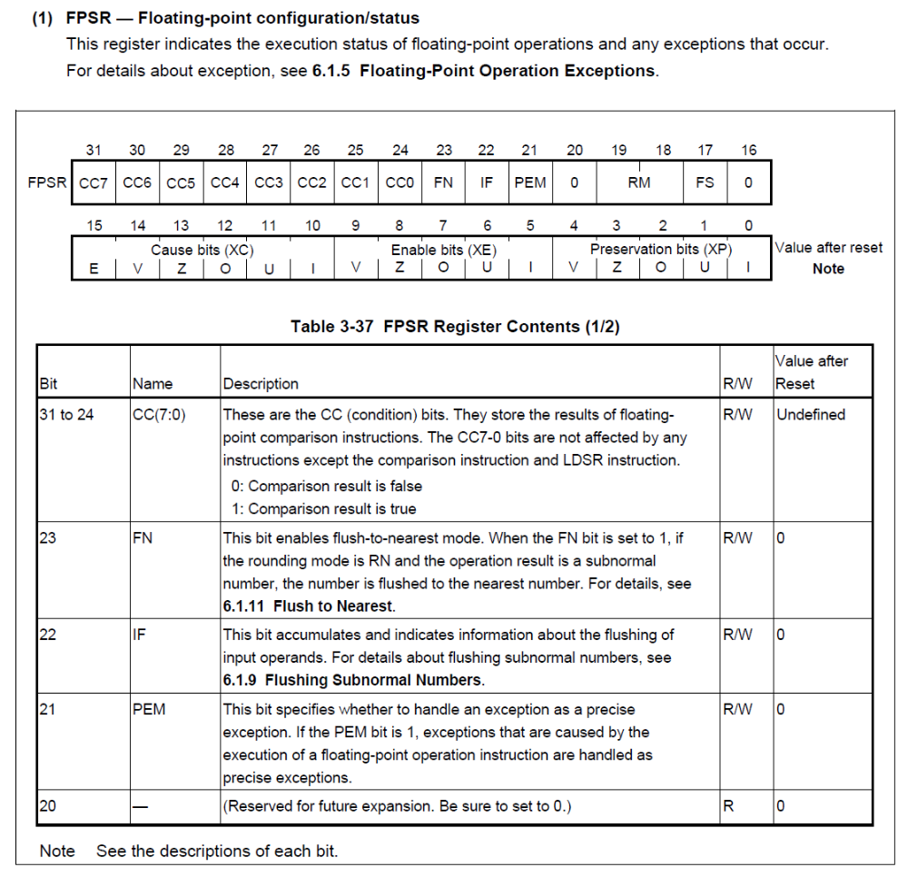

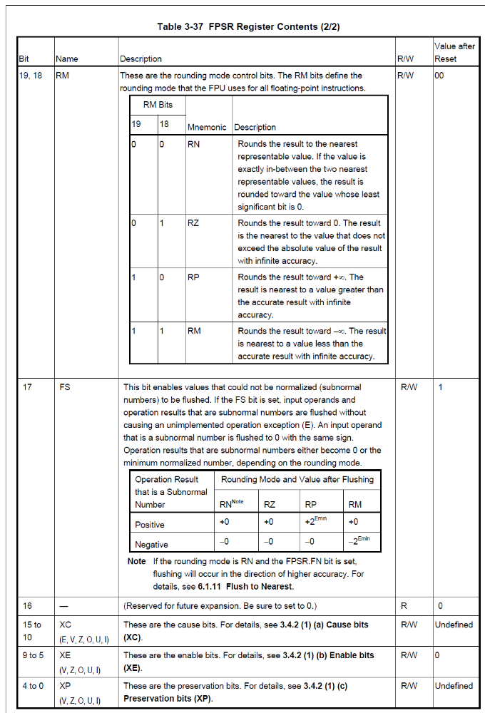

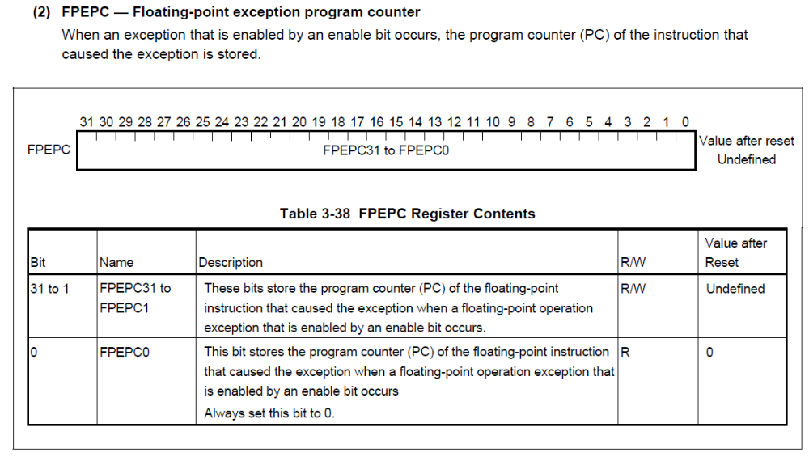

Verification Method
NA

Sub-Function: Exception Handling Routine Misalignment
Return to sub-function list link: Sub-Functions In This Document

NTCs
None – NTCs are addressed in section 4.21 (Reset Source)

SAN Linkage
SAN-148: When a MPU violation is detected, the access is not granted, but the related information such as access type (read, write), data size, and instruction type are stored in the memory error information register MEI. The memory error address register is used to store the address when a MAE (misaligned) or MPU exception occurs. Both registers can be accessed in the CPU supervisor mode only.

Description
This sub-function handles exceptions generated by a memory misalignment error.

Rationale
TBD

Implementation
The memory misalignment exception has an offset of 0x0C0.

Event Driven (AlgnErrIrq)

Registers used

Register | Use | Register No. (regID,selID) | Register Access
Register | Use | Register No. (regID,selID) | SV | UM
MEI | Memory error information register – used to indicate if the misalignment was caused during read or write | SR8, 2 | Yes | No  (via SAN)
MEA | Memory error address register - These bits store an address when a MAE (misaligning) or MPU violation  occurs. | SR6, 2 | Yes | No  (via SAN)

// Determine source of error and indicate in BRAMDAT0
TmpData = MEA
If (MEI & 0x0000 0001 = 0x0000 00001) Then
TmpSrc = McuDiagc1.MCUDIAGC_ALGNWR
Else
TmpSrc = McuDiagc1.MCUDIAGC_ALGNREAD
End If
NxtrSwRstFromExcpn (TmpSrc, TmpData)

Reference

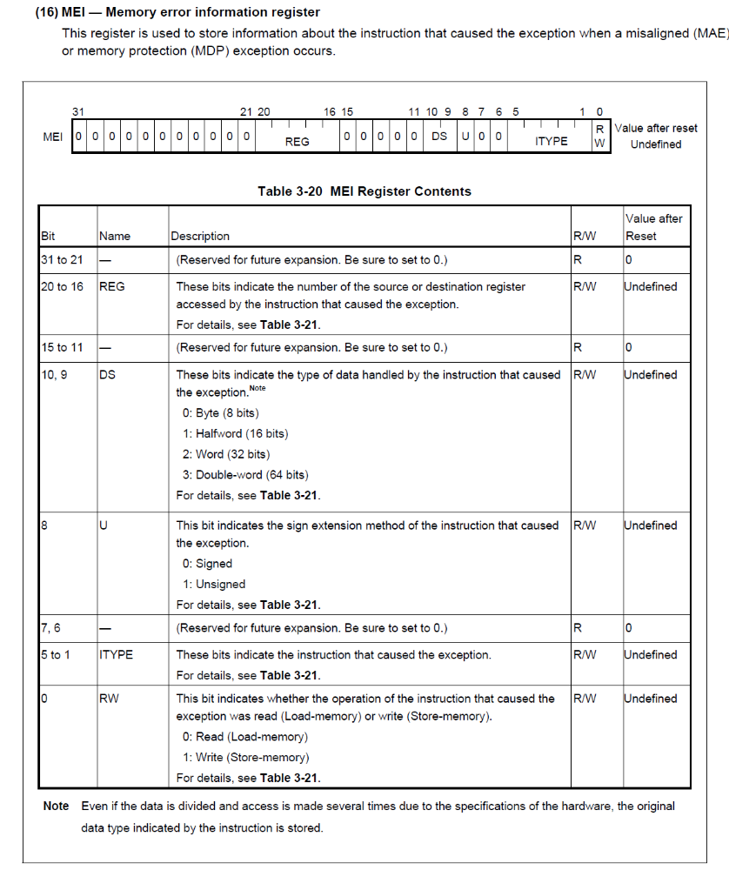

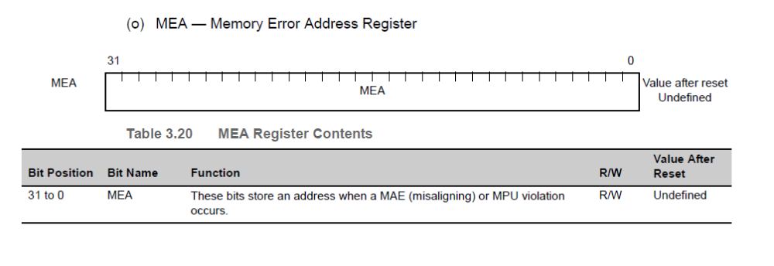

Verification Method
NA

Sub-Function: Exception Handling Routine Reserved Instruction
Return to sub-function list link: Sub-Functions In This Document

NTCs
N/A

SAN Linkage
None

Description

Rationale
This is basically an exception generated by processing an illegal opcode function.

Implementation
The Reserved Instruction exception has an offset of 0x060.

Event Driven (ResdOperIrq)

Registers used
Register | Use | Register Access
Register | Use | SV | UM
None

// Identify reset cause and reset

NxtrSwRstFromExcpn (McuDiagc1.MCUDIAGC_RESDOPER, 0)

Verification Method
N/A

Sub-Function: Server Routine FENMI PEG
Return to sub-function list link: Sub-Functions In This Document

NTCs
None – NTCs are addressed in section 4.21 (Reset Source)

SAN Linkage
SAN-183: For PE guard violations, a proper error handling shall be performed. For this the ECM shall be configured accordingly.

Description
This server function is called by the MCU handler and is responsible for responding to a PEG (Processor Element Guard) error. The Nexteer design has this configured in the ECM to be an exception of type FENMI. The design notes the source of the error (for later use in the reset cause function), clears the ECM status registers and issues a software reset.

Rationale
FENMI Interrupts are used to represent serious failures within the microcontroller or it’s peripherals that are critical to the overall design. As a result, the Nexteer strategy is to indicate the fault type in backup memory (data retained through a software reset) and force a software reset where the reset type is then indicated and the fault is set (assuming the system can operate to that point).

Note that the function FeNmiPeg is called from the MCU handler.

Implementation

Event Driven (FeNmiPeg)

Registers used
Register | Use | Register Access
Register | Use | SV | UM
None

// Identify reset cause and reset
NxtrSwRstFromExcpn(McuDiagc1.MCUDIAGC_PROCRELMGUARD, 0)

Verification Method
NA

Sub-Function: Server Routine FENMI SPI 2 Bit ECC Error
Return to sub-function list link: Sub-Functions In This Document

NTCs
None – NTCs are addressed in section 4.21 (Reset Source)

SAN Linkage
None

Description
This server routine is called from the MCU handler and is responsible for responding to a SPI RAM peripheral 2 Bit ECC Error. The Nexteer design has this configured in the ECM to be an exception of type FENMI. The design notes the source of the error (for later use in the reset cause function), clears the ECM status registers and issues a software reset.

Rationale
FENMI Interrupts are used to represent serious failures within the microcontroller or it’s peripherals that are critical to the overall design. SPI use in the design applies to several critical functions (motor position, gate drive and power supply control) thus the FE designation.

Note that the function FeNmiSpiDblBit is called from the MCU handler.

Implementation

Event Driven (FeNmiSpiDblBit)

Registers used
Register | Use | Register Access
Register | Use | SV | UM
ECCCSIH0CTL (ECC Control / Status Register for SPI 0) | Indicates a SPI double bit error in SPI 0 | Yes | Yes
ECCCSIH1CTL (ECC Control / Status Register for SPI 1) | Indicates a SPI double bit error in SPI 1 | Yes | Yes
ECCCSIH2CTL (ECC Control / Status Register for SPI 2) | Indicates a SPI double bit error in SPI 2. Note that SPI3 is not considered and is assumed the default if 0, 1 or 2 are not detected. | Yes | Yes

TmpData = 0
// Identify which SPI peripheral is at fault (Data0), identify and save address (Data1)
If (ECCCSIH0ECDEDF0 = 1) Then
TmpData = ECCCSIH0EAD0
TmpSrc = McuDiagc1.MCUDIAGC_SPIRAMDBLBIT0
Else If (ECCCSIH1ECDEDF0 = 1)
TmpData = ECCCSIH1EAD0
TmpSrc = McuDiagc1.MCUDIAGC_ SPIRAMDBLBIT1
Else If (ECCCSIH2ECDEDF0 = 1)
TmpData = ECCCSIH2EAD0
TmpSrc = McuDiagc1.MCUDIAGC_ SPIRAMDBLBIT2
Else
TmpData = ECCCSIH3EAD0
TmpSrc = McuDiagc1.MCUDIAGC_ SPIRAMDBLBIT3
End If

NxtrSwRstFromExcpn(TmpSrc, TmpData)

Reference
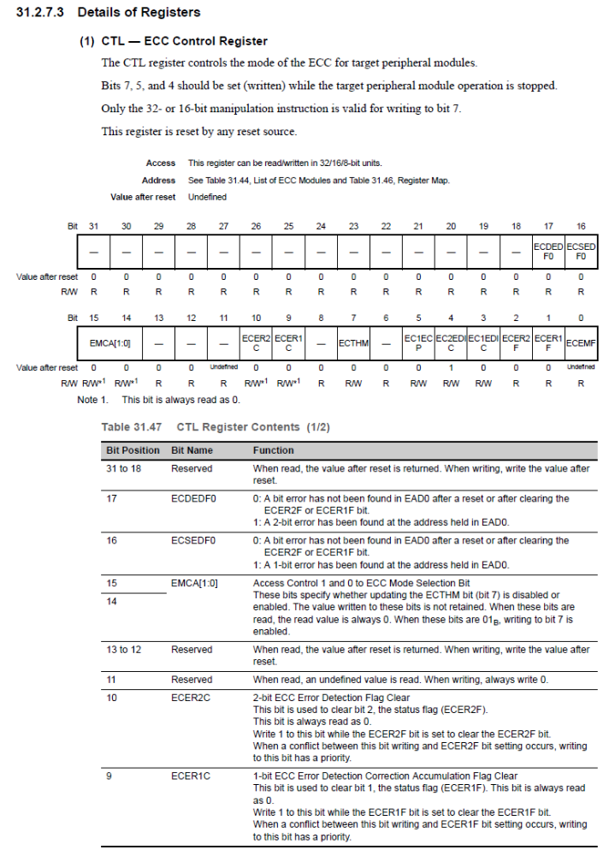

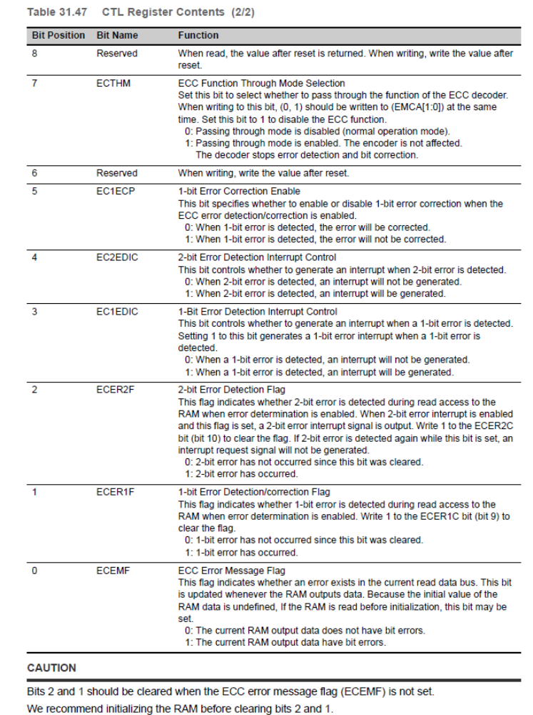

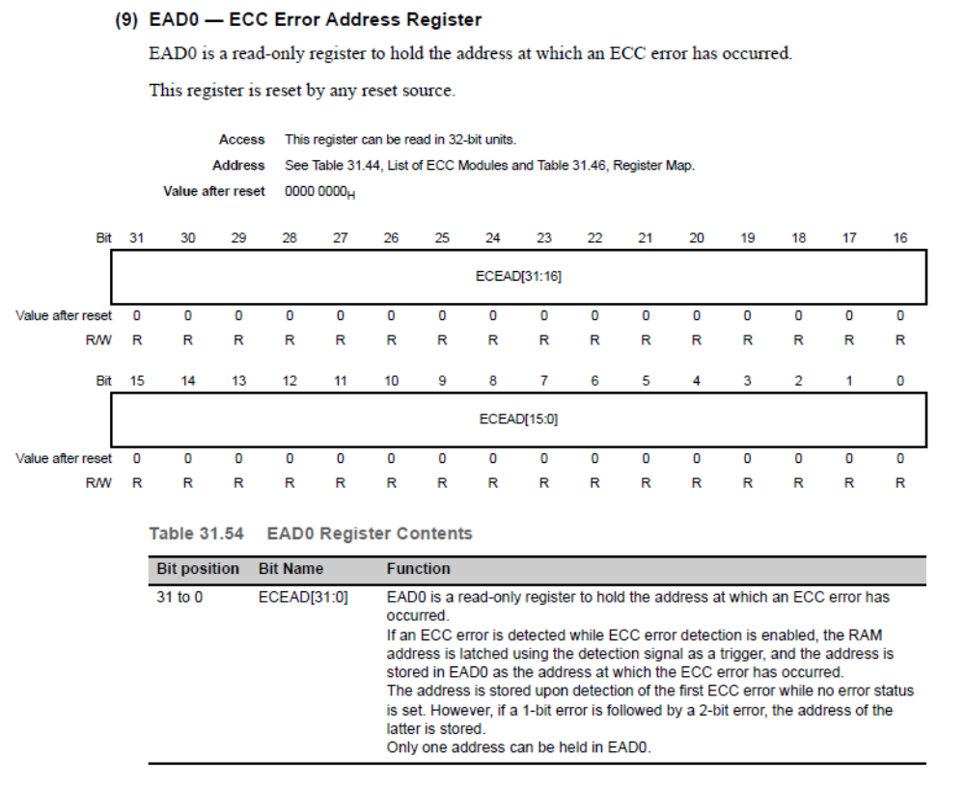

Verification Method
NA

Sub-Function: Server Routine FENMI DMA Transfer Error
Return to sub-function list link: Sub-Functions In This Document

NTCs
None – NTCs are addressed in section 4.21 (Reset Source)

SAN Linkage
SAN-723: When a data parity error is detected, a flag will be set in P-Bus data parity status register APDPERRST_xx (xx stands for the module name) and an internal error signal is propagated towards ECM. In this case the MCU should move to safe state.
SAN-724: If a data parity error has occurred during DMA transfer, a DMA transfer error will be notified.

Description
This server routine is called from the MCU handler and is responsible for responding to DMA transfer errors. The Nexteer design has this configured in the ECM to be an exception of type FENMI. The design notes the source of the error (for later use in the reset cause function), clears the ECM status registers and issues a software reset.

Rationale
N/A

Implementation

Event Driven (FeNmiDmaTrf)

Registers used
Register | Use | Register Access
Register | Use | SV | UM
DMASSDMACER | Indicates the status of the two DMAC channels | Yes | Yes

// Indicate data for reset cause (Data0) and information on the responsible DMA channel (Data1)
NxtrSwRstFromExcpn(McuDiagc1.MCUDIAGC_DMATRFERR, DMASSDMACER)

Reference
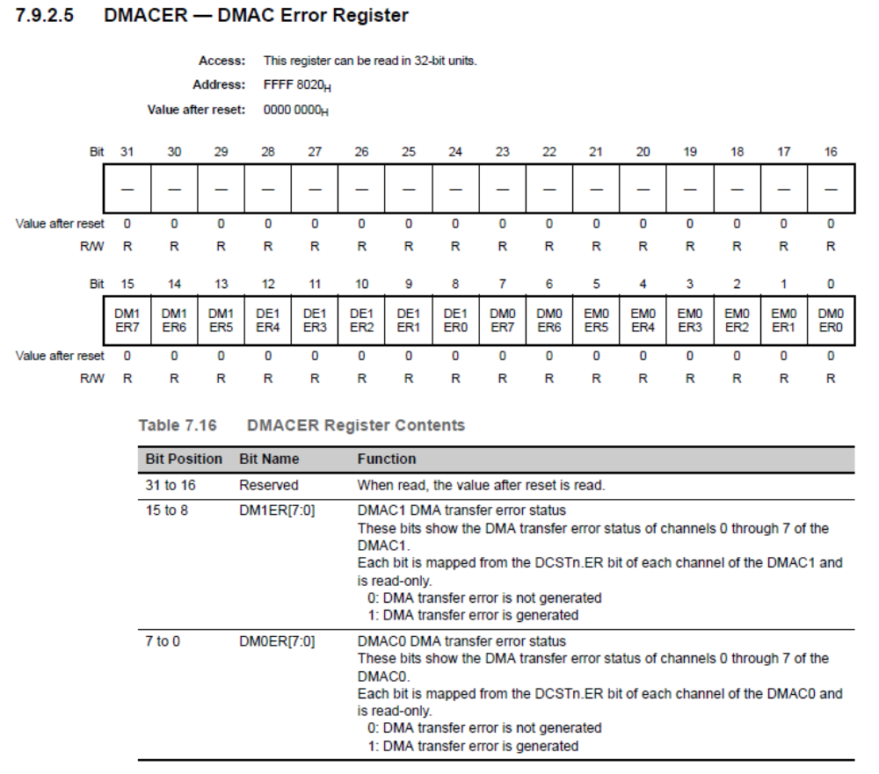

Verification Method
NA

Sub-Function: Server Routine FENMI DMA Access Violation Error
Return to sub-function list link: Sub-Functions In This Document

NTCs
None – NTCs are addressed in section 4.21 (Reset Source)

SAN Linkage
SAN-100: When the CPU makes an illegal access to the global DMA registers (e.g. access in user mode), then an access violation flag will be set in the related transfer module and an internal error signal will be propagated to the ECM to take the proper action.

Description
This server routine is called from the MCU handler and is responsible for responding to DMA privileged access errors. The Nexteer design has this configured in the ECM to be an exception of type FENMI. The design notes the source of the error (for later use in the reset cause function), clears the ECM status registers and issues a software reset.

Rationale
FENMI Interrupts are used to represent serious failures within the microcontroller or it’s peripherals that are critical to the overall design. As a result, the Nexteer strategy is to indicate the fault type in backup memory (data retained through a software reset) and force a software reset where the reset type is then indicated and the fault is set (assuming the system can operate to that point).

Note that the function ExcpnHndlgFeNmiDMAREGACSPROTECNERR is called from the MCU handler.

In future versions of this document we may want to consider using the registers DM0CMV, DM1CMV and DTSCMV to provide more information when the fault is triggered. Note that these registers require supervisor mode to be accessed – note that the exceptions are already be in SV mode. Initial design will not include them.

Implementation

Event Driven (FeNmiDmaRegAcsProtnErr)

Registers used
Register | Use | Register Access
Register | Use | SV | UM
DMASSDMACER | Indicates the status of the two DMAC channels | Yes | Yes

// Indicate data for reset cause (Data0) and information on the responsible DMA channel (Data1)
NxtrSwRstFromExcpn (McuDiagc1.MCUDIAGC_DMAREGACSPROTECNERR, DMASSDMACER)

Reference

Verification Method
NA

Sub-Function: Server Routine FENMI ECM Master/Checker Compare
Return to sub-function list link: Sub-Functions In This Document

NTCs
None – NTCs are addressed in section 4.21 (Reset Source)

SAN Linkage
SAN-656: If there is a mismatch between ECM master and checker an ECM compare error will be set in the ECMmESSTR0/1 register. In that case, the safe state shall be entered.

Description
This server routine is called from the MCU handler and is responsible for responding errors in which the master and checker compare error. The Nexteer design has this configured in the ECM to be an exception of type FENMI. The design notes the source of the error (for later use in the reset cause function), clears the ECM status registers and issues a software reset.

Rationale
N/A

Implementation

Event Driven (FeNmiEcmMstChkrCmp)

Registers used
Register | Use | Register Access
Register | Use | SV | UM
None

// Identify reset cause and reset
NxtrSwRstFromExcpn (McuDiagc1.MCUDIAGC_ECMMSTCHKRERR, 0)

Verification Method
NA

Sub-Function: Server Routine FENMI Watchdog

NTCs
None – NTCs are addressed in section 4.21 (Reset Source)

SAN Linkage
None

Description
This server routine is called from the MCU handler and is responsible for responding internal watchdog failures. Note that the design is intended to use this server function to also sort to see if the timing failure can be further discriminated to a watchdog, program flow, alive monitor or a deadline monitor failure It is assumed that the MCU will provide the capability to allow Nexteer to select / direct unused features in the design to this routine.

The Nexteer design has configured in the ECM to be an exception of type FENMI without a Reset. The design notes the source of the error (for later use in the reset cause function), clears the ECM status registers and issues a software reset.

Rationale
The SAN recommends a reset when using the ECM for watchdog failures. The Nexteer design will defeat the reset and replace the functionality with a software reset – this is to allow the capability to store parse the fault into watchdog, program flow, alive monitoring and deadline monitoring and provide more information for debug purposes. The ECM configuration as a reset would not allow this to be done.

Note that the function FeNmiWdg is called from the MCU handler.

Implementation

Event Driven (FeNmiWdg)

Registers used
Register | Use | Register Access
Register | Use | SV | UM
EntityStatusGRef (not a register, but key part of this design) | This is a structure contained within the AutoSAR module that will provide the means to discriminate different failures that result in a watchdog timeout. | NA | NA

Pseudo Code

TmpSrc = McuDiagc1.MCUDIAGC_FENMIWDG
TmpData = 0
For Each SupervisedEntityID
If (EntityStatusGRef→ProgramFlowViolationCnt != 0) Then // Program Flow
TmpSrc = McuDiagc1.MCUDIAGC_FENMIPROGFLOW
TmpData = SupervisedEntityID
End the For Loop
ElseIf (EntityStatusGRef→FailedSupervisionRefCycles !=0) // Alive Monitor
TmpSrc = McuDiagc1.MCUDIAGC_FENMIALVMONR
TmpData = SupervisedEntityID
End the For Loop
ElseIf (EntityStatusGRef→DeadlineViolationCnt !=0) // Deadline Monitor
TmpSrc = McuDiagc1.MCUDIAGC_FENMIDEADLINEMONR
TmpData = SupervisedEntityID
End the For Loop
Else
End If
End For

// Store data for reset cause use and reset
NxtrSwRstFromExcpn (TmpSrc, TmpData)

Verification Method
NA

Sub-Function: Server Routine FENMI DTS Double Bit ECC
Return to sub-function list link: Sub-Functions In This Document

NTCs
None – NTCs are addressed in section 4.21 (Reset Source)

SAN Linkage
None

Description
This server routine is called from the MCU handler and is responsible for responding to DTS ECC failures.

The Nexteer design has configured this in the ECM to be an exception of type FENMI without a Reset. The design notes the source of the error (for later use in the reset cause function), clears the ECM status registers and issues a software reset.

Rationale
Note that the function FeNmiDts is called from the MCU handler.

Implementation

Event Driven (FeNmiDtsDblBit)

Registers used
Register | Use | Register Access
Register | Use | SV | UM
None

Pseudo Code

// Identify reset cause and reset
NxtrSwRstFromExcpn (McuDiagc1.MCUDIAGC_DTSDBLBIT, 0)

Verification Method
NA

Sub Function: Server Routine Process Unknown Exception Error

NTCs
None – NTCs are addressed in section 4.21 (Reset Source)

SAN Linkage
None

Description

The Process Unknown Exception Error needs to be called when the OS detects an unknown exception.

Rationale

Implementation

Event Driven (ProcUkwnExcpnErr)
// Perform software reset from exception and pass appropriate arguments
NxtrSwRstFromExcpn(MCUDIAGC_UKWNEXCPN, McuDiagcData1_Arg)

Verification Method
NA

Sub-Function: Server Routine Process Memory Protection Unit Exception Error

NTCs
None – NTCs are addressed in section 4.21 (Reset Source)

SAN Linkage
None

Description
The Process Memory Protection Unit Exception Error needs to be called when the OS detects a memory protection violation.

Rationale

Implementation

Event Driven (ProcMpuExcpnErr)
// Perform software reset from exception and pass appropriate arguments
NxtrSwRstFromExcpn(MCUDIAGC_MPU, McuDiagcData1_Arg)

Verification Method
NA

Sub-Function: Server Routine Process Privileged Instruction Exception Error

NTCs
None – NTCs are addressed in section 4.21 (Reset Source)

SAN Linkage
None

Description
The Process Privileged Instruction Exception Error needs to be called when the OS detects a protection violation.

Rationale

Implementation

Event Driven (ProcPrvlgdInstrExcpnErr)
// Perform software reset from exception and pass appropriate arguments
NxtrSwRstFromExcpn(MCUDIAGC_PRVLGDINSTREXCPN, McuDiagcData1_Arg)

Verification Method
NA

Sub-Function: Server Routine Process Permanent Os Error

NTCs
None – NTCs are addressed in section 4.21 (Reset Source)

SAN Linkage
None

Description
The Process Permanent Os Error needs to be called when the OS detects a fatal, permanent failure.

Rationale

Implementation

Event Driven (ProcPrmntOsErr)
// Perform software reset from exception and pass appropriate arguments
NxtrSwRstFromExcpn(MCUDIAGC_PRMNTOSERR, McuDiagcData1_Arg)

Verification Method
NA

Sub-Function: Server Routine Process Non Critical Os Error

NTCs
None – NTCs are addressed in section 4.21 (Reset Source)

SAN Linkage
None

Description
The Process Non Critical Os Error needs to be called when the OS detects a non-fatal failure.

Rationale

Implementation

Event Driven (ProcNonCritOsErr)
// Update error code variable that is polled in periodic function
ExcpnHndlgOsErrCod_C = McuDiagcData1_Arg

Verification Method
NA

Periodic (ExcpnHndlgPer1)

** NOTE: variable ExcpnHndlgOsErrCod must reside in global shared memory **

If (ExcpnHndlgOsErrCod != 0x0000) then
// Set code for non-fatal OS error – Error Code is on the data ExcpnHndlgOsErrCod
SetNtcSts(NtcNr1.NTCNR_0x031, 1, NtcSts1.NTCSTS_FAILD, 0)
End If

Verification Method
NA

Sub-Function: Server Routine Shutdown Hook
Call EcuM_Shutdown()

Sub-Function: Exception Handling Routine EIINT
Return to sub-function list link: Sub-Functions In This Document

It is assumed that the MCU configuration will directly provide a client/server call to the necessary FDDs to accomplish their tasks. It would be redundant to place them within this document only to call out another document, so this is the chosen approach.

Please refer to other microcontroller diagnostic FDDs to see their specific exception handler functionality.

Sub-Function: Reset Source Determination
Return to sub-function list link: Sub-Functions In This Document

NTCs
003.0 Code Flash ECC Single Bit (Hard Fault)
003.1 Code Flash ECC Double Bit Detection
003.2 Code Flash ECC Address Parity Fault
010.0 MBIST Startup Test Failure
013.0 Local RAM ECC Single Bit (Hard Fault)
013.1 Local RAM ECC Double Bit (Hard Fault)
016.1 DTS ECC Double Bit (Hard Fault)
017.1 CSHI0 RAM ECC Double Bit (Hard Fault)
018.1 CSHI1 RAM ECC Double Bit (Hard Fault)
019.1 CSHI2 RAM ECC Double Bit (Hard Fault)
01A.1 CSHI3 RAM ECC Double Bit (Hard Fault)
021.0 BIST Code 2-Bit ECC Failure
021.2 LBIST Startup Test Failure
021.4 BIST Not Complete
021.5 CPU Lock Step Error Forcing Startup Test Failure
021.6 DMA Lock Step Error Forcing Startup Test Failure
022.0 Lock Step Compare Fault
022.1 System VCIE Bit Error
022.2 Reserved Instruction (Illegal Op Code) Fault
022.3 Memory Misalignment - Read
022.4 Memory Misalignment - Write
022.5 Instruction Fetch Error
025.0 Data Protection Violation (MDP Exception)
025.1 Execution Protection Violation (MIP Exception)
026.0 ECM Status Bit Set Prior to ECM Init
026.2ECM Startup Master nERROR Output Control Fault
026.3 ECM Startup Checker nERROR Output Control Fault
026.7 ECM Runtime Master-Checker Compare Fault
028.1 FPU Invalid Operation (V Bit)
028.2 FPU Divide by Zero (Z Bit)
028.3 FPUOverflow (O Bit)
028.4 FPU Unknown Error
029.0 Unknown Reset Reason
029.1 Unknown ECM Reset Reason
029.4 Unknown Software Reset
029.5 Failed Backup RAM Read Write Test
029.6 FBL Pre-OS Startup Exception
029.7 Corrupt Start up / Reset Information
02A.0 Program Flow
02A.1 Deadline Monitoring
02A.2 Alive Monitoring
02C.0 Watchdog Timeout
02D.1 PEG Runtime Fault
02D.3 IPG RunTime Fault
02D.5 PBG Runtime Fault
030.0 Operating System Fatal Fault
030.1 Unhandled Exception
031.0 Operating System Non-Fatal Fault
036.0 DMA Transfer Error
036.1 DMA Register Access Protection Violation
048.0 CVM Over Voltage Startup Test Failure
048.1 CVM Under Voltage Startup Test Failure
049.0 Internal CVM Over Voltage Monitor Fault
049.1 Internal CVM Under Voltage Monitor Fault
049.7 External Over Voltage Monitor Fault

SAN Linkage
SAN-621: Upon detection of under/overvoltage of the core power supply, the signal at the CVMOUT pin changes its state to low and a dedicated flag will be set in the CVMF register. It is also possible to generate a reset if the software has enabled it. In that case, transition the MCU into the safe state shall be entered.
SAN-1024: As the usage of backup registers is strongly application dependents, the user should judge whether or not to apply the proposed write verify check. Moreover, if the data retained in the back-up register will be frequently used in the safety related application, then the contain should be moved to LRAM as it is protected by ECC and thus provide a high fault coverage.
SAN-1094: As the usage of backup registers is strongly application dependents, the user should judge whether or not to apply the proposed write verify check. Moreover, if the data retained in the back-up register will be frequently used in the safety related application, then the contain should be moved to LRAM as it is protected by ECC and thus provide a high fault coverage.
SAN-1096: Detected failures during the execution of the test shall be handled at application level.

Description
This function processes information from pre-OS tests and resets to determine the cause of anything unexpected and log the correct Nexteer Trouble Code. Backup RAM data is used to provide this information to the function.

Rationale
In order to log Nexteer Trouble Code information, the Diagnostic Manager must be initialized prior to setting or clearing NTCs.

Implementation

Initialization (ExcpnHndlgInit2)

SetNtcSts(NtcNr1.NTCNR_0x003, 0, NtcSts1.NTCSTS_PASSD, 0)
SetNtcSts(NtcNr1.NTCNR_0x010, 0, NtcSts1.NTCSTS_PASSD, 0)
SetNtcSts(NtcNr1.NTCNR_0x013, 0, NtcSts1.NTCSTS_PASSD, 0)
SetNtcSts(NtcNr1.NTCNR_0x016, 0, NtcSts1.NTCSTS_PASSD, 0)
SetNtcSts(NtcNr1.NTCNR_0x017, 0, NtcSts1.NTCSTS_PASSD, 0)
SetNtcSts(NtcNr1.NTCNR_0x018, 0, NtcSts1.NTCSTS_PASSD, 0)
SetNtcSts(NtcNr1.NTCNR_0x019, 0, NtcSts1.NTCSTS_PASSD, 0)
SetNtcSts(NtcNr1.NTCNR_0x01A, 0, NtcSts1.NTCSTS_PASSD, 0)
SetNtcSts(NtcNr1.NTCNR_0x021, 0, NtcSts1.NTCSTS_PASSD, 0)
SetNtcSts(NtcNr1.NTCNR_0x022, 0, NtcSts1.NTCSTS_PASSD, 0)
SetNtcSts(NtcNr1.NTCNR_0x025, 0, NtcSts1.NTCSTS_PASSD, 0)
SetNtcSts(NtcNr1.NTCNR_0x026, 0, NtcSts1.NTCSTS_PASSD, 0)
SetNtcSts(NtcNr1.NTCNR_0x028, 0, NtcSts1.NTCSTS_PASSD, 0)
SetNtcSts(NtcNr1.NTCNR_0x029, 0, NtcSts1.NTCSTS_PASSD, 0)
SetNtcSts(NtcNr1.NTCNR_0x02A, 0, NtcSts1.NTCSTS_PASSD, 0)
SetNtcSts(NtcNr1.NTCNR_0x02C, 0, NtcSts1.NTCSTS_PASSD, 0)
SetNtcSts(NtcNr1.NTCNR_0x02D, 0, NtcSts1.NTCSTS_PASSD, 0)
SetNtcSts(NtcNr1.NTCNR_0x030, 0, NtcSts1.NTCSTS_PASSD, 0)
SetNtcSts(NtcNr1.NTCNR_0x031, 0, NtcSts1.NTCSTS_PASSD, 0)
SetNtcSts(NtcNr1.NTCNR_0x036, 0, NtcSts1.NTCSTS_PASSD, 0)
SetNtcSts(NtcNr1.NTCNR_0x048, 0, NtcSts1.NTCSTS_PASSD, 0)
SetNtcSts(NtcNr1.NTCNR_0x049, 0, NtcSts1.NTCSTS_PASSD, 0)

// Confirm state of backup data is valid
If (((BRAMDAT0 & 0xFFFF 0000) >> 16) XOR (BRAMDAT0 & 0x0000 FFFF)) != 0x0000 FFFF) Then
// Set fault – BRAMDAT0 data is corrupt and cannot be trusted
SetNtcSts(NtcNr1.NTCNR_0x029, 128, NtcSts1.NTCSTS_FAILD, 0)
Else If ((BRAMDAT0 = McuDiagc1.MCUDIAGC_PWRONRST) or (BRAMDAT0 = McuDiagc1.MCUDIAGC_FLSPROGMCMPL)) Then
// No checks needed – normal power on start up or flash programming event
Else If ((SYSBSEQ0ST.DEBUGMODE = 1) AND (SYSBSEQ0STB. DEBUGMODEB = 0))
// No checks needed in debug mode
Else If (BRAMDAT0 = McuDiagc1.MCUDIAGC_ECMRST)
ProcEcmRst() // Reset from ECM
ElseIf (BRAMDAT0 = McuDiagc1.MCUDIAGC_PINRST)
ProcPinRst() // Reset from External Pin (Power Supply)
ElseIf (BRAMDAT0 = McuDiagc1.MCUDIAGC_COREVLTGMONRHI) // Overvoltage internal to uC
SetNtcSts(NtcNr1.NTCNR_0x049, 1, NtcSts1.NTCSTS_FAILD, 0)
ElseIf (BRAMDAT0 = McuDiagc1.MCUDIAGC_COREVLTGMONRLO) // Low voltage internal to uC
SetNtcSts(NtcNr1.NTCNR_0x049, 2, NtcSts1.NTCSTS_FAILD, 0)
Else
ProcStrtUpOrSwRst() // Check for start-up, non-reset faults
End If

FunctionCall ProcEcmRst
//Check for lock step fault in either core
// By design, lock step is the only ECM fault resulting in a reset - confirm
If ((ECMMSSE001 = 1) or (ECMCSSE001 = 1)) Then
// Set lock step fault
SetNtcSts(NtcNr1.NTCNR_0x022, 1, NtcSts1.NTCSTS_FAILD, 0)
Else
// Set unknown ECM reset fault
SetNtcSts(NtcNr1.NTCNR_0x029, 2, NtcSts1.NTCSTS_FAILD, 0)
End If
// Clear all the bits of ECMmESSTR0
ECMESSTC0_Desired = 0xFDFF DFF3;
WrProtdRegEcm_u32 (ECMESSTC0_Desired, Address of ECMESSTC0);

// Clear all the bits of ECMmESSTR1
ECMESSTC1_Desired = 0x6000 07F7;
WrProtdRegEcm_u32 (ECMESSTC1_Desired, Address of ECMESSTC1);

FunctionCall ProcStrtUpOrSwRst

Switch: BRAMDAT0
// Pre-OS failures, (non-sw reset)
Case: McuDiagc1.MCUDIAGC_MEMBISTERR
SetNtcSts(NtcNr1.NTCNR_0x010, 1, NtcSts1.NTCSTS_FAILD, 0) // MBIST Proof
Break
Case: McuDiagc1.MCUDIAGC_BIST2BITERR
SetNtcSts(NtcNr1.NTCNR_0x021, 1, NtcSts1.NTCSTS_FAILD, 0) //BIST 2 bit ECC
Break
Case: McuDiagc1.MCUDIAGC_LOGLBISTERR
SetNtcSts(NtcNr1.NTCNR_0x021, 4, NtcSts1.NTCSTS_FAILD, 0) //LBIST Proof
Break
Case: McuDiagc1.MCUDIAGC_BISTNOTCMPLERR
SetNtcSts(NtcNr1.NTCNR_0x021, 16, NtcSts1.NTCSTS_FAILD, 0) //BIST not complete
Break
Case: McuDiagc1.MCUDIAGC_CPULOCKSTEPERR
SetNtcSts(NtcNr1.NTCNR_0x021, 32, NtcSts1.NTCSTS_FAILD, 0) //CPU Lock Step Proof
Break
Case: McuDiagc1.MCUDIAGC_DMALOCKSTEPERR
SetNtcSts(NtcNr1.NTCNR_0x021, 64, NtcSts1.NTCSTS_FAILD, 0) //DMA Lock Step Proof
Break
Case: McuDiagc1. MCUDIAGC_ECMSTSSTRTUPFLT
SetNtcSts(NtcNr1.NTCNR_0x026, 1, NtcSts1.NTCSTS_FAILD, 0) // ECM Status Prob
Break
Case: McuDiagc1.MCUDIAGC_MSTERROUTPCTRLFLT
SetNtcSts(NtcNr1.NTCNR_0x026, 4, NtcSts1.NTCSTS_FAILD, 0) //Master Control Proof
Break
Case: McuDiagc1.MCUDIAGC_CHKRERROUTPCTRLFLT
SetNtcSts(NtcNr1.NTCNR_0x026, 8, NtcSts1.NTCSTS_FAILD, 0) //Checker Control Proof
Break
Case: McuDiagc1. MCUDIAGC_BACKUPRAMTSTFAILR
SetNtcSts(NtcNr1.NTCNR_0x029, 32, NtcSts1.NTCSTS_FAILD, 0) //Back-Up Test Fail
Break
Case: McuDiagc1.MCUDIAGC_PREOSEXCPN
SetNtcSts(NtcNr1.NTCNR_0x029, 64, NtcSts1.NTCSTS_FAILD, 0) //Pre-OS Exception
Break
Case: McuDiagc1.MCUDIAGC_STRTUPCOREVLTGMONROVER
SetNtcSts(NtcNr1.NTCNR_0x048, 1, NtcSts1.NTCSTS_FAILD, 0) //CVM OV Proof
Break
Case: McuDiagc1.MCUDIAGC_STRTUPCOREVLTGMONRUNDER
SetNtcSts(NtcNr1.NTCNR_0x048, 2, NtcSts1.NTCSTS_FAILD, 0) //CVM UV Proof
Break
Case: McuDiagc1.MCUDIAGC_RSTUKWN
SetNtcSts(NtcNr1.NTCNR_0x029, 1, NtcSts1.NTCSTS_FAILD, 0) // Unknown Rst to FBL
Break
// Software Resets
Case: McuDiagc1.MCUDIAGC_CODFLSSNGBITHARDFLT
SetNtcSts(NtcNr1.NTCNR_0x003, 1, NtcSts1.NTCSTS_FAILD, 0)
Break
Case: McuDiagc1.MCUDIAGC_CODFLSDBLBIT
SetNtcSts(NtcNr1.NTCNR_0x003, 2, NtcSts1.NTCSTS_FAILD, 0)
Break
Case: McuDiagc1.MCUDIAGC_ADRPAR
SetNtcSts(NtcNr1.NTCNR_0x003, 4, NtcSts1.NTCSTS_FAILD, 0)
Break
Case: McuDiagc1. MCUDIAGC_LCLRAMECCSNGBITHARDFAILR
SetNtcSts(NtcNr1.NTCNR_0x013, 1, NtcSts1.NTCSTS_FAILD, 0)
Break
Case: McuDiagc1.MCUDIAGC_LCLRAMDBLBIT
SetNtcSts(NtcNr1.NTCNR_0x013, 2, NtcSts1.NTCSTS_FAILD, 0)
Break
Case: McuDiagc1.MCUDIAGC_DTSDBLBIT
SetNtcSts(NtcNr1.NTCNR_0x016, 2, NtcSts1.NTCSTS_FAILD, 0)
Break
Case: McuDiagc1.MCUDIAGC_SPIRAMDBLBIT0
SetNtcSts(NtcNr1.NTCNR_0x017, 2, NtcSts1.NTCSTS_FAILD, 0)
Break
Case: McuDiagc1.MCUDIAGC_SPIRAMDBLBIT1
SetNtcSts(NtcNr1.NTCNR_0x018, 2, NtcSts1.NTCSTS_FAILD, 0)
Break
Case: McuDiagc1.MCUDIAGC_SPIRAMDBLBIT2
SetNtcSts(NtcNr1.NTCNR_0x019, 2, NtcSts1.NTCSTS_FAILD, 0)
Break
Case: McuDiagc1.MCUDIAGC_SPIRAMDBLBIT3
SetNtcSts(NtcNr1.NTCNR_0x01A, 2, NtcSts1.NTCSTS_FAILD, 0)
Break
Case: McuDiagc1.MCUDIAGC_VCIE
SetNtcSts(NtcNr1.NTCNR_0x022, 2, NtcSts1.NTCSTS_FAILD, 0)
Break
Case: McuDiagc1.MCUDIAGC_RESDOPER
SetNtcSts(NtcNr1.NTCNR_0x022, 4, NtcSts1.NTCSTS_FAILD, 0)
Break
Case: McuDiagc1.MCUDIAGC_ALGNREAD
SetNtcSts(NtcNr1.NTCNR_0x022, 8, NtcSts1.NTCSTS_FAILD, 0)
Break
Case: McuDiagc1.MCUDIAGC_ALGNWR
SetNtcSts(NtcNr1.NTCNR_0x022, 16, NtcSts1.NTCSTS_FAILD, 0)
Break
Case: McuDiagc1.MCUDIAGC_INSTRFETCH
SetNtcSts(NtcNr1.NTCNR_0x022, 32, NtcSts1.NTCSTS_FAILD, 0)
Break
Case: McuDiagc1.MCUDIAGC_ MPU
SetNtcSts(NtcNr1.NTCNR_0x025, 1, NtcSts1.NTCSTS_FAILD, 0)
Break
Case: McuDiagc1.MCUDIAGC_ PRVLGDINSTREXCPN
SetNtcSts(NtcNr1.NTCNR_0x025, 2, NtcSts1.NTCSTS_FAILD, 0)
Break
Case: McuDiagc1.MCUDIAGC_ ECMMSTCHKRERR
SetNtcSts(NtcNr1.NTCNR_0x026, 128, NtcSts1.NTCSTS_FAILD, 0)
Break
Case: McuDiagc1.MCUDIAGC_FPUERRINVLDOPER
SetNtcSts(NtcNr1.NTCNR_0x028, 2, NtcSts1.NTCSTS_FAILD, 0)
Break
Case: McuDiagc1.MCUDIAGC_FPUERRDIVBYZERO
SetNtcSts(NtcNr1.NTCNR_0x028, 4, NtcSts1.NTCSTS_FAILD, 0)
Break
Case: McuDiagc1.MCUDIAGC_FPUERROVF
SetNtcSts(NtcNr1.NTCNR_0x028, 8, NtcSts1.NTCSTS_FAILD, 0)
Break
Case: McuDiagc1.MCUDIAGC_FPUERRUKWN
SetNtcSts(NtcNr1.NTCNR_0x028, 16, NtcSts1.NTCSTS_FAILD, 0)
Break
Case: McuDiagc1.MCUDIAGC_FENMIPROGFLOW
SetNtcSts(NtcNr1.NTCNR_0x02A, 1, NtcSts1.NTCSTS_FAILD, 0)
Break
Case: McuDiagc1.MCUDIAGC_FENMIDEADLINEMONR
SetNtcSts(NtcNr1.NTCNR_0x02A, 2, NtcSts1.NTCSTS_FAILD, 0)
Break
Case: McuDiagc1.MCUDIAGC_FENMIALVMONR
SetNtcSts(NtcNr1.NTCNR_0x02A, 4, NtcSts1.NTCSTS_FAILD, 0)
Break
Case: McuDiagc1.MCUDIAGC_FENMIWDG
SetNtcSts(NtcNr1.NTCNR_0x02C, 1, NtcSts1.NTCSTS_FAILD, 0)
Break
Case: McuDiagc1.MCUDIAGC_PROCRELMGUARD
SetNtcSts(NtcNr1.NTCNR_0x02D, 2, NtcSts1.NTCSTS_FAILD, 0)
Break
Case: McuDiagc1.MCUDIAGC_INTPRPHLGUARD
SetNtcSts(NtcNr1.NTCNR_0x02D, 8, NtcSts1.NTCSTS_FAILD, 0)
Break
Case: McuDiagc1.MCUDIAGC_PRPHLBUSGUARD
SetNtcSts(NtcNr1.NTCNR_0x02D, 32, NtcSts1.NTCSTS_FAILD, 0)
Break
Case: McuDiagc1.MCUDIAGC_PRMNTOSERR
SetNtcSts(NtcNr1.NTCNR_0x030, 1, NtcSts1.NTCSTS_FAILD, 0)
Break
Case: McuDiagc1.MCUDIAGC_UKWNEXCPN
SetNtcSts(NtcNr1.NTCNR_0x030, 2, NtcSts1.NTCSTS_FAILD, 0)
Break
Case: McuDiagc1.MCUDIAGC_DMATRFERR
SetNtcSts(NtcNr1.NTCNR_0x036, 1, NtcSts1.NTCSTS_FAILD, 0)
Break
Case: McuDiagc1.MCUDIAGC_DMAREGACSPROTECNERR
SetNtcSts(NtcNr1.NTCNR_0x036, 2, NtcSts1.NTCSTS_FAILD, 0)
Break
Default:
SetNtcSts(NtcNr1.NTCNR_0x029, 16, NtcSts1.NTCSTS_FAILD, 0) // unknown SW Reset
Break
End Switch

FunctionCall ProcPinRst
SetNtcSts(NtcNr1.NTCNR_0x049, 128, NtcSts1.NTCSTS_FAILD, 0) // External Pin Reset

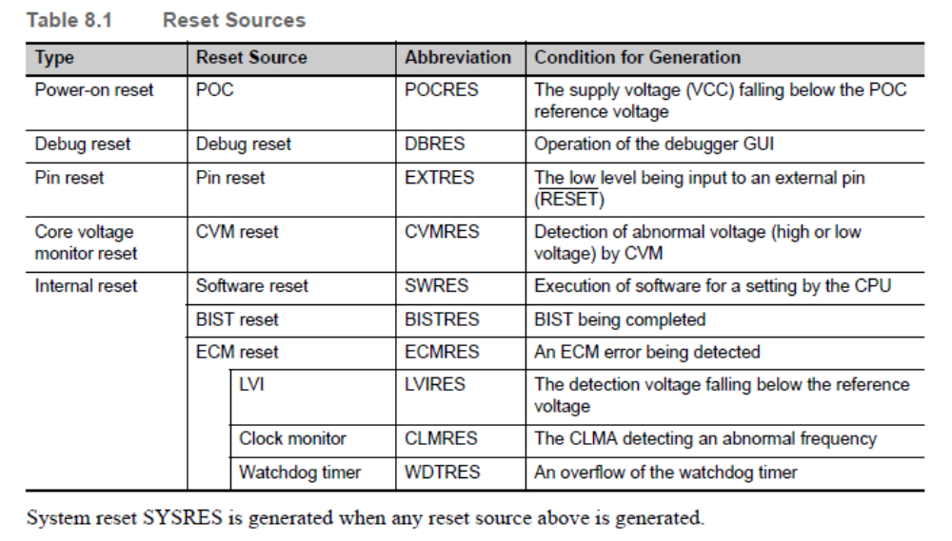

Verification Method
NA

Special Functions
For this design, some special functions are used to identify the first failure of data and respond. Once data is changed from its known, good states (power on reset or flash programming complete) the BRAMDAT0 will not be updated until a valid power up process occurs or a flash program event is requested.

Data 1 is ONLY updated by the reset cause in the case of a back-up register corruption. This is done to not “lose” data following an NTC event.

// SetMcuDiagcIdnData(Microcontroller Diagnostic Identification Data)
SetMcuDiagcIdnData (McuDiagcData0, McuDiagcData1)
// Update data if different from PwrOnRst or FlsProgmCmpl – OR if flash prog is requested
If ((McuDiagcData0 = McuDiagc1.MCUDIAGC_FLSPROGMREQ) Or
(BRAMDAT0 = McuDiagc1.MCUDIAGC_PWRONRST) Or
(BRAMDAT0 = McuDiagc1.MCUDIAGC_FLSPROGMCMPL)) Then
BRAMDAT0 = McuDiagcData0
BRAMDAT1 = McuDiagcData1
End If
Done

Revision Record & Change Approval

Rev | Date | Change Control # | Drw | Change Description
1.0.0 | 10/20/2015 | EA4#1831 | MK | Initial Release
1.1.0 | 11/19/2015 | EA4#2536 | SK | Removed CVMREN Initialization. Refer Anomaly EA4#2522
1.2.0 | 01/08/16 | EA4#3186 | LWW | Replaced Os Protection and Error Hook

