Clock Configuration and Monitoring RH850
(ClkCfgAndMon)

FDD #CM109A

1. Function In This Document 5
2. Critical Registers 5
3. Sub-functions 6
3.1. NTCs 6
3.2. SAN Linkage 6
3.3. Description 6
3.4. Rationale 6
3.5. Implementation 6
3.6. Reference 8
3.7. Verification Method 12
4. Revision Record & Change Approval 12

Renesas Document References:
Hardware User’s Manual (HWUM) version 1.00 dated July 2015
Safety Application Note (SAN) R01AN2118EJ0120 Rev. 1.20 Release December 1, 2015

Function In This Document
N/A

NTCs
N/A

SAN Linkage
N/A

Description
This function configures and starts the PE’s clock monitor logic. This logic will cause a signal to the ECM if the monitored clocks exceed their low or high limit thresholds over their sample intervals.

Each of four clock monitor circuits compares the number of rising clock edges which occur on two clock signals. In the time required for each “sampling clock” to produce 16 rising edges (after each reference rising edge) the rising edges of the corresponding “monitored clock” are counted and compared to programmed low and high limits for that monitor circuit. A comparison outside the range defined by the limits causes a signal to the ECM.

Per HWUM 31.5.3.2 and 31.5.3.3, each clock monitor channel’s enable bit, when set to one, locks that channel’s low and high limit registers until any reset occurs. Each clock monitor channel’s enable bit can be controlled by writing to the respective control register CLMAnCTL0.

Rationale
The sample and monitor clocks of CLMA1 and CLMA3 are both derived from the same basic oscillator. For this reason, variation in these sources will occur in both sample and monitor clock circuit inputs and the resulting counts will not show the variation that will occur with CLMA0 and CLMA2 where the two oscillator inputs have independent variations. Instead of adding the two tolerances which is appropriate with independent error sources, a fraction of the total tolerance should be used by MCAL with the positively correlated errors of CLMA1 and CLMA3. Unless Renesas describes new sources of frequency error it may be desirable to tighten the tolerances of CLMA1 and CLMA3.

Assumption:
A programmable “option byte” OPBT0 value affects the values used with the Renesas formulae here. The assumption used here are that OPBT0[21:20] is either 0b00 or 0b11. These two values yield identical upper and lower limit values for the clock monitor circuits. Currently CM106A documents the use of OPBT0[21:20] = 0b00.

All four monitor circuits will be initialized and armed since, in addition to the existence of a reasonable frequency pulse stream from the two oscillators, the additional channels each verifies that some distinct frequency divider flip-flops are functioning.

Implementation
The following table lists the values available from different sources which may be used to initialize the clock monitor circuits.

Clock monitor | OPBT0 [21:20] | monitored clock | sampling clock | Renesas formula min hex  (%tol.) | Renesas formula max hex  (%tol.) | Derived Tolerance for MCAL (+/-%)
CLMA0 | Don’t Care | Main Osc | HS intOsc / 4 | 73  (-10.16) | 8F  (11.72) | (10, -10), (1, -1)
CLMA1 | Don’t Care | Peripheral clk /2 | Main Osc / 8 | 9E  (-1.25) | A1  (0.625) | (1, -1) (1, -1)
CLMA2 | 00 | WDTCLKI = 8Mhz | Main Osc / 16 | 72  (-10.94) | 8D  (10.16) | (10, -10), (1, -1)
CLMA3 | Don’t Care | Clk CPU | Main Osc / 2 | 13E  (-0.625) | 141  (0.313) | (1, -1) (1, -1)

Note: Renesas also documents a hardware requirement that each clock monitor lower limit be larger than zero and that each upper limit must be greater than or equal to the corresponding lower limit plus three.

The use of “Don’t Care“ in this table means that the value has no impact on the circuit behavior.

The Renesas formulae compute clock monitor limit values assuming that the two clocks of each monitor have independent variation from nominal. While this is completely true for CLMA0 and CLMA2, it is wrong for CLMA1 and CLMA3 which use the same oscillator as the source of both inputs. Those channels’ limits are likely wider than they need to be but the digital hardware design limits on how close the two limit values of each monitor can be to each other prevents those tolerances from being very much tighter.

Renesas’ MCAL provides an input tolerance for each of the clocks involved with each monitor circuit. MCAL accepts input tolerance quantized to whole percentage so the minimum non-zero tolerance of one percent is used for CLMA1 and CLMA3 inputs. The minimum crystal oscillator tolerance (one percent) is used with the ten percent tolerance of the “high-frequency” oscillator for CLMA0 and CLMA2.

A snapshot of the spreadsheet used to evaluate clock monitor limit values has been included in the “reference data” section below.

MCAL Input:
In the McuGeneralConfiguration container
McuClm0Operation true
McuClm0MonitoringClockAccuracy 1
McuClm0SamplingClockAccuracy 10
McuClm1Operation true
McuClm1MonitoringClockAccuracy 1
McuClm1SamplingClockAccuracy 1
McuClm2Operation true
McuClm2MonitoringClockAccuracy 1
McuClm2SamplingClockAccuracy 10
McuClm3Operation true
McuClm3MonitoringClockAccuracy 1
McuClm3SamplingClockAccuracy 1

Reference

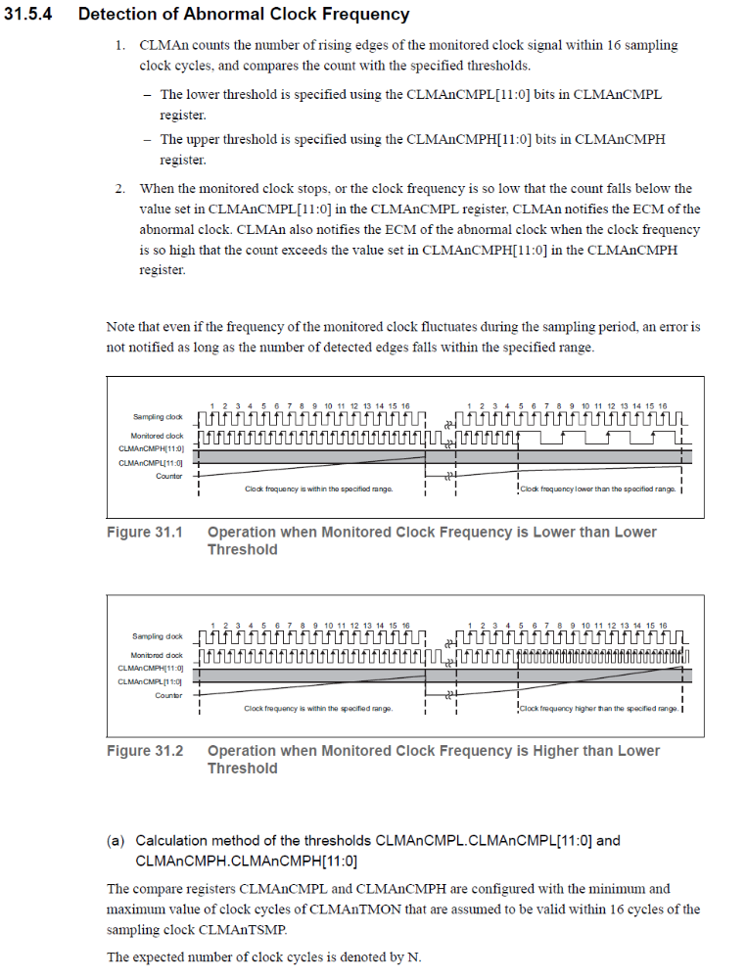
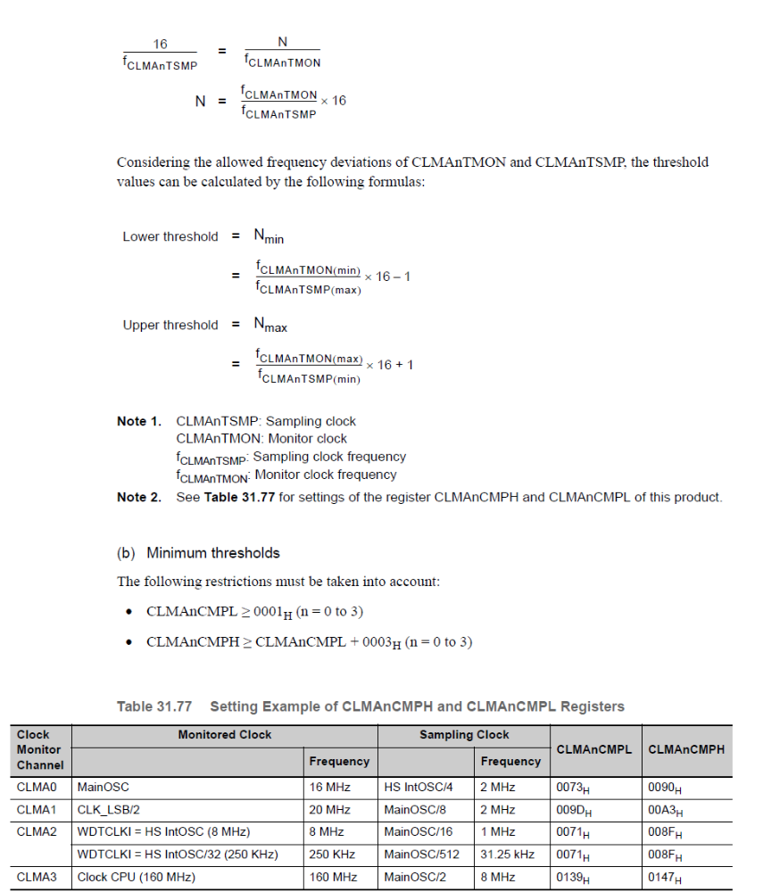

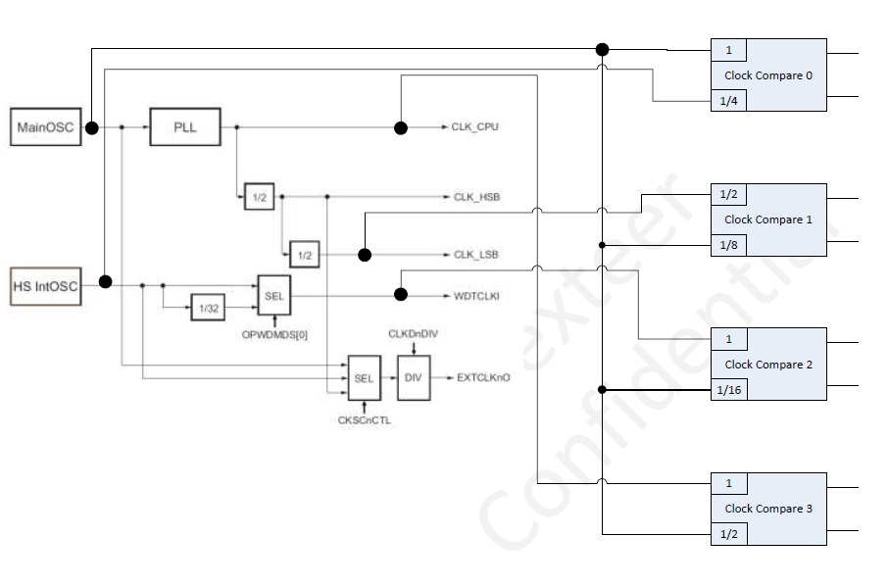

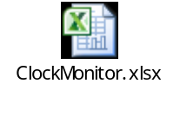

Verification Method
N/A

Revision Record & Change Approval

Rev | Date | Change Control # | Drw | Change Description
01.00.00 | 03/02/2016 | 2475 | EC | Initial release

